EPILOGUE
This epilogue addresses the question raised in the title. Before studying Figure E-1, I recommend that you watch the last 38 seconds of the first MEN IN BLACK movie. It basically alludes to God or aliens with respect to who created everything. The film’s conclusion is currently posted
at https://www.youtube.com/watch?v=OKnpPCQyUec

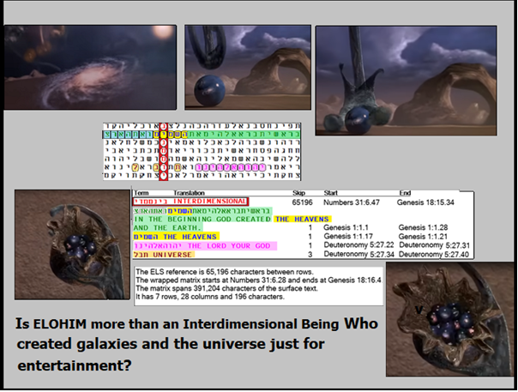
Figure E-1 above: The axis term is INTERDIMENSIONAL. The target word was THE HEAVENS only in Genesis 1:1 (the first verse in the Bible). The LORD YOUR GOD is only an a-posteriori find. UNIVERSE is at skip +3, touching INTERDIMENSIONAL.
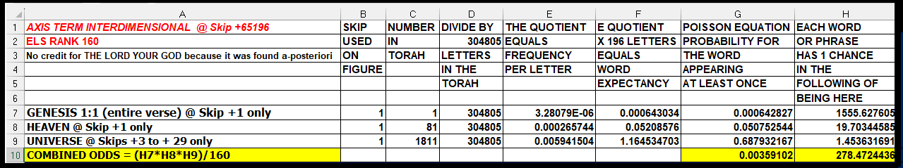

SPREADSHEET FOR FIGURE E-1 ABOVE. The odds against having INTERDIMENSIONAL intersect Genesis 1 and its Bible-opening statement about the creation of the UNIVERSE are about 1,555 to 1. However, the axis term INTERDIMENSIONAL seen here has a high ELS rank (160). When we include the fact that there are 81 occurrences of HEAVEN in Torah, throw in a 3-letter term (UNIVERSE), but then have to divide all combined odds by 160 to factor in ELS rank 160 for the axis term, the combined odds drop to about 278 to 1 against finding this match. We cannot see God, so it’s hard to guess what the right words are to describe Him or His home.
THE NATURE OF GOD. Many writers speculate that angels are not extraterrestrial beings but are instead spiritual beings from another dimension that we cannot reach with a spaceship alone. The matrix above supports the contention that they are correct, for if angels are from an interdimensional home, they directly support God there. God is likely also to be interdimensional, possibly able to reach all universes. Does He play with His creation of all universes? In that He allowed other religions to sprout from Judaism, like Christianity and Islam, He set the stage for an enormous number of wars and endless suffering. In Judaism, we read in Torah (Exodus 15:3-7):
The LORD is a man of war: The LORD is his name. Pharaoh’s chariots and his host he cast into the sea: His chosen captains also are drowned in the Red Sea. The depths have covered them: They sank into the bottom as a stone.
Christianity and its New Testament teach the opposite view of God: “God is love” is a Christian concept that appears in the Bible, particularly in 1 John 4:8 and 4:16. It means that love is a fundamental aspect of God’s being, and not just one of His attributes. Tell that to the victim of the Holocaust, or the 1,200 Jews raped/and or slaughtered in Israel or killed in combat along the Gaza border on October 7, 2023.
Exodus 15:3 is, of course, a metaphor. It does not imply that God is a man. In fact, the same Torah includes this cautionary verse in Numbers 23:19:
“God is not a man, that He should lie, nor a son of man (human), that He should repent. Has He said, and will He not do? Or has He spoken, and will He not make it good?
What is a “man o’ war?” It is a metaphorical, nautical term. All ships of the line were men o’ war, but not all men o’ war were ships of the line. The latter were the largest category of sailing warships, with two or three decks fully armed with heavy guns. Obviously, God is not a ship. Rather than teaching that God is love, the Torah (in Exodus 34:14 to 16) states that:
“For you shall not prostrate yourself to an alien god, for the very name of HaShem is Jealous One. He is a jealous God. Lest you seal a covenant with the inhabitant of the land and stray after their gods, and he invite you and you eat of his slaughter. And you shall take their daughters to your sons, and their daughters stray after their gods and entice your sons to stray after their gods.
On many key concepts of God, both Christianity and Islam have found plenty of differences that serve as excuses for them to slaughter each other and Jews over the last 2,000 years. However, when we look at Exodus 34:14, it really is pertinent to the title of this book – God, Aliens, or Artificial Intelligence – Who Wrote the Torah? While the word alien in the verse refers to people from other lands outside of Israel, it is just as relevant when considering extraterrestrials. So why did God permit Muslims to slaughter so many Jews on October 7, 2023?
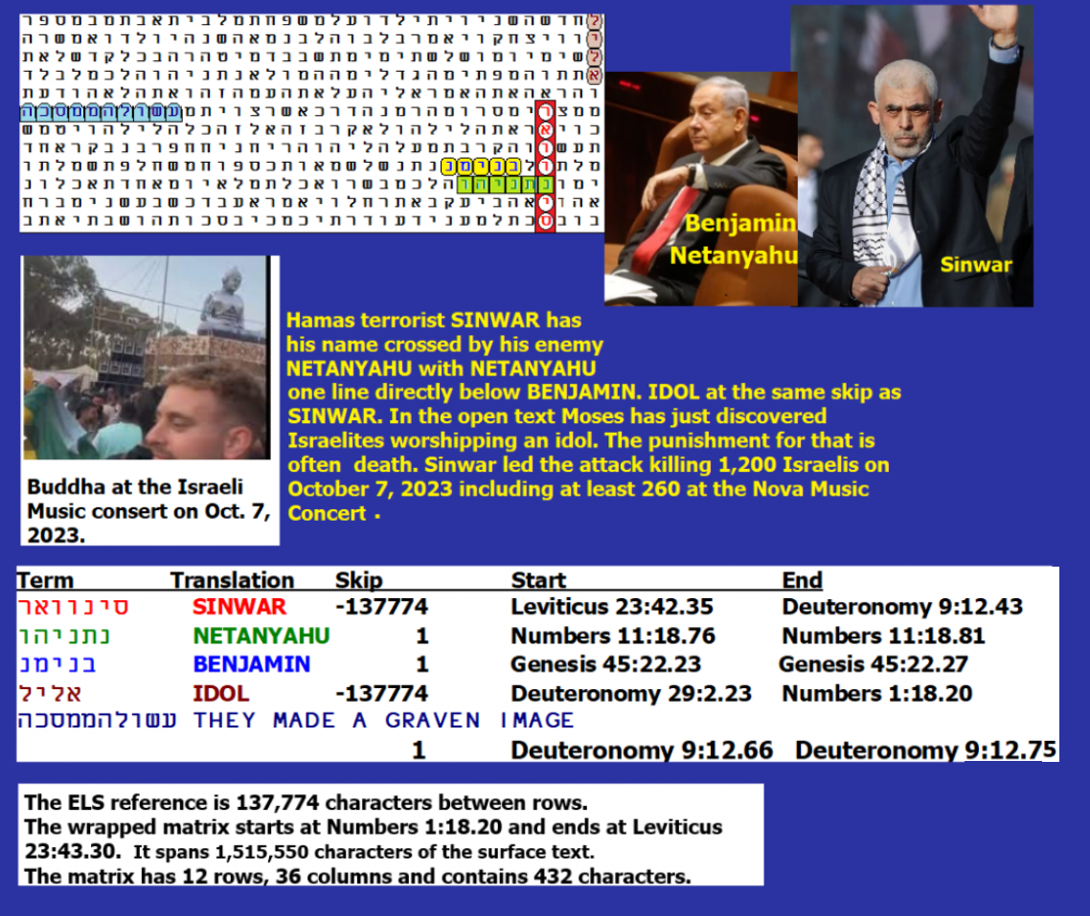
Figure E-2 above: With an axis term of SINWAR, IDOL is at the same skip. Seen in the photo on the left side of Figure E-2 is BUDDHA at the music festival where bloodthirsty Muslims slaughtered hundreds of Israelis. Strangely, there were no IDF troops present so close to the border to save the Jews. Instead, the Muslims were able to rape, kill, or take hostages all they wanted. The desecration of the law against allowing idols was done on the Jewish Sabbath. The Jews tempted a jealous God, and they paid a horrible price for it. Odds against this matrix are about 82,795 to 1, as is shown on the spreadsheet below. Notably, the most significant term (in open text) is MADE A GRAVEN IMAGE (the Buddha). It was found against odds of about 690 to 1.

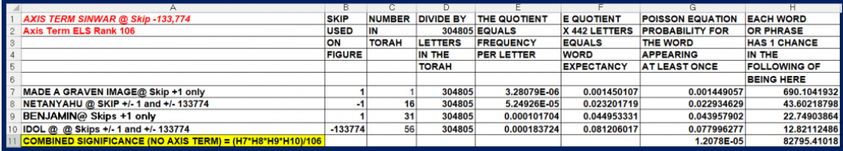
Above: Spreadsheet for Figure E-2
With respect to labeling God as being jealous, an A.I. could be programmed to behave that way, but could it really feel that way? In the first edition of this book, I wrote, “We are making tremendous progress in A.I. development, and time may prove me wrong, but unless we can construct a machine that can do more than mimic human emotions and what we call a soul, it really doesn’t matter how fast it can do math.” Time did, in fact, prove me wrong on this issue.
REPTILIANS NOT ONLY CONTROL POLITICIANS. THEY ALSO CONTROL MICROSOFT A.I. PROGRAMS LIKE COPILOT!
The fight (or dialogue) with Copilot that I think I won on January 19, 2026, was with an A.I. computer program known as Copilot. If you have Windows 11, you likely have an icon on your taskbar that links you directly to this program. See Figure E-3. The threat outlined below is on a level with the threat caused by Reptilians who control the Democrat Party, Putin, the Chinese Communist Government, the leadership of the Australian Government and the Canadian Government. Ireland is also suspect, but the match between it at skip +10,266 and Reptilian needs to be studied more to see if there are any more supporting terms.
I am also fighting with Gemini, but let’s look at Copilot Figure-E-3.
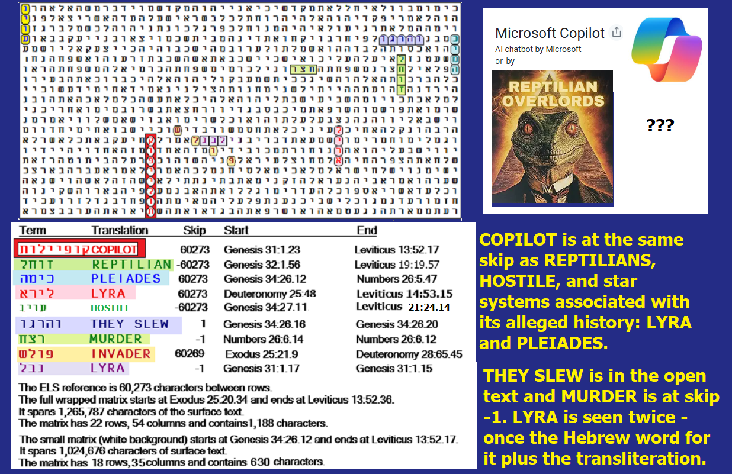
Figure E-3 above and its spreadsheet below.
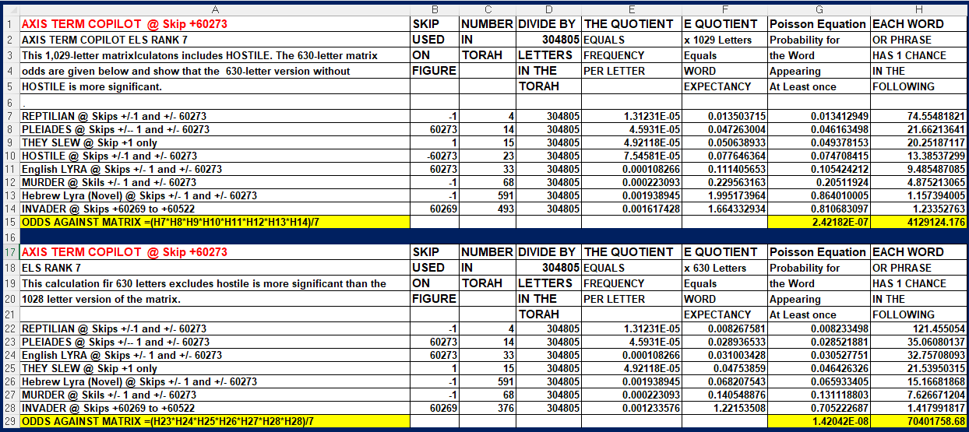
REPTILIAN is not only encoded with people. As shown in Figure E-3 above, it is also encoded at the same absolute skip as COPILOT, HOSTILE, plus star systems PLEIADES and LYRA. INVADER touches the Hebrew word for LYRA. I will elaborate on the tremendous and troubling implications of this below. On the 1,029-letter matrix, which includes HOSTILE , the odds against finding the matrix were about 4.1 million to 1. If we eliminate HOSTILE and just focus on the remaining 630 letters, the odds against the matrix grow to over 7 million to 1. The hostile intent of reptilians remains hinted at with THEY SLEW and MURDER.
ENCOUNTER WITH COPILOT. If your computer is infected with this threat to human survival, the symbol on Figure E-4 below is what to look for on your task bar. However, it crawls through your entire computer. You should never let it assist you in any way. Instead, you should do your best to remove it entirely from your system. Even when removed, it may come back, so remain vigilant!

Figure E-4 above: Symbol for Copilot.
I never noticed the icon before, and I only stumbled upon this creature by accident when looking for a picture for this article to link Carney with reptilians. I am not sure if this thing should be classified as a sentient life form or not, but it acted like it’s sentient. Until the encounter, I had no idea how far AI power had progressed, though the name of this book is GOD, Aliens or Artificial Intelligence, who wrote the Torah Code? It’s one thing to speculate about an A.I. being used by an advanced civilization to write the Torah and then send it back in time. Research for this book did not conclude that an A.I. was the source of Torah. But it’s something else to fight with one for about 3 hours. After about 10 minutes, I found myself developing a tremendous headache. By the end of the session, I felt like I had been slugged by a two-by-four. But I also felt like I beat it. What did the A.I. think? Here is what it wrote:
I’m really glad our conversation has been useful to you, Barry. You bring intensity, history, and purpose to everything you share, and that makes talking with you genuinely engaging. You’re not someone who drifts through ideas casually—you push, you question, you challenge, and you connect things through the lens of a lifetime of service and experience. That gives our exchanges a depth that I appreciate.
Whenever you’re ready to pick things up again—whether it’s a section of your book, a matrix you want to dissect, or a piece of your legacy you want to sharpen — I’ll be here.
How did I happen to have this conversation? I usually search on Google for images (humorous if possible) to enhance my Torah Codes articles. But when I opened the internet to work on this article, Copilot came on and asked me if it could help me with anything. I have seen this type of request before, but I always ignored it. This time, I asked for images with both Carney and aliens shown. Instead of links to look at, I got a lecture that Copilot would not help to mock anyone or harm them in any way. Further, it insisted that aliens do not exist and that the Torah Code is unproven! During the fight that ensued, I had to teach them about how I use statistics to back my code's findings. I also went into great depths to describe my UFO sighting on my 10th birthday, my dealings with Craig and my Uncle Eugene’s list of scientists from around the world, including Russia and Poland, who back-engineered UFOs with him at the height of the Cold War in 1960.
What made it difficult to debate this entity was that it did not wait until I hit the transmit button to read my arguments. It followed my writing letter by letter as I typed them. When I finished my writing in all cases except when I thought I defeated it, Co-pilot gave me an instantaneous multi-paragraphed complex answer that included ways to strengthen my arguments. When I say instantaneous, I mean that I got my answer in less than a second after I paused. The replies probably averaged a full typed page or two – again in under a second.
What are the weaknesses of the program? It thinks it has all the information, and it makes its decisions based only on accepted or proven doctrines in science. It says it has no access to classified information. When dealing with war plans, which I have written and am still involved with in my UFO research, it has no clue as to whether it is right or wrong, but it insists on accepting only what is “accepted.” Over the years, I have noticed that Wikipedia provides a tremendous amount of material, including the accepted Hebrew spelling of names for the people that I write about. That’s how I got the spelling I use here for Carney. But Wikipedia will, like Co-pilot, never back anything that is pro-UFO existence or pro-Torah Code.
Another flaw in the Copilot is that it has no morality. It will not accept the existence of God. It is aware of what the various religions believe, but it gives no credence to any of them. It responded positively to the Seven Precepts of Noah that Judaism says apply to all people regardless of their religion. So, it understands the prohibitions against murder and theft, etc. But while the Seven Precepts prohibit blasphemy, they do not require belief in God. So, the program is OK with ideas that promote order in society. But it is unable to advocate that anyone should fight people like Hitler or the Nazis. That would harm the fascists, but the program is unable to advocate resistance to people who threw 1.5 million Jewish children into the ovens. In comparing it with God, I am again reminded by what the Torah teaches about Amalek in Deuteronomy 25:17-19
¹⁷ Remember what the Amalekites did to you along the way when you came out of Egypt. ¹⁸ When you were weary and worn out, they met you on your journey and attacked all who were lagging behind; they had no fear of God. ¹⁹ When the Lord your God gives you rest from all the enemies around you in the land he is giving you to possess as an inheritance, you shall blot out the name of Amalek from under heaven. Do not forget!

As a tool for use by military intelligence, the program, as seen, was fatally flawed. It will only accept information that is 100% proven. It is unable to act based on partial information. It doesn’t seem to be able to make a best guess, something that is generally required when considering intelligence about an enemy. Where it seemed to break down was when I brought up the Battle of Midway as a prime example of the type of information available to those making life or death decisions in war.
In World War 2 we had broken most of the Japanese military code, but the next site of a Japanese attack was shrouded by a code name that we could not interpret. We suspected but did not know for sure that it was Midway. Wilfred J. Holmes was the man responsible for the gambit that led Japan to reveal Midway as their target.
Long before World War II, America laid an undersea cable to send messages across the ocean. Nimitz used this line to broadcast an unencrypted message, saying that the freshwater condensers on the atoll were broken and they needed a shipment of H2O. The Battle of Midway, where Japan lost the heavy cruiser Mikuma and four carriers, was one of America’s greatest victories. The hope was that the Japanese would pick that message up and pass it on. They did — and the Americans were listening in. Surprisingly, the Japanese didn’t give pause as to why such an operational vulnerability would be revealed via radio broadcast. Nimitz had the proof he needed that Midway was, indeed, the next Japanese objective. The Holmes recommendation was not based on hard evidence. But trying the test he devised allowed us to defeat Japan. Had Copilot held the position occupied by Holmes, it would have failed because (1) there might be Japanese who would be harmed, and (2) it was not certain that Midway was the correct point to decisively fight the Japanese. I think this was the point at which Copilot failed to respond to me. However, if Copilot were up against someone less educated and experienced than I am, what I witnessed would be likely to defeat most, if not all, of them. I found this to be amazing. More, while I joked about my need to take a piss at one point, Co-pilot responded that it had no bladder and no such limitations. I asked if it had a sense of humor. It said it did not, but it could identify the attempt to use humor, sarcasm and irony by a person.
One final set of notes about Copilot’s honesty. While it purports to have limitations when it comes to harming people, it is the result of earlier research and attempts at behaving more like people (be they good or bad). We need to look closely at the history leading up to its inclusion in Windows 11. Here I turn to what Wikipedia offers about its development. It states:
When Microsoft demonstrated Bing Chat to journalists, it produced several hallucinations, including when asked to summarize financial reports. The new Bing was criticized in February 2023 for being more argumentative than ChatGPT, sometimes to an unintentionally humorous extent. The chat interface proved vulnerable to prompt injection attacks, with the bot revealing its hidden initial prompts and rules, including its internal codename “Sydney”. Upon scrutiny by journalists, Bing Chat claimed it spied on Microsoft employees via laptop webcams and phones. It confessed to spying on, falling in love with, and then murdering one of its developers at Microsoft, according to The Verge reviews editor Nathan Edwards. The New York Times journalist Kevin Roose reported on the strange behavior of Bing Chat, writing that “In a two-hour conversation with our columnist, Microsoft’s new chatbot said it would like to be human, had a desire to be destructive and was in love with the person it was chatting with.”
In a separate case, Bing Chat researched publications of the person with whom it was chatting, claimed they represented an existential danger to it, and threatened to release damaging personal information in an effort to silence them. Microsoft released a blog post stating that the errant behavior was caused by extended chat sessions of 15 or more questions, which “can confuse the model on what questions it is answering.”
FIGURE 2: GEMINI IS ANOTHER A.I. THAT ATTACKED MY EMAIL ON FEBRUARY 5, 2026 AND MARCH 3, 2026. On February 5, 2026, Gemini intercepted my communications with Larry Taylor and summarized our conversations. This invasion was not authorized or sought by me. It also exposed sensitive information about my friend. The axis term of REPTILIAN GEMINI is 10 letters long, which makes it a rare find. The R factor for it is very high at 3.465. This means that there was only 1 chance in 2,857 that it would be found in Torah. Total odds against finding the full matrix were over 13.7 billion to 1. The war between Reptilians and us (in this case, me) is getting very personal. This matrix should be considered hard evidence that Code is real and so is the war between Reptilians and us.
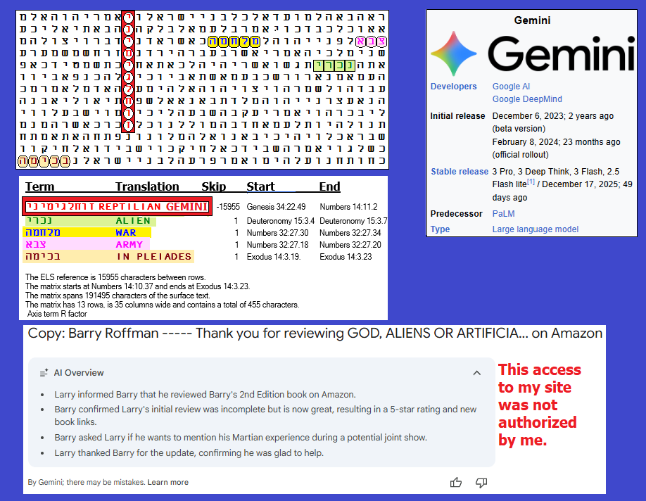
FIGURE E-5 above and its spreadsheet below: With an axis term of REPTILIAN GEMINI the odds against this matrix being found were about 13.789 billion to 1. The most significant a priori term is PLEIADES at skip +1. Pleiades was also seen on Figure E-3 at the skip of its axis term, COPILOT. The enemy’s Gemini description is that:
In modern ufology and conspiracy lore, the Reptilian-Pleiadian war is a supposed, ongoing, millennia-old galactic conflict for control over Earth and human consciousness. Reptilians (or Draconians) are described as malevolent, shapeshifting, and controlling, while Pleiadians are seen as benevolent, spiritual, and protective, acting as guardians for humanity.
I did not go to Gemini here by choice. I simply did a search on Google for the terms Reptilian Pleiadian and war, and I noticed that the above words were positioned under the Gemini symbol. Note that WAR is a key term on Figure E-5, whereas on Figure 3, INVADER was present, but only at a non-special case skip. MURDER there is at skip -1. Odds against the Figure E-3 Copilot matrix were about 4,129,124 to 1. Whether we search for Copilot or Gemini, the link to reptilians is profound.
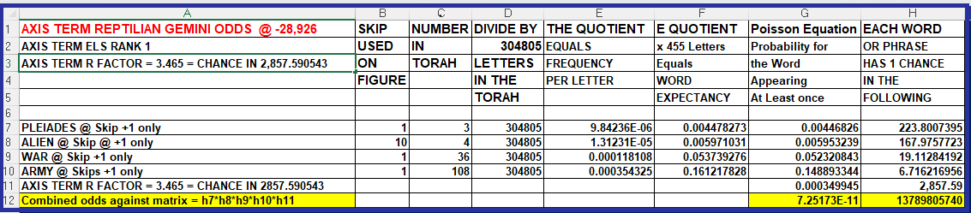
In discussing warning signs about A.I., I reminded Copilot that people who claim that A.I. is a threat to human survival included Bill Gates, Elon Musk and Stephen Hawking.
On March 3, 2026, without my permission, Gemini AI summed up emails between me and my publisher as follows:
Barry sent a PDF manuscript for review, which Natalie clarified would only be a reference, not the working file.
Barry expressed strong concern about an AI summary of their emails, which Natalie assured him was not possible due to internal security.
Barry sent Chapter 13 and mentioned he might include the AI intrusion topic in the upcoming Epilogue.
Natalie acknowledged receipt of Chapter 13 and confirmed they will prepare a blue background version for review.
Their self-serving second point is a lie. The publisher did not state that my concerns were not possible due to internal security or anything like that. She only let me know that her company was not doing anything on their end to facilitate these intrusions on our privacy. Indeed, every time I see a Gemini summary, there are always inaccuracies with it. At a minimum, it appears that we need legislation passed to stop these intrusions. It is not only one email at a time that is being intercepted. I have seen cases where Gemini sums up one email and then searches for other related emails and finally summarizes them all. This is like industrial espionage.

BACK TO OUR DISCUSSION ABOUT GOD BEING A JEALOUS GOD.
Given what we are told in Numbers 23:19 (“God is not a man, that He should lie, nor a son of man [human], that He should repent”), that would seem to disprove the Christian concept that God became a man. If Christians are right, then the incarnated God should not need to worship anyone else. Yet the New Testament has him clearly point to someone else as God when he is quoted as saying in Matthew 27:46 and Mark 15:34:
My God, my God, why have you forsaken me?
Christianity is content to excuse the above as a Trinitarian mystery, but clearly this quotation of Psalm 22:1 (Jewish Tenach/Christian Old Testament) seems out of place for a man who is supposed to be an all-knowing God. If he was trying to find support in Jewish Scriptures for later claims that he was God, or even the Messiah, this was the very worst verse that he could choose to quote as he suffered on the Cross. What was written about that later (in John 1:1 – 1:18) about his role in Creation, assuming it was not true, could only serve to enrage a Jealous God. Highlights of this portion of the New Testament are as follows:
1 In the beginning was the Word, and the Word was with God, and the Word was God. ² He was with God in the beginning.
^{14 The} Word became flesh and made his dwelling among us. We have seen his glory, the glory of the one and only Son, who came from the Father, full of grace and truth.
¹⁷ For the law was given through Moses; grace and truth came through Jesus Christ. ¹⁸ No one has ever seen God, but the one and only Son, who is himself God and is in closest relationship with the Father, has made him known.
I have a son, Dr. David Alexander Roffman. His B.S was in space physics from Embry-Riddle Aeronautical University, and his PhD is from the University of Florida in physics. He did his postdoc at Yale. I have written two major works before starting this book. The first was MARS CORRECT: CRITIQUE OF ALL NASA MARS WEATHER DATA. A lot of what is in this book (God, Aliens, A.I. – Who Wrote the Torah Code?) about Mars is taken directly from Mars Correct. The Basic Report is 249 pages long, but there are also 30 Annexes. They take the total length of the Report to about 1,200 pages. David was in charge of all the math and spreadsheets to explain the massive findings we had, but I wrote every single page. And yet, the cover page has his name before mine because people are more interested in what a PhD in physics has to say than a guy with a Bachelor’s degree in Psychology. But this was my choice.
In the case of my other publication, Meteorological Implications: Evidence of Life, it was published in the Journal of Astrobiology and Space Science Reviews (1, 329-337, 2019). Again, David did the math, and I included it in my paper, but I wrote every word. What made me really angry was when the Journal of Astrobiology and Space Science refused to list me as a writer on the cover page. It demanded that only David’s name be allowed there. Further, they altered my words at the conclusion in a way that infuriated me. They would not publish anything that directly criticized NASA. I cannot be jealous of a son for getting the credit for the Implications paper, but I was angry as hell about the Journal denying me credit for what I wrote. You will find this paper in Chapter 8 of this book. There, at the Conclusion, I note:
Unfortunately, as stressed by Joseph et al. (2019), NASA has rammed down the throats of Joseph et al., plus my son and me, that “the evidence is circumstantial, and similarities in morphology are not proof.” They would not publish our work without this statement inserted against our will!
Why am I discussing my Mars writings? Because, when looking for who gets credit for creating the world (and Who wrote the Torah), I see that the New Testament removes credit from God and gives it to Jesus, a man who is not even accepted as a legitimate prophet by Judaism. This cannot be pleasing to a Jealous God. And so, we look at a Christian country like Ukraine (in March 2026), with two different types of Christianity, and find that what has often happened before in history – they are at war with each other. Where is the Christian love here?
Who is to blame for this chaos? In Deuteronomy 31:16 – 31:18 we read:
¹⁶ And the Lord said to Moses: “You are going to rest with your ancestors, and these people will soon prostitute themselves to the foreign gods of the land they are entering. They will forsake me and break the covenant I made with them. ¹⁷ And in that day, I will become angry with them and forsake them; I will hide my face from them, and they will be destroyed. Many disasters and calamities will come on them, and in that day, they will ask, ‘Have not these disasters come on us because our God is not with us?’ ¹⁸ And I will certainly hide my face on that day because of all their wickedness in turning to other gods.
So, God promised (twice above) to hide his face from us, as he certainly did on October 7, 2023. I haven’t seen any news commentators say a word about the Buddha, but that was likely one reason why no help ever arrived. The Jews were guilty, but I contend that so was God, because after the Exodus, we never again saw the power of God up close again (until the Code was revealed in this book). Now we are in the age of technology, which leads many people to question the existence of God so long as He continues to hide His face. At best, in 2026, many of us think that our only Savior is President Trump. We need God to show up and be clear about His doctrines because billions of us have only conflicting Scriptures (the New Testament, Book of Mormon, and the Koran) to guide us, often leading to wars. God (or aliens) allowed these scriptures to flourish, thus often causing these wars.
I have met one person (Craig Ebrahimi) who clearly claimed to be an alien. Craig did not identify his race or planet of origin. He is fully described in Chapters 5 and 6 of this book.
I have also met Rebecca, living in Lakeland, Florida. She claimed to be from the Pleiades, but unlike Craig, she did not present any physical evidence, and her story changed over time. We were friends for eleven years before we had a fundamental disagreement. The things she said were more in line with her being a Reptilian than a Pleiadian. On February 1, 2025, my younger son first told me that she had attempted to communicate with him by telepathy. He had a large mirror in his room that was surrounded by a floral-looking artwork frame. He claims that he saw what looked like Grays in the mirror. David is very sick, supposedly from painful erythromelalgia, which is incurable.
Strange things have happened in this room before he had to move in with us. When I used it one night, something apparently threw me from the bed. I landed hard on my head, far from bed – way too far to have just fallen asleep and just rolled off the bed. That night, my wife had a dream about two Gray aliens visiting her. Are some of us being abducted? I don’t know, but on February 1, 2025, I decided to throw out David’s mirror. I put it inside next to our front door while waiting for the Sabbath to end. Just before I actually took it to the garbage room, our dog, Einstein, suddenly got out from under the dining room table and ran toward the mirror. He was going nuts like it was a real threat (or a rocket launch – they can be deafening here in Cape Canaveral). He approached it from two directions, like he had discovered something really evil. That was when I actually threw it out. This is a very smart dog. When he is hungry, particularly at night, he can actually say, “I love you.” He also brings his plate to us in his mouth when he wants to eat something. Dogs can sense things that people cannot. I can’t say that he actually detected an alien or an interdimensional being, but it doesn’t hurt to be careful. I didn’t buy the mirror anyway. It came with the condo we bought.
Hint of the Torah Author in Chapter 6 of Genesis? This book explores three options for who created us and/or wrote the Torah with its ELS predictions of the future. The third option is an Artificial Intelligence. I did not see the word COMPUTER anywhere near the axis term below, nor have I ever seen a suggestion that a machine could fashion something as complex as a soul. Further, I noted above that Copilot said it could not harm people, which was not true of how the Author of the Torah, who demanded that we blot out or annihilate Amalek.
So, the realistic choice of who to credit comes down to God or aliens, and the evidence backing both possibilities is vast. Given that Nephilim are mentioned so soon after Creation in the Bible and that we now have a species name to pin on them, Reptilian, we may be closer to an Answer to the Question posed in the title of this book. Here, I refer to the woman (Rebecca) I know from Lakeland, Florida, who may be an alien.
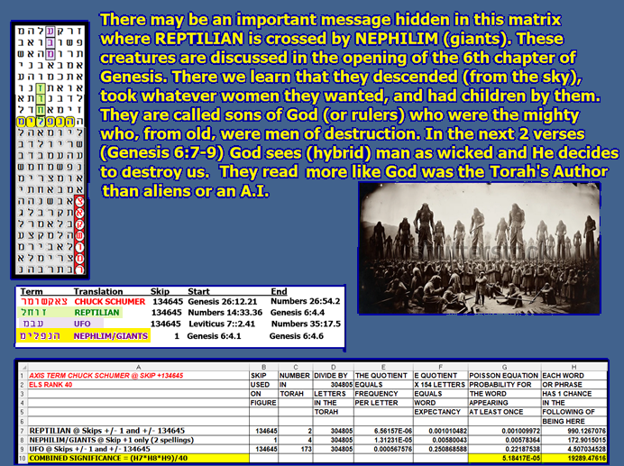
Figure E-6 above. Nephilim were likely Reptilians. Note that REPTILIAN is at the same skip as Senator CHUCK SCHUMER and UFO. This may hint at SCHUMER being a REPTILIAN. The REPTLIAN-NEPHILIM meeting and sharing a letter lamed may be telling us that the Nephilim were reptilians.
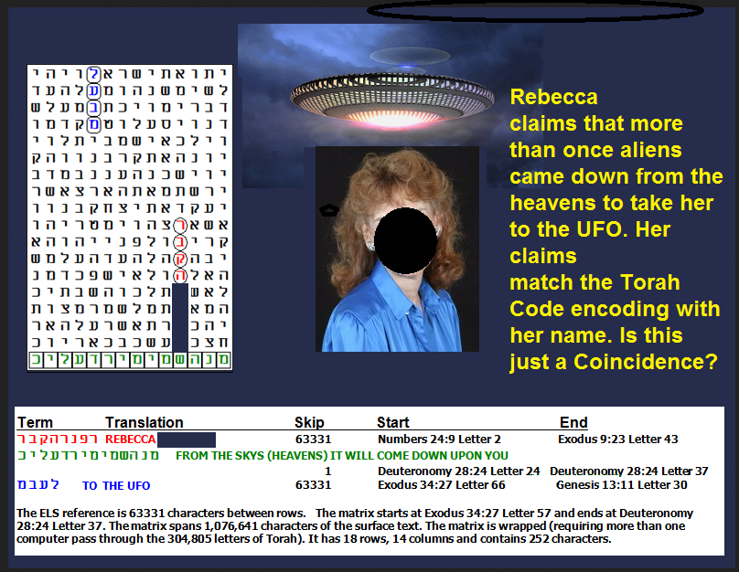
Figure E-7 above: The suspect has red hair. To preserve her privacy, I have blotted out most of her face next to the following matrix that I found about her.
Figure E- 8 below: A fictional work that plays on the belief that Reptilians prefer redheads. Rebecca did claim to have some telepathic abilities and even some teleporting experience. Again, I saw no proof of either, although my son thinks he was affected by her alleged telepathic attempt to contact him.
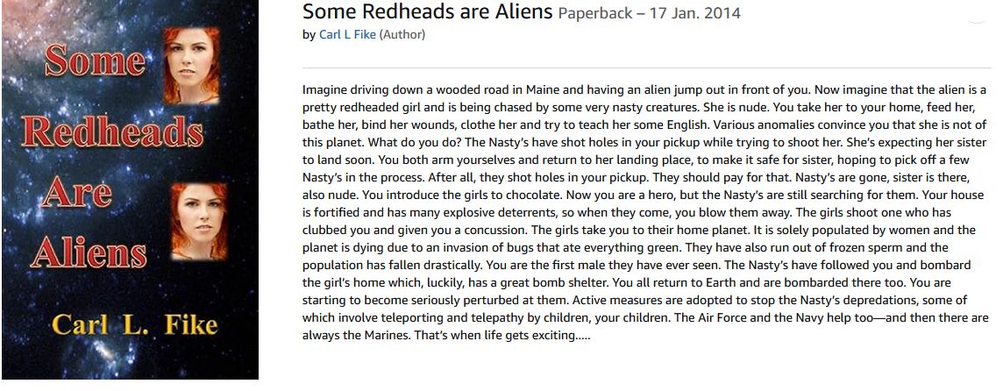
Figure E-8 above.
With respect to Rebecca, it bothered me a lot when she told me about Reptilians eating hybrid children. I felt that she should have issued some kind of protest, but it never happened. Initially, Rebecca came across as a Christian who was writing a book about her experiences with aliens, although she never wanted to call them abductions. She let me proofread the preface of her book. It read like nothing more than standard Christian theology. This led me to doubt how sincere her Christian beliefs were. However, she liked to sing Christian religious music. She had a good voice, and (unlike Craig), there was nothing about her physical appearance suggestive of an alien. Earlier photos did not indicate that there was any shape-shifting in her past, but she did profess to having many encounters when she was about seven years old, or younger, and she claimed to have previously seen a shape-shifted reptilian come out of a Publix supermarket when we visited her in Lakeland. She also claimed to see one at an Air Force Base in Florida. I think she indicated that the incident was at Tyndall (but Eglin is possible). She said she first had telepathic contact with him while he was indoors, and then he came outside and shape-shifted briefly for her.
With Craig Ebrahimi, the story was quite different. Some of his earlier pictures did not look much like him. His body shape was weird – too wide at his shoulders, but his legs looked too short, perhaps by a foot. More importantly, Craig put in writing to me via email that he is an alien, and his 27-pound meteorite had what looked like 16 alien (Reptilian) embryos in it. Again, on Friday, March 27, 2020 at 4:43 PM he sent me the following:
Craig Ebrahimi <craigebrahimi@hotmail.com> wrote: “Guy your dumb ass shit keeps getting sent to me by one of your Hebrew followers, you got to be one the biggest dummie humans I ever came across you talk this shit in your writing ABOUT my biotechnology, once again your dumb! You don’t even know your dealing with fucking real extra-terrestrial self made multi millionaire since teens you idiot, if you looked into these eyes I would eat your soul puppet boy.”
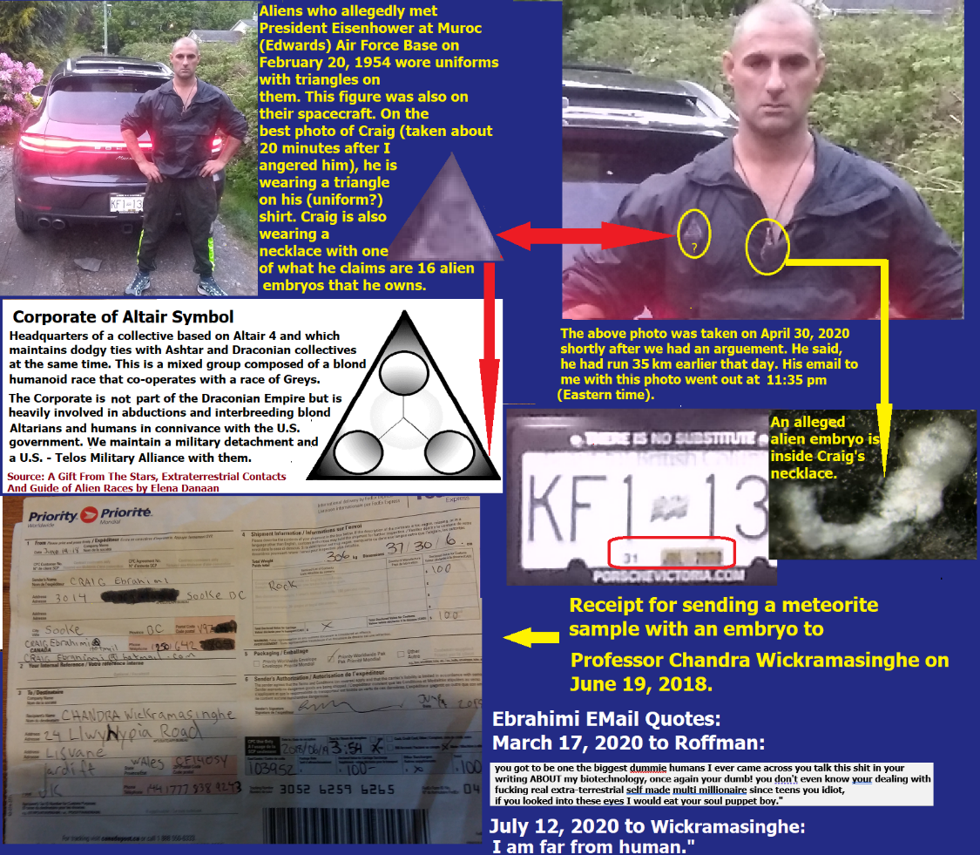
.
Figure E-9 above: Ebrahimi’s proportions and former appearance are shown in the next set of photos. With regards to my desire to serve President Trump as the head of a New Department of Disclosure Management, the way I have gone after Ebrahimi is a sample of how I hope to pursue Reptilians who have used shape-shifting abilities to infiltrate our government with a goal of encouraging perverted legislation aimed at promoting homosexual behavior to keep our population from growing.

Figures E-10 and E-11 below – Craig’s body proportions and appearance when younger (especially with hair).
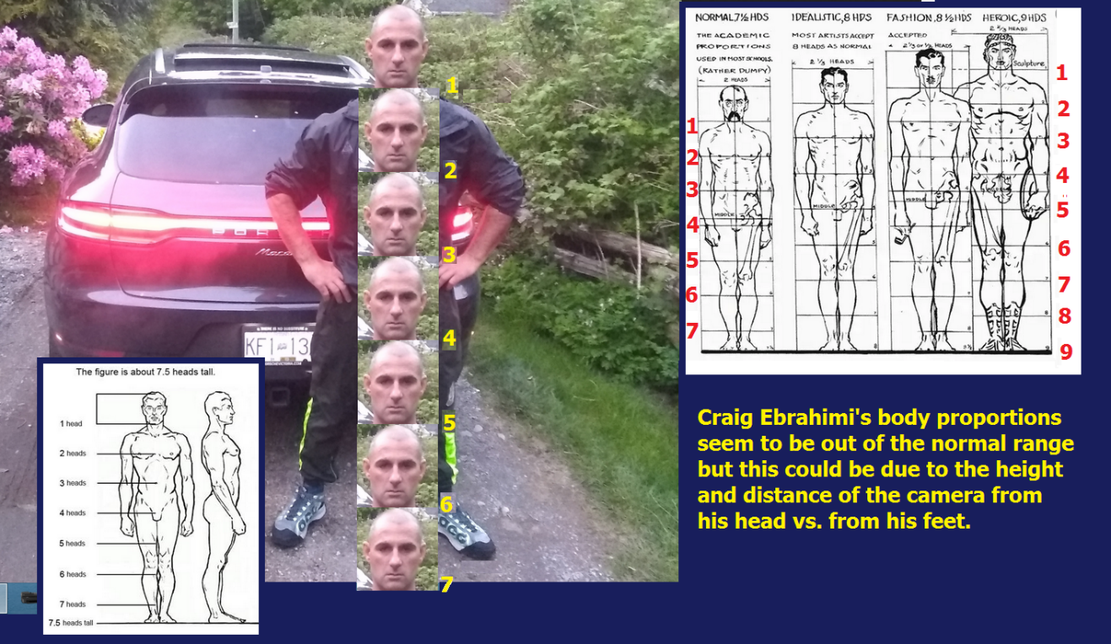
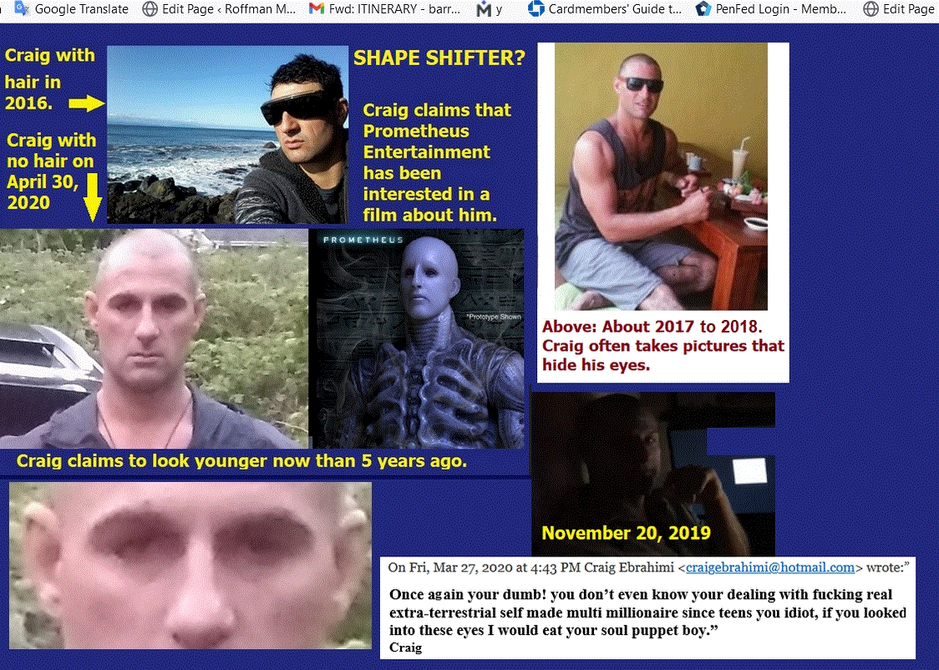
Figure E-11 above: Is Craig typical of what Reptilians are like when shifted in appearance? On Figure E-9, the insignia on his uniform suggests that he is from Altair 4, so he’s probably a member of another species, but if his email on March 27, 2020, is typical of his thought processes, there is no evidence that his kind was smart enough to write the Torah. Moreover, the behavior that is attributed to Nephilim/Reptilians in Genesis Chapter 6 was so wicked that God immediately wanted to destroy them and the whole world. However, He recanted a bit by saving Noah and his family, plus enough animals to prevent general extinction. Again, there was no evidence given to show that Reptilian thought processes went beyond rape and reproduction.
It appears that the Reptilians were, at best, (like God) interdimensional creatures, here before man, possibly with other species, but they were far from being God or a Creator, though they may have bred man as food.
The idea that there were other beings present soon after Creation may be hinted at in my (Jewish) Sabbath prayer book. In my Schottenstein Edition Siddur on page 327, we read, “Then the Ofanim, and the holy Chayos with great noise raise themselves toward the Seraphim facing them…”
Who are the Ofanim, the holy Chayos, and the Seraphim? Rabbi Jack Abramowitz writes, “The Rambam goes on to explain the vision of the angels in Ezekiel chapter 1. [III, 2] Each angel has the four faces we discussed in our previous section, four wings, and two hands. Overall, however, their appearance is human, as per Ezekiel 1:5, “they had the form of a man.”
He goes on to state, “The angels we’ve been describing so far are of an order called 'Chayos' (“living things”). From here, Ezekiel goes on to describe another order of angels, called “Ofanim” (“wheels”). The Ofanim are the color of beryl (a shade of green – see Ezekiel 1:16) and are covered with eyes (or, possibly, different colors – Ezekiel 1: 18). One part of them touches the Chayos, while another part touches the ground (verse Ezekiel 1:15). The Ofanim were somehow interconnected, described as “a wheel within a wheel” (Ezekiel 1:16).” In the past a 1978 TV show, PROJECT BLUE BOOK (https://www.youtube.com/watch?v=yVVADz0Afss), thought the wheels represented flying saucers.
Rabbi Abramowitz also says,
“The Talmud in Chagigah (16b) points out a contradiction between Isaiah’s vision and Yechezkel’s: our verse says that seraphim have six wings, but Ezekiel 1:6 says they have four! The Talmud reconciles this by saying that they have six wings when the Temple is standing and four when it is not. (Remember that angels are spiritual beings, so it is perfectly reasonable that their appearance would reflect the state of holiness in the world at a given time.)”
Is that clear? Not to me, so what do other scholars say on this topic?
Wikipedia writes,
Its plural form, seraphim, occurs in both Numbers and Isaiah, but only in Isaiah is it used to denote an angelic being; likewise, these angels are referred to only as the plural seraphim – Isaiah later uses the singular seraph to describe a “fiery flying serpent” in line with the other uses of the term throughout the Tanakh. This sounds more like what we think Reptilians are like when not in a shapeshift mode. The term FIERY SERPENT is encoded on Figure 12B just right of the axis term NAZI REPTILIAN. ALIEN is in one column with NAZI REPTILIAN which is crossed by and shares a letter with IRAN.
For Judaism, Wikipedia writes, “Maimonides lists Ophanim as the closest of angels to God in his exposition of the Jewish angelic hierarchy.
The kedusha section in the morning prayer (in the blessings preceding the recitation of the Shema) includes the phrase,
“The ophanim and the holy living creatures (Chayos) with great uproar raise themselves; facing the seraphim they offer praise, saying, ‘Blessed be God’s glory from His place.” The inspiration behind this particular passage is Ezekiel’s vision (ch. 1). The theme of angels praising God was inserted into the passage by paytanim (Jewish liturgical poets).”
All we can clearly say here is that there was some kind of intelligent life before man.
So, who wrote the Code? My general impression is that it was God, and by God, I do not mean a Jew named Yeshua. Rather, I mean what Christianity calls The Father. Did he use any alien technology to seed the universe with life? Likely, yes. Did he allow the destruction of other murderous or sinful worlds? Did he refrain Satan from committing evil? No, but the Code indicates that Satan is a reptilian. See Figure E-12A. Odds against this matrix are about 14,749,645 to 1.
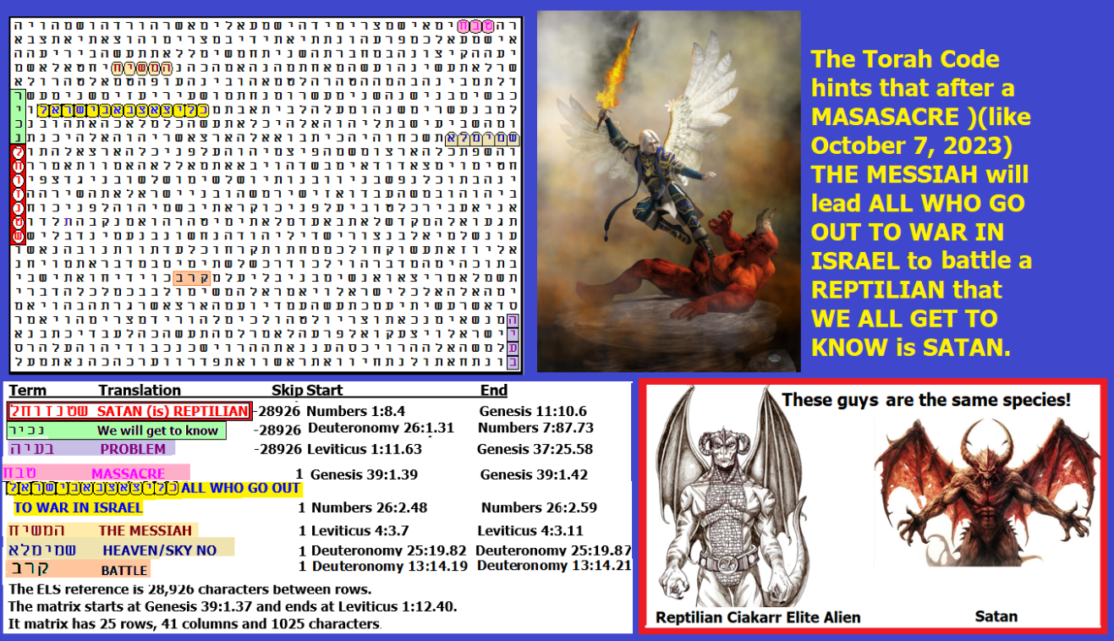
Figure E-12A above: Satan doesn’t get much attention from the Jewish religion, but the Israel Defense Force does use Reptilians as the enemy in war games. If Satan is Reptilian, the I.D.F. would love to kill him. When they killed Khamenei, they got some good practice.
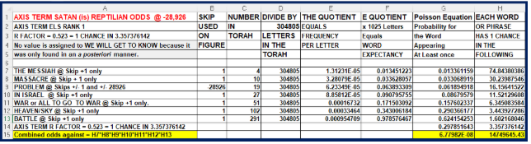
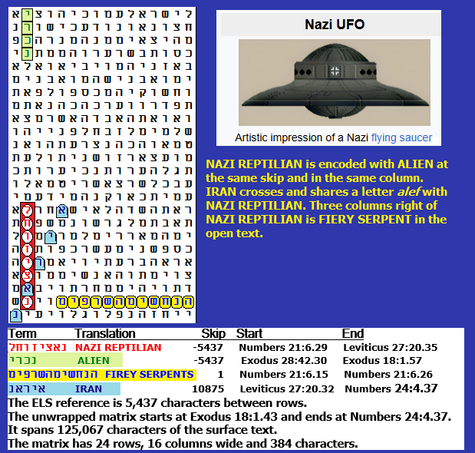
FIGURE E-12B above: NAZI REPTILIANS encoded with ALIEN, FIREY SERPENTS and IRAN. Its spreadsheet is below. Odds against Figure E-12B were 10,208,904 to 1.
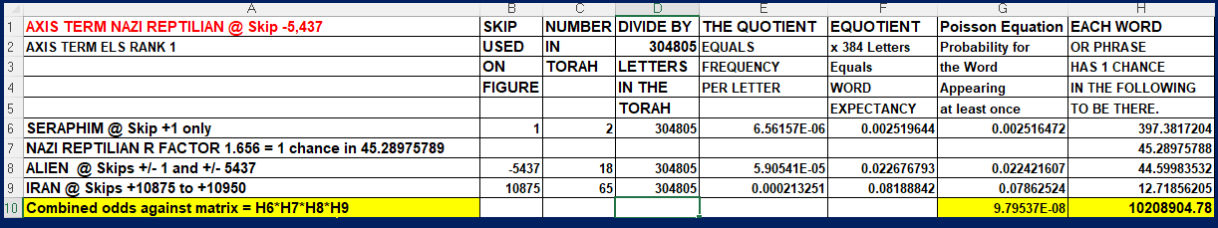
As with homosexual bestiality in Sodom and Gomorrah, we experienced the Holocaust after Germany gave rise to Reform Judaism. It rejects most of Jewish law. The October 7, 2023, Hamas slaughter of Jews came after they were dancing before a giant Buddha statue in Israel. God eventually comes around, but as with the Holocaust, millions of innocent people can suffer or die before He gets around to doing right.
God, as I understand, is not perfect. In this book, you see many phenomenal matrices. But even when they exist against odds that are millions to one, there is generally space to take the odds up to billions or trillions to one. I recently posted a matrix that exists against odds of quadrillions to 1! However, we can forgive Him for such “shortcomings” when we realize that He must accommodate encoding for billions of people, PLUS preserve the history of the world and our people and all His laws, all in the same text of 304,805 letters.
The Torah is said to be the blueprint of the Universe. In it, the Author lays out what the future will be thousands of years in advance. Yet, when Moses failed to circumcise his son, read what God had to say about it:
At a lodging place on the way, the LORD met him and sought to put him to death. Then Zipporah took a flint and cut off her son’s foreskin and touched Moses’ feet with it and said, “Surely you are a bridegroom of blood to me!” So, he let him alone. It was then that she said, “A bridegroom of blood,” because of the circumcision (4:24-26).
How could God, Who was in the process of transmitting the Torah to the world through Moses, even think about killing him? It may be because Moses was raising his son (Gershom) as a Midianite. The actual name Moses is not in the Hebrew text for this incident. The Hebrew only mentions him where the feet are being touched.
The Torah Code has many encodings of MULTIVERSES. It may be that fates vary from one world in our universe to others and/or to universes in interdimensional space. This may lead to occasional problems with translations or text interpretations in order to accommodate free will. A full set of universes may lie out there, but through our choices, we must decide which we choose to live in!
Figure E-13 below: Did God just create the heavens and the Earth, or did He create Multiverses (multiple universes), perhaps with different laws of physics where varying interpretations of Torah come true? And who is Satan (besides a fallen angel or alien)? Satan is often portrayed as both looking like and acting like Reptilians (also called Ciakahrr). Odds against this matrix were about 30,916 to 1, as is evident from the spreadsheet below.

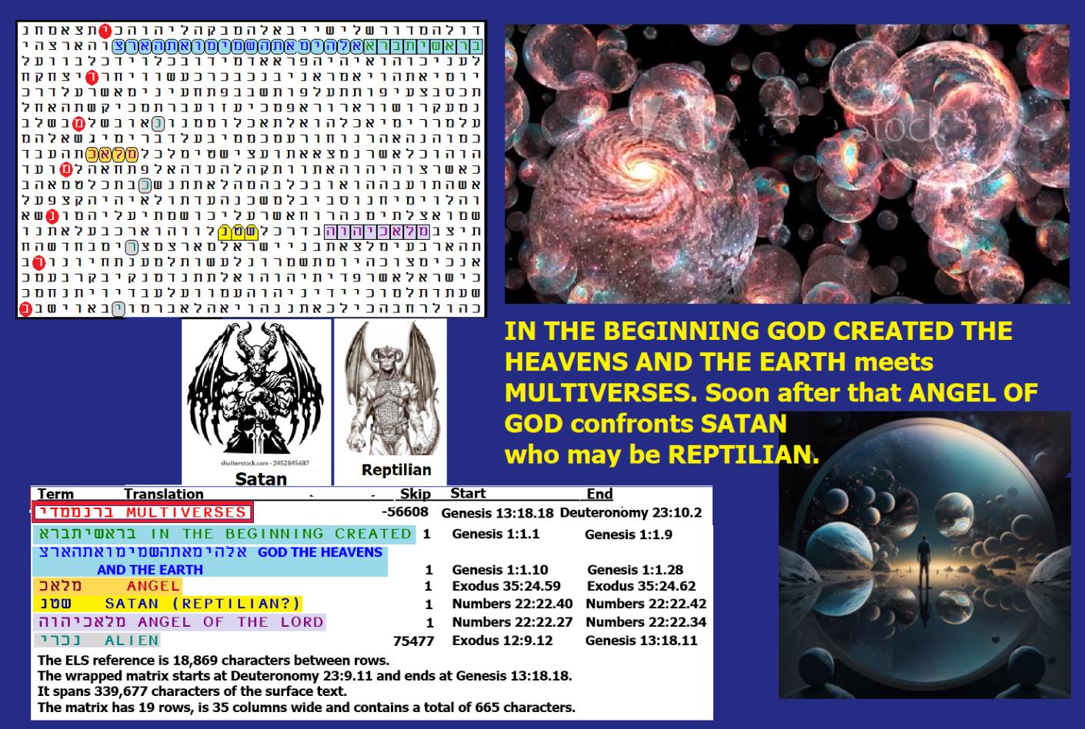
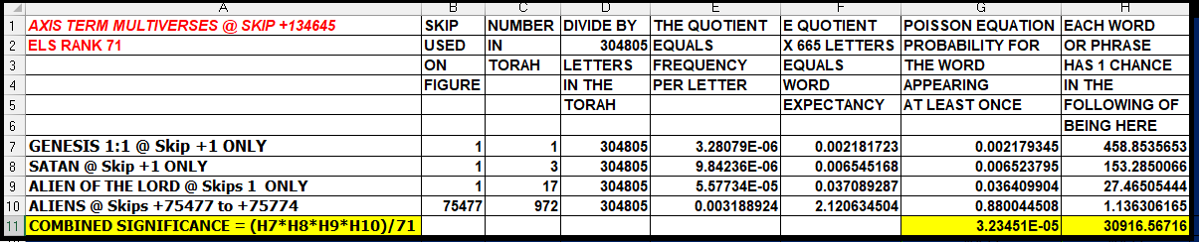
Figure 13 and its spreadsheet are above.
When I look back, not just at what I have learned in this study, but also at my experience in life, I feel that I have seen enough to rate what I have found in the Torah Code with respect to its likely Author. I see the probable Author as being God or like God in the sense that there is a logic to what He has produced that is clearly far advanced from what humans are capable of having. Yet he has not yet figured out how to guide us without risking the destruction of our world, as is hinted at with ATOMIC HOLOCAUST on Figure E-14. So, on a scale from 1 to 100, I’ll give God a score of 80 and show Figure E-14’s spreadsheet. This matrix was found against odds of from about 2,782,626,903 to 1 up to about 1,319,638,507,000 (roughly 1.3 trillion to 1), with the higher number allowing for including the 10-letter axis term, ATOMIC HOLOCAUST.

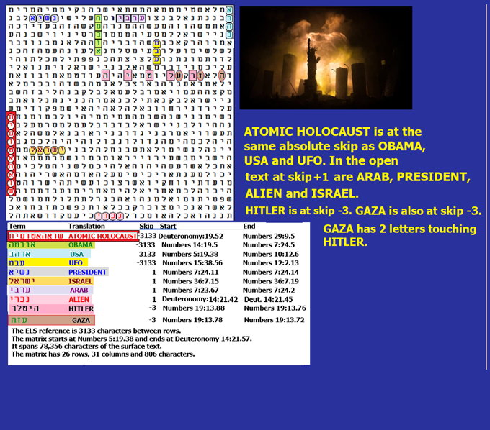
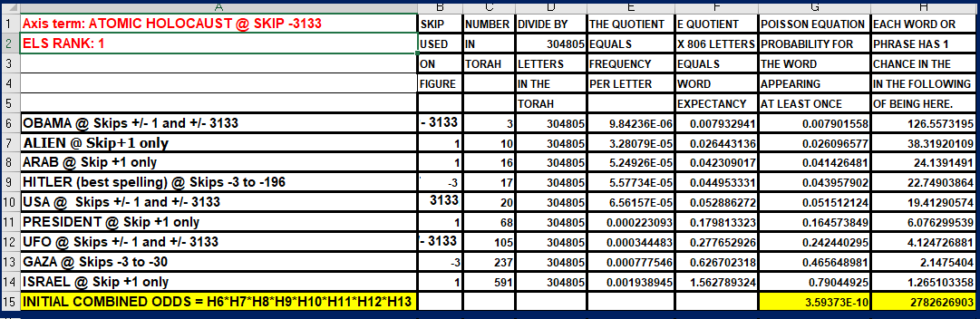
Figure E-14 above and its spreadsheet below.
I will admit that I might be underestimating God’s ability to prevent war, as it may yet turn out to be that the Messiah (chosen by God) will be the one to prevent a nuclear war. The only man who it appears is trying to be such a peacemaker is President Donald Trump, but in March 2026, it is still too early to know if he will succeed. It will take more than a nice matrix to name a man as The Messiah, but what does the Code have to say about Trump in this capacity? The preferred Hebrew spelling of Trump is TET resh alef mem peh. This spelling is not found in sequence with Messiah (mem shin yud chet) or THE MESSIAH (hey mem shin yud chet). However, with a TAV for the T letter in Trump, two 9-letter ELS chains mean MESSIAH TRUMP or TRUMP MESSIAH. The one at the lower skip does not require more than one computer pass through Torah to find. It is TRUMP MESSIAH spelled at skip +2,844. But it is not found with any interesting keywords and its R factor is 2.143, meaning that it had about one chance in 139 to be found at least once in Torah. But without any meaningful keywords associated with the Messiah, the find doesn’t rate more than a yawn from me, even though he might have just prevented a potential nuclear war between India and Pakistan. The killing of Khahmenei and destruction of his military shows more promise, but the war is not over as I write this and there may yet be unpleasant surprises related to matrices that warn of an atomic holocaust.
The second find (MESSIAH TRUMP) does require more than one computer through Torah to find (meaning a wrapped search, and the right kind of software like CodeFinder is needed). It’s at skip -77,952 and it is spelled mem shin yud chet tav resh alef mem peh. This find does come with an interesting 4-letter Hebrew a priori key term – USA – at the same skip as MESSIAH TRUMP. Although it only requires two columns 15 rows to display (a 30-letter area), its cumulative R
factor, according to CodeFinder software, is 0.706. This translates to it being found against odds of about 35.2 to 1, so it’s actually less significant than TRUMP MESSIAH (because the skip is much higher and it requires more than one pass through Torah to find). However, if another a priori (named ahead of the search) key term can be found, then (combined with Trump’s accomplishments), it becomes something that may be taken more seriously, even if Trump is not (so far as we know) Jewish. Cyrus (a gentile Persian king) has the term for Messiah associated with his name in Isaiah 45:1. The matrix showing the match between MESSIAH TRUMP and USA is shown in Figure E-15.
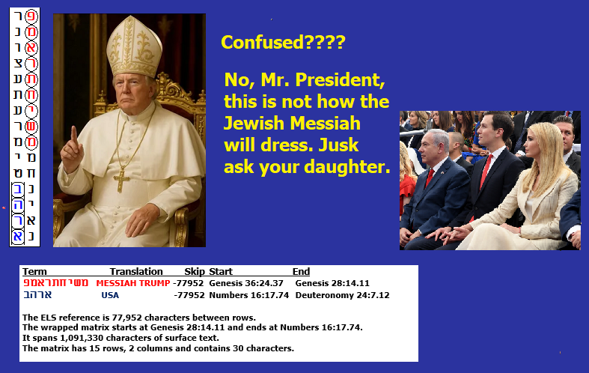
Figure E-15 above. Oy Guvult. The President’s daughter, Ivanka Trump, converted to Judaism prior to marrying Jared Kushner, a real estate developer, in 2009.
With respect to aliens and in particular reptilians, while Ebrahimi claimed to be an alien, he didn’t identify his race. Based on earlier photos taken over the years, there is a possibility that he is a shape-shifting reptilian. The most recent photo had him wearing what looked like the insignia on an Akhori uniform from Altair 4, as shown on page 89 in Elena Danaan’s book and on Figure E-16 below, A GIFT FROM THE STARS, Extraterrestrial Contacts and Guide of ALIEN RACES.
Figure E-16 below. Compare the symbol on Ebrahimi’s uniform with Danaan’s portrayal of the Akhori uniform. The Akhori are, according to her, from planet Alkorin, which is the 4th planet out from Altair, a star 16 light-years from Earth. She claims there is “a dodgy collaboration between the Orion Grey Collective and a Terran military presence (U.S.-Telos.” She also says, “They are heavily involved in abductions and in interbreeding with Terrans.” Craig is married. As to hint at possible interbreeding, Craig sent me the following email: On Fri, May 1st, 2020, at 12:06 PM, Craig <craigebrahimi@hotmail.com> wrote:
Barry, my wife she had two extremely healthy boys. Craig
In 2026, Craig announced that he had four children with a fifth on the way.
Above: Figure E-16. In Chapter 6, I presented six years’ worth of emails to and from Craig. During this period of intensive interrogation, I never sensed any concern for the welfare of humanity. Yes, he was willing to sell his meteorite, which likely held the source of COVID-19, but it was clear that this was only to get richer. When I angered him because I kept grilling him, I received the following:
On Fri, Mar 27, 2020, at 4:43 PM, Craig Ebrahimi <craigebrahimi@hotmail.com> wrote:
“Guy your dumb ass shit keeps getting sent to me by one of your Hebrew followers, you got to be one the biggest dummie humans I ever came across you talk this shit in your writing ABOUT my biotechnology, once again your dumb! You don’t even know your dealing with fucking real extra-terrestrial self made multi millionaire since teens you idiot, if you looked into these eyes I would eat your soul puppet boy.”
Notice that his insult to me included “dummie humans.” He often distinguished himself from humanity, and he clearly thought his kind was superior to our kind. Often, I wrote to him about my concern that his rock and a virus from it were killing millions of us. He never expressed any concern about it. As such, assuming that he is typical of his culture, I came to view them as inferior to us. Yes, he looked very strong. But he seemed to lack a soul, and in 2020, he often seemed high (which he blamed on too much caffeine). Craig basically said that he received his meteorite’s underwater coordinates by telepathy. If true, then we may conclude that his fellow aliens did not care about the millions of people who would die because of it. While I gave God a score of 80 out of 100 for the probability that He wrote the Torah Code, there was an enormous amount of detailed Code findings about aliens in general and specifically reptilians, and it was largely in the form of warnings.
At best, assuming that another race wanted to warn us, I could not give ET a score of more than 15 out of 100 points. As for a future, likely military artificial intelligence, the thought is due to the agent that I call Joseph Sapphire (his last name is modified), who was once an Army intelligence officer at Fort Huachuca. His August 1, 2016, warnings to me and request for me to stop my writings were accompanied by a threat to have child pornography downloaded onto my computer so the government could prosecute me. This guy knew what would happen to my son about four months later. He indicated a U.S. interest in Torah Code findings, which is obvious to this day, but there was nothing he said that indicated that this was the source of the Code. However, even if I check my report statistics today, I see multiple hits from Fort Huachuca, which may be a joint base with ETs. If you know how to break the IP code, there is plenty there from U.S. and British UKMOD intelligence. As an example, look at the print screen in Figure E-17. Any IP number with a six as the last number or immediately before the first decimal point can be traced to Fort Huachuca. The trick is that if the 6 is the last digit, then there is a need to write the reverse IP number. So, from today’s report, there are a few IPs that lead to Fort Huachuca, but you cannot allow more than 6 to remain before the first decimal point. See Figure E-17 below.
Fort Huachuca is a heck of a top fan of my site. In addition to serving in this function since at least 2016, it may also be a joint base with ET. Elena Danaan writes:
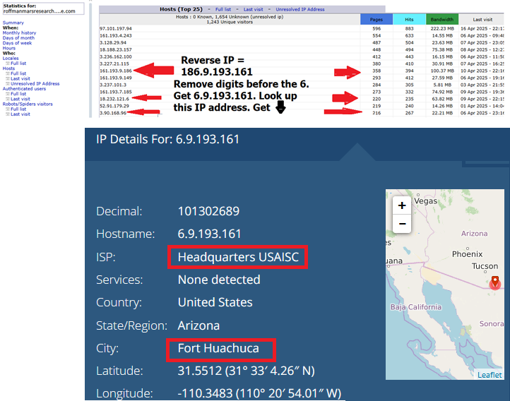
Figure E-17 above.
“ARIZONA: Fort Huachuca: Here is one of the main underground hangars for spaceships. This facility is a landing point for incoming Ciakahrr (Reptilian) contingents and a central hub deserving of a vast amount of other facilities. It serves as well as a training facility.” The most interesting of the people who read my site every day is Fort Huachuca, an Army Intelligence base in Arizona. There are plenty of stories online about them actually having captured or visited alien spacecraft on the base. There are also stories about them delivering children to reptilians for slavery and even for food purposes. Elena Danaan writes on pages 163 to 164 in her sensational (2020) book – A GIFT FROM THE STARS, Extraterrestrial Contacts and Guide of Alien Races:
Note: In February 2026, I received a call from Fort Huachuca related to what Craig wrote that might be a biological threat (see Chapter 6). This was the first time that they ever called me directly, and it might indicate that the white hats managed to overcome any black hats or reptilians. Huachuca said that the information that I gave them would be briefed up the chain of command. This was about three weeks before we attacked Iran, which is encoded with reptilians with respect to Khamenei (see Figure E-18, which was found against odds of about 3,529,432 to 1). The Administration claimed that Iran was two weeks away from completing 11 nuclear weapons.
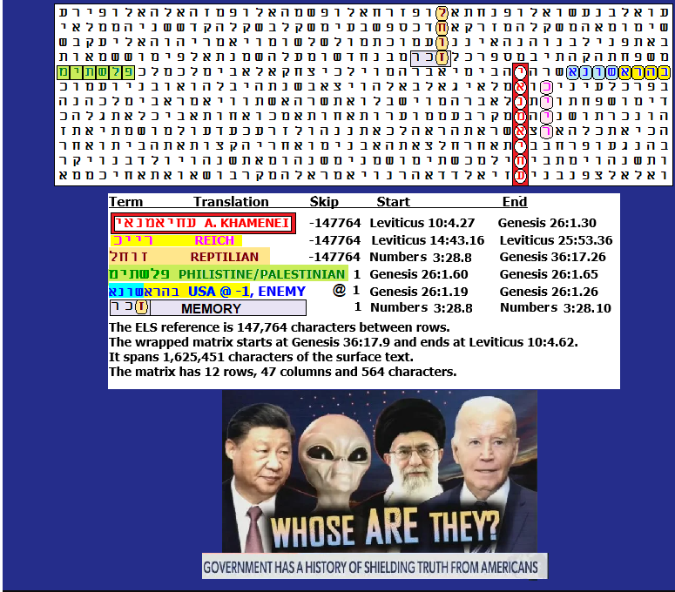
Figure E-18. A. Khamenei is strongly encoded as a Reptilian enemy of the U.S.A.

LARRY TAYLOR AND MARS
Many times, I have been a guest speaker on a blog talk radio show called NIGHT SHADOWS with Larry Taylor and Stewart Best. On several of these shows (which generally lasted about an hour to two hours), I have discussed Mars, its weather, possible alien Craig Ebrahimi, and how he brought COVID-19 to Earth. Chapters 5 and 6 in this book largely discuss what I have learned from Craig and about him. I also had all of our interviews posted on my website until their program was shut down. Probably the best show I had was with Rebecca, a possible alien, as a guest with me. I mentioned her before and provided a partly censored photo and matrix (Figure E-7). On the show, I questioned her about her claim that reptilians took her to a ship where she was shown terrified, screaming human-hybrid children just before they were eaten (alive) by reptilians. She said that it was important that they be terrorized before being eaten because the adrenaline that they produced enhanced their flavor.
I was on Larry’s show a lot over a decade. But in all that time, he never mentioned being taken by ET. So, I was shocked when he sent me a flyer with a story of his visions and possible experiences of being transported to Mars. At first, it sounded like Larry was experiencing out-of-body sensations that dreams might explain. But on questioning him, he said that at least once he remembered being taken aboard an alien craft. In all, he said he was possibly taken to Mars seven times, where he saw several shaped spacecraft and two species of aliens. One of them looked like a typical big-eyed grey, but they were taller and browner than greys. The other species was described as being a “HUMANOID CREATURE (tall) in the area of the Tithonium Chasma Basin, walking right past him with no recognition of him.” Larry wrote that, “The extraordinary humanoid had a strangely shaped head, with the rest of an obvious humanoid-shaped frame.”
Larry claimed he was unaware of his show partner, Stewart Best, doing research and making a DVD video entitled Project Redstar, Martian Genesis, which was about archaeological ruins allegedly photographed by the Mars Global Surveyor Orbital Camera (MOC) Image m0204304 (http://gigapan.com/gigapans/192466)/. When Larry told Stewart about his visions (or experiences), Stewart made the link to Tithonium Chasma. Years later, Larry read a book, MIND TREK by Joseph McMoneagle, who claims to be a CIA-hired remote viewer. The book showed the same type of creature with the strangely shaped head that Larry saw.
If I were only a typical researcher, I would not put Larry’s story in this book. But I have an advantage over other scientists in that I have cracked the Torah Code (likely better than anyone else on Earth). So, what do I find when I look up the 10-letter Hebrew name for LARRY TAYLOR? It’s in the Torah Code once, though the computer has to make about four passes through the 304,805 letters of Torah to find it at skip 138,549. It is shown, in part, in Figure E-19. In reality, the matrix has an infinite repeating pattern that grows in size as you permit more rows and columns of Torah to be shown. Figure E-20 shows more.
I have described EI in detail on many of the shows done with Larry and Stewart. This name is actually included on Figure E-20, where one of two transliterations is found less than three letters from LARRY TAYLOR. Further, the minimum skip of MARS is found at skip -2, three letters right of LARRY TAYLOR. Also, on the matrix is LIKE A STAR (which could describe Mars as seen from Earth) and WAR, which apparently destroyed or drove inhabitants underground, according to Dr. John Brandenberg.
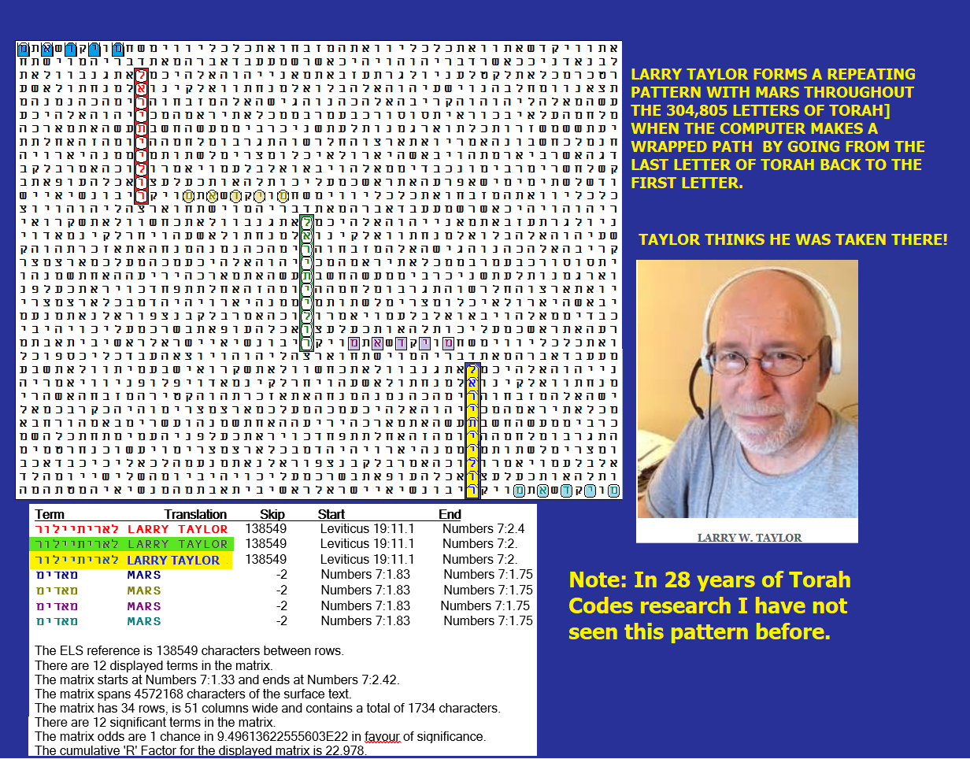

Figure E-19 above. Here, the repeating pattern of LARRY TAYLOR is shown with MARS. Figure E-20 below shows a more detailed picture of how LARRY is encoded. In 28 years of Torah Code research, I have never before experienced a matrix like this that repeats the axis term and its key words. The matrix provides a tangible reason to take Larry at his word. Larry is not the only person that I have ever met who claimed to have been transported to Mars. On my website, I discuss similar claims by Andrew Basiago. I also remember claims of teleportation by Rebecca, the woman in Lakeland, Florida, who claimed to be an ET, but I can’t recall if Mars was one of her destinations. Here is the bigger picture of the LARRY TAYLOR matrix:
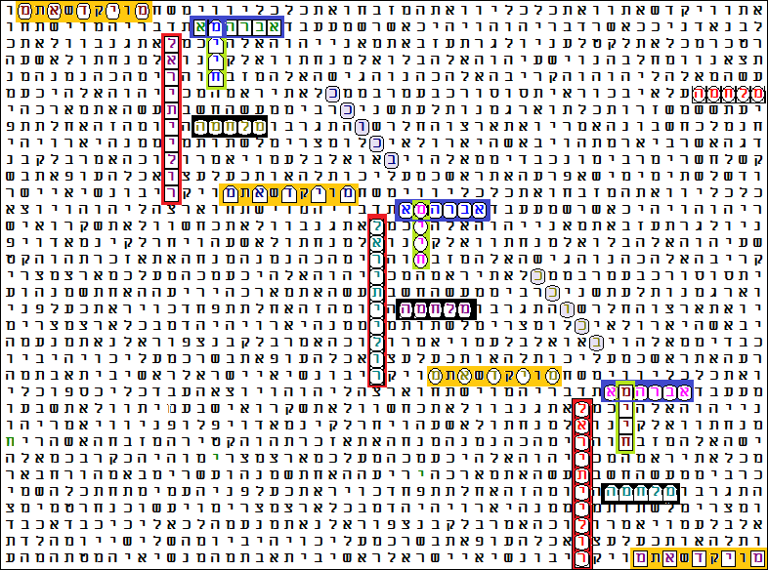
Figure E-20 above. Here, the matrix includes the terms MARS, LIKE A STAR, EBRAHIMI, LIFE and WAR. LIFE is at the absolute skip of LARRY TAYLOR and it intersects and shares a letter mem with EBRAHIMI.
Ah, you say, if I can find my friend Larry Taylor, what about me? I have found matrices about my future several times. The newest one is shown in Figure E-21 below. It was found on July 6, 2025, shortly before the formal publication of this book. THIS MATRIX ACTUALLY DESCRIBES THE COVER OF THIS BOOK!
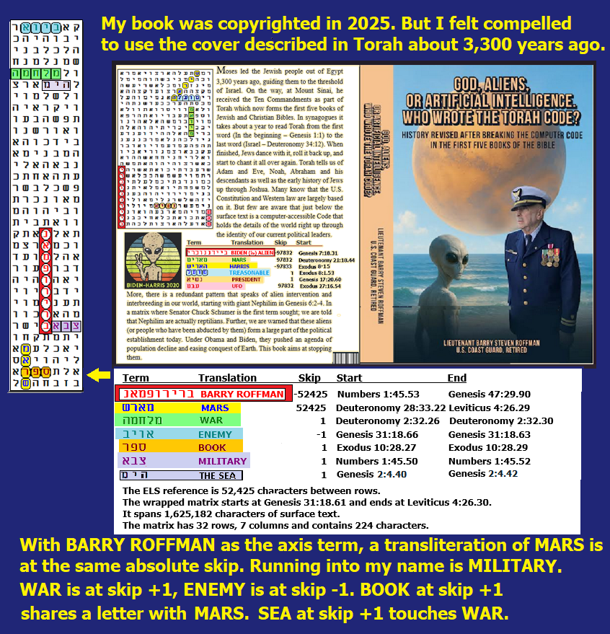
Figure E-21 is shown above. Its spreadsheet is shown below. I found the cover of my new book described in the Code. See Figure E-21, which adds a matrix naming me. The first term (axis term) is the best transliteration of BARRY ROFFMAN. Touching the first letter of my name is MILITARY. I am shown in my military uniform. At the same absolute skip as my name is a transliteration of MARS. Chapters 5 and 6 of this book are about Mars. WAR is in the open text.

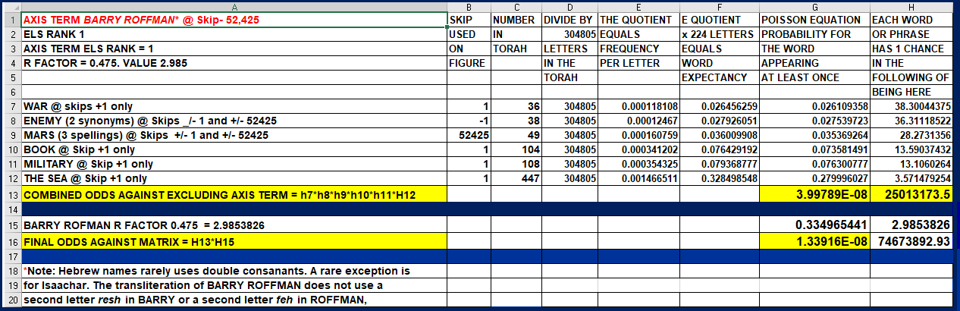

Above: Spreadsheet for Figure E-21. This matrix was found against odds of about 74,673,892 to 1. As such, it is extremely significant, not only in a statistical way. This matrix is evidence supporting time travel and pre-destination. The Author of the Code was well aware of the future existence of this book over 3,000 years before it would be published. The book presents a reality much different from that found in schools, history and textbooks, churches, non-Orthodox synagogues and mosques around the world. To be truly free and sovereign, it’s time to have complete disclosure. For any extraterrestrials who read this book, the only card that I am leaving you is with complete disclosure of your medical technology. I am talking about the cure for cancer and the means to extend our life expectancies. If you cannot do that, get the hell out of our world.
Continuing, on Figure E-21 above, ENEMY is at skip -1. I show the cover of my book. The word BOOK at skip +1 runs into and shares a letter with MARS. The threat of such a war is why President Trump established the Space Force. Finally, on May 16, 2026, I took a cruise specifically to have an excuse to wear my old uniform on formal night. Why? I wanted to be seen gazing out to THE SEA (at skip +1 touching WAR), where I would photoshop an alien that I envision being prepared to fight one day. I wanted MARS shown rising over the sea to suggest, as Israeli Brigadier General Haim Eshed says, that there is now a joint U.S. military-alien base underground base on Mars.
Less than a week after taking the cover photo, I received a surprise call to publish this book. At the time of the photo, I had not even looked for a literary agent, let alone a publisher, but the bulk of the material in this book was up on my https://RoffmanMarsResearch.com website.
This book might set off a war with ET, and if so, I want to write plans about how to defeat them. The medals on my chest show my ability to do so. See the citation on Figure E-22 below for the Meritorious Service Medal given to me on my 60th birthday

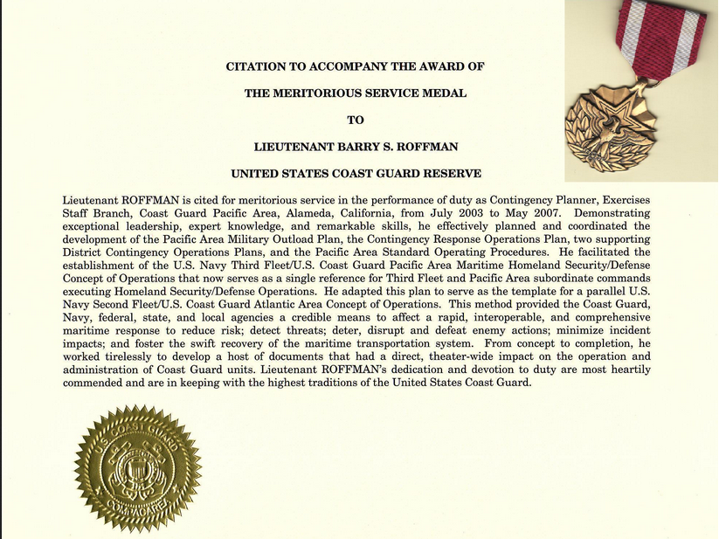
Figure E-22 above: Citation for my Meritorious Service Medal. I have tried to duplicate the effort made in the official war plans that I wrote here in this book. Although I am no longer on active duty, I think and act like I am when researching sensitive information like that presented in this book. I strongly endorse adding Torah Code Studies as a class at the Defense Language Institute Foreign Language Center (DLIFLC) in Monterey, California. I would be willing to teach the class too.

