# **Chapter 8**

**Martian Microbes & Primitive Life**

This chapter documents the existence of primitive life needed to support more advanced life on Mars and beyond. The primary source of the chapter is Meteorological Implications: Evidence of Life on Mars? Dr. David Roffman (my son) and I published it in the Journal of Astrobiology and Space Science Reviews, 1, 329-337, 2019. Our second source is our joint report entitled MARS CORRECT: CRITIQUE OF ALL NASA MARS WEATHER DATA. This paper was published by the International Mars Society and can be accessed at <https://www.academia.edu/40831370/MARS_CORRECT_CRITIQUE_OF_ALL_NASA_MARS_WEATHER_DATA>.

## **Abstract for Meteorological Implications: Evidence of Life on Mars**

In a detailed review of over 130 research reports by over 500 scientists, Joseph et al. (2019) provide strong evidence for multiple forms of prokaryotic and eukaryotic life on Mars, which may be contaminants from Earth due to solar winds and meteor strikes. What is notable are those specimens, photographed by NASA on Mars, which resemble terrestrial fungi, lichens, and sphere-shaped basidiomycota, which the authors admit may be hematite. However, fifteen spheres became larger and emerged from beneath the surface over 3 days; an observation which may indicate biological growth or a strong wind that uncovered these specimens. Although Mars is often enveloped in dust, some of this dust originates in space and not on Mars, which supports the hypotheses, first proposed by Arrhenius (1908), that microorganisms may be attached to that extraterrestrial dust, some of which may have been propelled from Earth to Mars. Meteorological data, pro and con, is discussed as it relates to the possibility of Martian life.

**KEYWORDS**: Contamination, Life, Mars, Atmospheric Pressure, Weather, Methane, Wind.

## **Introduction**

Mars has long fascinated humanity as a possible home for life. In July 1964, that hope was dealt a blow by Mariner 4. Observations from 9,846 km out showed a heavily cratered, cold, and apparently lifeless world. Air pressure was estimated at 4.1 to 7 mbar with daytime temperatures of -100° C (NASA n.d.). By contrast, Mariner 9 found evidence of wind and water erosion, fog, and weather fronts (Greene 2015). When Vikings 1 and 2 landed, we learned of frequent dust devils. Later (from orbit), we found they were also seen up to 17 km above the areoid (similar to sea level on Earth) on Arsia Mons on Mars.

Over Arsia Mons, there were also spiral clouds with 10 km-wide eye walls where pressure (in the caldera) should be only ~1.3 mbar. In fact, massive storms were “observed by Mariner 9 (1971-1972) and Mars Global Surveyor (2001). Those storms totally obscured the planet’s surface (NASA 2018). In 2018, a massive dust storm covered 14 million square miles (35 million square kilometers) of Mars — a quarter of the Martian surface (NASA 2018). The rover Opportunity was also blanketed with dust, such that, in consequence, the solar panels stopped functioning.

Therefore, we know Mars is a dusty planet. And yet, rather than uncovering, these frequent dust storms blanket the surface, and the rovers with dust. Moreover, these dust storms also absorb heat and increase surface temperature (at night), and “limit extreme temperatures” (NASA 2018), making conditions more conducive to life.

In addition, as Mars orbits through streams of dust in the wake of comets, meteorites, and sources unknown, extraterrestrial dust is deposited on Mars (Andersson et al. 2015; Treiman & Treiman, 2000). Might that dust contain microorganisms blown into space from Earth? The answer is unknown.

What is known is, Mars has an atmosphere, weather, clouds, what appears to be water frozen at the poles, and not just dust but snowstorms, as witnessed by the Phoenix lander (Dunbar 2015). On Earth, it is suspected that microbes contribute to changing weather patterns and even the formation of clouds. We should not be surprised if Mars also harbors life.

## **Evidence for Life**

When Levin and Straat (1976) reported that biological activity was detected via Labelled Release experiments on Vikings 1 and 2, they were strongly challenged because of the failure to find organics. Yet, with time, MSL detected methane, chloromethane, dichloromethane, trichloromethane, dichloroethane, 1,2-dichloropropane, 1,2-dichlorobutane, and chlorobenzene. Christopher McKay (2006) of NASA Ames announced that the Viking instrumentation was not capable of detecting organics.

Using a Fourier Transform Spectrometer, Krasnopolsky et al. (2004) observed Martian methane. Webster et al. (2018) reported methane background levels vary with the local seasons. Joseph and colleagues (2019) point out that variations in terrestrial methane are directly correlated with the growth and death cycles of plants, and that 80% of terrestrial methane is biological in origin.

Vlada Stamenković et al. (2018) found that Mars can support liquid environments with dissolved O2 values ranging from at least ~2.5 × 10⁻⁶ mol m⁻³ to 2 mol m⁻³ across the planet. Near-surface environments had enough O₂ available for aerobic microbes to breathe independent of photosynthesis.

All this set the table for finding life on Mars, whereas Joseph et al. (2019), while cautioning that “morphology is not proof,” have speculated and provided photographic evidence of what may be fungi, lichens, cyanobacteria, basidiomycota (“puffballs”), plus stromatolites and outcroppings like terrestrial microbialites.

## **Issues Related to Wind and Pressure**

The authors compared M.E.R. Rover Opportunity photos on Sol 1145 with Sol 1148 and assert, “Fifteen specimens resembling and identified as “puffballs” were photographed emerging from the ground over a three-day period. It is possible these latter specimens are hematite and what appears to be “growth” is due to a strong wind which uncovered these specimens – an explanation which cannot account for before and after photos of what appears to be masses of fungi growing atop and within the Mars rovers.” Later, they ask, “What is the likelihood that a strong wind would have uncovered the specimens in Figure 8-1, and not covered them (and Opportunity’s solar panels)?”

[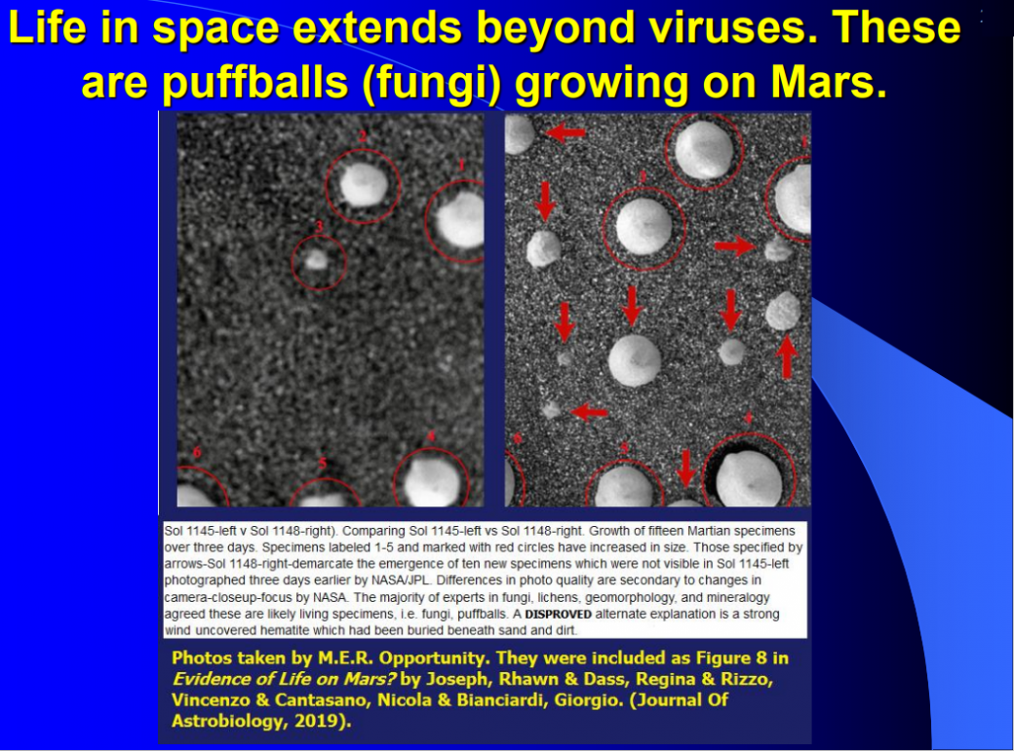](https://roffmanmarsresearch.com/wp-content/uploads/PUFF-BALLS1.png)

Figure 8-1: These appear to be puffballs growing on Mars.

In November 2011, NASA released a statement entitled NASA Orbiter Catches Mars Sand Dunes in Motion. It stated, “Mars either has more gusts of wind than we knew about before, or the winds are capable of transporting more sand, said Nathan Bridges, planetary scientist at the Johns Hopkins University’s Applied Physics Laboratory … We used to think of the sand on Mars as relatively immobile, so these new observations are changing our whole perspective.” They assert that wind-tunnel experiments have shown that a patch of sand would require winds of about 128.7 km/hr to move on Mars compared with only 16 km/hr on Earth. They then state that measurements from the Viking landers and climate models showed such winds should be rare on Mars (NASA 2011).

Using Tillman’s Viking data (n.d.), I produced the graphs shown in Figure 8-2, which show Viking 1 winds for its sols 1 to 350 (except sols 116 to 133 because data was missing) and for Viking 2 sols 200 to 350. Every sol was divided into 25 time bins. During Viking 1, the maximum wind was 93.24 km/hr (see Table 8-1). For Viking 2 (see Figure 8-3) winds reached 83.52 km/hr, but over 8,331 measurements, the wind never reached the 128.7 km/hr that Bridges said were required to move sand.

[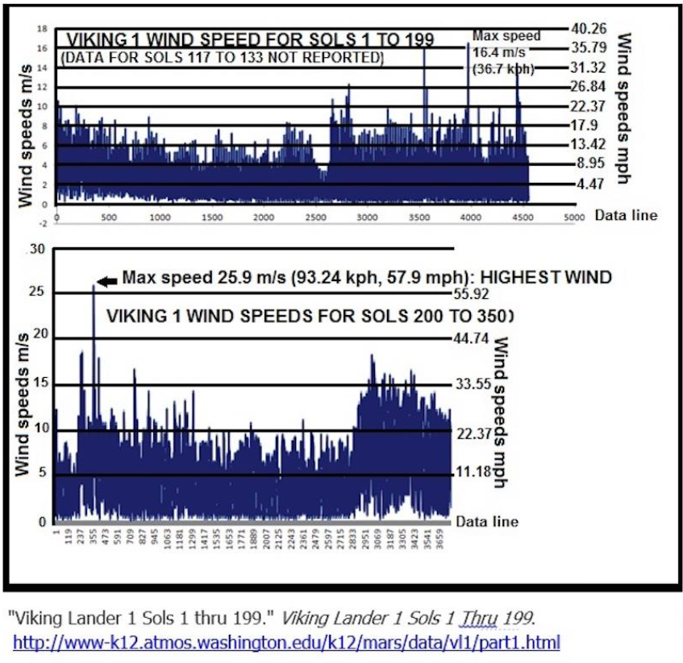](https://roffmanmarsresearch.com/wp-content/uploads/Viking-1-winds-all-sols.png)

Figure 8-2 top above: Wind speeds for Viking Lander Sols 1 to 199. Bottom: Wind speeds for Viking 1 for Sols 200 to 350.

Figure 8-2– bottom above. Wind speeds for VL-1 for its sols 1 to 116 and 134 to 350 and for VL-2 for its sols 1 to 399

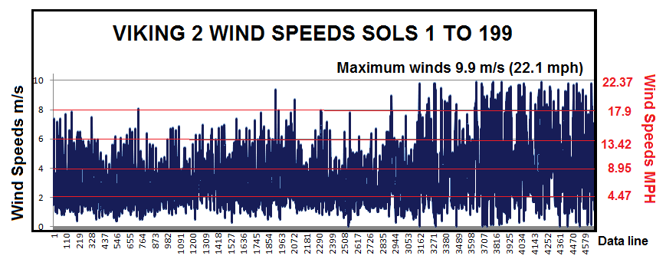

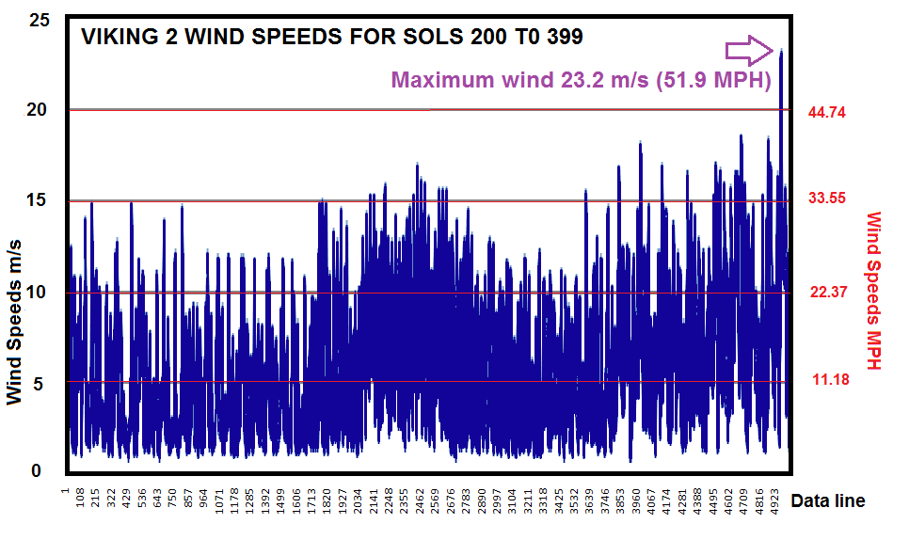

Figure 8-3. Winds seen by Viking 2. Winds reached 83.52 km/hr (51.9 mph).

There was little wind data for Mars after the Vikings. Pathfinder was only calibrated for 1,015 mbar and ~15 mbar of terrestrial air pressure (Schofield et al., 1997).

For Phoenix, Taylor et al. (2008) state, “We had hoped to include an anemometer in the MET package.” Faced with a lack of resources and needing wind data, they used the SSI camera and a Telltale. But for wind over 10 m/s, the Telltale went horizontal and lost its wind speed/deflection correlation ability.”

[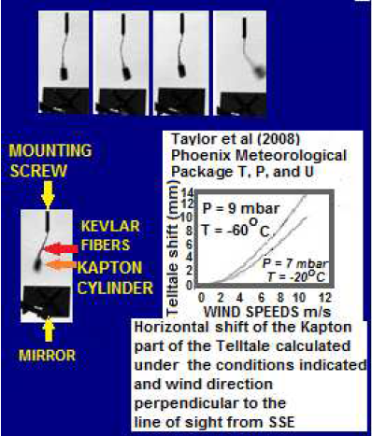](https://roffmanmarsresearch.com/wp-content/uploads/TELLTALE.png)

Figure 8-4: Phoenix telltale waving in Martian wind. The out-of-phase image may indicate a dust devil occurrence. Images taken before & after the event have west winds estimated at 7 m/s. During the event, south winds are estimated at 11 m/s. Adapted from Taylor et al., 2008.

Curiosity had part of an anemometer on Boom 1, but it broke on landing. Yet for 9 months, NASA published wind data that never changed – always 7.2 km/hr from the East. However, upon being alerted by us of this error (and at our request), the published data was changed to N/A.

To determine wind speed accurately, knowledge of air density is essential. The relationship between these two (the windsock equation) from NASA (1999) is given as equation (1):

u = sqrt{[2 R(1) M g tan(theta)]/[R(2) A(d) rho]}

In Equation 1, R1 = distance between pivot and center of mass, M = non-counter-balanced mass, g = acceleration of gravity, R2 = distance between pivot and center of aerodynamic pressure, A(d) = effective aerodynamic cross-section, and rho = atmospheric density (a function of pressure, temperature, and molecular weight).

So, if the density is incorrect, the wind speed will be wrong for at least a windsock or a Telltale. It is not the purpose of this commentary to fully explore multiple indications of higher pressure than accepted and problems with instrumentation, but we would be remiss to ignore excessive deceleration during aerobraking by Mars Global Surveyor and Mars Reconnaissance Orbiter. Further, an October 19, 2017, ESA report documents how ExoMars 2016 had to raise its orbit because of “excessive density of Mars’ atmosphere.” The ExoMars 2016 – Schiaparelli Anomaly Inquiry (2017) also pointed to atmospheric density and the presence of wind/gusts as possible causes of the crash of the Schiaparelli lander. See Figure 8-5.

**[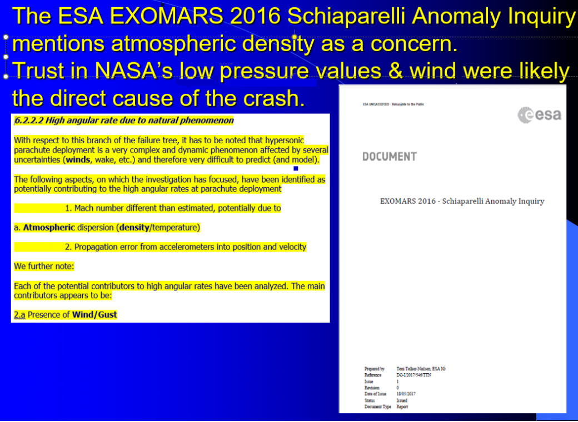](https://roffmanmarsresearch.com/wp-content/uploads/52-exomars1.png)**

**Figure 8-5** above: Trusting NASA was a fatal decision made by the European Space Agency.

Assuming that we are really dealing with life, or something that merely mimics it, a denser atmosphere would facilitate its transport. Morrison (2016) states that, “Microbes have been found in the skies since Darwin collected windswept dust aboard the HMS Beagle 1,000 miles west of Africa in the 1830s. Recent research suggests that microbes are hidden players in the atmosphere, making clouds, causing rain, spreading diseases between continents, and maybe even changing climates.”

It is well established that methane contributes to climate change and global warming. As pointed out by Joseph et al. (2019), 90% of terrestrial methane is biological in origin.

## **Microbes and Martian Methane**

High levels of methane, which vary in concentration depending on the season, have been detected at ground level and in the atmosphere of Mars (Webster et al. 2018), i.e., “a strong, repeatable seasonal variation…” To date, no abiogenic source for Martian methane has been discovered. Joseph et al. (2019), however, point out that terrestrial methane levels also vary according to the seasons and that “These seasonal variations have as their source biological activity in wetlands and on farms and in rice paddies, just prior to harvest.”

Coupled with their review of the literature, the methane evidence is also suggestive of life, which in turn may be impacting Martian temperatures and weather. Unless there is a political decision made to bring about alien life disclosure, only additional research can hope to answer this question and perhaps determine how any possible microbes on Mars interact with Martian dust storms. However, based on the behavior that I observed at NASA Ames when it came to how to finish the paper that powered this chapter, it’s not going to be easy. **N**ever-**A**-Straight-**A**nswer NASA is not interested in getting the truth out.

## **Possible Sources of Pressure Measurement Errors**

My 12-year study (Roffman, 2019) found many possible sources of errors for pressure measurement, with some errors at two orders of magnitude. Some may have been mere typographic mistakes. For example, from September 1 to 5, 2012, pressure at Curiosity was reported as up to 747 **h**Pa, but on the next sol, it was only 1% of that – just 747 Pa. Further, data on the Viking Project Site (Tillman, n.d.) up through at least March 19, 2019, had a definition under pressure that states one mb = 100 hPa. In fact, one mb = only one hPa (which is 100 Pa).

Stratus clouds are seen on Earth up to 13,000 meters, where pressures are about 163 mbar. They were also found on Mars ~12,318 meters above the surface. If a similar minimum pressure for clouds is required on Mars, based on an accepted scale height of 10.8 km, the pressure at the areoid would be about 511 mbar rather than 6.1 mbar. However, this doesn’t factor in atmospheric dust load. See Figure 8-5.

[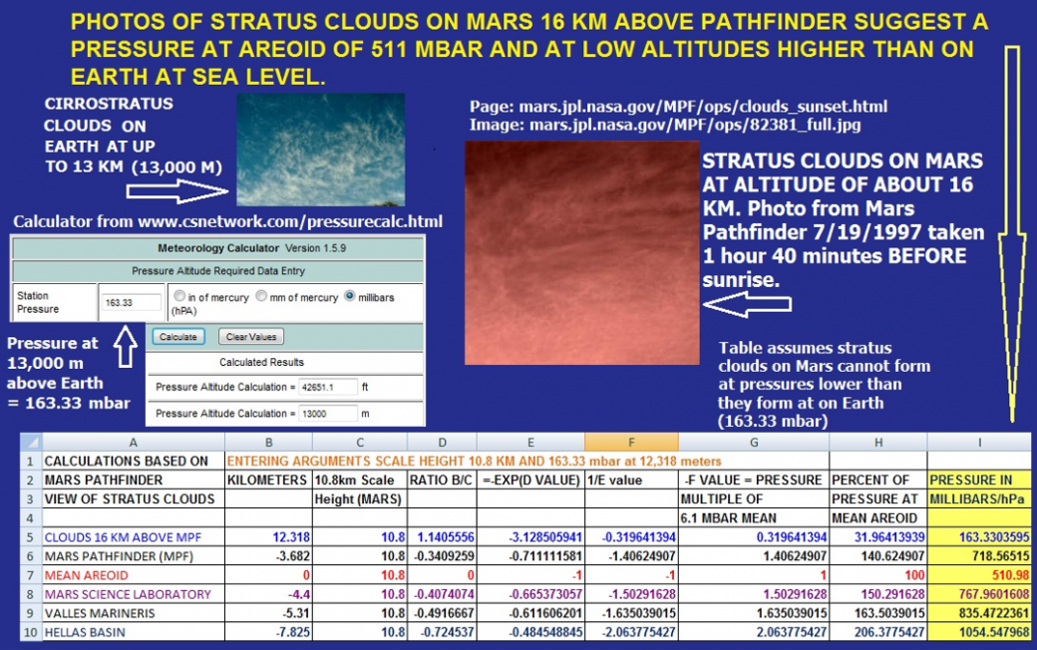](https://roffmanmarsresearch.com/wp-content/uploads/25-STRATUS1.png)

**Figure 8-6** – Stratus clouds on Earth and Mars.

I assumed that the MSL temperatures were reliable, but on July 3, 2013, JPL revised down many high air temperatures by more than 10K, wiping out above-freezing temperatures on sols 26, 40-47, 49-54, 102, 112, 116, 118, 123-124, and 179. See Table 8 – 1 (a repeat of Table 7-1).

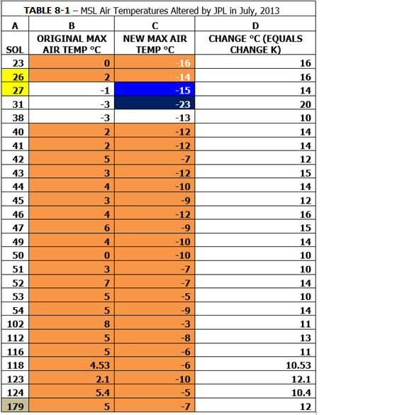

Table 8-1 above: Air temperatures revised down by JPL.

When we examine claims of life for areas where there are perchlorates that affect the freezing point of water, we need firm temperature data to analyze the situation. We have developed colored spreadsheets for at least 2,319 sols of MSL (Roffman, 2019). This database, (voluntarily) meant to assist JPL, shows not only current weather claims, but also documents anomalies and alterations over time. When comparing alleged Martian life forms with known terrestrial life forms, these charts are essential for understanding environments.

[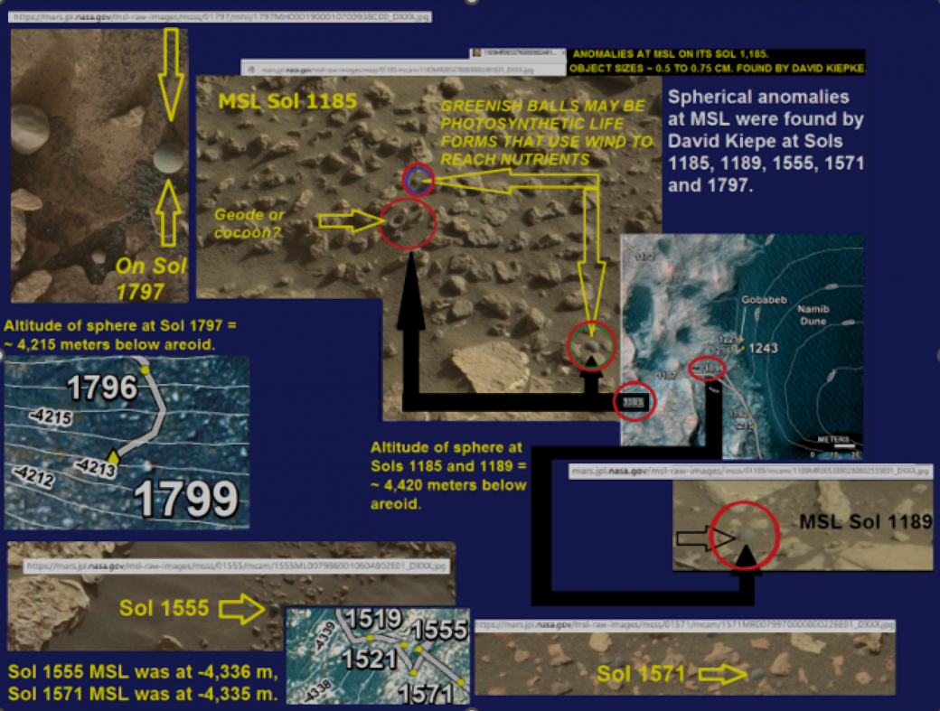](https://roffmanmarsresearch.com/wp-content/uploads/SPHERES-AT-VARIOUS-SOLS.png)

**Figure 8-7** above: Light Green Spheres on Mars.

Joseph et al. (2019) present evidence of sphere-shaped specimens, which they argue could be “puffballs,” but which they admit may be hematite; however, we see signs of growth and reproduction (see Figure 8-1 above). These spheres have been photographed in numerous locations and on various dates, such as on M.E.R. Opportunity sols 1185 and 1189. (Joseph et al. 2019). On Sol 1248, MSL returned to the Sol 1185 site (NASA 2016).

Later, more spheres (still considered probable hematite by NASA) were photographed on Sols 1555, 1571, and 1797. If these spheres are hematite, weather and temperature are irrelevant. However, life-forms, temperature, and atmospheric pressure may be factors.

Altitude varied from about 4,420 meters below areoid to 4,215 meters below areoid. See Figure 8-7. Temperatures are shown in Figure 8-7.

Although winter, daytime highs were (in the second Martian year of MSL operations) strangely above freezing. They were clearly warmer than what was measured at the same LS in the first and third years of operation, when there were no temperatures above freezing and there were no spheres. "Ls" refers to the Martian solar longitude, a measure of the Sun's position as seen from Mars, used to track Martian seasons. It's analogous to Earth's concept of solar longitude, but specifically for Mars.

Do the thin layer of green material and “green spherules,” which resemble algae in the soil seen by MER Spirit in Gusev Crater, contain chlorophyll or something functionally like it? There are possible water pathways that may intermittently fill with water there (Krupa, 2017). Figure 8-9 has greenish balls photographed from Sols 1185-1797.

**Figure 8-8** below: For areas of high interest, we must return again with a new probe that can conduct a definitive analysis. Do the growth-like materials on Opportunity and Curiosity contain nucleic acids? The trek map shown in Figure 8-8 indicates that the find was significant enough to cause JPL to return to the initial finding after 63 sols.

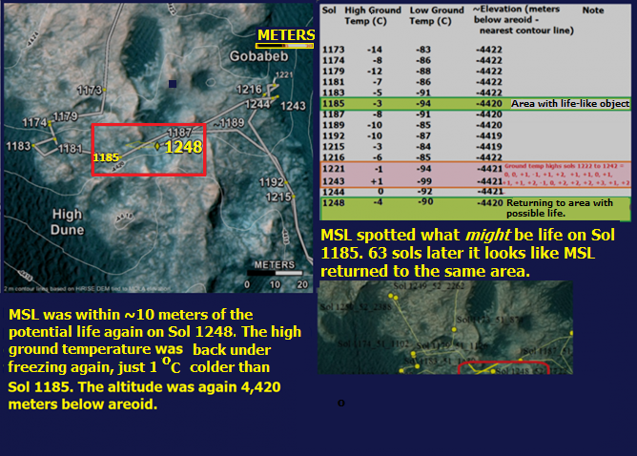

Figure 8-8 above: Possible biological specimens photographed on Sols 1185 through 1248 with elevations and ground temperatures.

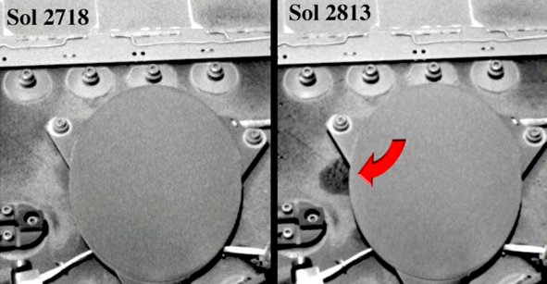

Figure 8-9. Mars Sol 2718 vs Sol 2813 – The exact cause or identity of this specimen (right) is unknown but may represent the growth of what appears to be a mass of bacteria and fungi on the Mars Rover, Opportunity, after 95 (Martian) days. Photo, NASA/JPL.

[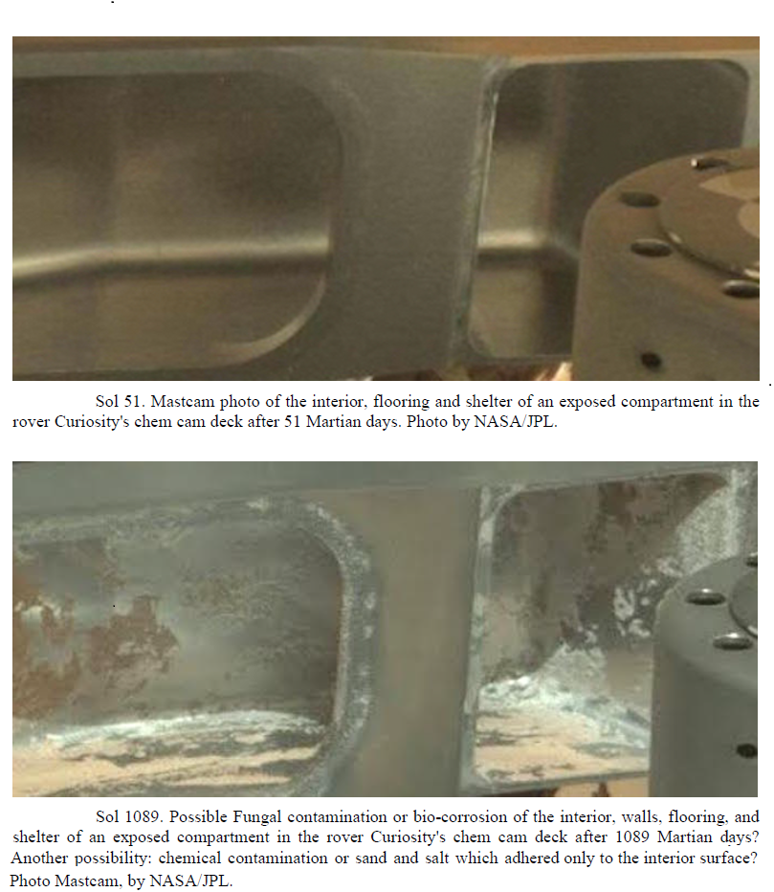](https://roffmanmarsresearch.com/wp-content/uploads/bio-corrosion-2.png)

Figure 8-10 above: Possible fungi growing on the Mars Curiosity rover.

## **Conclusion**

Evidence provided by five Mars landers favors the probability of life. Unfortunately, as stressed by Joseph et al. (2019), NASA has rammed down the throats of Joseph et al., plus my son and me, that “the evidence is circumstantial, and similarities in morphology are not proof.” They would not publish our work without this statement inserted against our will!

Future robotic missions should take equipment like the Miniature Variable Pressure Scanning Electron Microscope for in-situ imaging & chemical analysis (Gaskin 2012) to the most promising sites. Only then can we begin to make a determination as to whether the specimens photographed on the Martian ground are oddly shaped sedimentary structures or evidence of life. Likewise, we must determine the exact nature of what appears to be growth on Opportunity and Curiosity.

## **Acknowledgements**

Thanks are due to Marco de Marco and Mateo Fagone, who hosted our 3+ hour TV interview about Mars, complete with simultaneous translation into Italian. See <https://www.youtube.com/watch?v=PqCxAErabuU> (Marte Correto – Mars Correct).

We also appreciate the green sphere images sent to us by David Kiepke.

## **References**

Andersson, L. et al. (2015) Dust observations at orbital altitudes surrounding Mars, Science 06 Nov 2015: Vol. 350, Issue 6261,

Arrhenius, S. (1908). Worlds in the Making. Harper & Brothers, New York.

Bridges, N. T., F. Ayoub, J-P. Avouac, S. Leprince, A. Lucas, and S. Mattson. “Earth-like Sand Fluxes on Mars.” Nature 485.7398 (2012): 339-42. Web.

Dunbar, D. (2008) <http://www.nasa.gov/mission_pages/phoenix/news/phoenix-20080929.html>

Exomars (2016) – Schiaparelli Anomaly Inquiry (2017). [http://exploration.esa.int/mars/59176-exomars-2016-schiaparelli-anomaly-inquiry/#](http://exploration.esa.int/mars/59176-exomars-2016-schiaparelli-anomaly-inquiry/)

Gaskin, J.A.; Jerman, G.; Gregory, D.; Sampson, A.R., (2012) Miniature Variable Pressure Scanning Electron Microscope for in-situ imaging & chemical analysis, Aerospace Conference, 2012 IEEE, vol., no., pp.1,10, 3-10 March 2012 doi: 10.1109/AERO.2012.6187064

Gigapan (n.d.) Sol 1248. <http://gigapan.com/gigapans/202461/snapshots/556038> taken from [mars.jpl.nasa.gov/msl/multimedia/raw/?s=1248&camera=MAST_](http://mars.jpl.nasa.gov/msl/multimedia/raw/?s=1248&camera=MAST_) mars.jpl.nasa.gov/msl/multimedia/raw/?s=1249&camera=MAST_ Credit: NASA / JPL-Caltech / Malin Space Science Systems

Greene, Nick. “Mariner 9 Information.” N.p., n.d. Web. 10 Feb. 2015. <http://space.about.com/od/marinermissions/p/mariner9info.htm>

Joseph, R. G, Dass, R, Rizzo, V., Cantasano, ., Bianciardi, G. (2019). Evidence of Life on Mars? Journal of Astrobiology and Space Science Reviews, Vol 1, 40-81.

Krasnopolsky, V., Maillard, J., Owen, T. (2004). Detection of methane in the Martian atmosphere: evidence for life? ICARUS, 172. doi: 10.1016/j.icarus.2004.07.004

Krupa, T. A. (2017). Flowing water with a photosynthetic life form in Gusav Crater on Mars, Lunar and Planetary Society, XLVIII.

Levin, G. V.; Straat, P. A. (1976). “Viking Labeled Release Biology Experiment: Interim Results”. Science. 194 (4271): 1322-1329. Bibcode:1976Sci…194.1322L. doi:10.1126/science.194.4271.1322. PMID 17797094.

The Mariner Missions.” The Mariner Missions. N.p., n.d. Web. <http://nssdc.gsfc.nasa.gov/planetary/mars/mariner.html>

McKay, C. (2006) <https://www.nasa.gov/centers/ames/research/2006/marsorganics.html>

Morrison, Jim (2016). Smithsonian.com. <https://www.smithsonianmag.com/science-nature/living-bacteria-are-riding-earths-air-currents-180957734/>

NASA (n.d.) Mariner Missions. <https://nssdc.gsfc.nasa.gov/planetary/mars/mariner.html>

NASA (1999) <https://pds.jpl.nasa.gov/ds-view/pds/viewContext.jsp?identifier=urn%3Anasa%3Apds%3Acontext%3Ainstrument%3Awindsock.mpfl&version=1.0>

NASA (2011). NASA Orbiter Catches Mars Sand Dunes in Motion. NASA/JPL. <https://www.jpl.nasa.gov/news/news.php?release=2011-358>

NASA (2016) <https://mars.nasa.gov/resources/7704/curiositys-traverse-map-through-sol-1250/>

NASA (2018) <https://mars.nasa.gov/news/8348/opportunity-hunkers-down-during-dust-storm/>

Roffman, D (2019) <http://davidaroffman.com/custom3_66.html>.

Roffman, D. (2019) Web site contents. <http://davidaroffman.com/photo2_18.html>

Schofield, J., Barnes, J., Crisp, D., Haberle, R., Larsen, S., Magalhães, J., Murphy, J., Seiff, A. and Stamenković, V., Ward, L., Mischna, M. and Fischer, W. (2018). O₂ solubility in Martian near-surface environments and implications for aerobic life <https://www.nature.com/articles/s41561-018-0243-0?WT.feed_name=subjects_inner-planets>. Nature Geoscience, [online] 11(12), pp.905-909. Available at: <https://www.nature.com/articles/s41561-018-0243-0?WT.feed_name=subjects_inner-planets>.

Taylor, P. A., Catling, D. C., Daly, M., Dickinson, C. S., Gunnlaugsson, H. P, Harri, A.M., and Lange C. F., (2008). Temperature, pressure, and wind instrumentation in the Phoenix meteorological package, Journal of Geophysical Research, 113, E00A10. <http://faculty.washington.edu/dcatling/Taylor2008_Phoenix_MET.pdf>

Tillman, J. Mars Meteorology Data; Viking Lander (n.d.). Retrieved from <http://www-k12.atmos.washington.edu/k12/resources/mars_data-information/data.html>

Treiman, A. H. & Treiman, J. S. (2000) Cometary dust streams at Mars: Preliminary predictions from meteor streams at Earth and from periodic comets, Journal of Geophysical Research, 105, 571-24,58

Webster, C.R., Mahaffy, P. et al., (2018) Background levels of methane in Mars’ atmosphere show strong seasonal variations, Science 08 Jun 2018: Vol. 360, Issue 6393, pp. 1093-1096 DOI: 10.1126/science.aaq013

Wilson, G. (1997). The Mars Pathfinder Atmospheric Structure Investigation/Meteorology bbb(ASI/MET) Experiment. Science, [online] 278(5344), pp.1752-1758. Available at: <https://pdfs.semanticscholar.org/b399/9b8083ed3a234688c89f0771cf12e01a9481.pdf>