Chapter 3
ET Infiltration in the U.S. Government?
The axis term on Figure 3-1 is ALIEN IN OUR GOVERNMENT. BIDEN is at the same absolute skip. OBAMA is one skip away from BIDEN. These two men made up the core of alien infiltration of our government, but as this chapter makes clear, I can find matrices labeling most of their administrations as alien/Reptilian. The Torah Code matrix on Figure 3-1 is real, but the link to a humorous video about him is at (https://www.youtube.com/watch?v=Sa-rP-yCqPk). However, the link seemed to cause problems on my computer, so be careful with how you open it.
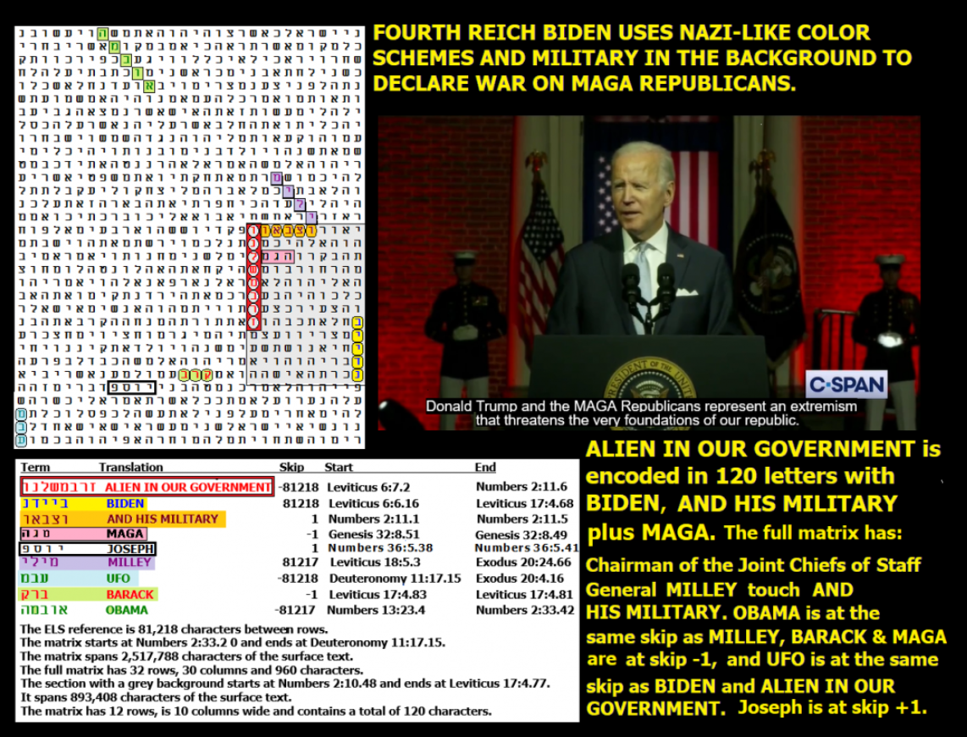
Figure 3-1 above and its statistical spreadsheets (below). While the full 960-letter matrix is of interest in light of the continuing UFO/UAV coverup, the incredible match between AN ALIEN IN OUR GOVERNMENT, BIDEN, AND HIS MILITARY and MAGA (Make America Great Again) in only 120 letters with AN ALIEN IN OUR GOVERNMENT and BIDEN at the same absolute skip was shocking. Before looking for the axis term (AN ALIEN IN OUR GOVERNMENT), I expected that if it matched anyone, it would be OBAMA. OBAMA was on the full 960-letter matrix, but at skip 81,217, his name was one skip off the axis term (81,218). The odds against the match (1.78 to 1) meant that the match was easier to find than calling a coin toss correctly. But the odds against a match between AN ALIEN IN OUR GOVERNMENT and BIDEN (before considering ELS rank 2 of the axis term) were 2,540 to 1 or half of that (1,270 to 1) if we consider just the match but no other terms in the 120-letter box with it.
By far the most significant odds for Figure 3-1 were just for the 120-letter area shaded in grey. Odds against this section of the matrix were 166,704 to 1.
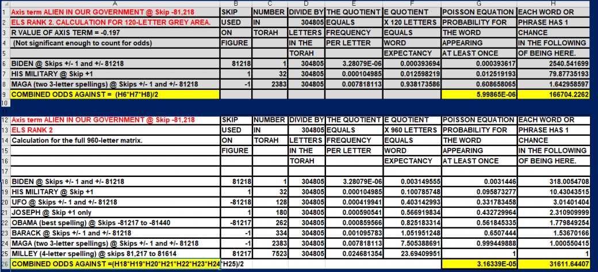
Odds against the full 960-letter Figure 3-1 were about 31,611 to 1.
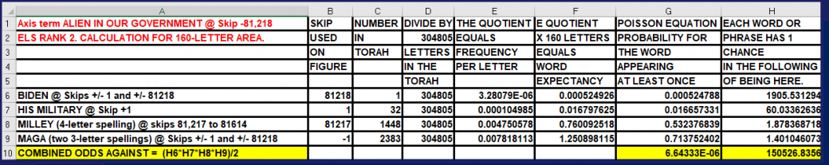
If we expand the shaded area of Figure 3-1 up from 120 letters to 160 letters to include (General) MILLEY, the significance drops from 166,704 to 1 against down to 150,526 to 1. Therefore, the expansion to show this short 4-letter spelling of his last name is not justified.
On Figure 3-1, is the Code telling us that Biden is an Alien or that Aliens Work at the White House?
I expected that if AN ALIEN IN OUR GOVERNMENT would match anyone, it would be OBAMA. This is because his early years were largely shrouded in mystery. Was he born in Hawaii or Kenya, as his own relatives contended? Was he always an American, or when he traveled in Pakistan with an Indonesian passport, what happened to his U.S. citizenship? Indonesia did not allow for dual citizenship. What about Michelle Obama? Why are there so few pictures of her when she was young? Joan Rivers, shortly before she died (or was killed) said that “everyone knows that Michelle was a tranny” (transgender man). Barack, in public, twice called his wife “Michael.” People have said that they witnessed Barack or one of his security agents morph into a Reptilian alien for a fraction of a second. See Figure 3-2.
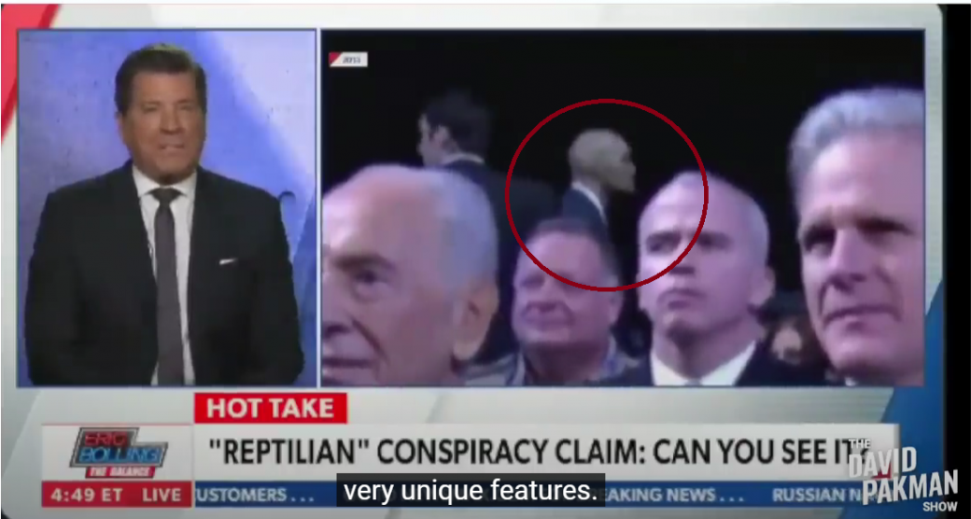
Figure 3-2 above: This picture allegedly shows a Reptilian acting as a security agent for President Biden.
The most suspicious thing about OBAMA is the amount of time that seems to be missing when we look at his life before his meteoric rise to the White House. In contrast, Biden at first appears to have no major missing time spans in his life. However, he was largely out of the public arena when he used COVID-19 as an excuse to stay home and in his basement during the 2020 election. And, as of January, 2025 (see Figure 3-3), he has managed to return to his Delaware home/s on 570 days in office. This time back home (1.56 years) is almost 40% of his reign.
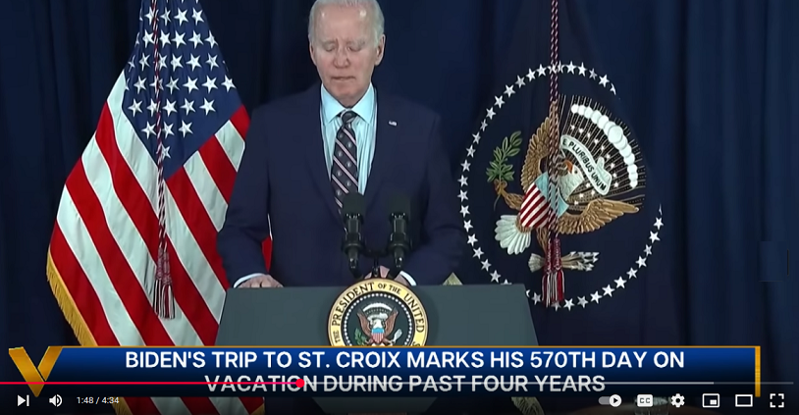
FIGURE 3-3 – Biden seemed to live on Planet Delaware. He spent almost half his time away from the White House.
By the summer of 2024, the vast majority of the nation knew that Biden was out of contact with reality and, in fact, he was not really running the country for the four years of his presidency. Who was really running the nation? While people guess that it was his wife, his staff, or Obama, the Code has another answer. The nation was run by a hostile ET, likely reptilian, or someone who had abducted and scrambled Biden’s brain. See Figure 3-4 with an axis term of BIDEN is ALIEN. MARS, UFO, and ENEMY are at the same absolute skip. PRESIDENT and TREASONABLE are at skip +1. This is a tough fact to absorb. It’s one thing to learn that the President is a traitor. But to understand that he (and Obama) were either not human or were controlled by hostile aliens is much harder to accept. How can we prevent this from happening again? I’d start with requiring DNA tests for anyone (particularly Democrat) who advocates homosexual or transgender positions. These people want a human population in America who are not capable of having babies. We need 2.1 children per American woman to have a stable population. See https://www.pop.org/episode-2-2-1-kids-a-stable-population/, But we are getting only 1.6 children per woman. At this rate, our population will collapse and make it easier for ET to conquer us. This is exactly what they want and are working hard to achieve.
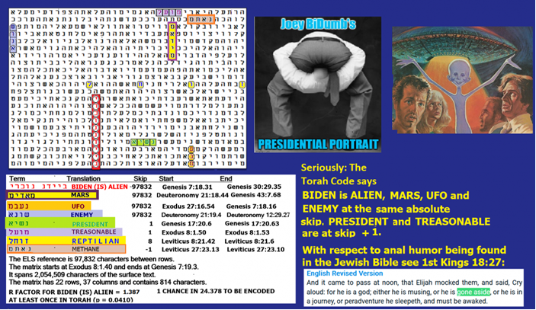
Figure 3-4: The axis term is BIDEN (is) ALIEN. MARS, UFO, and ENEMY are at the same absolute skip. PRESIDENT and TREASONABLE are at skip +1.
On Figure 3-4 CodeFinder indicates that the R factor of the axis term is 1.387. This means that there was only one chance in 24.378 that the 10-letter term BIDEN (is) ALIEN would even be found once in the Torah Code. The most interesting a priori term found was MARS at the same absolute skip of the axis term. Odds against it occurring at a special case skip (+/- 1 and +/- 97,832) in an 814-letter matrix were about 125 to 1. METHANE is on the matrix because it was found in the Martian atmosphere and it usually indicates the presence of some sort of life. Final odds against finding this matrix were over 61 million to 1, as the spreadsheet below indicates.
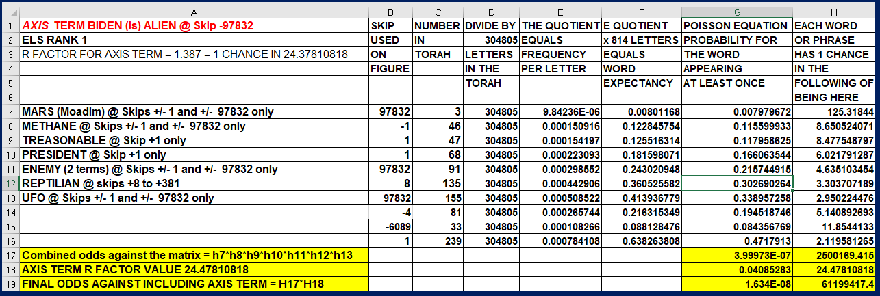
UNDER DEMOCRATS, REPTILIANS CONTROLLED THE WHITE HOUSE. The Torah Code not only alleges that aliens rule our government. It also names the major players that are Reptilian implants. Let’s examine who belongs to the enemy within, starting with Figure 3:5.
Figure 3-5 below. The 9-letter term is OBAMA IS A REPTILIAN. Its R factor is 0.697

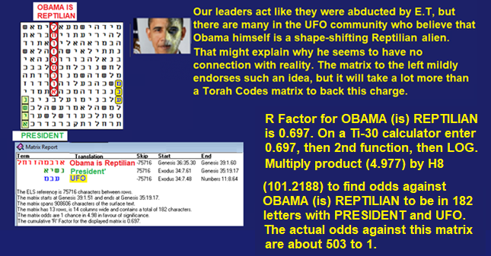

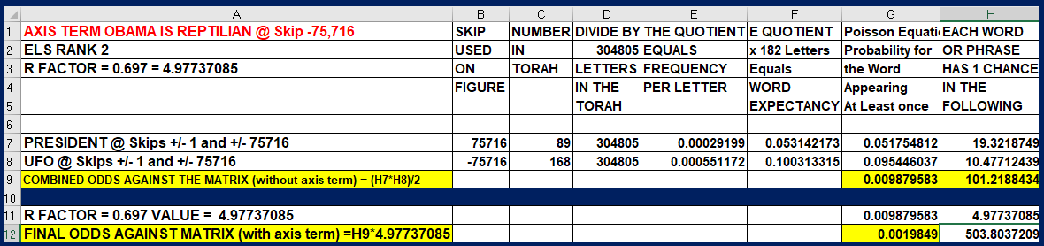

Figure 3-6 below: SENATOR CHUCK SCHUMER. The former Senate Majority Leader is now educed to a mere Senator. On Figure 3-6, he is encoded at the same skip as, although on the larger to the right below to show SPY, I had to expand the basic matrix (CHUCK SCHUMER, REPTILIAN, THE NEPHILIM, and UFO) with a white background from 154 letters to 987 letters (on the matrix shown further down on the right). Besides insinuating that Schumer is a Reptilian or brainwashed by them, the matrix makes another equally startling revelation. The letter L (lamed) in the Hebrew word for REPTILIAN is the same lamed that we see in the open text for THE NEPHILIM (which means GIANTS). The matrix thus solves an ancient and vital question: Who were or are the Nephilim? Giant Reptilians!
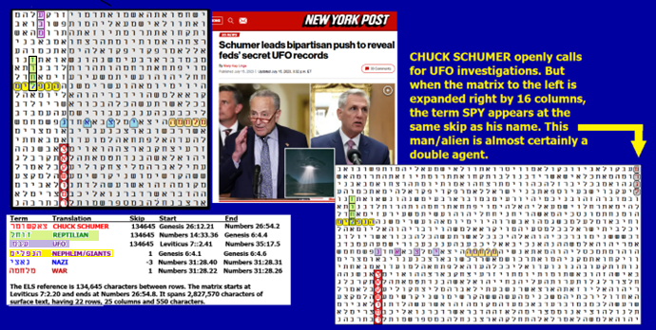

Figure 3-6 above. Note the relationship between CHUCK SCHUMER, REPTILIAN, and THE NEPHILIM.
What does the Torah say about these creatures?
Genesis 6:1 to 6:4, The Wickedness of Mankind
When men began to multiply on the face of the ground, and daughters were born to them, the sons of God saw that the daughters of men were fair; and they took to wife such of them as they chose. ³ Then the Lord said, “My spirit shall not abide in man forever, for he is flesh, but his days shall be a hundred and twenty years.” ⁴ The Nephilim were on the earth in those days, and also afterward, when the sons of God came in to the daughters of men, and they bore children to them. These were the mighty men that were of old, the men of renown.
The spreadsheets showing the odds against the Schumer matrices are given below.
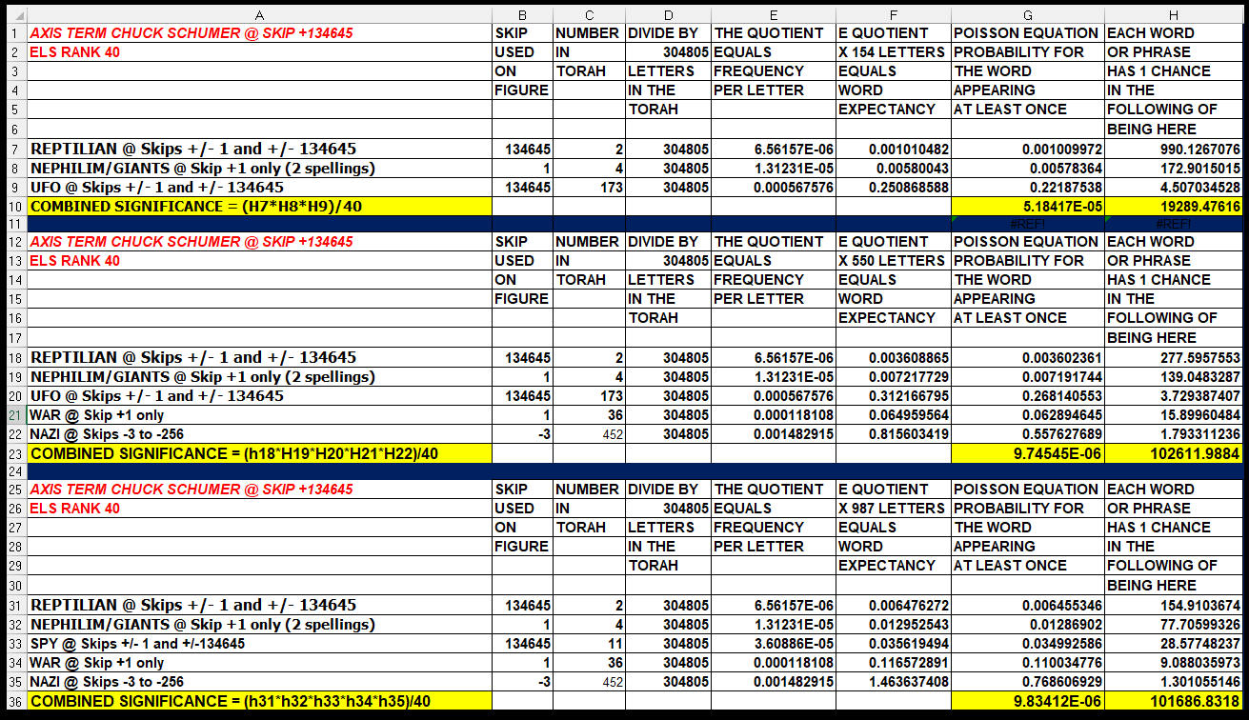
FIGURE 3-7: Is General Milley a Reptilian? On Figure 3-7, the axis term is MARK MILLEY. GENERAL is at the same skip, and UFO is at the same absolute skip. REPTILIAN is at skip -1. There are three terms that mean STRANGER, FOREIGNER, or ALIEN. The third is in Leviticus 24:16. It is about blasphemy, and it deals with how to punish a blasphemer. It says,
“HE WHO BLASPHEMES GOD’S NAME SHOULD BE KILLED.”
This full phrase touches MARK MILLEY. That’s likely to happen IF it can be proven that Milley is indeed a Reptilian. The former Chairman of the Joint Chiefs of Staff, GENERAL MARK MILLEY, was a blasphemous man during the Trump Administration (and a traitor). On TV, he rejected accompanying Trump and his Bible when the church across the street from the White House was burned. Milley actually accepted a pardon from President Biden in the last 15 minutes of that Administration. So as soon as President Trump began his new term in 2025, he ordered the portrait of Milley to be taken down at the Pentagon.
On Figure 3-7 it only takes 264 letters to show MARK MILLEY with REPTILIAN at skip -1. Odds against matching MILLEY and REPTILIAN at a special case skip are about 1,115 to 1. Is Milley really a Reptilian, a Reptilian-human hybrid, or merely someone who was abducted and brainwashed by Reptilians? Based on (1) his refusal to be photographed with the President holding a Bible in front of the burnt St. John’s Church across the street from the White House on June 1, 2020, (2) his rebellious TV-broadcasted speech about it, we can (3) take his behavior plus Figure 3-9 where he is at the same exact skip as TO HYBRIDIZE and UFO, plus (4) his Army Times remarks about fighting hybrids, and (5) his mysterious contact with me about the abstract of my Mars Correct Report, I think he is likely to be a hostile Reptilian-human hybrid.
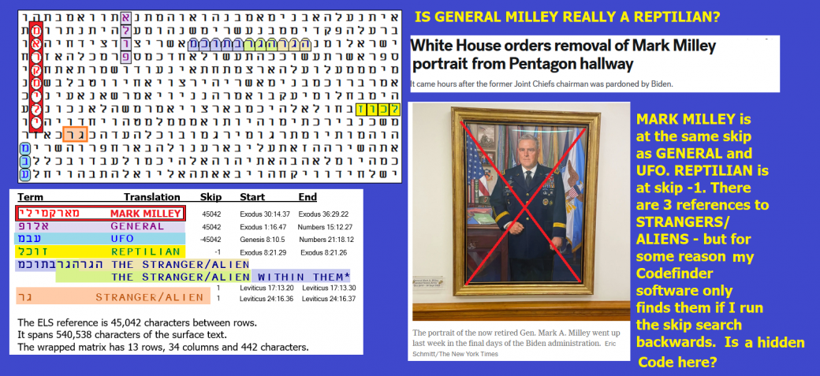
Figure 3-7 above. As per the spreadsheet below, there was only about one chance in 1.3 million to find REPTILIAN at a special case skip (-1) in a full 442-letter matrix with MARK MILLEY and his rank (GENERAL) at the same skip as his name. MARK MILLEY is the axis term, and UFO is at the same skip too (but in the opposite direction). A word for STRANGER or ALIEN appears three times in the open text. Again, the most significant term was REPTILIAN. Odds against its appearance at a special case skip on the full 442-letter matrix were about 690 to 1. The next most important term was Milley’s rank (GENERAL) at the same skip as his name. Odds against this find were about 172.9 to 1.
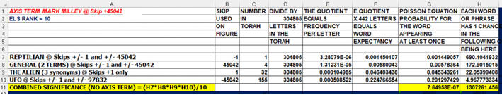
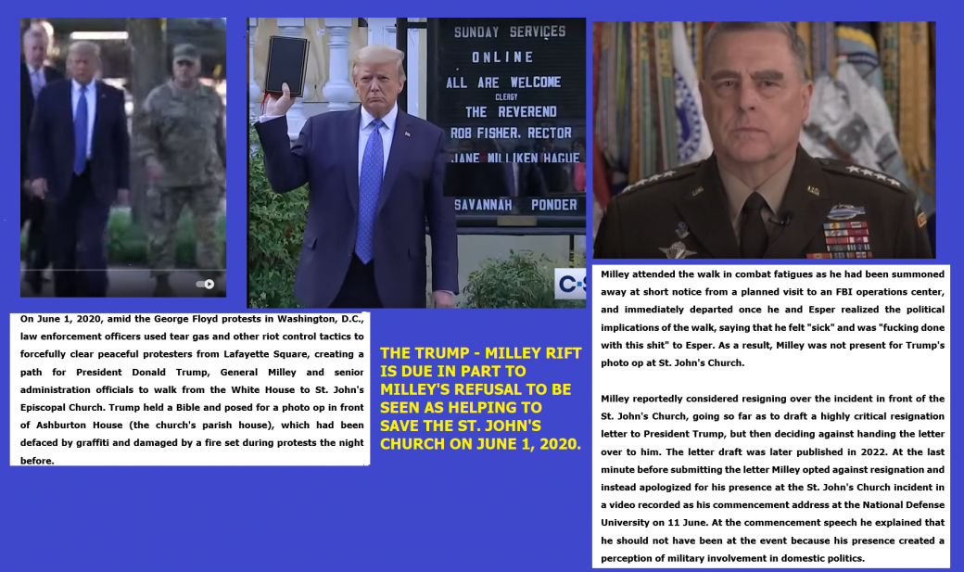
Figure 3-8 above. Milley wanted nothing to do with Trump’s desire to save a historic church (St. John’s) across the street from the White House. He backed away from the President before a group photo could be taken. This is not proof, like the Torah Code offers, that he is a Reptilian, but it is consistent with what is written about their murderous outlook with respect to humans.
General Milley, the former Chairman of the Joint Chiefs of Staff, is also on Figure 3-1, at one skip off the axis, touching AND HIS MILITARY, which touched ALIEN IN OUR GOVERNMENT (at the same absolute skip as BIDEN). Milley’s name is not statistically significant at all on the full matrix, but it is of personal interest because, on December 8, 2015, he sent me a weird Facebook invitation. On it, he included nothing at all except the abstract of the Roffman (father and son) Report, Mars Correct – Critique of All NASA Mars Weather Data (https://www.academia.edu/40831370/MARS_CORRECT_CRITIQUE_OF_ALL_NASA_MARS_WEATHER_DATA). The current Abstract differs from what he sent back to me largely with respect to the number of Martian days (1,171 then vs. 3,025 below) that MSL Curiosity was on Mars later.
Did General Milley mean to praise us by making it clear that he was aware of our research, or threaten us by implying that he knew all the sensitive things we were finding (not then, but eventually even evidence for time travel)? His attention led me to publish several Torah Codes matrices about him. When he wrote me, I had not yet written about evidence for primitive life on Mars.
I hid Figure 3-9 (see below) and the bulk of the article about Milley for 5 months, but since he stepped in it by talking in public about fighting Little Green Men and Hybrid Armies at 34:10 to 50 in this video, link (https://www.inquisitr.com/u-s-military-prepping-for-alien-invasion-army-chief-warns-cadets-prepare-for-little-green-men-and-hybrid-armies-video), I declared it time for me to let the public see what the Code says about him. The Army Times had damage control up about his remarks (but they apparently didn’t know about him contacting me before). They say “little green men” was used in a non-extraterrestrial, military context as recently as 2014 when Russia annexed Crimea, to refer to men wearing unmarked green uniforms, whose origin was unconfirmed. Further, the military has long talked of a hybrid threat of regular forces, criminal elements, terrorist groups, and cyber threats, etc. Obviously, the General could have avoided the controversy by defining these terms for the public when he used them. But by 2022, we were dealing with a war in Ukraine, one in which there have been articles about an alien ark activating underground in Kherson, Ukraine, in the area where Putin first invaded in 2022.
Figure 3-9 below – GENERAL MARK MILLEY, UFOs, and (alien) HYBRIDIZATION
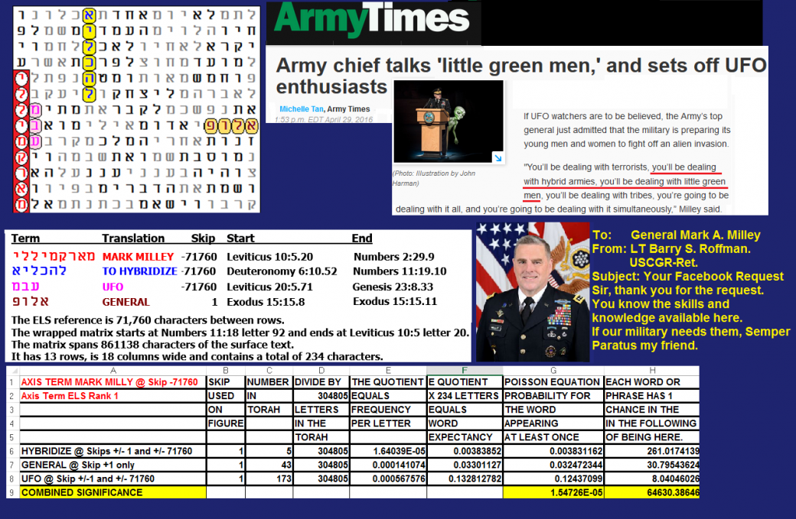
Figure 3-9 above: HYBRIDIZE is at the same absolute skip as MARK MILLEY and UFO.
Back to the Codes for now. Is MILLEY’s name significant on a matrix measuring 16 rows by 10 columns with BIDEN, AND HIS MILITARY, AN ALIEN IN OUR GOVERNMENT, and MAGA in it? No. While odds against the smaller 12 X 10 matrix with BIDEN, AN ALIEN IN OUR GOVERNMENT, AND HIS MILITARY, and MAGA were about 166,704 to 1, if we add four rows to accommodate a non-special skip MILLEY, the significance still drops to 150,526 to 1. The general rule is that when you start with two outstanding terms that are very close like BIDEN and AN ALIEN IN OUR GOVERNMENT, new terms will not add any significance to the matrix unless they are (1) at a special case skip (+/- 1 or the absolute skip of the axis term – here +/-81,218) or (2) in the area of the original close match – here 120 letters.
But before looking at General Milley further and asking if he may be one of the officers in our government willing to work for ET so long as the pay is good, you may want to look at what he chose to send me. It was an unsolicited segment of my work, a draft Abstract Basic Report published on March 3, 2021, by the International Mars Society. It read as follows:

Abstract for Basic Report for Mars Correct: Critique of All NASA Mars Weather Data
We present evidence that NASA is seriously understating Martian air pressure. Our 12-year study critiques 3,025 Sols up through 8 February 2021 (8.51 terrestrial years, 4.52 Martian years) of highly problematic MSL Rover Environmental Monitoring Station (REMS) weather data, and offers an in-depth audit of over 8,311 hourly Viking 1 and 2 weather reports. We discuss the analysis of technical papers, NASA documents, and personal interviews of transducer designers. We troubleshoot pressures based on radio occultation/spectroscopy, and the previously accepted small pressure ranges that could be measured by Viking 1 and 2 (18 mbar), Pathfinder and Phoenix (12 mbar), and MSL (11.5 mbar – altered to 14 mbar in 2017). For MSL, there were several pressures published from August 30 to September 5, 2012, that were from 737 mbar to 747 mbar – two orders of magnitude high – only to be retracted. We challenged many pressures, and NASA revised them down. However, there are two pressure sensor ranges listed on a CAD for Mars Pathfinder. We long thought the CAD listed two different sensors, but based on specifications of a new Tavis sensor for InSight that is like that on PathFinder, it appears that the transducer could toggle between two pressures ranges: 0-0.174 PSIA/12 mbar (Tavis Dash 2) and 0-15 PSIA/1,034 mbar (Tavis Dash 1). Further, an Abstract to the American Geophysical Union for the Fall 2012 meeting, shows the Finnish Meteorological Institute (FMI) states of their MSL (and Phoenix) Vaisala transducers, “The pressure device measurement range is 0 – 1025 hPa in temperature range of -45°C – +55°C (-45°C is warmer than MSL night temperatures), but its calibration is optimized for the Martian pressure range of 4 – 12 hPa.” So, in fact of the first five landers with meteorological suites, three were actually equipped to measure Earth-like pressure.
All original 19 low μV values were removed when we asked about them, although eventually 12 were restored. REMS always-sunny opacity reports were contradicted by Mars Reconnaissance Orbiter photos. We demonstrate that REMS weather data was regularly revised after they studied online critiques in working versions of this report. REMS even labelled all dust 2018 Global Dust Storm weather as sunny, although they did list the μV values then as all low. Vikings and MSL showed consistent timing of daily pressure spikes, which we link to how gas pressure in a sealed container would vary with Absolute temperature, to heating by radioisotope thermoelectric generators (RTGs), and to dust clots at air access tubes and dust filters. Pathfinder, Phoenix, and MSL wind measurements failed. Phoenix and MSL pressure transducer design problems included confusion about dust filter location and a lack of information about nearby heat sources due to International Traffic and Arms Regulations (ITAR). NASA Ames could not replicate dust devils at 10 mbar. Rapidly filled MER Spirit tracks required wind speeds of 80 mph at the assumed low pressures. These winds were never recorded on Mars. Nor could NASA explain drifting Barchan sand dunes. Based on the above and dust devils on Arsia Mons to altitudes of 17 km above areoid (Martian equivalent of sea level), spiral storms with 10 km eye-walls above Arsia Mons and similar storms above Olympus Mons (over 21 km high), dust storm opacity at MER Opportunity blacking out the sun, snow that descends 1 to 2 km in only 5 or 10 minutes, excessive aero braking, liquid water running at or near the surface in numerous locations at Recurring Slope Lineae (RSL) and stratus clouds 13 km above areoid, we argue for an average pressure at areoid of ~511 mbar rather than the accepted 6.1 mbar. This pressure grows to 1,050 mbar in the Hellas Basin.
I published an article entitled Teleportation, Basiago & Torah Code. Part of the article was the full Air Force Teleportation Physics Study (AFRL-PR-ED-TR-2003-0034) by Dr. Eric W. Davis. On page 56, it states, in part,
“Most claimed instances of human teleportation of the body from one place to another have been unwitnessed. There are also a small number of credible reports of individuals who reported being teleported to/from UFOs during a UFO close encounter, which were scientifically investigated (Valee, 1988, 1990, 1997).
As I document in my teleportation article, it appears that our military teleportation abilities are further advanced than what the public is aware of. Was Biden of alien descent, or was he merely maintaining direct contact with ETs when he is largely out of the public eye? He was in Delaware pretty much every week. ETs could easily use superior teleportation skills to bring him where they choose to and scramble his brain (if he still had one) in any way that they wanted to every time they got him isolated in Delaware. We should not ignore the Torah Code matrix at the start of this chapter. By the way, when trying to understand why Biden raided President Trump’s home in Florida, we should not overlook the possibility of Biden attempting to find documents or evidence of Trump’s knowledge of ETs on Earth and/or Government teleportation and/or related time travel capabilities.
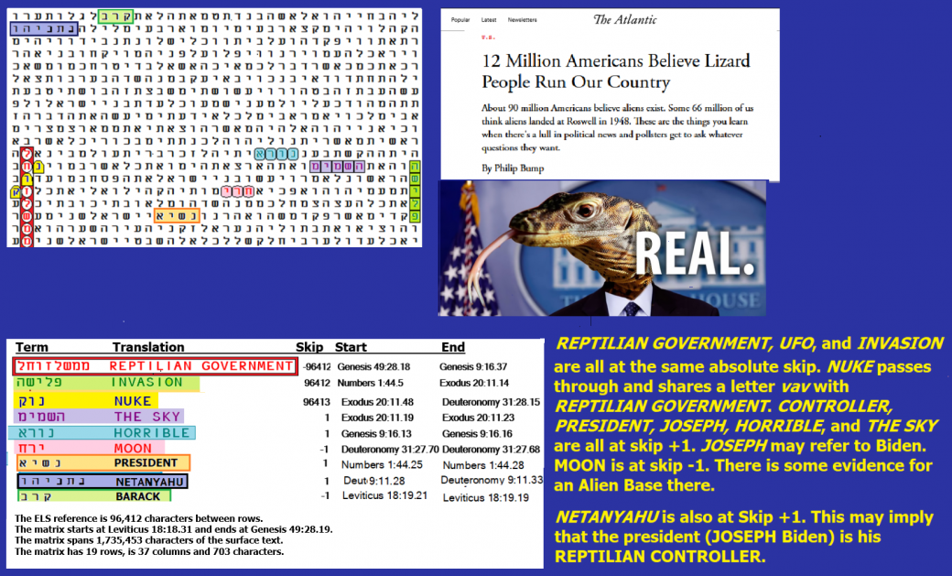
Figure 3-10 above. The axis term is REPTILIAN GOVERNMENT. At the same skip is INVASION.
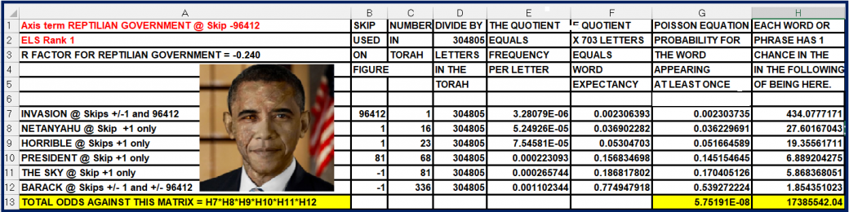
Spreadsheet for Figure 3-10 is above. Note the high significance of INVASION (Only one chance in 434 that it would be there at a special case skip). This is what our REPTILIAN GOVERNMENT is all about. But who knew enough about them to give us such a warning over 3,000 years ago?

OTHER GOVERNMENT INFILTRATORS
Figure 3-11: Chris Wray, Director of the FBI
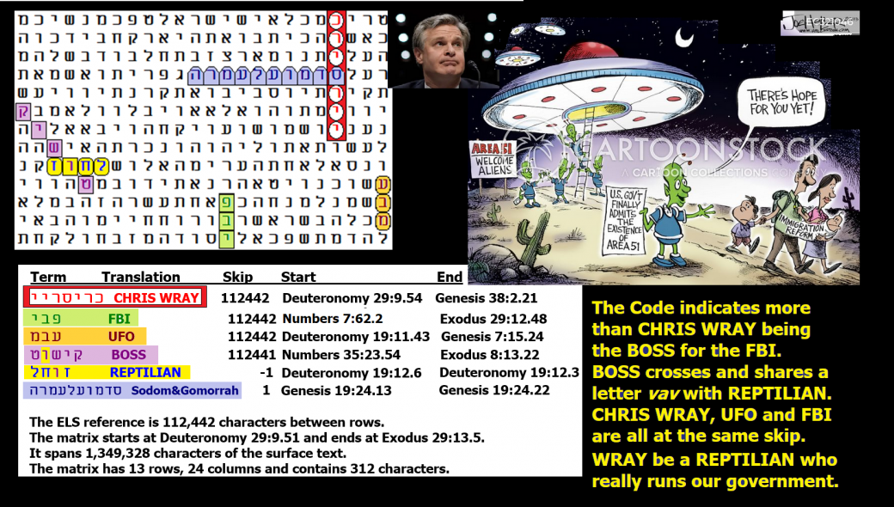
Figure 3-11 above: Axis term CHRIS WRAY who is presented as not only as the boss of the FBI, but also as a REPTILIAN BOSS.
Spreadsheet below for Figure 3-11. The matrix was found against odds of about 28,955,985 to 1. As expected, the most significant keyword was REPTILIAN. Before considering the ELS rank of CHRIS WRAY, REPTILIAN was found at a special case skip (-1) against odds of at least 977 to 1.
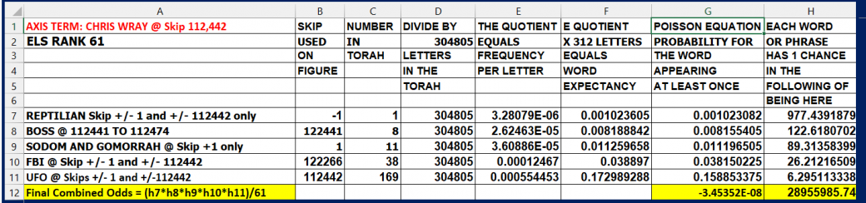

WHICH MATRICES SPECIFICALLY LINK REPTILIANS TO OUR GOVERNMENT?
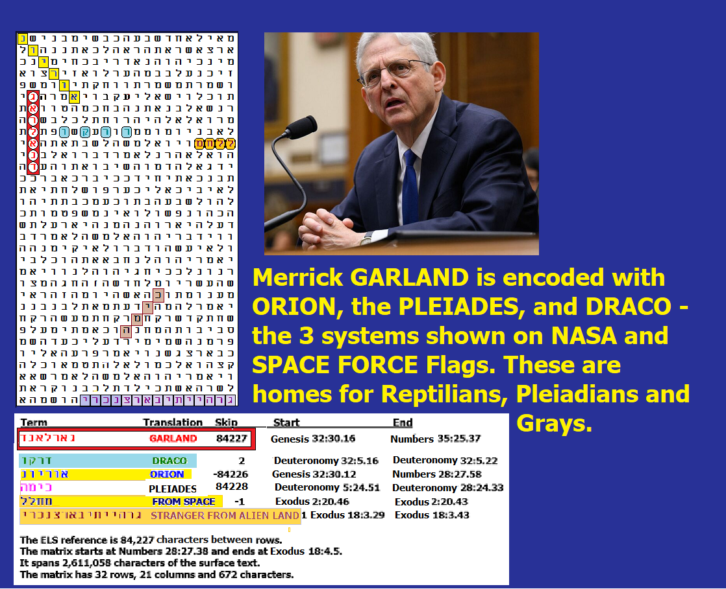
Figure 3-12 above links ex-U.S. Attorney General Merrick GARLAND with some home constellations of REPTILIANS – ORION (yellow and blue) and the PLEIADES (light brown). A synonym for Reptilians is DRACO (light blue), skip +2). DRACO pertains to the constellation Alpha Draconis. FROM SPACE is at skip -1. In the open text is STRANGER FROM AN ALIEN WORLD. what is being exposed is that most, if not all, people in Biden’s administration are either Reptilians or are traitors who serve their cause. Most are likely here to seize control of our planet and/or destroy it., or use it for their own purposes.
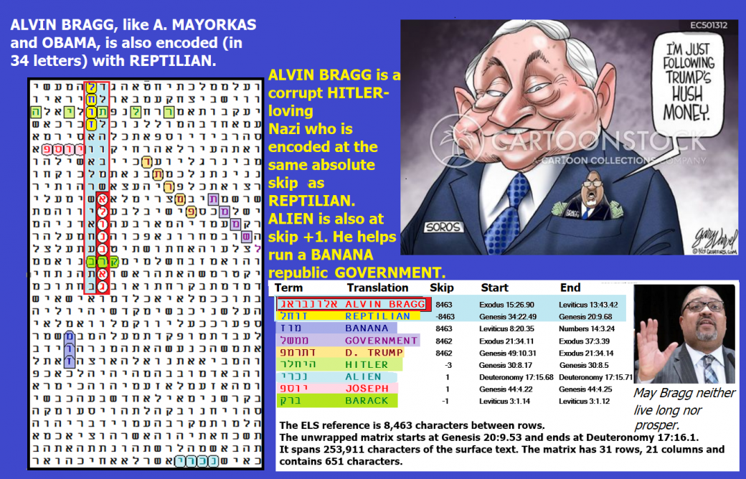
Figure 3-13 above: ALVIN BRAGG, who showed no loyalty to anything but his sick desire to destroy President Donald Trump (and any hope of a united America) is encoded in only 34 letters with REPTILIAN at the same absolute skip as his name. Odds against them both being encoded in 651 letters are about 156 to 1, though odds against them being so close in two columns and 17 rows are about 2,988 to 1. Overall odds against Figure 3-13 are about 170,073,613 to 1.
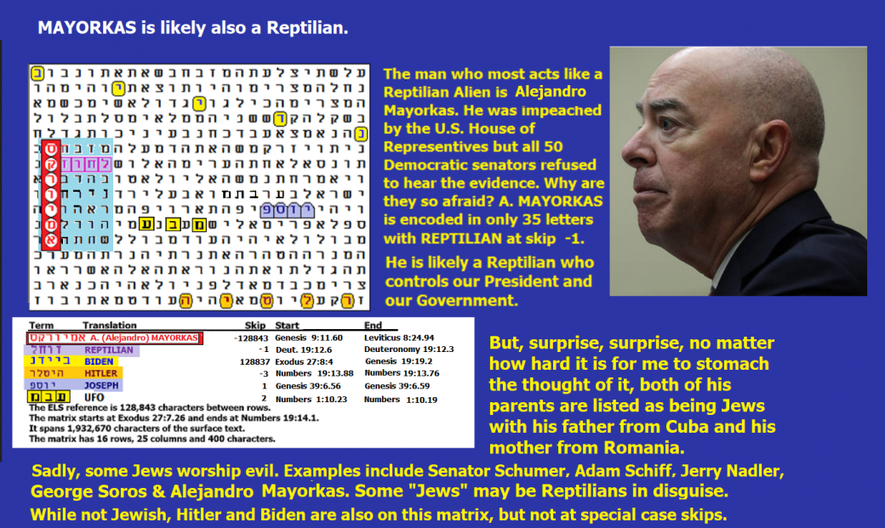
Figure 3-14 above: A. MAYORKAS is encoded touching REPTILIAN at skip-1 in a box that has only 35 letters. Originally, I wrote that you should listen to Senator Cruz attack the Democratic Senate for failing to hear any evidence in the Alejandro Mayorkas impeachment, but the link I had for that great speech is now gone. A similar attack is at https://www.youtube.com/watch?v=YDQd2jOKjgE .

Figure 3-15. Senator Cruz blasts Mayorkas.
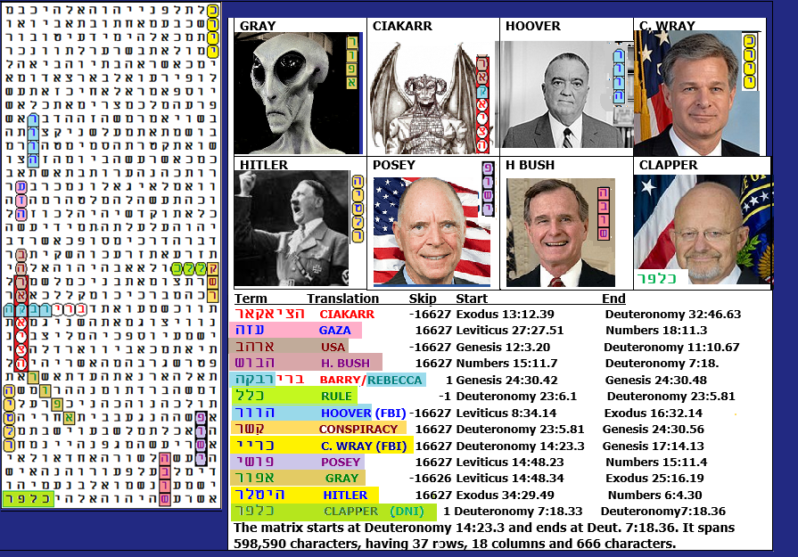
Figure 3-16 above: Congressman POSEY’s book, The Manson Connection, is about our government assisting in abductions (and sometimes murder) by aliens.
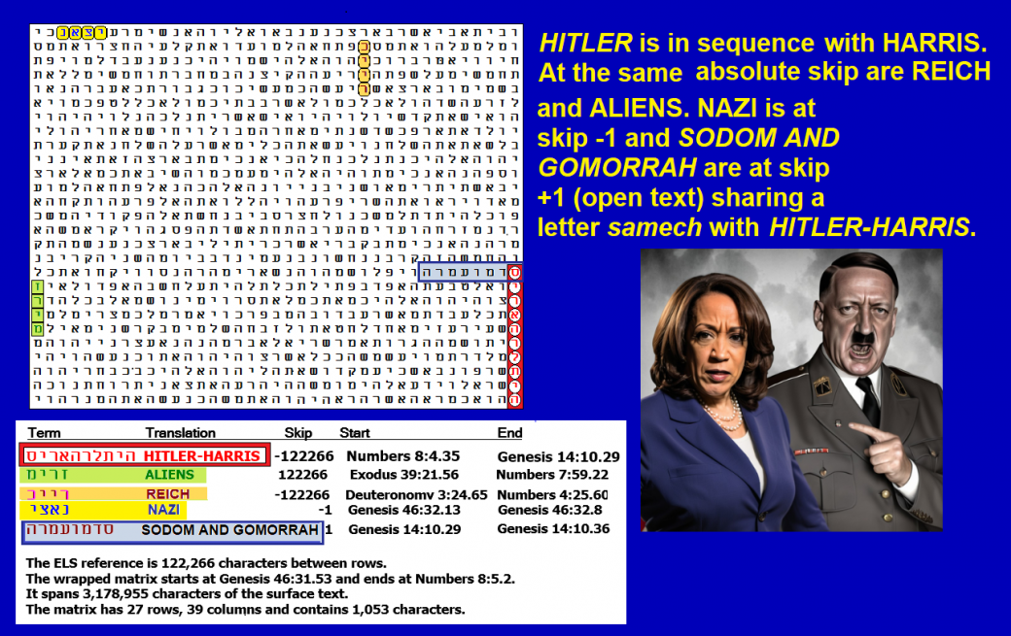
Figure 3-17 – HITLER HARRIS in sequence. ALIENS is at the same absolute skip. HITLER HARRIS shares the first letter with SODOM AND GOMMORAH in the open text. REICH is at the same skip as HITLER HARRIS and ALIENS. NAZI is at skip -1.

Figure 3-18 below: TIM WALZ is a REPTILIAN.


Figure 3-18 above and its spreadsheet below. The 28-letter matrix looks extremely significant. If it were based on the lowest ELS of TIM WALZ, odds against it would be about 10,886 to 1. However, we do not see this match until the 84th ELS of Tim Walz. Dividing 10,886 by 84 we find that this match exists against odds of about 129 to 1. It’s really much better than these odds make clear because of terms that only become visible when the matrix is expanded from 28 to 120 letters – still considered a tight matrix. Then we see that Walz’s title of GOVERNOR (of Minnesota) is there at one skip less than that of WALZ. Further, ENEMY is at the same skip as WALZ. Odds against this matrix are about 5,898 to 1. Although this matrix did not occur until the 84th ELS of TIM WALZ, there is likely to be a lot of other information about him in matrices with lower ELS ranks for axis terms. It takes a lot of time for me to find what I do. Although I did not conclude that an artificial intelligence wrote this Code, I do believe that an A.I. should be set up along the lines of Project Creator Decoder to efficiently deceipher the massive quality of other critical warnings encoded. My vision of Creator Decoder is found on my website at https://arkcode.com/photo4_113.html. It was addressed to Fort Huachuca, Level-3/CACI, MIT, MITRE, NASA Ames, G.E., IBM, Drakes Holding and the NSA, however I do not know what they did with the information.
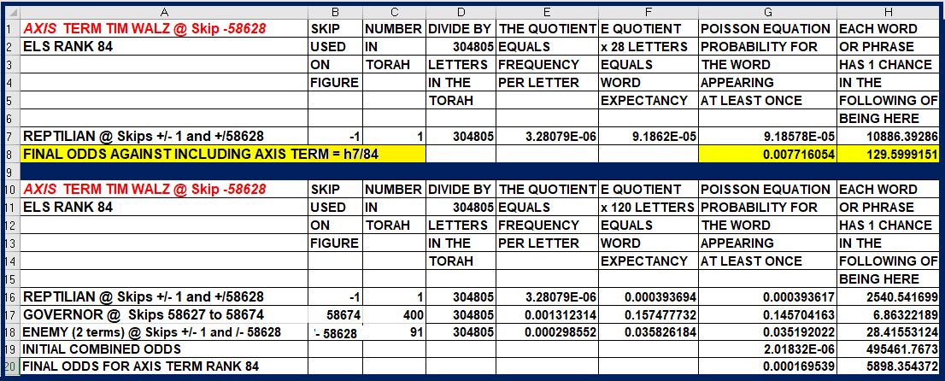
Above: Spreadsheet for Figure 3-18.
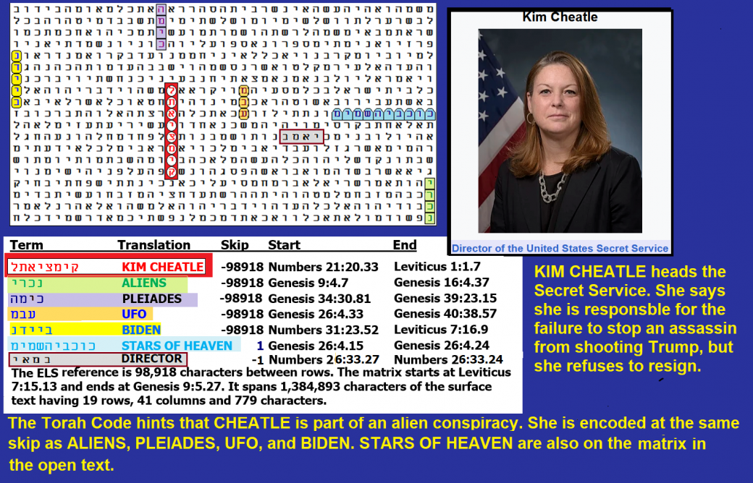
FIGURE 3-19 – KIM CHEATLE, Director of the United States Secret Service. One of her jobs was to protect President Trump, but he was still shot in the head under her watch. Errors made were numerous, but were they part of an alien (Reptilian) plan?
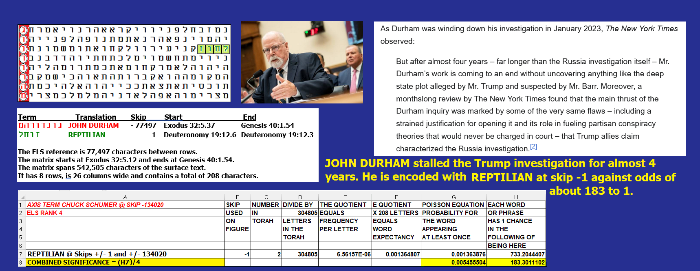
Figure 3-20 above. JOHN DURHAM is encoded with the only REPTILIAN at skip +/-1. Odds against this march are about 183 to 1. In April 2019, U.S. Attorney General William Barr had tasked Durham with overseeing a review of the origins of the Russia investigation and to determine if intelligence collection involving the Trump campaign was "lawful and appropriate". After 3 1⁄2 years of investigation and prosecutions, Durham had secured one guilty plea and a probation sentence for a charge unrelated to the origins of the Trump-Russia investigation, and two unsuccessful trial prosecutions.
Figure 3-21: Although it takes a row split of 3 to see it, against odds of over 87 million to 1, HAKEEM JEFFRIES is encoded with REPTILIAN and WAR at the same absolute skip plus B. OBAMA at skip -1.
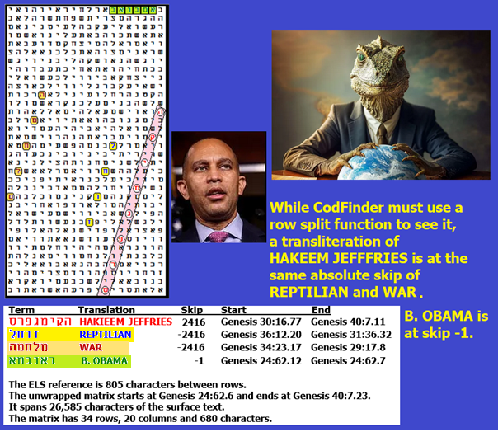
Figure 3-21 above and its spreadsheet below. HAKEEM JEFFRIES, Democratic minority leader in the House of Representatives, is at the same absolute skip as REPTILIAN and WAR. B. OBAMA is also on the matrix at skip -1. Both men should be considered to be aliens (reptilians) or people who have been abducted and brainwashed/programmed to follow the reptilian agenda of weakening or destroying America and humanity.

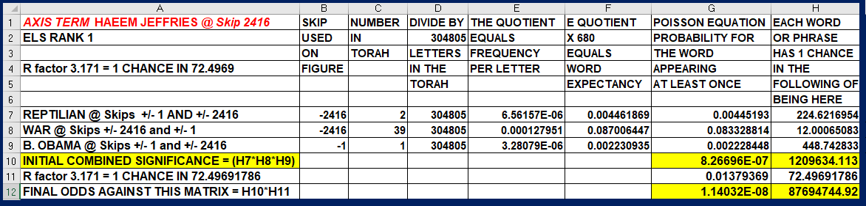
Figure 3-22 below: John Brennan, former Director of the CIA, is a reptilian.

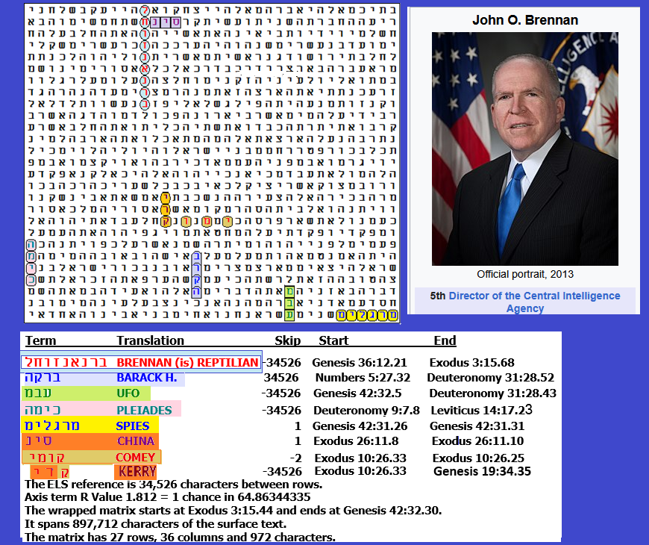

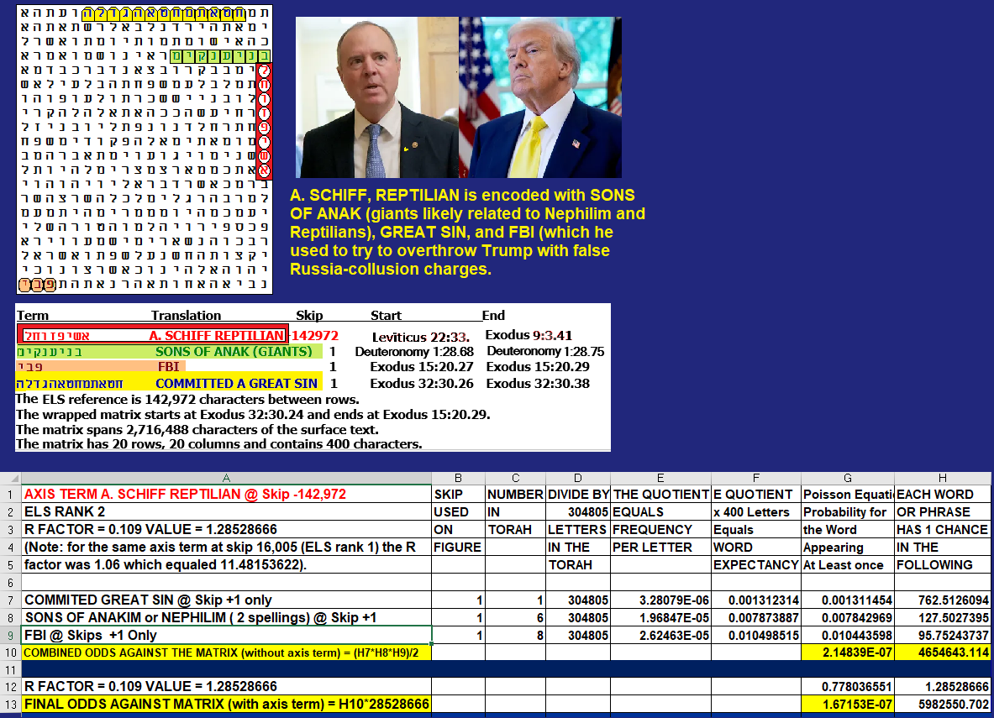

Figure 3-23 above: The famous liar A. (Adam) SCHIFF is also encoded with REPTILIAN, probably descended from the ANAKIM who likely arose from the Nephilim. His GREAT SIN was treason. He wanted to be FBI Director if Hilary Clinton won the 2016 election. Under Biden he used the FBI to try to impeach President Trump. Odds against this matrix were almost six million to 1. Figure 3-24 below shows another ELS of A. SCHIFF REPTILIAN.

SUMMARY: ALIENS ENCODED AS INFILTRATING OUR GOVERNMENT.
- PRESIDENT JOE BIDEN is encoded with ALIEN IN OUR GOVERNMENT. BIDEN (is) ALIEN is also encoded with MARS, UFO, and ENEMY at the same absolute skip.
- PRESIDENT BARACK OBAMA is (in sequence). Encoded with REPTILIAN and at the same absolute skip as UFO and PRESIDENT.
- Senator CHUCK SCHUMER is at the same skip as REPTILIAN, UFO, and SPY. The term NEPHILIM (giants) in the open text goes through and shares a letter lamed with REPTILIAN. WAR and NAZI are on the same row as each other.
- HITLER - (VP) HARRIS is encoded in sequence with ALIENS at the same skip.
- GENERAL MILLEY is encoded with GENERAL and UFO at the same absolute skip, plus REPTILIAN and ALIEN (3 times). See Figure 3-1 for additional matches.
- FORMER FBI DIRECTOR CHRIS WRAY is encoded with REPTILIAN at skip-1 crossing BOSS and with FBI and UFO at the same skip as CHRIS WRAY.
- U.S. ATTORNEY GENERAL MERRICK GARLAND is encoded with STRANGER FROM AN ALIEN LAND/PLANET in the open text.
- ALVIN BRAGG is encoded with REPTILIAN at the same absolute skip and just one column away.
- A. MAYORKAS touches REPTLIAN at skip -1 in 35-letter box.
- CIAKAHRR (Reptilian) is encoded with HITLER, HOOVER, USA, BUSH, C. WRAY, and CONSPIRACY all at the same absolute skip. Former Director of National Intelligence James CLAPPER is at skip +1.
- TIM WALZ, 2024 Democratic Party vice presidential nominee, is encoded with REPTILIAN at skip -1 sharing a letter zayin with it in a 28-letter box. UFO and WEIRD are at skip -1. During his campaign, Walz called Vance weird, but Walz put tampon dispensers into boys’ locker rooms.
- Former Secret Service Director KIM CHEATLE is encoded at the same skip with ALIENS, PLEIADES, UFO, and BIDEN.
- JOHN DURHAM played a major role in investigating President Trump for almost four agonizing years. Against odds of about 183 to 1. He, too, is encoded on Figure 3-20 with REPTILIAN at skip-1.
- House Minority Leader HAKEEM JEFFRIES in a row split three unwrapped matrix is encoded in 680 letters with REPTILIAN and WAR at the same absolute skip of a transliteration of HAKEEM JEFFRIES. B. OBAMA is at skip -1. Odds against this matrix are about 87,694,744 to 1. Although it takes a row split of 3 to see it, against odds of over 87 million to 1, HAKEEM JEFFRIES is encoded with REPTILIAN and WAR at the same absolute skip plus B. OBAMA at skip -1.
- On Figure 3-22 above, former CIA Director John BRENNAN is also in sequence with REPTILIAN, At the same absolute skip are BARACK H., KERRY (Secretary of State), PLEIADES and UFO. At Skip +1 touching BRENNAN (is) REPTILIAN is CHINA. SPIES are in the open text and COMEY is at skip -2. KERRY and COMEY share a letter kuf. Odds against this matrix were about 13,752,292 to 1.
- Adam Schiff worked hard to try to impeach Trump over the Russia Collusion hoax. A. SCHIFF is encoded as a REPTILIAN who had a GREAT SIN. See Figures 3-23 above and 3-24 below. He is a hostile spy.
