# **Chapter 13**

**President Kamala Harris?**

The main axis term for this chapter is **PRESIDENT HARRIS** on Figure 13-1. It is at skip +119,183. It’s encoded only once in Torah and was only sought by me after Biden was basically destroyed in his debate with Trump. The first letter of **PRESIDENT** (*nun*) is also the first letter of another **PRESIDENT** in the open text. There is a third **PRESIDENT** also on the row where the other two PRESIDENTs appear or begin. The matrix hints at who controls her. Her name is crossed by and shares a letter alef with **NAZI.** Nazi at skip -119,184 is one skip off the axis term. **ALIENS** (at skip +119,182) is also at one skip off the axis term. We just learned in 2025 that Biden was not in control of the White House for a long time. Who was? Likely the Fourth Reich, which Nazis and Reptilian aliens control. That’s why I searched for **NAZI, ALIENS,** and **UFO**, which are all on the matrix. Originally, I wrote that, “Harris will likely become President for at least part of the Hebrew Year 5785 (which occurs in parts of 2024 and 2025). Hebrew year of her partial 'rule' (5785) is on the matrix at skip -1.”

On July 21, 2024 (15th of Tammuz 5784), Joe Biden, the 46th president of the United States, announced his withdrawal from the 2024 presidential election and endorsed Vice President Kamala Harris as his replacement. After Biden was forced to withdraw, Harris actually began her unofficial reign as “acting” President. During this period, the public was never told who was really running America. The Hebrew New Year began at sunset on Wednesday, October 2, 2024. On July 15, 2025 we still have not been told who was running the show, complete with thousands of pardons signed by autopen. So, she actually served in this capacity for about 73 days in 5784, and (per the Code) an additional 110 days in the Hebrew year of 5785.

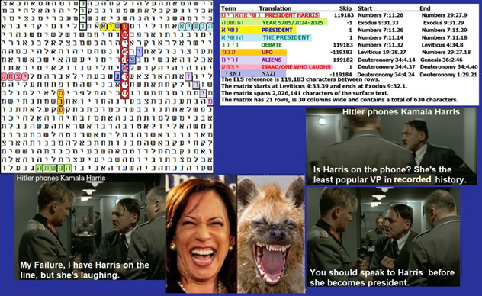

**Figure 13-1 above: *PRESIDENT HARRIS*** was predicted to be a ***NAZI PRESIDENT*.**

$$=$$

Odds against Figure 13-1 above are about 12,854,441 to 1.

**STATISTICAL SIGNIFICANCE OF FIGURE 13-1**. The full 630-letter matrix was found against odds of about 12.8 million to 1. The most significant term is the Hebrew year **5785**. It was found at a special case skip (-1) against odds of about 121 to 1. The most interesting combination of keywords has the 9-letter axis term (**PRESIDENT HARRIS**) beginning with a letter *nun* (N). What is this **nun** in the open text horizontal to the axis term? It is also the first letter of Nasey (*president*) in the open text! So, the Torah here translates itself from encoded to unencoded text. Further, while I often hear moronic Democrats compare Trump with Hitler (something never found in the Torah Code), **PRESIDENT HARRIS** is crossed by and shares a letter *alef* with **NAZ**I. All of this is in 54 letters (6 columns by nine rows). Odds against such a quality match are about 19,682 to 1. To just show **PRESIDENT HARRIS** with **NAZI** only takes 36 letters (4 columns by nine rows) without considering contradicting letters. Actually, the matrix is even more significant because there was only about one chance in 2 that there would be any 9-letter ELS of PRESIDENT HARRIS in Torah.

**ISAAC** is also on Figure 13-1 in the open text. The name means **ONE WHO LAUGHS**. Harris is famous for being unable to stop laughing, even when there is nothing funny. People are probably more likely to laugh at her rather than with her. She is a pro-Palestinian, anti-Semitic idiot. I would have said, “God help America” when she moved up in office, but her boss (Biden) was also a Jew-hating Nazi who despises America and our Constitution.

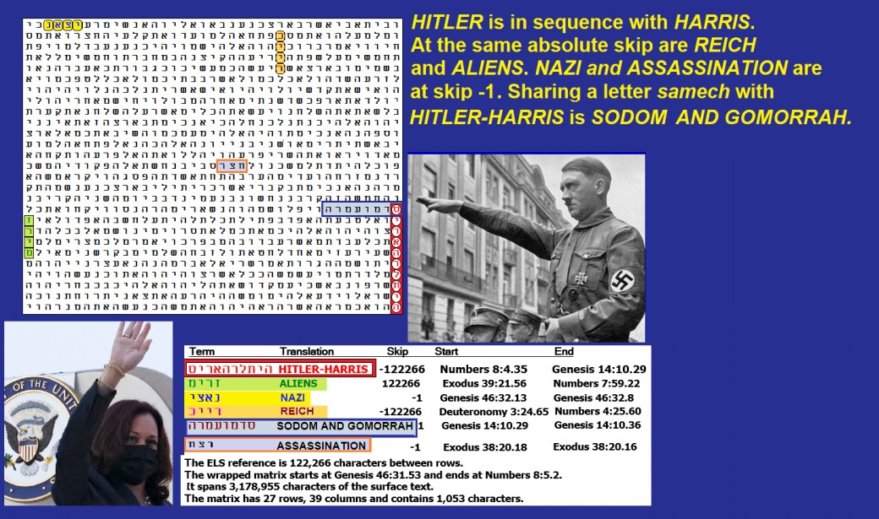

**Figure 13-2 above. HITLER HARRIS** is in sequence and with **ALIENS** at the same absolute skip. **HITLER HARRIS** shares the first letter with **SODOM AND GOMMORAH** in the open text. **REICH** is also at the same skip as **HITLER HARRIS** and **ALIENS. NAZI** is at skip -1.

**Figure 13-3 below:** Two congressmen (Doug Lamborn and Joe Wilson) call out Harris as antisemitic exactly two years and 1 day before the attack on Israel on October 7, 2023.

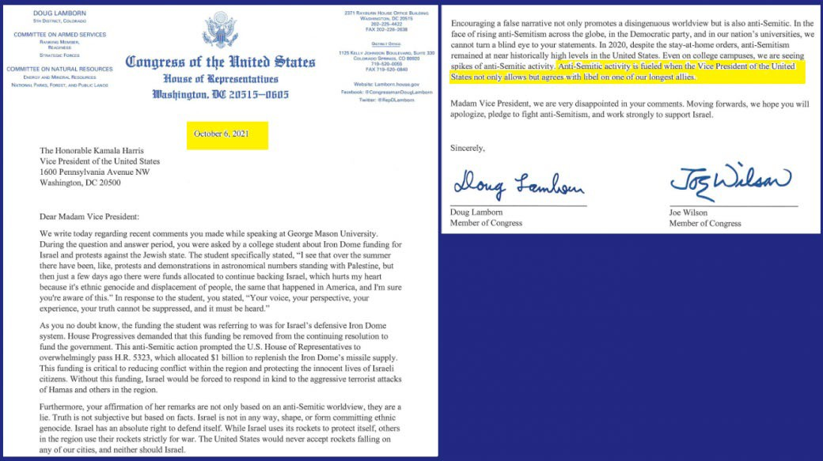

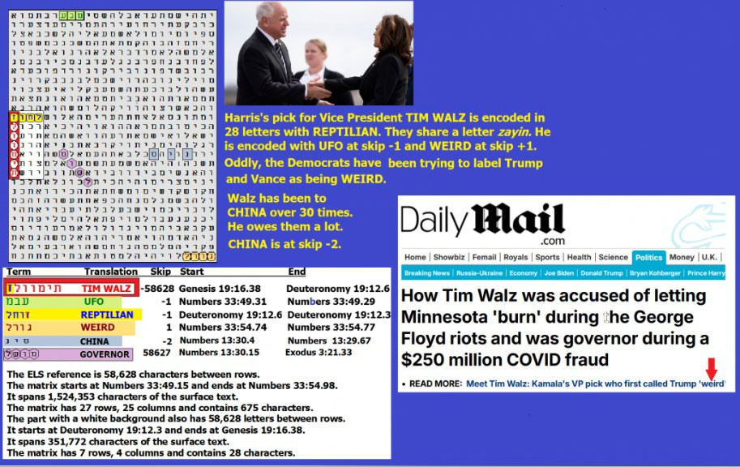

Figure 13-4 above. **TIM WALZ i**s encoded in 28 letters with **REPTILIAN** at skip -1.When Harris won the Democrat nomination for President, she chose **TIM WALZ** as her vice-presidential candidate. **WALZ** is strongly encoded with being a **REPTILIAN**. Amazingly, it only takes 28 letters to show **TIM WALZ** vertically at skip -58,628 and REPTILIAN horizontally at skip-1, sharing the letter *zayin* (Z) in **REPTILIAN** with **TIM WALZ**. See Figure 13-4. Odds against this matrix are about 5,898 to 1.

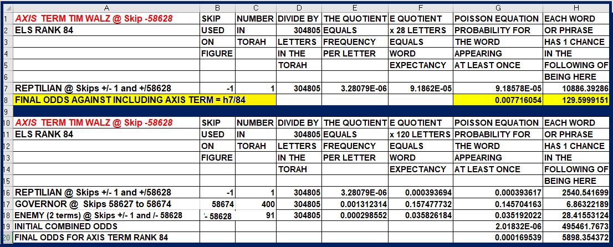

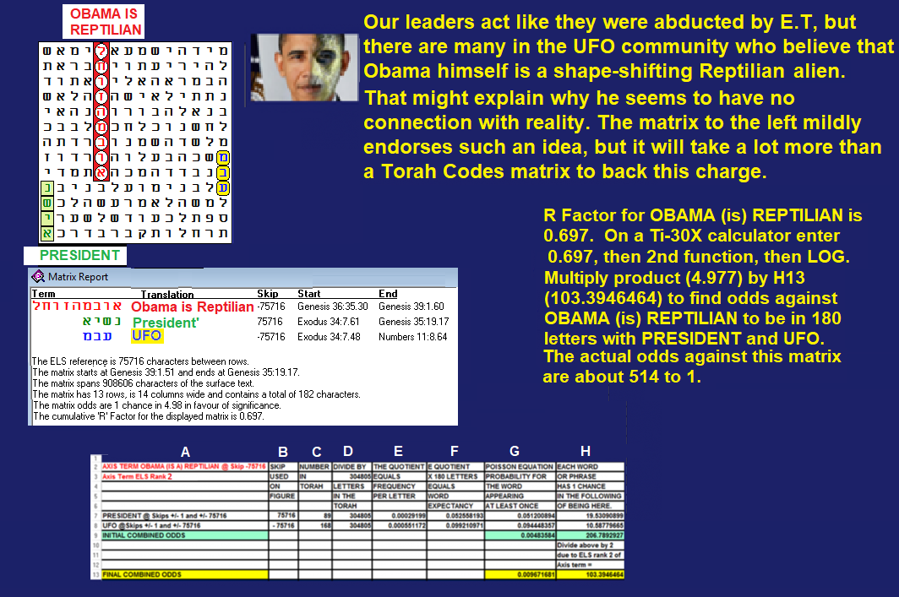

**FIGURE 13-5 above**: The axis term at skip -75,716 is **OBAMA IS REPTILIAN**. Without counting the axis term, odds against this matrix with **PRESIDENT** and **UFO** at the same skip as **OBAMA IS REPTILIAN** were about 103 to 1. The axis term has an R-factor **o**f 0.697. This equates to one chance in 4.97737085 that the term would be found at least once in Torah, although this term ranks only second in ELS rank because it is found the first time at a lower skip, namely +67,569. So, if we do use the R factor for this 9-letter term, then 103.39 X 4.97737085 = 532.016. So, the matrix actually had only about one chance in 532 to be found.

If Obama is reptilian and Tim Walz is reptilian, it seems like what we are being warned about is that the leadership of the Democratic Party is firmly in alien hands. This message is again encoded with a warning that **BIDEN IS ALIEN** in Figure 13-6, which was found against odds of over 48 billion to 1.

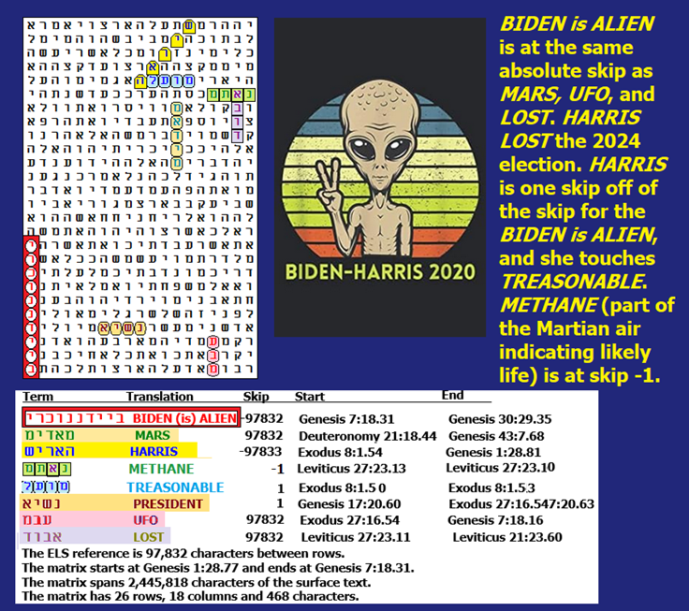

**FIGURE 13-6 above**: Here, the axis term is **BIDEN (is) ALIEN. MARS** is at the same absolute skip. **HARRIS** is at skip-97,833, while **BIDEN IS ALIEN** is at skip-97,832. The difference of 1 produces the diagonal display of **HARRIS** with all her letters touching each other, and the word **TREASONABLE** at skip +1 touching the first letter of her name. She is certainly treasonable, and she was not selected through the normal primary process. Instead, she was picked by the aliens. Also, at the absolute skip of **BIDEN IS ALIEN**, we find **UFO**: There are allegedly several species that have made it to Mars. The life there gives off methane (CH4). At skip +1 is **METHANE**. **PRESIDENT** is at skip +1. Finally, **LOST i**s at the skip of **BIDEN IS ALIEN**. I looked for this word because in 2024, Biden got his confused backside thrown off the ticket, and **HARRIS** lost the election.

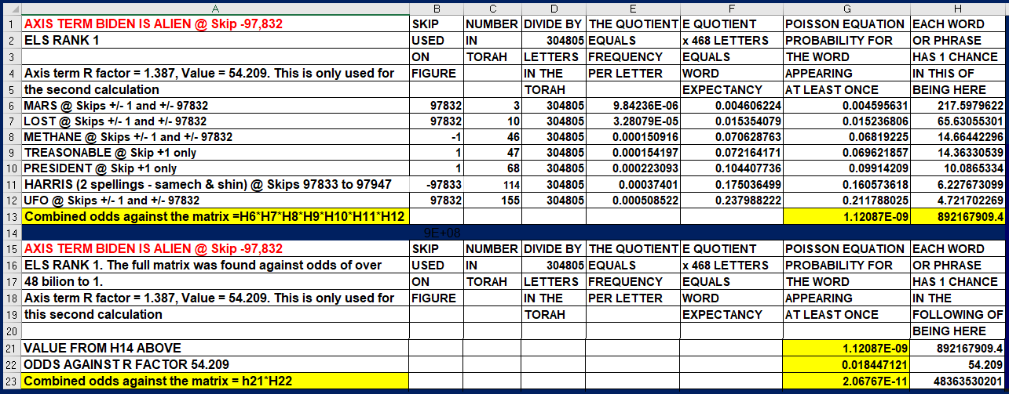

The strong link of alien origin (or brainwashing) between Obama, Biden, Harris, and Walz, plus other Democratic leaders identified in Chapter 3 of this book, raises the question of just how far alien colonization of our planet has gone, as well as how do we fight what is happening to us? I suspect we have millions of ETs who are here leading more mundane lives, but are voting to help their kind take over our nation and planet. I have written a lot about one of them in two chapters of this book – Craig Ebrahimi – and shown that there is evidence pointing to him spreading COVID-19 around this planet. I also briefly described a woman (Rebecca) in Lakeland, Florida, who all but outright claimed to be from a solar system around the star Meia in the Pleiades. Her personality was much like that of a religious (terrestrial) Christian woman. Still, our 11-year friendship ended when she and her husband answered some questions and told some stories that made her (really – them) appear to be more reptilian than Pleiadian. If the three people that I speak about here are aliens (really, reptilians) in disguise, then our situation may be akin to what is true if you find one cockroach crawl out from under your refrigerator. The chances are that you have an infestation.

Before we can address such threats, we must know for sure that they exist. One of the many purposes of the Torah Code seems to be to warn us about the threat’s reality, and even to tell us who to watch out for. The cover of this book is meant to imply that if asked to, I will lead any required legal battle to free our government of corruption, but such a battle would be as hard as trying to modify the Constitution in a way to reflect the battle at hand. I would prefer to take my role after President Trump agrees to (1) permit disclosure and (2) establish a new Department of UFO Disclosure Management with me heading it and serving on the President’s Cabinet. Trump supposedly wanted to do a UFO disclosure during his first term, but was silenced. Just how much fight does he have in him? I hope it’s enough, but he still faces threats against himself and his family. I have had my life threatened twice because of what I know. It is unconstitutional to oppose freedom of the press.

There may be an entire branch of our military that knows the truth about aliens. I speak about, of course, the United States Space Force, founded by a man who is trying hard to fulfill the role of Messiah as understood by Judaism: the peacemaker Donald Trump. While I want to serve in Trump’s Cabinet, I am also willing to accept a commission in our Space Force, but I am 78 years old. I know ET well enough to know how to plan to defeat him. Father Time may be a tougher opponent, but I suspect that those who serve in positions that require interaction with friendlier types of visitors will have medical procedures that can help a lot of us live longer.

May we all live long and prosper!