# **Chapter 12**

**Trump!**

This chapter presents a few of the many matrices found during President Trump's first and early second terms. A more complete list of President Trump matrices is at <https://roffmanmarsresearch.com/?page_id=2596>.

[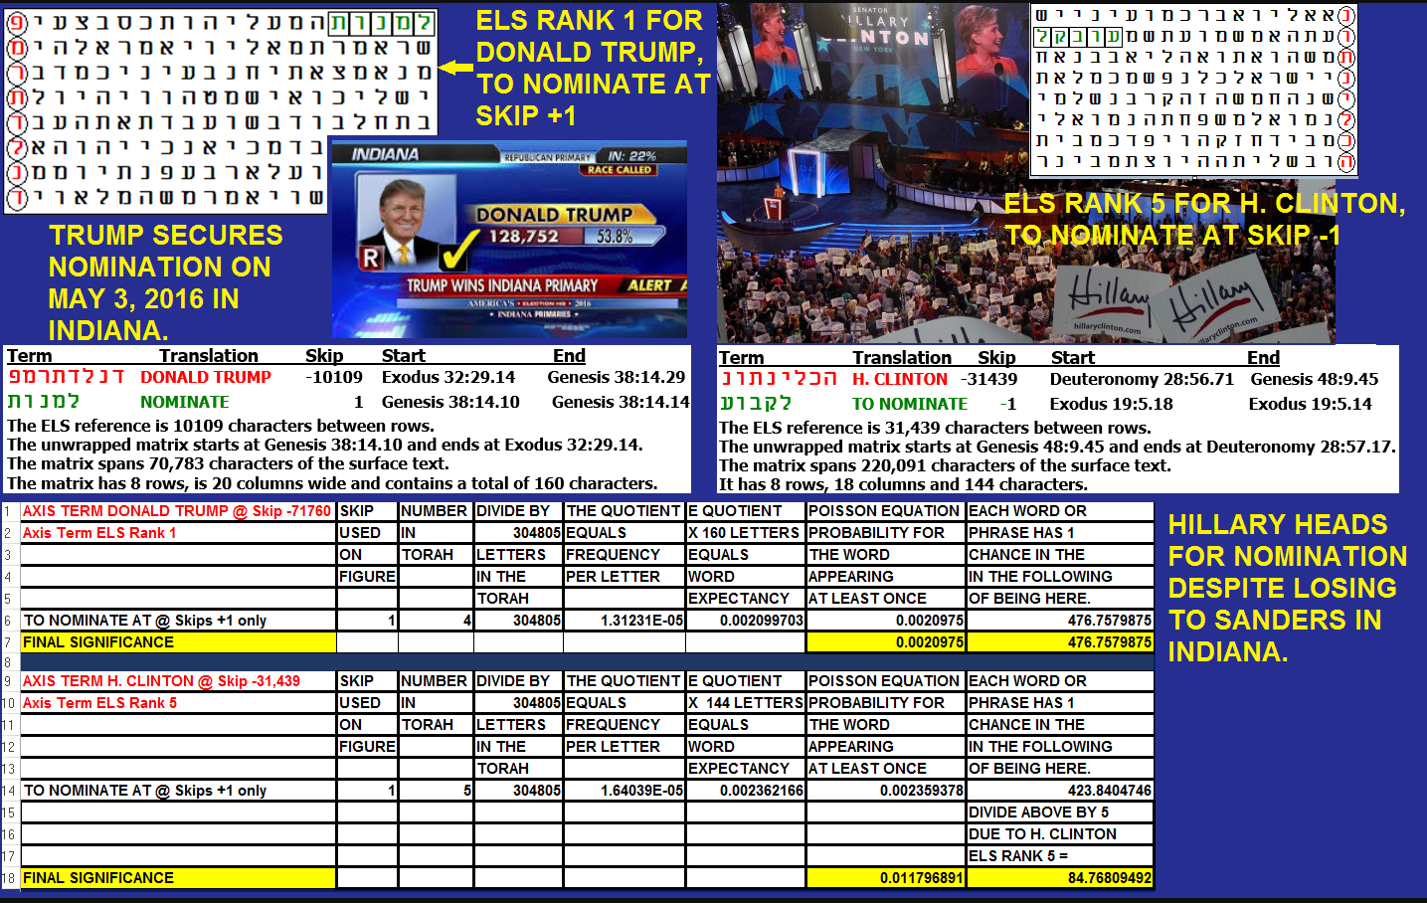](https://roffmanmarsresearch.com/wp-content/uploads/2016-nominees.png)

**Figure 12-1.** **Trump and Clinton nominations in 2016.** I found the above matrices in late 2015 or early 2016 when the two nominees were about to start their election campaigns. This experiment was simpler than those I typically run now. All I wanted to know was if the candidates were each found at an ELS and whether they could be paired with the word **NOMINATE**. If so, I also wanted to know who had the smaller, more significant matrix. The verb with **TRUMP** was found four times in Torah at skip +1. For **CLINTON**, I found **H. CLINTON**. The **H** initial for the first name was important because we already had a President Bill Clinton, and I needed a way to distinguish her from him. Both **DONALD TRUMP** and **H. CLINTON** have 8 letters in Hebrew. The **H. CLINTON** matrix (144 letters) was slightly smaller than the **DONALD TRUMP** matrix (160 letters in area), but it was not based on the lowest skip of **CLINTON**. Instead, it was a match that was only found at **ELS rank 5** of **H. CLINTON**. That means that, by my standard protocol, I had to divide by 5 the odds of the **H. CLINTON** match with the verb found for **TO NOMINATE** (spelled *lamed kuf bet vav ayin*).

I found **DONALD TRUMP** and **H. CLINTON**. The **CodeFinder** dictionary offers two 5-letter words for **TO NOMINATE**. One of them, spelled *lamed mem nun vav tav*, is at skip +1 (the best-case scenario) and matches with **DONALD TRUMP** at **ELS rank 1** (also, best case scenario) in a 160-letter matrix. For a term at skip +1, I only search for word frequency at skip +1. As noted above, the verb with **TRUMP** was found four times at that skip. But for special case terms at skips -1 or at the absolute skip of the axis term, I use the letter frequency at skips +/- 1 plus +/- the skip of the axis term. So, for **DONALD TRUMP** this works out to be that the match was found against odds of about 476 to 1, while for **H. CLINTON**, she was found with the verb against odds of about 423.81 divided by 5, which is about 84 to 1. This means that the **Trump** matrix was about 423.81/84.78 or 4.9989 (really, 5) times more significant than the **Clinton** matrix.

**FIGURE 12-2 below.** The effort to impeach Trump, in large part by an ignoramus known as Maxine Waters, begins. The axis term is **TRUMP IMPEACHED**. **CLINTON** is at skip -1.

**Figure 12-2 above:** No sooner than Trump was sworn in for his first term, Congresswoman/gender-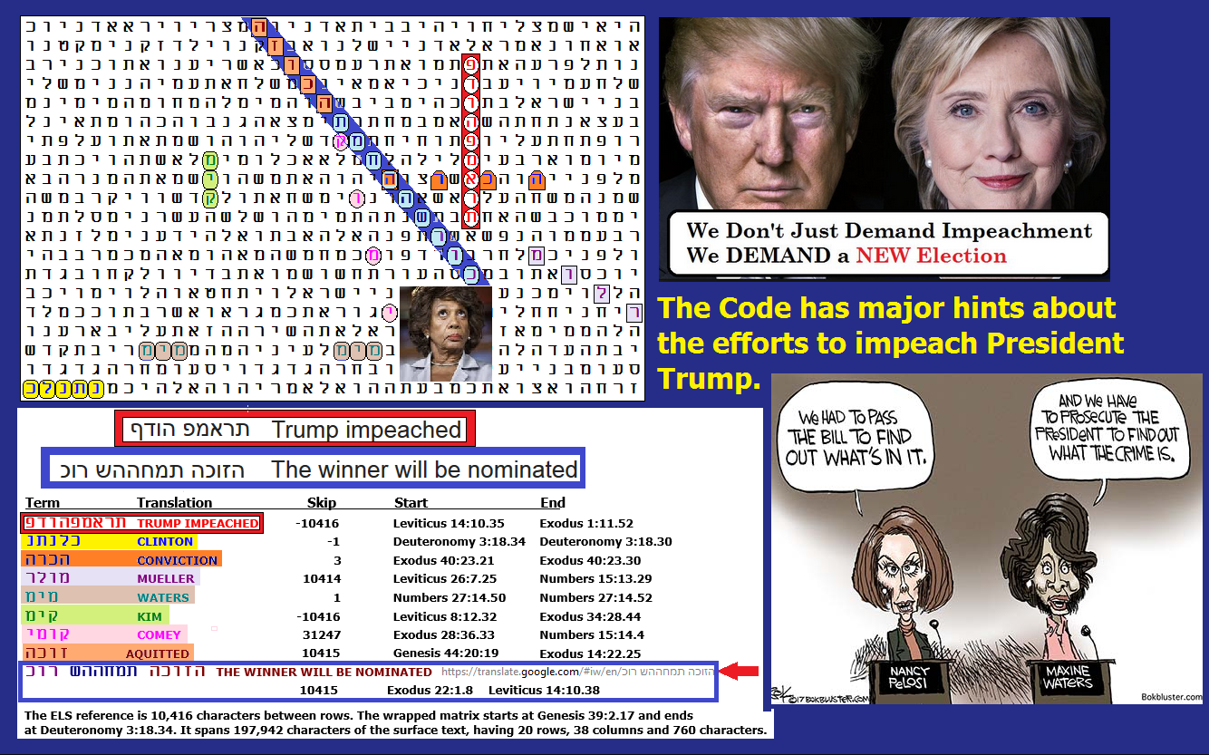confused Maxine Waters called for his impeachment. More, she did it again when he won his second term. So how did the Code's Author know about this 3,300 years ago?

[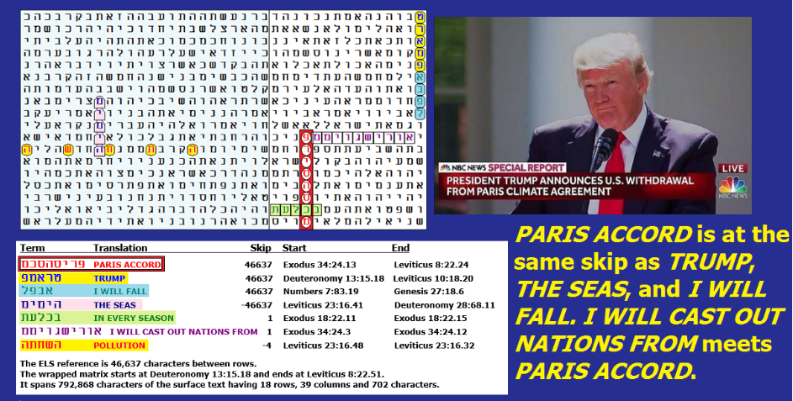](https://roffmanmarsresearch.com/wp-content/uploads/OARIS-ACCORD.png)

**Figure 12-3.** This page was posted on my site on 6/8/2017 and updated on 6/9/2017. My original focus was on the axis term: **PARIS ACCORD**. I saw **Trump** on the matrix at the same skip as **Paris Accord**, and I noted that following his name and in sequence with it was **I WILL FALL**. Sadly, that turned out to be true in the 2020 election. Thank God, he came back in the 2024 election.

For 28 years now I’ve worked on cracking the **Torah Code**. By now I pretty much know what to look for - *a priori* terms at special case skips +/- 1 or the absolute skip of the axis terms. On the matrix below there are three terms at the absolute skip of the axis term, which is **PARIS ACCORD**. Two of them – **TRUMP** and **THE SEAS** – are *a priori.* The third term was found *a posteriori,* which means it is not the kind of term that I normally include in a calculation for statistical significance. However, sometimes *a posteriori* finds offer an unexpected view of a possible future. I hoped that was not the case here, but as we saw in the 2020 election, it turned out to be true (even though new evidence shows that China sent false ballots to steal the election). The term, in sequence with **TRUMP**, is **I WILL FALL**. This was found on June 8, 2017, at about the time that former FBI Director James Comey was testifying in Congress in large part against the President. The matrix also includes **I WILL CAST OUT NATIONS FROM** touching **PARIS ACCORD**, and an **ELS** of **POLLUTION** touching **THE SEAS**.

As the spreadsheet below shows for **Figure 12-4**, the matrix was found against odds of 2,485,167 to 1, BUT... That number does not include the prediction that came true - **I WILL FALL**!

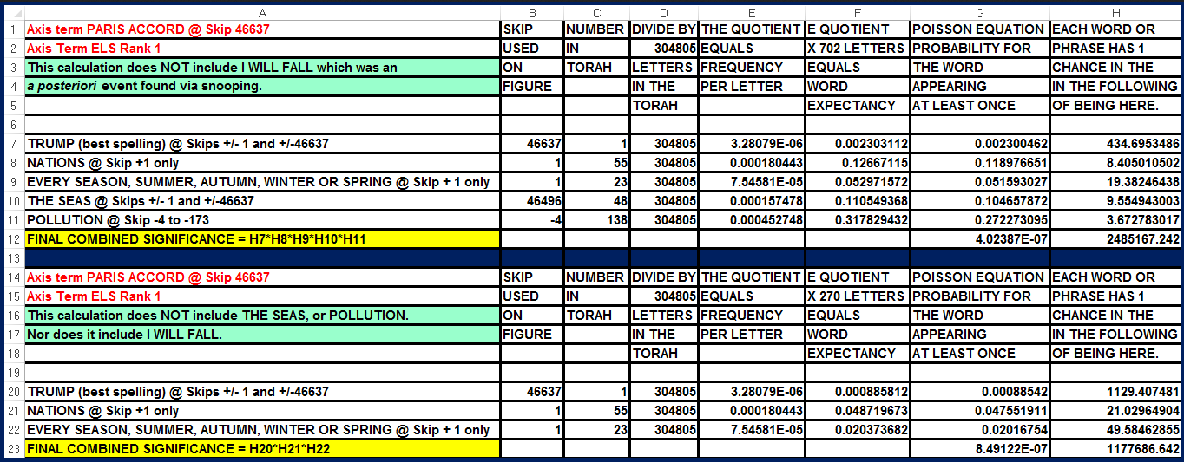

**Above:** Spreadsheet for **Figure 12-3.**

**Figure 12-4.** **Trump and the Media:** One reason for Trump to temporarily fall in the 2020 election was that the Media was his enemy. On **Figure 12-4**, the axis term is **DONALD TRUMP** at skip -10109. At skip +10109, we find **MEDIA** and **ENEMY**.

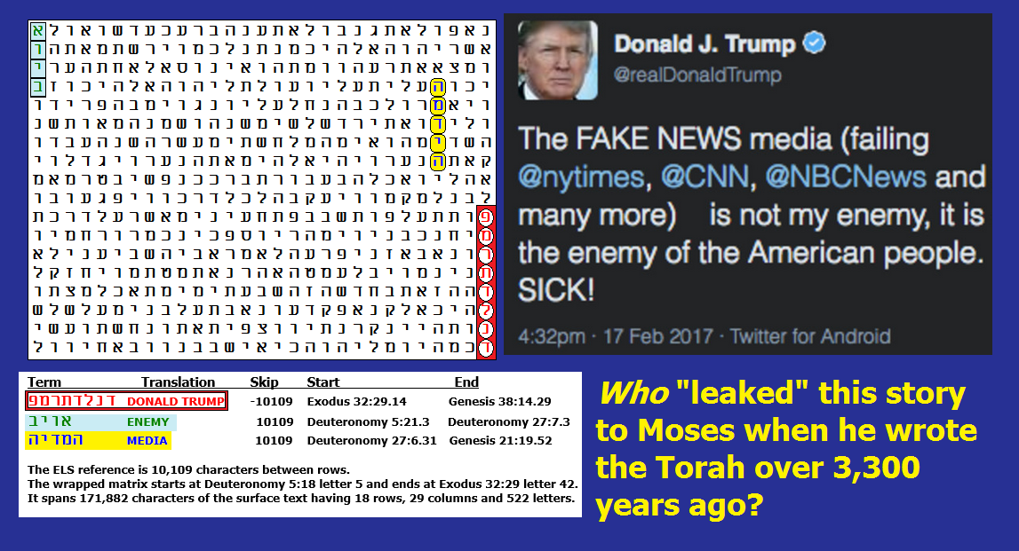

Odds against Figure 12-4 being found were about 5,786 to 1.

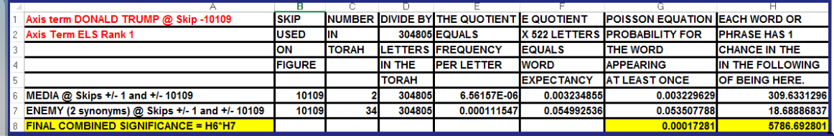

**Figure 12-5 below.** Shown earlier as Figure 11-1, the Code names Obama as an antisemite. When Trump was reelected, a major issue was how to reverse damage done to Jewish people in the Obama-Biden years.

. 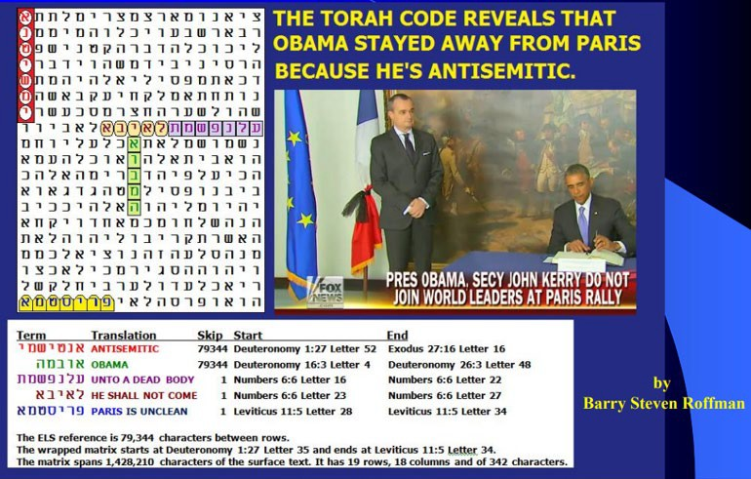

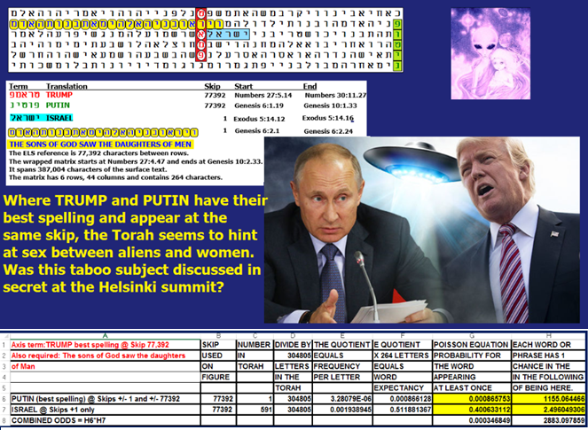

**Figure 12-6 above** shows the relationship between **TRUMP**, **PUTIN**, and what sounds like people who were not human but were interbreeding with the **DAUGHTERS OF MAN** (Genesis 6:2). The matrix was found against odds of about 2,883 to 1.

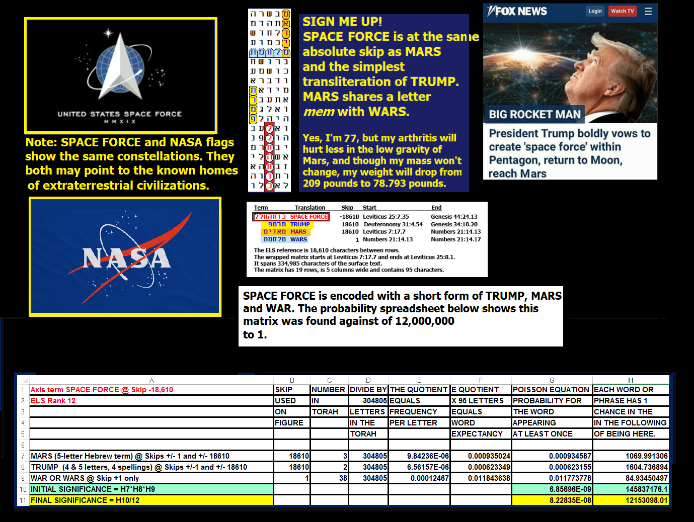

**Figure 12-7 above:** The flags of NASA and U.S. Space Force share maps of the Pleiades and Alpha Draconis. But NASA’s flag shows Orion, where Space Force only shows an exploded star in Orion (Betelgeuse). On the matrix, the axis term is **SPACE FORCE**. At the same absolute skip are **MARS** and a short transliteration of **TRUMP**. Sharing a letter ***mem*** with **MARS** is **WAR** in the open text. Both NASA and Space Force flags have the constellations Alpha Draconis (303 light years from Earth) and Pleiades (444.2 light years from Earth) on them, but NASA’s flag also shows Orion while it is missing and replaced by a single bright star on the Space Force flag. Wikipedia points to Alpha Draconis as the possible home of Reptilian aliens. **Betelgeuse** may go supernova. The Space Force flag may indicate knowledge of what might happen.

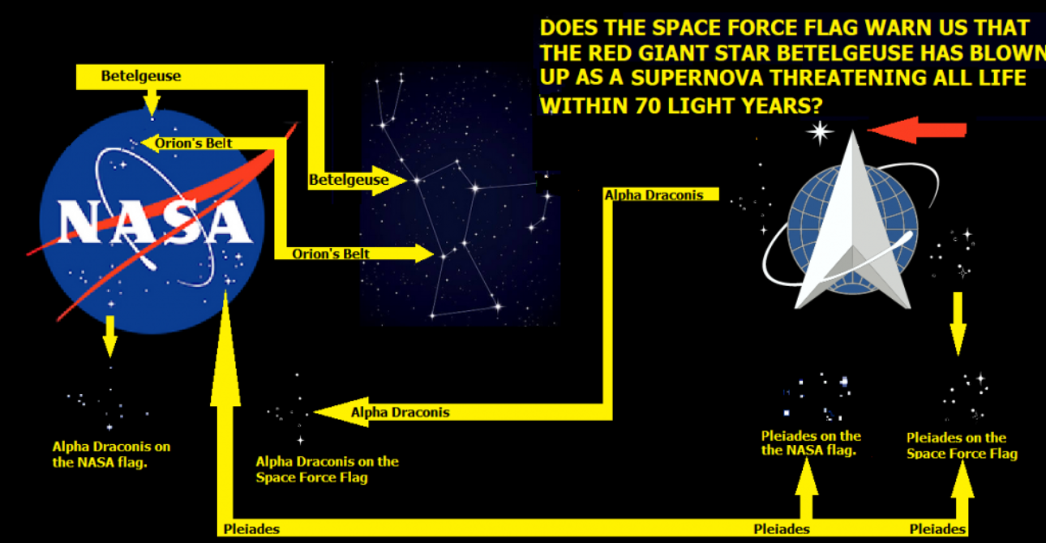

**Figure 12-8 above:** The flags of NASA and U.S. Space Force share maps of the Pleiades and Alpha Draconis. But NASA’s flag shows Orion, where Space Force only shows an exploded star there.

Alpha Draconis is 303 light years from Earth, and the Pleiades are 444.2 light years from Earth. Wikipedia points to Alpha Draconis as the possible home of Reptilian aliens. This book also has speculation that Reptilian shapeshifting politicians (or leaders who were brainwashed and brain-damaged by them) control Earth. This includes Obama and befuddledBiden. Oddly enough, the phrase **OBAMA IS REPTILIAN** is encoded in the Torah with **PRESIDENT** and **UFO** at the same absolute skip of 75,716. Wikipedia also points to the Pleiades as the home for the Nordics. A woman (Rebecca) that I have known for 11 years claimed that she was an ET from the Pleiades, and she said that people from there are humans. I suppose she meant that at some point in our earlier existence, some people developed the ability to travel in space, and now they are finding their way back to Earth. However, after 11 years, we had a fight when the lady sounded more like a reptilian. Her stories were not consistent.

[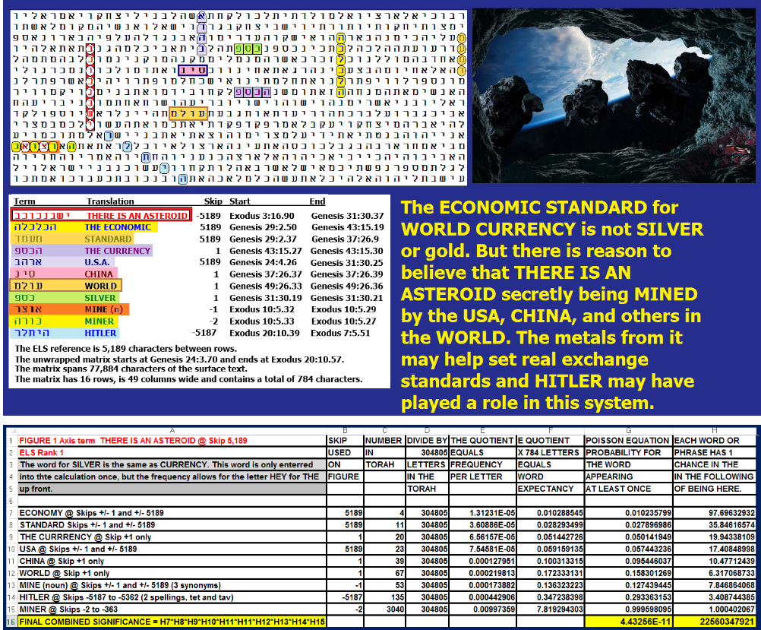](https://roffmanmarsresearch.com/wp-content/uploads/ASTEROID-ECONOMICS.png)

**Figure 12-9 above:** Asteroid-based economics – one reason President Trump established the Space Force. We may be mining asteroids now, but if the secret gets out, that would greatly reduce the value of what we extract.

Table 12-1 below has some estimates of asteroid mining values.

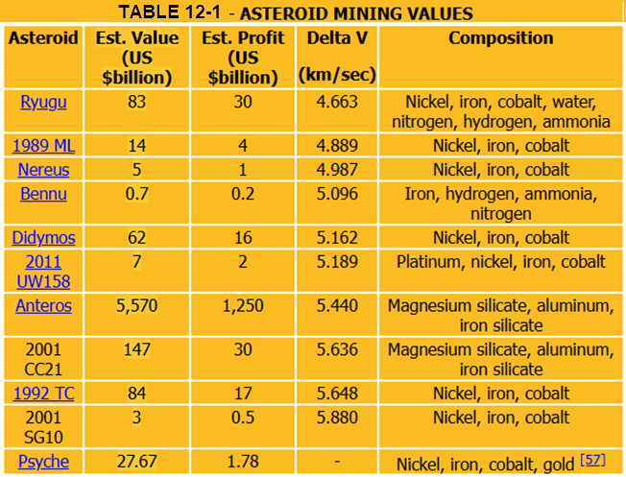

**Dr. Michael E. Salla** asserts that not just the United States, but China, Russia, and the U.N. have secret space programs, and a major objective of these programs is to extract trillions of dollars of rare metals from asteroids. See page 191 of his book The U.S. Navy’s Secret Space Program & Nordic Extraterrestrial Alliance. On **Figure 12-9**, I looked to see if any of this is encoded in Torah. It appears that it is. The axis term is **THERE IS AN ASTEROID**. At the same absolute skip are **THE ECONOMIC** or **THE ECONOMY**, **STANDARD**, and **USA**. Under **USA** are **CHINA** and **WORLD**. The noun **MINE** at skip -1 is overlapped by **MINER** at skip -2. **SILVER/MONEY** is three rows directly above **THE CURRENCY**. Odds against this matrix appearing by chance are about 22,560,347,921 to 1.

**Figure 12-10:** **ATTEMPTED ASSASSINATION:** On **Figure 12-10 below,** the axis term is **TRUMP ASSASSINATION** at skip +22,605. At the same absolute skip are **UFO**, **FALSE**, and **SPEAKER**. **OBAMA** is one skip off that of the axis term, and **CLINTON** is at skip -1. You say that the assassination attempts failed? The word **ATTEMPTER** is at skip +1. In 2021, there was another failed assassination attempt where the attempted assassin used a drone to shoot into Trump’s bedroom window. This was discussed in a congressional interview of FBI Director Chris Wray at <https://www.youtube.com/watch?v=Z46qSlU6K1A>. On the matrix, **DRONE** is at skip -22606 and **WINDOW** is at skip -22604. **WAR** is in the open text. The attempted killing, then, is part of an ongoing war against Trump and America. Who is trying to kill him? Besides **CLINTON** and **OBAMA**, the closest term at a special case skip is **UFO** at the same skip as **TRUMP ASSASSINATION**.

[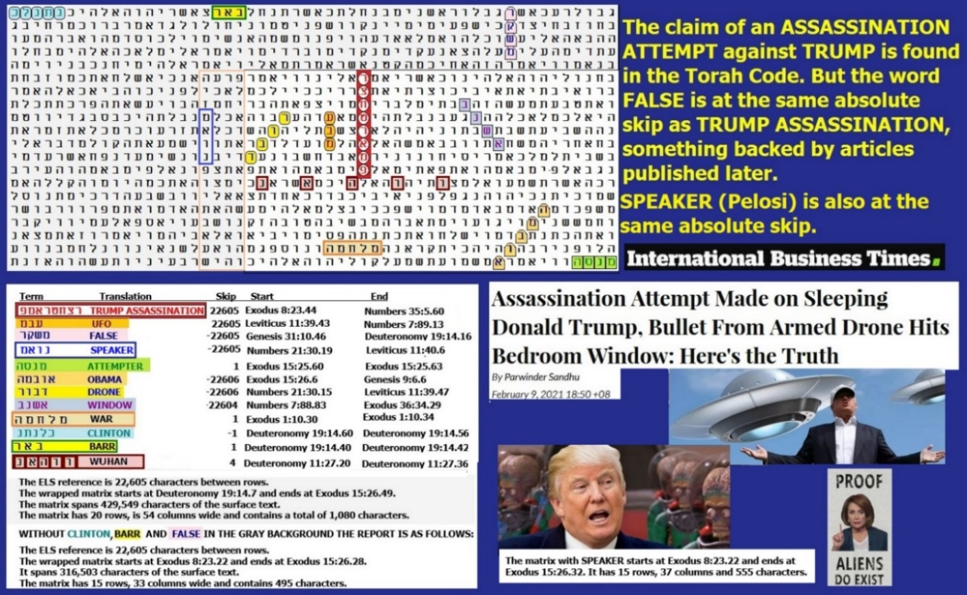](https://roffmanmarsresearch.com/wp-content/uploads/TRUMP-ASSASSINATION.png)

**Figure 12-10 above.** Odds against this matrix are 1,276,900,322 to 1; however, it is not yet proven that all the terms shown are going to be proven to be correct choices. It is of interest that the most significant *a priori* term was **ATTEMPTER**. All three assassination attempts were unsuccessful. There was only a 0.486 percent probability of finding this word. But for **WINDOW** (Trump’s at Mar-a-Lago), there was a 92.15% chance that it would be on at a non-special case skip on the matrix. In a situation like this, it is best to look at individual probabilities rather than the combined joint probability of the matrix. As for suspects named in the attempt, here only two names came up. **CLINTON** (Hillary) was there at a special case skip against odds of about 11.3 to 1, and **OBAMA** was present against odds of about 5.56 to 1.

**Above: Spreadsheet for Figure 12-10.** Odds against this matrix were about 127,694,032 to 1. The most significant key word was **ATTEMPTER**. It was found against odds of about 295 to 1 and it was likely used to indicate that the assassination ATTEMPT would fail.

**FIGURE 12-11 below: PELOSI RIPS UP TRUMP SPEECH:**

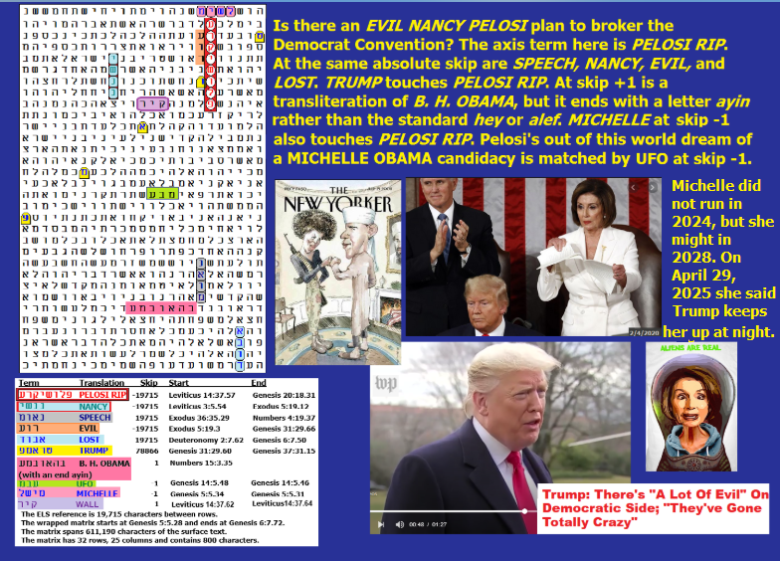

Perhaps the evilest manifestation of Pelosi’s behavior was the Figure 12-11 image of her ripping up her official copy of President Trump’s brilliant State of the Union speech while she was standing behind him on the night before her push to impeach him failed. The Codes capture this moment in almost photographic fashion. On the matrix below, the axis term is **PELOSI RIP**. At the absolute skip of the axis term are (1) a transliteration of **NANCY**, (2) every letter of **EVIL** touching **PELOSI RIP**, (3) **SPEECH**, and (4) the outcome of the next day's vote on her impeachment effort: She **LOST**. One letter of the best spelling for **TRUMP** touches **PELOSI RIP**. **THE WALL** is in the open text. Trump mentioned his border wall in his speech. This matrix may reveal the plan of the Establishment was to have a brokered convention that picked **Michelle Obama** as the candidate if nobody won the nomination on the first vote, but **MICHELLE** didn’t want it even though at skip -1 she touches **PELOSI RIP**. While I usually forget to look for it, there is a transliteration of **OBAMA** that ends in a letter ***ayin*** rather than ***hey*** or ***alef***. Using it, at skip +1, see **B. H. OBAMA**. This matrix was found against combined odds of over 441 billion to 1. **B. H. OBAMA** was found at skip +1 against odds of about 381 to 1, and the best spelling of **TRUMP** was found against odds of about 191 to 1.

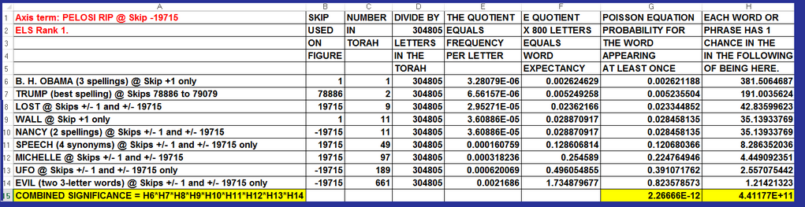

In May of 2025, we were shocked to learn that former Director of the FBI James Comey published a request for someone to assassinate President Trump. But it was no surprise to the Author of the Torah Code. Comey published a picture of seashells arranged to say 8647. The number 86 is a slang way to say eliminate or kill. The number 47 refers to President Trump, who is now the 47th President of the United States. See **Figure 12-12.**

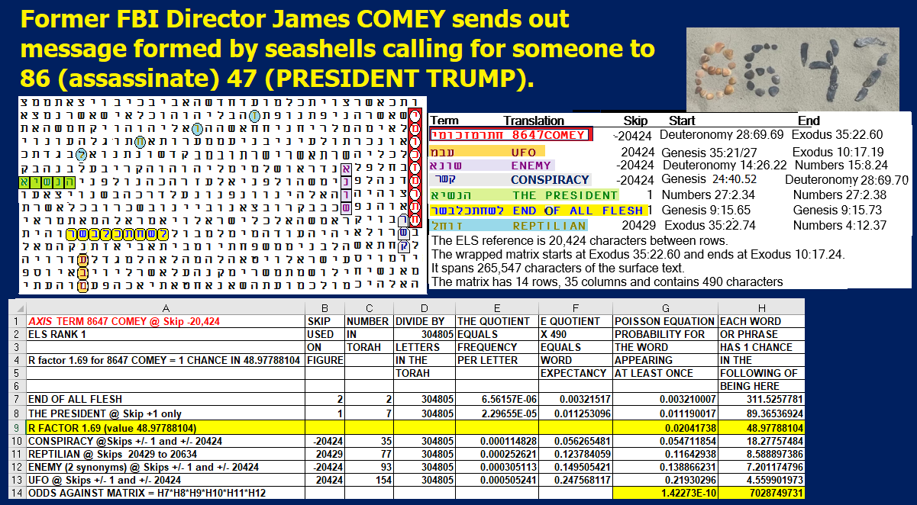

**FIGURE 12-12:** Against odds of over 7 billion to 1, **8647 COMEY** is near **THE PRESIDENT**, at the same absolute skip of **CONSPIRACY**, **UFO**, and **ENEMY**. **REPTILIAN** is here too.

**FIGURE 12-13.** **TRUMP FORDO AXIS TERM**

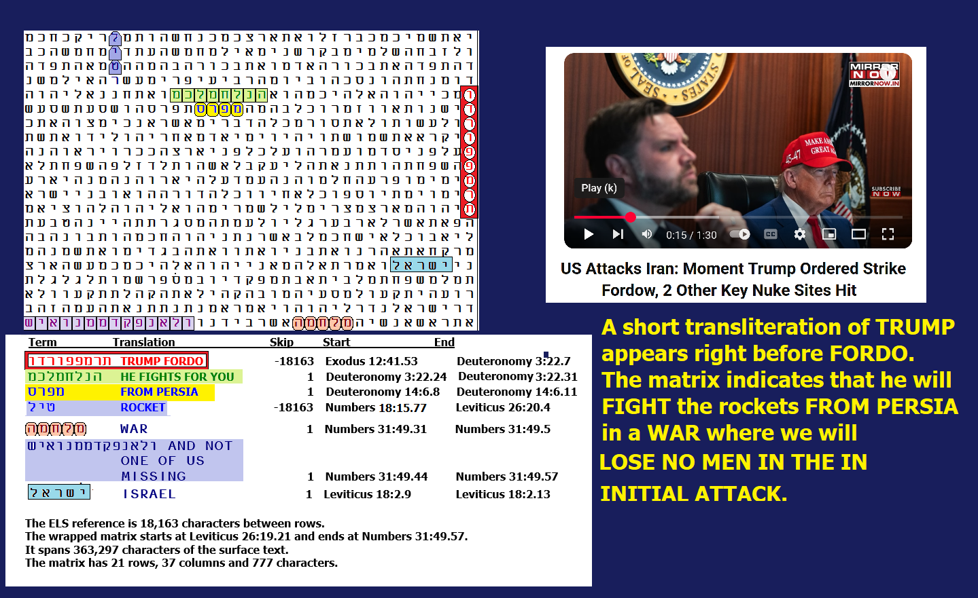

**Figure 12-13 above.** I will not offer a probability for this matrix because in the 9-letter axis term **TRUMP FORDO**, the transliteration of Trump is only 4 letters, which is shorter by a letter than the 5 letters that I usually use, but it is enough to recognize the name. At the same skip is **ROCKET**. America is helping **ISRAEL** shoot down rockets **FROM PERSIA** (Iran). In the opening attack of this **WAR**, the U.S. **DID NOT LOSE A MAN**. In fact, Iran never even saw our planes at all. But the Author of the Torah saw it all, and recorded it 3,300 years ago.