Chapter 9
Fighting Radical Islam and E.T.
This chapter will focus on the top leaders of radical Islam, Iran, Gaza, and Lebanon, whom Israel and/or the U.S. have found necessary to kill. On 10/22/2015, I published Figure 9-1 below. It was an outstanding matrix then, and it remains so as I update my studies of General Soleimani in 2025. On June 12, 2025, Israel went to war with Iran. That too is encoded as I will show at the end of this chapter, but I didn’t find any dates for it until June 13, 2025 because I did not know what to use as an axis term. What worked turned out to be the name of the operation – LION RISING. While I didn’t know the name of the axis term after the war started, the Israelis obviously did know it before they attacked (but, of course, they kept it a secret). My point here is that if Mossad chose to use the Code, they could have derived some useful intelligence from it but (unless they are using an IP address not yet deciphered by me) I do not yet detect heavy Israeli traffic at the website. As of June 15, 2025, in comparing known U.S. with Iranian and Israeli hits for 14 days on my roffmanmarsresearch.com site, I only see 5,823 U.S. hits, 14 Israeli hits, and 61 Iranian hits.

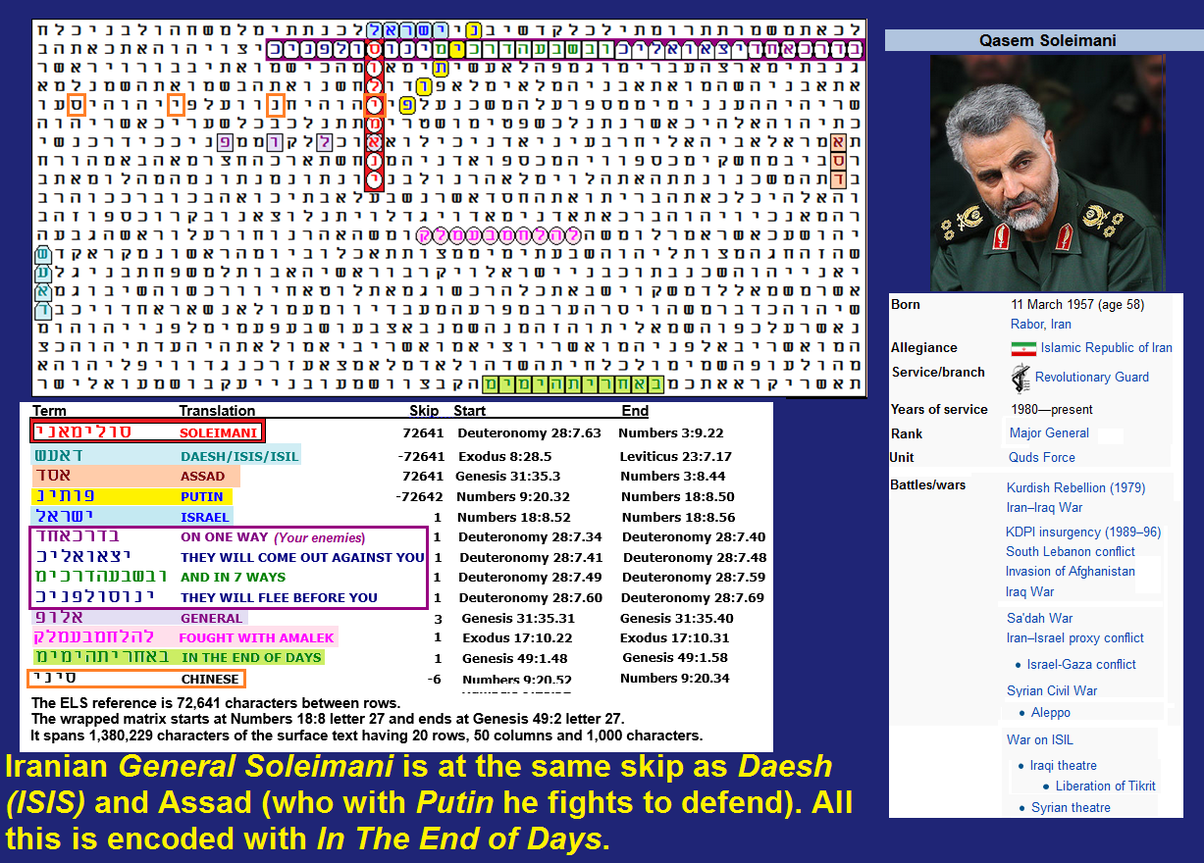
Figure 9-1 above. Its probability spreadsheet is below.
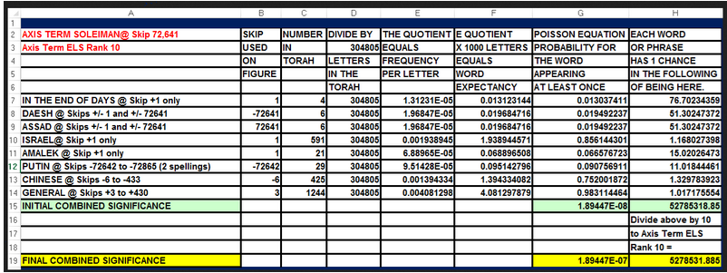
Figure 9-1 was found against odds of about 5,278,531 to 1.
On January 3, 2020, the Jerusalem Post wrote that Qasem Soleimani was reported killed at the Baghdad Airport. Iraqi state media reported that Soleimani and the deputy head of the Popular Mobilization Forces (PMF), Abu Mahdi al-Muhandis, were both killed in the attack. The PMF said, "The American and Israeli enemy is responsible for killing the mujahideen Abu Mahdi al-Muhandis and Qassem Soleimani," said Assadi. ISRAEL touches the axis term SOLEIMANI on Figure 9-1, and the dead Iranian general is encoded with NETANYAHU on Figures 9-2 and 9-3. The Israeli participation in the hit is found in the Jerusalem Post on January 12, 2020.
Iranian Army Major General Qasem SOLEIMANI was a commander of Iran’s Quds Force—a division primarily responsible for extraterritorial military and clandestine operations. The U.S. listed him as a known terrorist. In 2007, Soleimani was included on a list of Iranian individuals targeted with sanctions in United Nations Security Council Resolution 1747. The Quds Force has long provided military assistance to Hezbollah in Lebanon and Hamas in Gaza. After the U. S. invasion of Iraq, Soleimani gained increasing political and military influence in the country through al-Maliki's government and the Shia militia, which are equipped and directed by the Quds Force. Beginning in 2012, Soleimani helped bolster Syrian “president”/mass murderer Assad during the Syrian Civil War. Soleimani also assisted in the command of combined Iraqi government and Shia militia forces that advanced against the Islamic State (ISIL/ISIS/Daesh) in 2014–2015. Before his death, he was fighting alongside Russia and Assad against Assad’s opponent and Daesh in Syria. On Figure 9-1, the axis term is SOLEIMANI. DAESH (ISIS/ISIL) and ASSAD are at the same level as their names. Russian President PUTIN is close to SOLEIMANI. PUTIN shares a letter with Deuteronomy 28:7, which states of Israel’s enemies:
“On one way they will come out against you and in seven ways they will flee before you.”
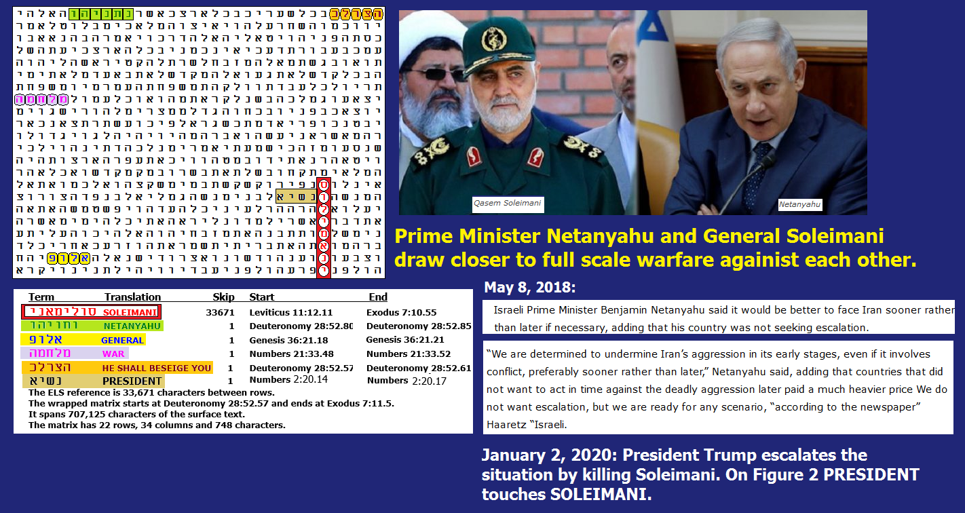
Figure 9-2 above: Soleimani and Netanyahu.
SIGNIFICANCE OF FIGURE 9-2. The most significant a priori term is NETANYAHU at Skip +1. Before adjusting the axis term ELS rank, NETANYAHU was found at skip +1 against odds of about 26 to 1. WAR was found in the open text against odds of about 11.8 to 1. Soleimani's rank of GENERAL is on the matrix in the open text against odds of about 10 to 1. PRESIDENT was located in the open text against odds of about 6.5 to 1, but these odds just refer to the word at skip +1 being anywhere on the 748-letter matrix. In actuality, it touches SOLEIMANI. No value was assigned to HE SHALL BESIEGE YOU because it was only found a posteriori. After dividing combined odds by 8 to account for the ELS rank of the axis term, the matrix was found against odds of about 2,494 to 1.
Iranians first sent hundreds of missiles flying toward Israel in 2024 and 2025. This is why many people think we are now in the End of Days, which is on Figure 9-1. ISRAEL is on the matrix. Netanyahu sees Iran as Israel’s ancient enemy – Amalek. Fought with Amalek is also on Figure 9-1. Finally, Soleimani’s rank, GENERAL, intersects his name, as do the CHINESE However, the word for CHINESE who are helping him and Putin had about a 75% chance of being on a matrix this large. Just before Soleimani received justice for killing over 600 Americans, both the Russians and the Chinese were conducting war games in the area.

FIGURE 9-3 links SOLEIMANI to BENJAMIN NETANYAHU, ISRAEL, PERSIA, LEBANON and IRAQ.

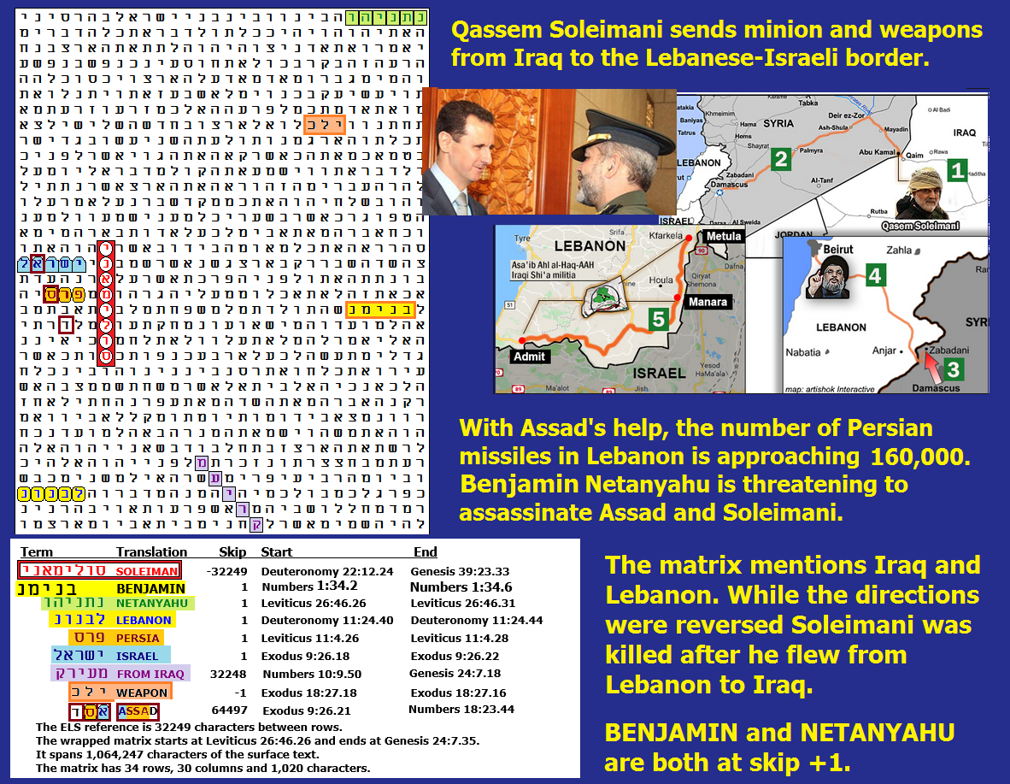

SIGNIFICANCE OF FIGURE 9-3. The most significant a priori term is LEBANON in the open text. Before adjusting for axis term ELS rank, LEBANON was found at skip +1 against odds of about 149.9 to 1. I originally looked for LEBANON because the map picture that I selected for the Figure had it on it. But on the night that Soleimani was killed, he flew from Lebanon to Baghdad, IRAQ. IRAQ was located at an ELS one off the skip of the axis term. NETANYAHU is at skip +1 against odds of about 19 to 1. In a big surprise, Netanyahu's first name BENJAMIN (at skip +1) has all five letters of the name in the same columns as 5 of the six letters of NETANYAHU at the top of the matrix. PERSIA was found at skip +1, but I used the combined frequency of PERSIA and IRAN because I would have settled for either name. As such, it was found at skip +1 against odds of about 12.4 to 1. ASSAD was not at a special case skip, but it was on the matrix against odds of about 3.5 to 1. No extra value was added for the fact that ASSAD shares a letter alef with ISRAEL and a letter samech with PERSIA. The other terms on the matrix were not statistically significant. Overall, Figure 9-3 was found against odds of about 1,320,763 to 1.
Spreadsheet for Figure 9-3.
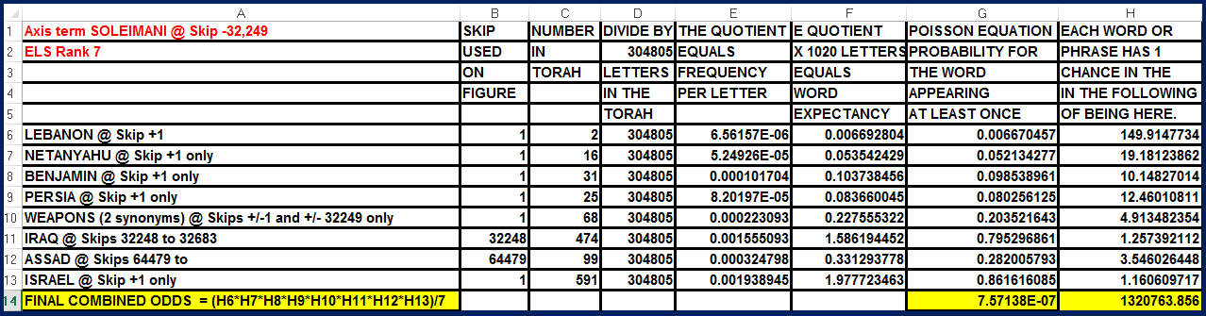

The Middle East is far more complex than most people think because some of the bad guys are not human. As has been true (largely with respect to leaders of the Democrat Party), some are alien invaders. They are named in Chapters 3 and 4 of this book. This is such a startling claim that before I proceed, I feel required to present more evidence than the matrices seen in Chapter 3, raising questions of species and loyalty for PRESIDENT JOE BIDEN, PRESIDENT BARACK OBAMA, Senator CHUCK SCHUMER, and Vice President HARRIS, GENERAL MILLEY, FORMER FBI DIRECTOR CHRIS WRAY, U.S. ATTORNEY GENERAL MERRICK GARLAND, ALVIN BRAGG, GOVERNOR TIM WALZ, former Secret Service Director KIM CHEATLE, Senator ADAM SCHIFF and JOHN DURHAM.
Let’s first discuss Israeli Retired Brigadier General Haim Eshed, and then how his knowledge fits in Craig Ebrahimi’s claim (backed by a reasonable amount of physical evidence) that Craig is an extraterrestrial. We will also look at alien attempts to limit or reduce the human population on Earth. Here, I refer to the alliance between the Democrat Party and all homosexual and transsexual causes that aim to reduce the size of the human population on Earth by mating people who can’t make babies. They further attack the human population by encouraging religious wars. Judaism, Christianity, and Islam each teach very different concepts about God. Why? The Muslim Koran has the following explanation:
…To each among you has been prescribed a Law and an Open Way. If God had so willed, He would have made you a single People, but (His plan is) to test you in what He has given you: so strive as in a race to all virtues. The goal of all is to God. It is He that will show you the truth of the matters in which you dispute.
(Koran, Ali translation, Table 5:51)
Having set the stage for explaining our true situation, let’s study the Haim Eshed part of the equation by looking at his book (Figure 9-4) and the matrix found about him (Figure 9-5).
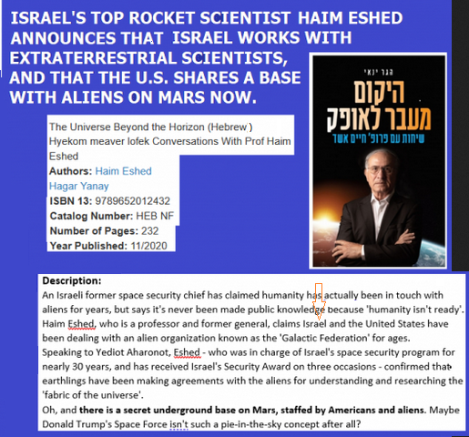
Figure 9-4 above: General Haim Eshed’s book and main claims.

Israel’s top scientist, Eshed, reveals that people are on Mars. 12/12/23
Whenever I choose to write another article about Mars or UFOs, a major concern is with respect to whom I am quoting. For UFOs/UVMs, I love to write about the works of Dr. Michael Salla, but the one thing that bothers me about his work is that he often quotes people who use pseudonyms. In November 2020, an author appeared (not yet interviewed by Salla – Israeli General/Professor Haim Eshed) who claimed not only that the Israeli Space Program had aliens working with it, but that there is also a joint U.S./Alien base on Mars! He is the most credible author in this field, and his claim is well supported in the Torah Code.
.
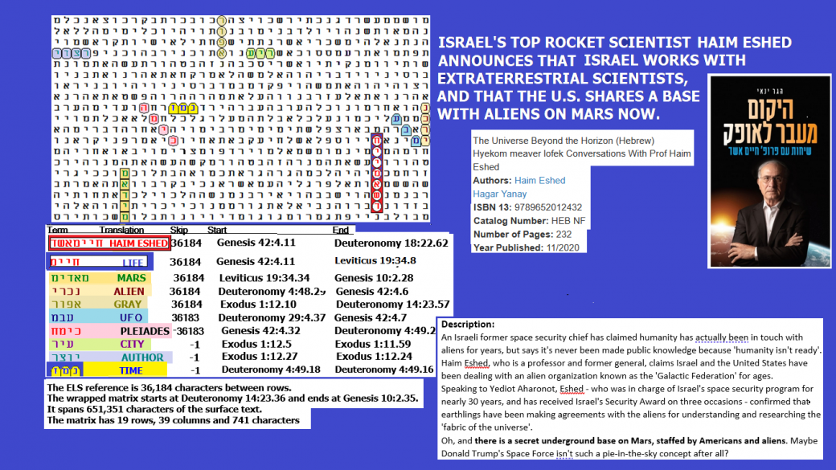
Above: Figure 9-5 with axis term HAIM ESHED matched with nine key words that describe his LIFE. Below: Spreadsheet showing the odds against these key words being found on the matrix (2,216,538 to 1).
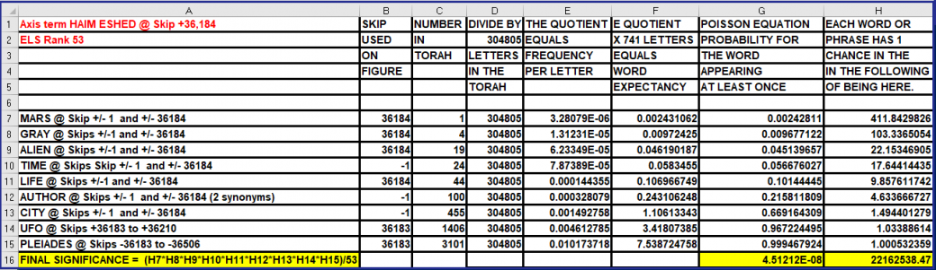

Wikipedia states that Haim Eshed (Hebrew: חיים אשד; born 1933) is a visiting professor of aeronautics and astronautics at 333 various space technology research institutions. A retired brigadier general in Israeli Military Intelligence, Eshed was director of space programs for Israel Ministry of Defense for nearly 30 years, is former chair of the Space Committee of the National Council for Research and Development for the Ministry of Science, Technology and Space, and a member of the steering committee of the Israel Space Agency. Eshed is responsible for the launch of 20 Israeli-made satellites, and he is widely cited as the father of Israel’s space program.
In 1967, Eshed was awarded the Chief of Staff Citation, the highest non-combat decoration awarded by the IDF. Throughout his career, he also received the Israel Defense Prize – the highest civilian defense honor of the State of Israel – three times, but the reasons remain classified.
Extra-terrestrial Claims: Eshed claimed in an interview with Israeli national newspaper Yediot Aharonot that the United States government had been in contact with extraterrestrial life for years and had signed secret agreements with a “Galactic Federation” in order to do experiments on Earth, and that there is a joint base underground on Mars where they collaborate with American astronauts.[20] He also stated that US President Donald Trump was aware of this and was “on the verge” of informing everyone of their existence. Still, he was stopped by the “Galactic Federation,” which wished to prevent mass hysteria.[21] The interview, in Hebrew, gained traction after parts were published in English by The Jerusalem Post.[22]
UNDERSTANDING FIGURE 9-5: The axis term (first term sought) is HAIM ESHED. He has the best reputation of anyone who has ever claimed that the United States has a base on Mars. He says we are not alone there; we share the base with aliens. The 5-letter Hebrew for Mars is pronounced MOADEEM, and it was the first keyword sought. Although I expected to find MARS at the same skip as HAIM ESHED, and I did, the ELS rank of MARS was high (53). It was, however, the only find of the planet at a special case skip. The odds against finding it this way were about 411 to 1.
The next most significant term found was GREY/GRAY, which was at the same skip as HAIM ESHED and MARS (skip +36,184). Odds against its appearance this way were about 103 to 1. Greys abduct people and are the most common type of aliens reported in the 1960s. To emphasize the fact that this find is not an accident, the next most significant term was ALIEN, which was again at the same skip as HAIM ESHED, MARS, and GREY (skip +36,184). Odds against its appearance this way were about 22 to 1. Finally, there is still one more major keyword also at skip +36,184. It’s LIFE. Chaim Eshed is the most serious person to report human (American) and alien life on Mars. But we don’t even need to travel away from his name to find LIFE because Chaim’s first name (Chaim) means LIFE! Odds against LIFE being somewhere on the matrix at a special case are about 9.85 to 1. However, this does not recognize the fact that this keyword is found inside the axis term.
TIME might seem like a questionable term to seek, but we are talking about a matrix with space travel as a major topic with MARS, ALIEN, GREY, PLEIADES, and UFO on it. Based on my research into UFOs, it appears that to be able to fly interstellar distances, we are really talking about the ability to fly not just from one point in space to another, but from one point in space-time to another. In other words, time travel. Odds against TIME being on the matrix were about 17 to 1.
Odds against each of the other terms found were less than 5 to 1. The word for CITY was sought and found at skip -1. Motivation for seeking it centered around the issue of how many people live on Mars now and how many may have lived there sometime in the past. While I would assume that populations are low, probably no more than a few hundred people, I have heard claims before that there may be over a hundred thousand residents now and that there may have been millions before a global catastrophe took place (according to John Brandenburg, a nuclear war). Overall, the matrix was found against odds of over 2.2 million to 1.
One thing is especially troubling about Eshed’s revelations. He says that President Trump was about to reveal the alien presence here on Earth, but the Galactic Federation of Worlds (GFW) asked (or directed?) him not to do it because it would cause a global panic. This implies that we are not allowed to have full sovereignty. ET is at least partially in charge of the Earth. Supposedly, they even prevented at least one nuclear war here (strangely associated with the Bay of Pigs invasion of Cuba, which was the year before the Cuban Missile Crisis).

Aliens in Gaza, massacre by Hamas, its destruction, & cost to Ashkelon.
This article was originally published by me on 11/17/2023. Although Eshed’s revelation was certainly astonishing, it left out the other side of the equation presented in the Torah Code. While Israel works with “white hat” ETs, evidently Hamas, like the Nazis before them, is now working with “black hat” Reptilian (and/or Gray) aliens. In Figure 9-6, the hostile (Reptilian) aliens are named as the CIAKAHRR. A simple transliteration of that name touches ALIEN IN GAZA.

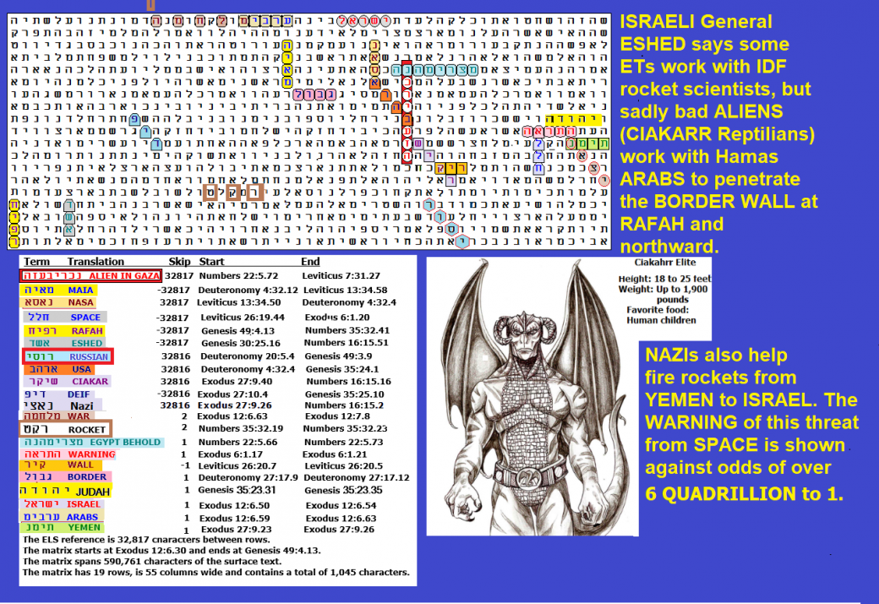

Figure 9-6 above: ALIEN IN GAZA is at the same skip (+32,827) as MAIA, a star in the Pleiades, NASA, SPACE, RAFAH (where major battles took place between Israel and Hamas), and ESHED. There are many indicators that suggest CIAKAHRR (Reptilian) aliens provided technology to the GAZA ARABS to break through the BORDER WALL. BORDER is at skip +1, WALL is at -1, and a short transliteration of CIAKAHRR is one skip off the axis term at +32,816 touching ALIEN IN GAZA. This caused a new ISRAEL WAR that involves getting involved with EGYPT, YEMEN, Iran, Lebanon, Syria, possibly Russia, Ukraine, China, and Taiwan.
FIGURE 9-6 spreadsheet below: The odds against finding this matrix are over six quadrillion to 1. I started publishing Torah Code matrices in 1997. This is the most significant matrix that I have ever found. However, I like Figure 9-7 a bit more because it reduces the area from 1,045 letters to 840 letters. Figure 9-7 describes the requirement for Israel to avenge all the 1,200 people, including children, massacred and over 240 people taken hostage (more of them were also murdered in captivity). Figure 9-7 was found against odds of almost 5 QUADRILLION to 1.
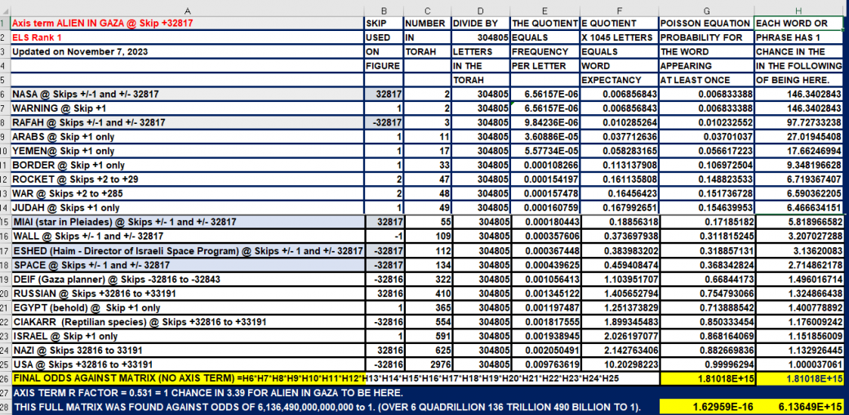

THE DEADLY MEANING OF FIGURES 9-6 AND 9-7. Quite simply, Figure 9-6 tells us that Israel is up against aliens in attacking Rafah. The leader of NASA and the Israeli Space Program (Haim Eshed) knows it. Figure 9-7 tells us that it is likely that two species of aliens finished taking over the U.S. Government under Biden - Ciakahrr (Reptilians) and Grays. Further, they serve the purpose of Hitler. It now remains to be seen how effective Trump can be at resisting what Democrats have set in motion.
Two people asked me to search for the matrix found on Figure 9-6. The first one was Larry Taylor, who, with Stewart Best, often interviewed me on their Night Shadows Talk Radio show. The second person making the request was Rebecca. Rebecca originally claimed to be from the Pleiades star system. I did a joint radio interview with her on the show on June 7, 2023. Sadly, although the show was available on my website until about December 2024, Stewart shut down his show in 2025 when he suffered a serious illness. When he did, the link to the interview no longer worked on my site. A smaller version of Figure 9-6 (area 1,045 letters) is shown below as Figure 9-7 (area 840 letters). The two men recently started another show, and on April 30, 2025, they had me on for 94 minutes. Taylor discussed the possibility that Aliens have taken him to Mars (backed in the Epilogue by Torah Code matrices – Figures E-14 and E-15).
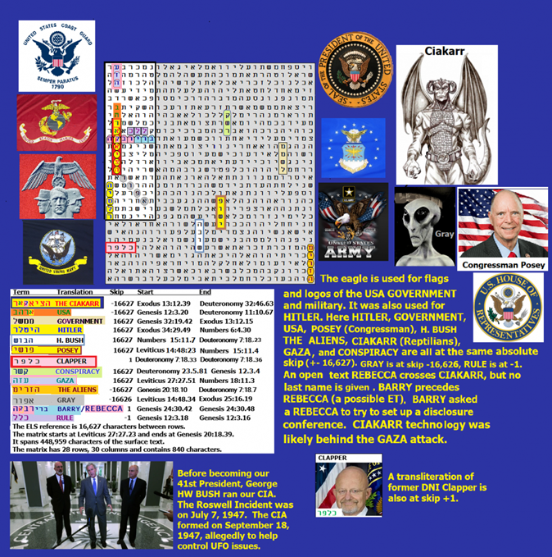
Figure 9-7 is above. Its spreadsheets are below. Notice that THE CIAKAHRR, GAZA, USA, GOVERNMENT, HITLER (best spelling), H. BUSH, CONSPIRACY, and THE ALIENS are all at the same special case skip of +/- 16,627. The small matrix exists against odds of about 68.9 billion to 1, whereas the larger matrix exists against odds of about 4.4 trillion to 1 if we just use BUSH or 26.7957 trillion to 1 if we use H. BUSH.
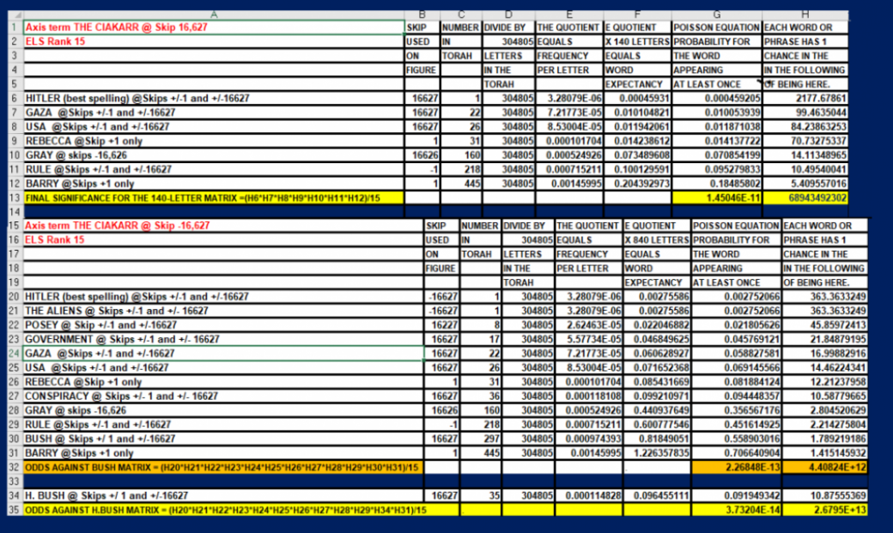
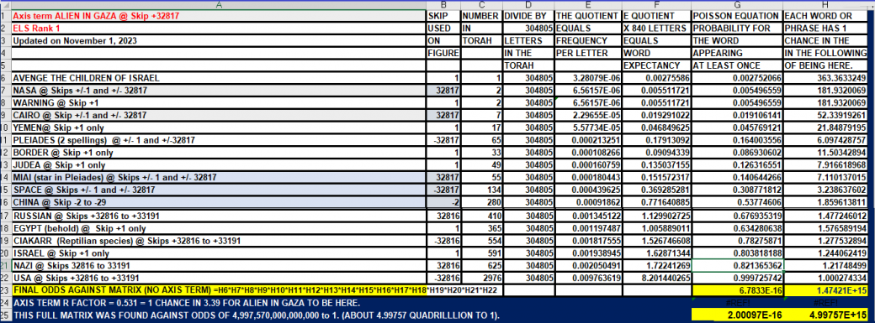
Spreadsheets for Figure 9-7 above.
Figure 9-8 below: Nuc military Iran & Israel
This matrix shows the axis term ATOMIC MILITARY (skip -60,790) touch and share a letter alef with both IRAN and ISRAEL (open text). The name of a suspected alien (Ebrahimi) is at skip +1. At the same skip as ATOMIC MILITARY is THE ALIEN. Craig Ebrahimi claimed to be from IRAN before he claimed to be an ALIEN. IRAN is at one skip off the axis term, and it touches ATOMIC MILITARY. UFO is at skip -60,791. The word for WAR is at skip +2 and is only seen on the larger (600-letter) matrix.
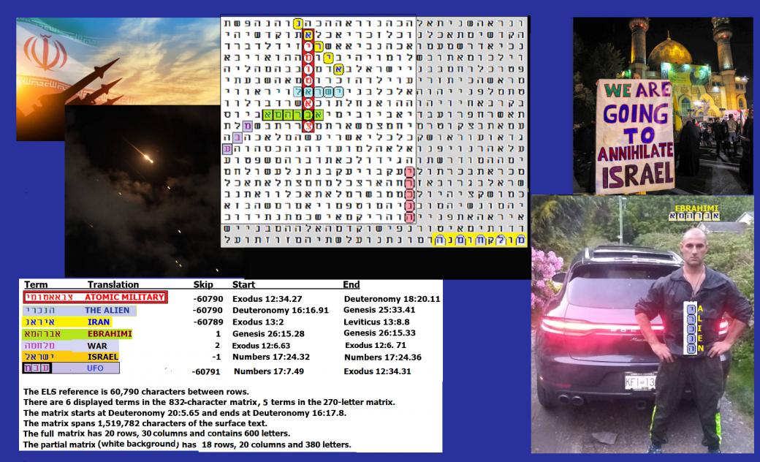
Figure 9-8 above: ATOMIC MILITARY and IRAN.
GAZA AND ET. If there are friendly ETs on Earth, they must reveal their presence and intentions. The world has been deceived by two huge lies:
- Gaza claims it was occupied territory up to October 7, 2023. In reality, Israel completely withdrew every single Jew from Gaza on September 22, 2005. It gave up all homes and left behind the keys for all greenhouse facilities for Gazans to form a healthy economy. In return, Gaza destroyed all greenhouses and began to fire missiles at Israel 12 days later. Hamas seized control of Gaza in June 2007. So, the “occupation” excuse for Gaza murdering 1,200 Jews on October 7 is nonsense.
- The invasion of Israel was accomplished only through Palestinian ingenuity. They had help, but it was not merely from Iran. It was alien help, Reptilian help from a group of murderous savages known as the CIAKAHRR. What are the Ciakahrr like? Satanic Nazis. That’s probably why the Ciakahrr and Satan are often drawn looking much like each other. See Figure 9-9.

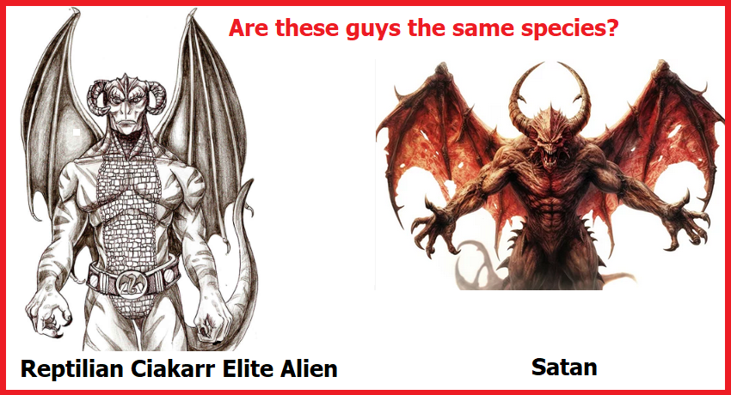
Figure 9-9 above – Should we use the description study Satan in literature or one derived by dissection in a lab? I recommend a dissection.
There is no Jewish tradition of an ELS Code in the Jewish Tenach (Old Testament) outside of the first five books (Torah). Yet the Reptilians are encoded in Zechariah 9:5 along with Gaza, and a major city missile target was Ashkelon, just 8 miles north of the Gaza border. Indeed, all within this one verse we learn that the king of Gaza will be killed and Ashkelon (a city of 158,613 in 2023) will be uninhabited. See Figure 9-10. This verse has not yet been fully investigated, but the book of Zechariah also describes a horrendous fate for Jerusalem (and women who get raped) before God finally takes vengeance on nations (and even Jews) that come against Israel.

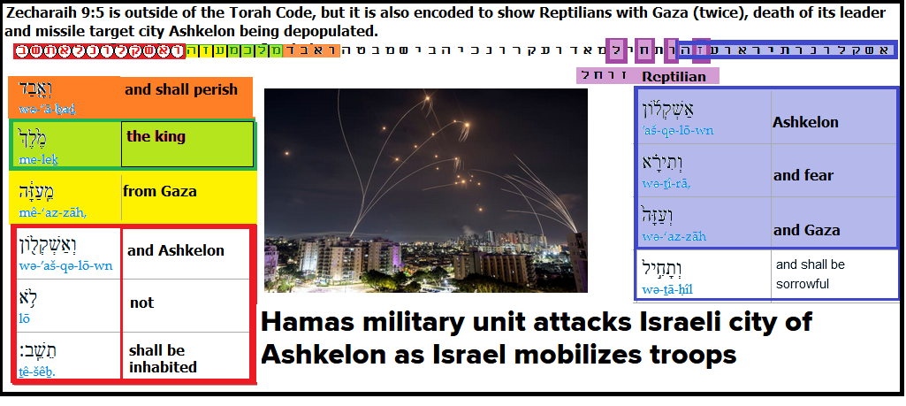

Figure 9-10 above is from Zechariah 9:5. Ashkelon was not destroyed yet, but it was hit by missiles from Gaza many times since the war began in 2023. The full verse says,
“Ashkelon shall see it and fear, Gaza also, and shall be sore pained, And Ekron, for her expectation shall be ashamed; And the king shall perish from Gaza, and Ashkelon shall not be inhabited.” Reptilian shares a letter zayin with the first Gaza.
If Ashkelon is evacuated, the Zechariah 9:5 Reptilian-encoded prediction will be proven true against odds of over 534 billion to 1. There is a long list of Hamas leaders who were assassinated by Israel here. While about 150 missiles were fired at Ashkelon on one day (October 10, 2023) in the first week of this war, there were no injuries, but Israel came under missile attack from Iran again. That the city may need to be evacuated may point to something like a dirty bomb or biochemical weapon in the future. It is believed that the Iranians managed to smuggle weapons-grade uranium out of the Fordow site before American B-2 bombers destroyed it. That Hamas leader SINWAR was born in Ashkelon but had to leave it when Israel won its independence in 1948 may have motivated him to commit such a SIN in this WAR, but Israel has killed him and his brother. The Code rightly predicted death from the order by Netanyahu. This will be shown later below with Figure 9-18.
The rape is described in Zechariah 14:1 which states,
“Behold, a day of the LORD comes, When your spoil shall be divided in the midst of you, For I will gather all nations against Jerusalem to battle; And the city shall be taken, And the women ravished; And half of the city shall go forth into captivity, But the residue shall not be cut off from the city.”
What a mess! The rape so far was only in the ~25 towns taken by Hamas on October 7, 2023, but it sounds like we have more treatment like it still to come, including, as we saw in the mass kidnappings on October 7. It seems a bit out of sequence, but before we were told about rape and kidnap in Zechariah 14:1, we cautioned about consequences in Zechariah 12:9:
“And it shall come to pass in that day, that I will seek to destroy all the nations that come against Jerusalem.”
Haniyeh was killed as predicted. Haniyeh, leader of Hamas, was declared dead on July 31, 2024. The axis term below is HANIYEH GAZA. Crossing it in pink is IN SORROW TO HIS GRAVE and EVIL. IRAN, the site of his death, is at skip +1 sharing a letter nun with his name in the axis term. On the same line, the text reads FOR MAN SHALL NOT SEE ME AND LIVE. That seems about right for a terrorist. GUILT touches and is directly under IRAN. The open text finishes off with HIS BLOOD SHALL BE DASHED. Right on! A planted explosive blew him to hell in a million pieces. While I usually don’t show 2-letter words, on the day that Haniyeh was having his funeral, Israel announced that their bombs three weeks earlier also killed Mohammed DEIF, who was the major planner for the October 7, 2023, slaughter of 1,200 Israelis. DEIF is at the same absolute skip as HANIYEH GAZA.

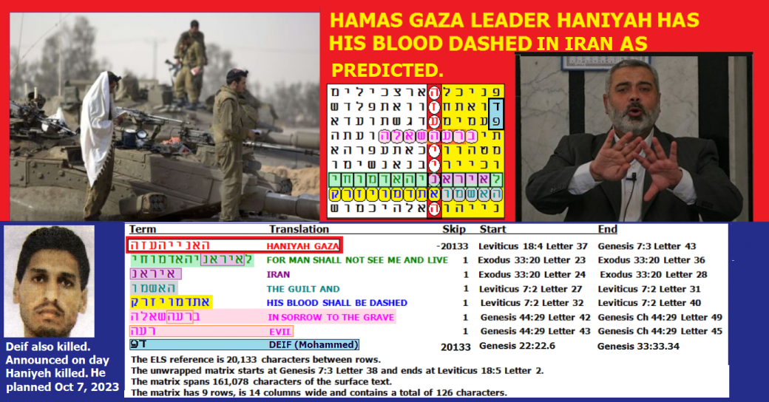
Figure 9-11 above was found by me many years ago, except that I did not look for Mohammed Deif until the day that Haniyeh was blown apart.
SPREADSHEET FOR FIGURE 9-11. As the spreadsheet below indicates, it was found against odds of about 39,706,500,000,000 to 1 (over 39 trillion to 1).
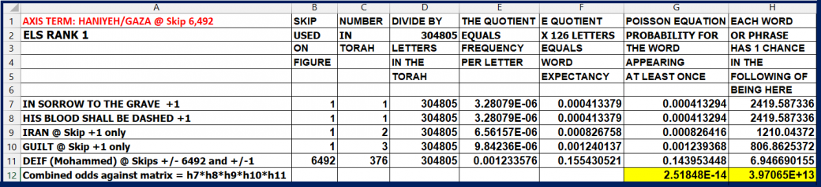
While we can express amazement about predictions that are later proven to be correct, we must not overlook predictions that our government is overrun with hostile aliens that have strong mind control powers.

Rafah, Gaza and Haniyeh
As is shown on the spreadsheet below, Figure 9-11 odds against finding this matrix were about 1.2 billion to 1.
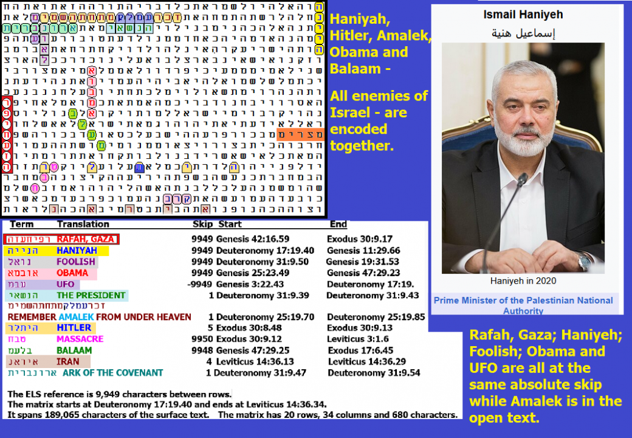
Figure 9-12. The axis term is RAFAH, GAZA, which was the last place in Gaza to fall to Israel in its push to destroy Hamas in retaliation for the deadly and perverted attack against Israel on October 7, 2023.
RAFAH, GAZA is in the left column, while its prime minister HANIYEH is at the same skip (9,949 letters) in the right column. Between them and again at the same skip is a transcription of OBAMA. HANIYEH was foolish in deciding to launch its attack on Israel, just as OBAMA was foolish (really, a traitor) in constantly working to help IRAN acquire nuclear weapons. The word FOOLISH is again at the same skip of 9,947. A fifth term at this same absolute skip (but opposite direction) is UFO, which is only really significant if it turns out that, as I suspect, alien technology was used to help bust 6,000 Hamas terrorists into Israel.
PRESIDENT is on the matrix at skip +1 (open text). This matches up with anti-Semitic leaders OBAMA, AMALEK, and HITLER, plus the gentile prophet BALAAM. The last letter of HITLER (resh) touches two letters of MASSACRE. Odds against Figure 9-12 were about 1,225,448,567 to 1.
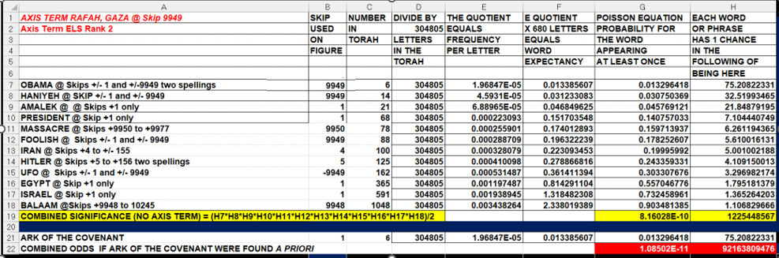

Israel Kills 3 Haniyeh Sons+ 4/16/2024
The matrix on Figure 9-13 was found against odds of over a trillion to 1 on the night of April 13, 2024, while Iran was firing 350 drones, cruise missiles, and 119 ballistic missiles at Israel. Thanks to an incredible missile defense system and some help from Jordan, the United Kingdom, France, and begrudging help from the U.S. that came with conditions to try to tie Israel’s hands with respect to retaliation, Israel suffered zero casualties or major damage. There is still a need to check to see if any of the over 100 ballistic missiles carried unexploded nuclear warheads.
The axis term on Figure 9-13 is CHILDREN OF HANIYEH (the leader of Hamas). At the same skip are MISSILE and GRANDFATHER. In addition to the Israeli missile killing THREE Haniyeh sons, it also killed FOUR Haniyeh GRANDCHILDREN. Both numbers are in the open text. Another Israeli missile killed 7 Iranian officers, including two Iranian generals killed on April 1, 2024, in Damascus, Syria, including General Mohammad Reza Zahedi, who led the elite Quds Force in Lebanon and Syria until 2016. It also killed Zahedi’s deputy, Gen Mohammad Hadi Hajriahimi. I have written before about Hamas having links to an alien race known as the REPTILIANS. REPTILIANS are on the matrix at skip -1 against odds of over 307 to 1. At the same odds is a reference to YOUR CITIES WILL BE A WASTE. All Gaza cities are now destroyed as a result of retaliation for the October 7, 2023 massacre and/or rape and kidnapping of over 1,200 Israelis.
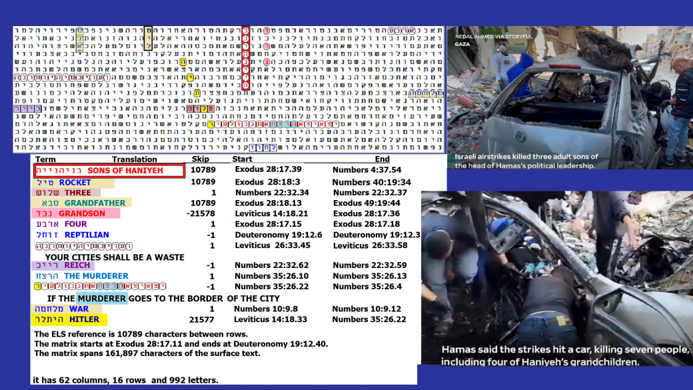
Figure 9-13 is above, and its spreadsheet is below. The latter shows that odds against finding this matrix are over 1.049 TRILLION TO 1.
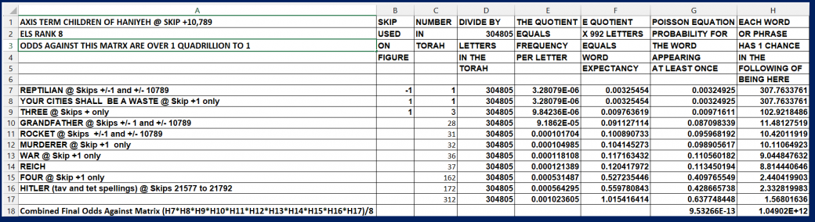

NASRALLAH GETS TOASTED 10/8/2024
FIGURE 9-14 below. Four NASRALLAH matrices are shown. In the top one, NASRALLAH at skip -60235 touches NETANYAHU (skip +1), matches up and shares a letter lamed with ISRAEL (open text, skip +1), and has the order TO KILL him (open text).
On the second matrix, NASRALLAH at skip 65,744 is encoded crossing and sharing a letter lamed with a terrorist home in THE LEBANON in the open text.
Third matrix on Figure 9-15: NASRALLAH and BIDEN are encoded at Skips +73,579 or -73,579. NETANYAHU is at Skip +1.
The fourth matrix above matches NASRALLAH at skip -9,185 with REICH at the same skip and REPTILIAN at skip +9,185.

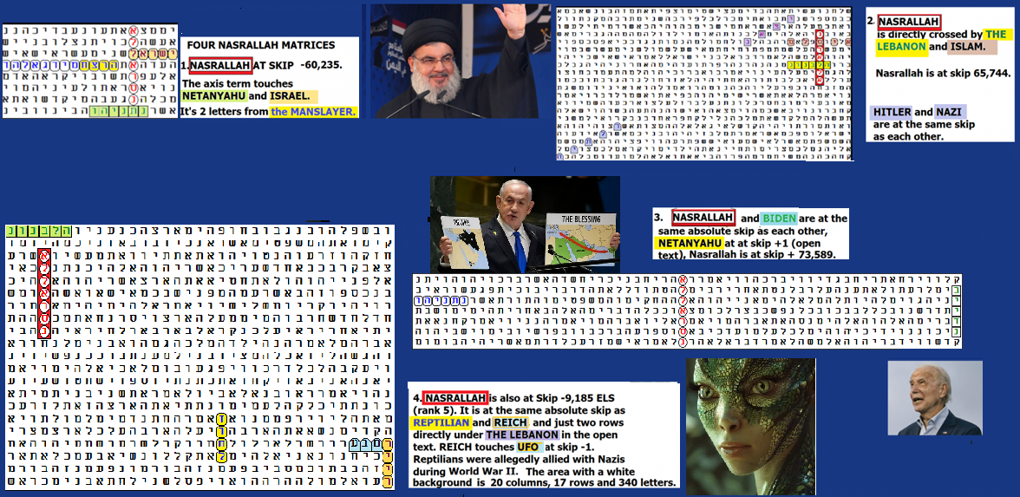
FIGURE 9-14 above: The Reptilian aliens are encoded with far more than NASRALLAH. As is shown in Figure 9-15 below, OBAMA is encoded as being a REPTILIAN.

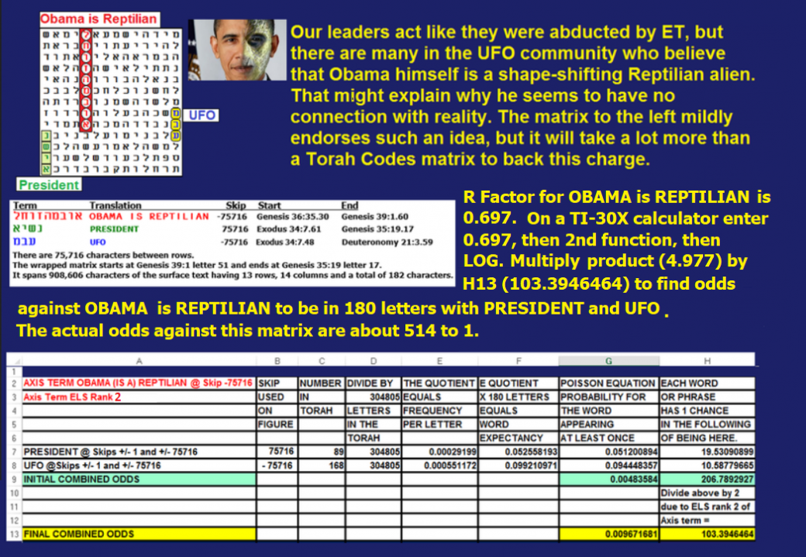
So is the Democratic nominee for Vice President is shown on Figure 9-16 below. It only takes 28 letters to show him intersect REPTILIAN at skip -1.
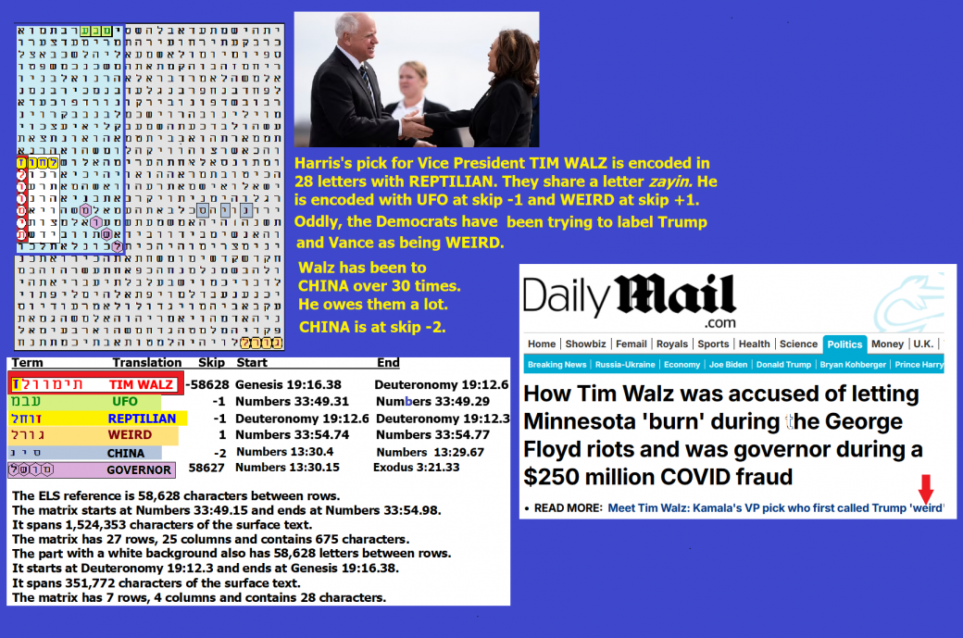
Figure 9-16 above. Evidence that the Democratic nominee for vice president in 2024 is a reptilian.
Figure 9-17 below links CIAKAAHRR to GAZA, VATICAN, Catholic and ALIEN GOD.


Figure 9-17 below: As I discussed in Chapter 2, there is an ELS train with, GAZA, and The CIAKAHRR (Reptilians) at skip +9450 that matches up with VATICAN and HOMOSEXUAL At skip -9450. HEADQUARTERS at skip +1 touches VATICAN. CATHOLIC is at skip +2. SNAKE is in the open text. This satanic figure was chosen as the inspiration for Rome’s Vatican theater, although half of the building is in Vatican City and the other half is in Rome. Behind the fangs over the stage is an image that is supposed to represent Jesus emerging from the nuclear ashes of a destroyed Jerusalem! All that is seen here is a perfect picture of the Reptilian agenda. Annihilate humanity via the infertility of homosexuality and then nuke the survivors, especially Jews.
Why Sinwar vs. Netanyahu 10/16/2024
After the October 7, 2023, massacre in southern Israel, probably the two greatest enemies of each other on Earth were Benjamin Netanyahu, the Prime Minister of Israel, and Yahya Sinwar, leader of Hamas in Gaza, He was killed by Netanyahu. Each was not only sworn to kill the other, but Netanyahu had promised to kill all Hamas terrorists who crossed the border into Israel on October 7, 2023 where they murdered over 1,200 Israelis in their homes, beheaded about 40 babies, and kidnapped (and in many cases raped) 250 more Israelis, dragging them into Gaza. Sinwar had promised to conduct future raids in an effort to exterminate all Jews in Israel. On Figure 9-19, the purpose of my experiment was to see if this horror is prerecorded in Torah. Sadly, it is. SINWAR shares his letter nunn with NETANYAHU. NETANYAHU touches BENJAMIN at 4 letters on the line above NETANYAHU. SINWAR is at the same skip as IDOL. IDOLATRY is described in the story of the Gold Calf on the matrix. The Torah records that God killed Jews for worshiping idols. More on this later, but it appears that God may have used Sinwar to kill Jews violating Jewish Laws at the music festival on the Sabbath and Simchat Torah. Most notable was that a large Buddha idol overlooked the center of the mayhem.'

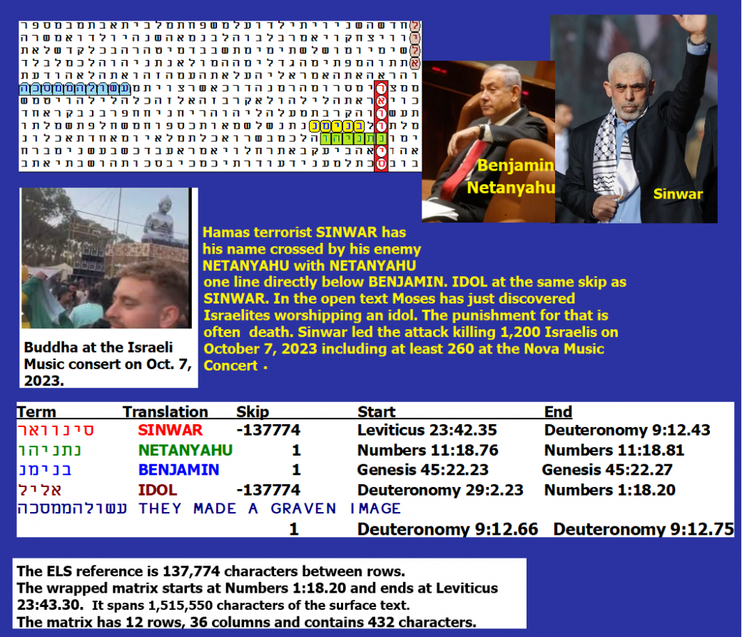

FIGURE 9-18 is above. Its spreadsheet is below. Odds against finding this matrix were about 82,795 to 1.
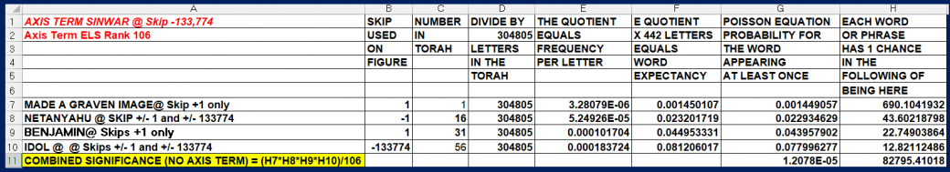
FORMAT OF ENCODING AND THE PERSONALITY OF THE ENCODER. This is not the first time that I have seen the first name of a man on one line and his second name on the next row down, pretty much letter for letter in the same columns, except where there is a slight difference in letter count for each name. Here we have four of the five letters of BENJAMIN (bet, nun, yud, mem) touch four of the six letters of NETANYAHU (nun, yud, hey, vav). In an earlier example, I found all four letters of the first name of an intelligence agent (Joseph) from Fort Huachuca, Arizona, on the first line touch four of the letters of his second name on the next line down. See Figure 9-20, upper left corner.
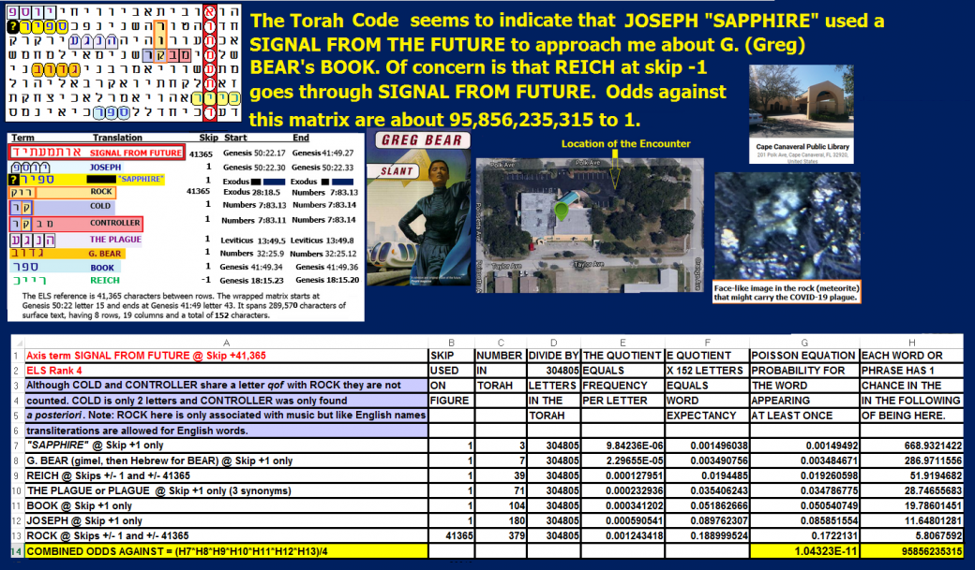
Figure 9-19 above: JOSEPH SAPPHIRE seemed to have info from the future.
This method of encoding may be used to emphasize extremely important information. The Joseph encoded here with his second name is on a matrix where the axis term is SIGNAL FROM FUTURE. He gave me information about my son’s future, and he may have even indicated that he was capable of time travel.
It is well worthwhile to compare the attacking force given to Moses to kill fellow Jews after the sin of their worshiping the golden calf, with somewhere between 5,600 and 6,000 used by Sinwar to murder Jews in the villages near Gaza. See Exodus 32:26 to 32:28:
²⁶ then Moses stood in the gate of the camp, and said, “Who is on the Lord’s side? Come to me.” And all the sons of Levi gathered themselves together to him. ²⁷ And he said to them, “Thus says the Lord God of Israel, ‘Put every man his sword on his side, and go to and fro from gate to gate throughout the camp, and slay every man his brother, and every man his companion, and every man his neighbor.’” 28 And the sons of Levi did according to the word of Moses; and there fell of the people that day about three thousand men.
The fact that there were ill-clad women dancing about at the concert, attacked by Sinwar, is also reminiscent of the plan of Balaam to get God to kill Jews via a plague. See Numbers 25:1 to 9:
¹ While Israel dwelt in Shittim the people began to play the harlot with the daughters of Moab. ² These invited the people to the sacrifices of their gods, and the people ate, and bowed down to their gods. ³ So Israel yoked himself to Ba′al of Pe′or. And the anger of the Lord was kindled against Israel; ⁴ and the Lord said to Moses,
“Take all the chiefs of the people, and hang them in the sun before the Lord, that the fierce anger of the Lord may turn away from Israel.” ⁵ And Moses said to the judges of Israel, “Every one of you slay his men who have yoked themselves to Ba′al of Pe′or.”
⁶ And behold, one of the people of Israel came and brought a Mid′ianite woman to his family, in the sight of Moses and in the sight of the whole congregation of the people of Israel, while they were weeping at the door of the tent of meeting. ⁷ When Phin′ehas the son of Elea′zar, son of Aaron the priest, saw it, he rose and left the congregation, and took a spear in his hand ⁸ and went after the man of Israel into the inner room, and pierced both of them, the man of Israel and the woman, through her body. Thus the plague was stayed from the people of Israel. ⁹ Nevertheless those that died by the plague were twenty-four thousand.
Having stated the nature of Israel’s sins above, the sins of Israel on October 7, 2023, are shown on the video link at https://twitter.com/nexta_tv/status/1710956060469784836. They should be examined as should Figure 9-20 below. Messages like this tend to support the idea that a jealous God rather than a cold extraterrestrial or Artificial Intelligence encoded the Torah.

Figure 9-20. The Jews killed on October 7, 2023, were not all innocent. A large Buddha may have had something to do with why God left them naked before the very fatal assault.

Israeli War Games Designed to Help Fight Aliens.
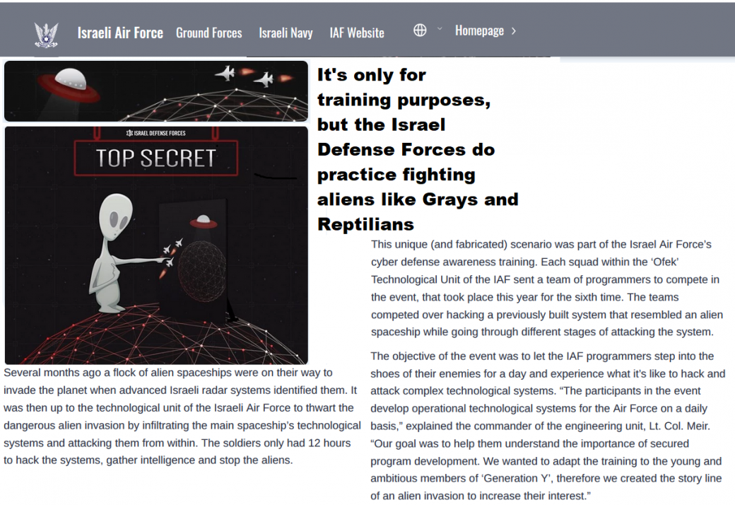
Figure 9-21 above. Semper paratus. After meeting and working with aliens (according to Israeli Brigadier General Haim Eshed, discussed earlier), Israel began war games aimed at defeating alien invaders. The U.S. established a new branch of its military, the Space Force.
Figure 9-22. Reptilian enemies introduce themselves to Iran. I have shown in this chapter that aliens (most probably reptilians) likely gave Hamas the technology that it needed to invade Israel on October 7, 2023. If this were true, it is logical to assume that Reptilians would also be open to helping Iran get missiles and other arms from Iran into Gaza. Figure 9-22 lends credence to this idea. On this Figure, the axis term REPTILIAN ENEMY touches IRAN at skip +1. Iran appears at this best-case skip only twice in Torah. WAR in the open text goes through and shares a letter with the REPTILIAN ENEMY. PRESIDENT is at skip +1. BARACK (Obama) is at skip -1, and so is UFO. There was only about one chance in 90,905,743 to find a matrix.
Iranian jet fighters have attempted to intercept UFOs in the past, with one F-14 in January 2012 that exploded, killing both crewmen. No cause for the tragedy was determined. However, there has been plenty of time for Iranians to patch up early contact problems. Reptilians love Nazis and hate Jews. Therefore, reptilians, in addition to supporting Hamas, likely also love radical Iran. Barack Obama (and Biden) permitted Iran to enrich enough uranium to make nine nuclear bombs. OBAMA is encoded with the ATOMIC HOLOCAUST. See Figure 9-23.

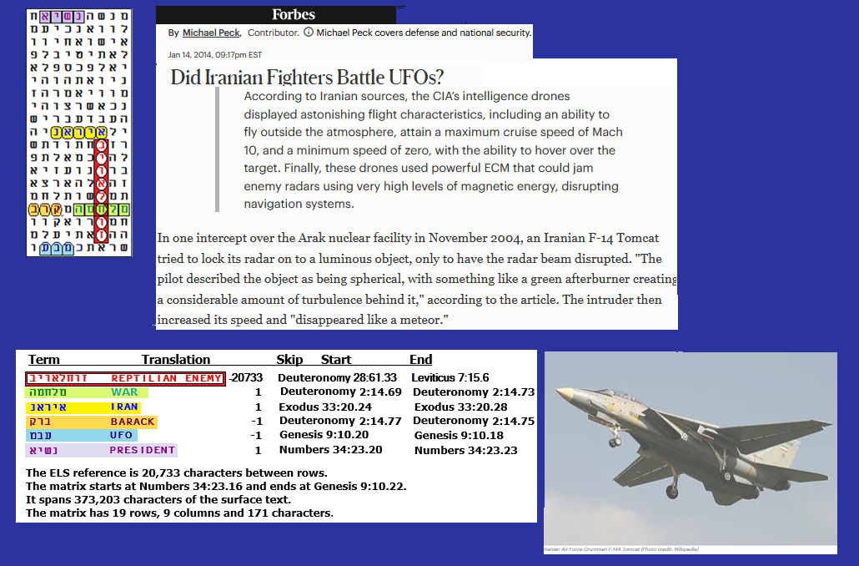
Figure 9-22 is above, and its probability spreadsheet is below. While IRAN was found at skip +1 on the 171-letter matrix against odds of about 891 to 1, it was actually found with REPTILIAN ENEMY in 45 letters against odds of about 3,387 to 1.
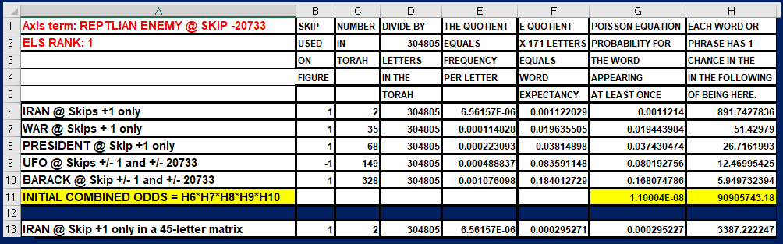
WAS IRAN A NUCLEAR THREAT TO AMERICA BEFORE ISRAEL ATTACKED IRAN? Absolutely. But there may be indications that America (specifically New York) may have someone (Arab) that might hit them with a nuclear bomb. Also, a danger that should not be overlooked is ALIEN. This term is close to ATOMIC HOLOCAUST in the open text on Figure 9-25. I have shown that reptilians likely gave Hamas the ability to penetrate Israel on October 7, 2023. Figure 9-26 deals with the New York threat.
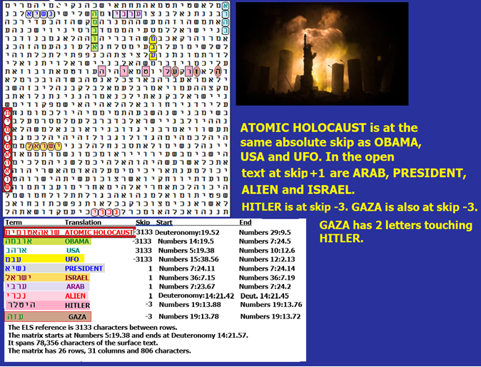
Figure 9-23 above and its spreadsheet below. Without counting the axis term (ATOMIC HOLOCAUST), the matrix was found against odds of about 2,782,626,903 to 1. The most significant a priori keyword was OBAMA, which was found at a special case skip (the same as the axis term) against odds of about 126 to 1. Normally, I don’t count the axis term, but in this case, it’s 10 letters long, which is rare. CodeFinder software indicates that it has an R factor of 2.676, which means that there was only one chance in 474 that it would be found at least once in Torah. On multiplying this number by the other odds found, there was actually only about one chance in 1,319,638,507,000 (about 1 in 1.3 trillion) that the matrix would be found. Note that ATOMIC HOLOCAUST is also at the same absolute skip as USA and UFO. Originally, I wrote this while the Trump Administration was trying to restart nuclear talks with Iran. Eventually, when the talks failed, he sent seven B-2 bombers to attack Iran’s three top nuclear targets.

