Chapter 7
Martian Lies and Bad Guys
This chapter details how a lack of logical Martian weather observations led to an understanding that our government is deliberately hiding the true nature of the Red Planet. It is a quick overview of findings in our over 1,200-page report – MARS CORRECT: CRITIQUE OF ALL NASA MARS WEATHER DATA. I say “our” report because my son, Dr. David Alexander Roffman (PhD, physics), did most of the math that went into the report. The report largely steered clear of politics and UFO discussions. This chapter will not be so kind. There are national security implications to what we have found, and the lies we uncovered with respect to what is really going on Mars have turned out to be the tip of the iceberg when it comes to corruption and lies on Earth.
The abstract for Mars Correct quickly sums up our non-political findings:
Abstract for Mars Correct:
Critique of All NASA Mars Weather Data
We present evidence that NASA is seriously understating Martian air pressure. Our 12-year study critiques 3,025 Sols up through 8 February 2021 (8.51 terrestrial years, 4.52 Martian years) of highly problematic MSL Rover Environmental Monitoring Station (REMS) weather data, and offers an in-depth audit of over 8,311 hourly Viking 1 and 2 weather reports. We discuss the analysis of technical papers, NASA documents, and personal interviews with transducer designers. We troubleshoot pressures based on radio occultation/spectroscopy, and the previously accepted small pressure ranges that could be measured by Viking 1 and 2 (18 mbar), Pathfinder and Phoenix (12 mbar), and MSL (11.5 mbar – altered to 14 mbar in 2017). For MSL, there were several pressures published from August 30 to September 5, 2012, that were from 737 mbar to 747 mbar – two orders of magnitude too high by NASA doctrine– only to be retracted. We challenged many pressures, and NASA revised them. However, there are two pressure sensor ranges listed on a CAD for Mars Pathfinder. We long thought the CAD listed two different sensors, but based on specifications of a newer Tavis sensor for InSight that is like the one on Pathfinder, it appears that the transducer could toggle between two ranges: 0-0.174 PSIA/12 mbar (Tavis Dash 2) and 0-15 PSIA/1,034 mbar (Tavis Dash 1). Further, an abstract to the American Geophysical Union for the Fall 2012 meeting shows the Finnish Meteorological Institute (FMI) states of their MSL (and Phoenix) Vaisala transducers, “The pressure device measurement range is 0 – 1025 hPa in a temperature range of -45°C – +55°C (-45°C is warmer than MSL night temperatures), but its calibration is optimized for the Martian pressure range of 4 – 12 hPa.” So, in fact, of the first five landers with meteorological suites, three were actually equipped to measure Earth-like pressure. All original 19 low µV values were removed when we asked about them, although eventually 12 were restored. REMS’ always-sunny opacity reports were contradicted by Mars Reconnaissance Orbiter photos. We demonstrate that REMS weather data was regularly revised after they studied online critiques in working versions of this report. REMS even labeled all dust 2018 Global Dust Storm weather as sunny, although they did list the µV values then as all low. Vikings and MSL showed consistent timing of daily pressure spikes, which we link to how gas pressure in a sealed container would vary with absolute temperature, heating by radioisotope thermoelectric generators (RTGs), and dust clots at air access tubes and dust filters.
Pathfinder, Phoenix, and MSL wind measurements failed. Phoenix and MSL pressure transducer design problems included confusion about dust filter location and a lack of information about nearby heat sources due to International Traffic and Arms Regulations (ITAR). NASA Ames could not replicate dust devils at 10 mbar. Rapidly filled MER Spirit tracks required wind speeds of 80 mph at the assumed low pressures. These winds were never recorded on Mars. Nor could NASA explain drifting Barchan sand dunes. Based on the above and dust devils on Arsia Mons to altitudes of 17 km above areoid (Martian equivalent of sea level), spiral storms with 10 km eye-walls above Arsia Mons and similar storms above Olympus Mons (over 21 km high), dust storm opacity at MER Opportunity blacking out the sun, snow that descends 1 to 2 km in only 5 or 10 minutes, excessive aero braking, liquid water running at or near the surface in numerous locations at Recurring Slope Lineae (RSL), and stratus clouds 13 km above areoid, we argue for an average pressure at areoid of ~511 mbar rather than the accepted 6.1 mbar. This pressure grows to 1,050 mbar in the Hellas Basin.
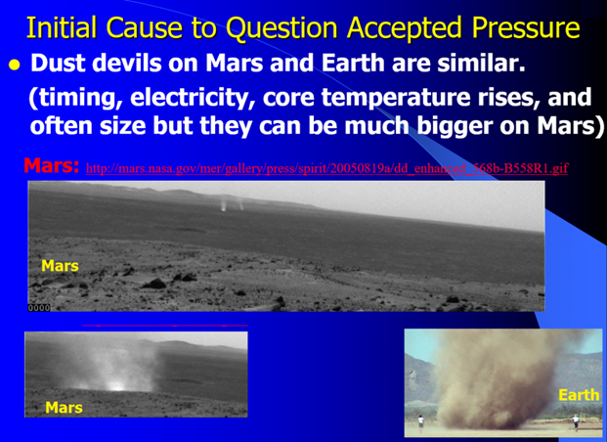
Figure 7-1 above – Martian and terrestrial dust devils. When my son was a 16-year-old college sophomore at Embry-Riddle Aeronautical University, he asked what he should write about for his first technical paper. I recommended Martian dust devils because I could not understand how they could form in such a thin atmosphere. The average pressure on Earth is 1013.25 millibars, but on Mars, it’s only about 6.1 millibars on average – less than 1% of Earth’s pressure. My second concern was based on Martian sky color. When Viking I sent the first pictures of the Martian sky back to Earth, it was bright blue. It should have been quite black, like on a lunar day. There was some green on the rocks that might have been lichens. But the King of Martian lies, NASA Administrator James Fletcher, immediately ordered his stooges to manually alter the sky color by tuning the sky color monitors at Jet Propulsion Laboratory (JPL) to show a butterscotch or reddish sky with only brown on the rocks. This angered many people there, but Fletcher (pictured in Figure 7-34 with President Nixon) threatened to throw out anyone who tried to fix their monitors. NASA continued to lie to us about the Martian sky color seen by every lander until Curiosity/Mars Science Lander (MSL) landed on the Red Planet on August 6, 2012. We first saw a butterscotch sky again, but then JPL altered the color back to blue, supposedly because the dust cap had been left on.
Why did Fletcher and others lie to us from 1976 to 2012 (36 years)? The answer lies in understanding what the Deep State is. I prefer to call it the Fourth Reich, but the truth is worse than even these names can indicate. Too much curiosity about UFOs was likely what led to assassination of President Kennedy, and possibly assassination attempts against President Trump. He survived two attempts in 2024 and one at Mar-A-Lago in 2021. Many of his enemies, who pose such a threat, are named and discussed in Chapter 3 of this book. The Torah Code exposes lies about Mars and politicians here on Earth. It gives us a much more coherent view of real world history.
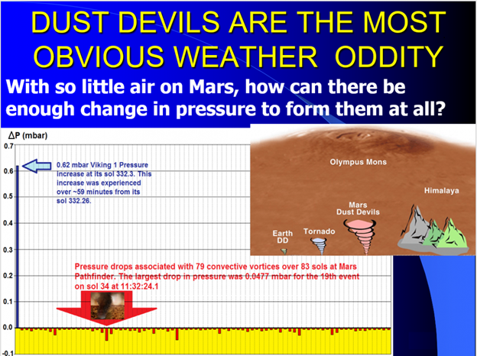
Figure 7-2 above. Relative magnitude of 0.62 mbar increases in pressure for Viking 1 at its sol 332.3 and pressure drops for 79 convective vortices/dust devils at Mars Pathfinder over its 83 sols. Source: Murphy, J. and Nelli, S., Mars Pathfinder Convective Vortices: Frequency of Occurrence (2002) http://tide.gsfc.nasa.gov/studies/Chen/proposals/IES/2002GL015214.pdf
Figure 7-2 offers evidence that internal events on the Vikings were having a much greater impact on pressure readings than dramatic events like dust devils. Pressure increases in the 0.26 to 0.3 time bins were comparable to pressure drops associated with global dust storms. An increase of 0.62 mbar in about 59 minutes that makes up one time-bin equates to a pressure rise 13 times greater than the largest (0.477 mbar) pressure fall shown for all 79 Pathfinder dust devil events, and about 21 times greater than the largest (0.0289 mbar) pressure drop seen for a Phoenix dust devil.
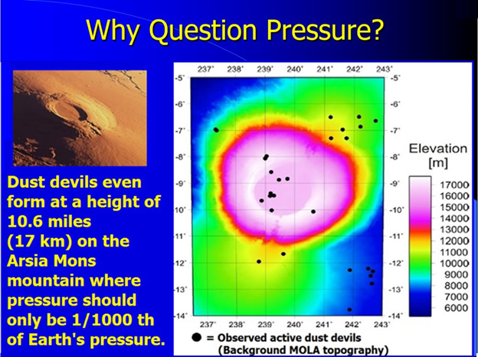
Figure 7-3 above: Thousands of dust devils per week occur in the Peruvian Andes near the Subancaya volcano (Metzger, 2001), which is 5,900 meters high. Dust devils are also seen in abundance on a Martian volcano, Arsia Mons. But the base altitude of some dust devils there has been about 17,000 meters. Such an altitude on Mars supposedly would have about 1.2 mbar pressure, compared to about 478 mbar at Subancaya on Earth. Reis et al. state that 28 active dust devils were reported in their study region for Arsia Mons, with 11 of them at altitudes greater than 16 km, and most inside the caldera (see Figure 7-2). They don’t fully understand how particles that are a few microns in size can be lifted there, and state that one mbar “requires wind speeds 2 to 3 times higher than at the Mars mean elevation for particle entanglement.”
Figure 7-4 below: Opacity changes at Opportunity from sols 1205 to 1235. Redrawn from http://www.jpl.nasa.gov/news/news.cfm?release=2007-080 for Opportunity between sols 1205 and 1235.
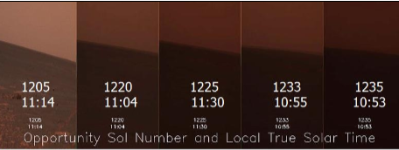
Figure 7-4 above. All photos were taken between 10:53 and 11:30 local time. The dust in the Martian air over Opportunity blocked 99 percent of direct sunlight. This fact alone makes it very hard to accept that pressures would be unaffected.

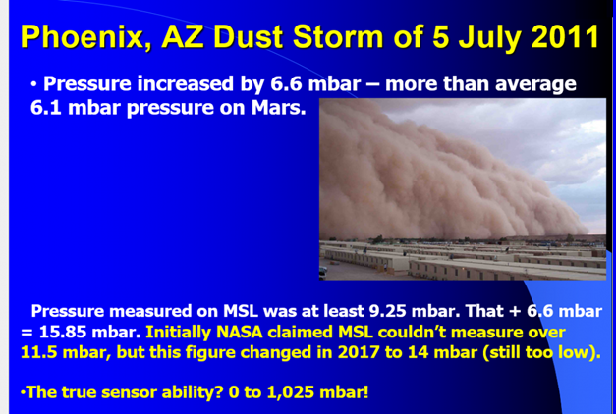
Figure 7-5 above: Arizona Dust Storm of July 5, 2011. Pressure at Luke Air Force Base increased during the dust storm by 6.6 mbar – more than the average pressure (6.1 mbar) at the areoid on Mars.
Figure 7-6 below: Print-screen (recorded on July 23, 2017) of the FMI Abstract entitled Pressure and Humidity Measurements at the MSL Landing Site Supported by Modeling of the Atmospheric Conditions.

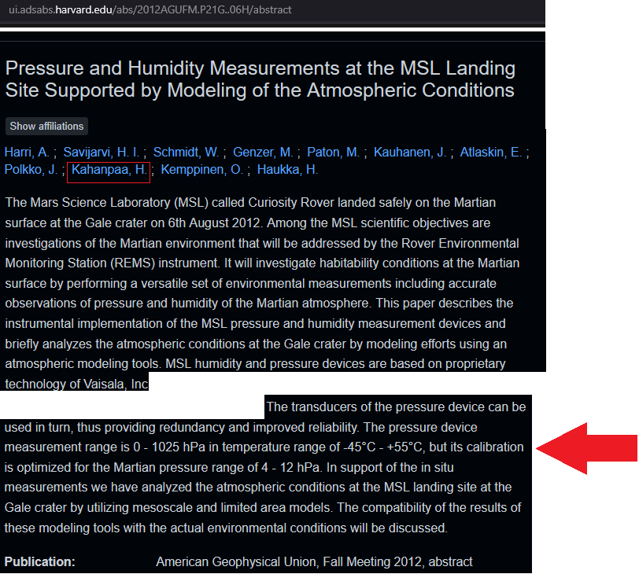
In the initial versions of this research, we wrote that MPF was restricted to 10 mbar on the surface, and MSL was held to 11.5 mbar. The mean pressure recorded for MSL sol 370 was 11.49 mbar (at least until we challenged it and JPL revised it). The original pressure indicates that for much or most of that day, the actual pressure was almost certainly above the maximum pressure that the Vaisala pressure transducer could measure. The REMS Team published 1,177 Pa and 1,200 Pa pressures for sols 1,160 and 1,161, but after over two months of our questioning these pressures on our websites, JPL backed off and revised the pressures to 899 and 898 Pa. They likewise backed off a 1,154 Pa pressure for sol 1301 and changed it to 752 Pa. However, the REMS Team and the FMI read our findings. So, when we found on July 24, 2017, that REMS was suddenly posting a maximum pressure range of up to 1,400 Pa, all we could say was, “How convenient!” But it is totally inconsistent with everything they published before. Then there is that little matter of the transducer actually being capable of measuring up to 1,025 hPa (102,500 Pa – see Figure 7-6 material highlighted in red above).
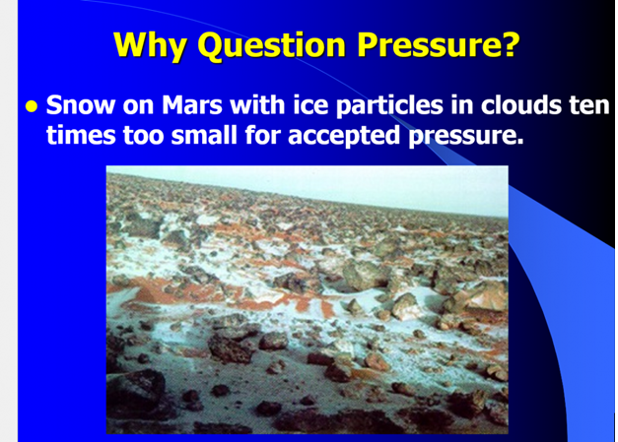
Figure 7-7 above: 2 µm ice particles survive on Mars because, in fact, the pressure is much higher than NASA has been telling us.
THE ISSUES OF SNOW, WATER ICE, AND CARBON DIOXIDE ON MARS.
Phoenix captured snow on Mars. This was not unexpected. Richardson et al. (2002) discussed snow on Mars before Phoenix saw it, but they declared that in order to get a good fit to all other data, cloud ice particle sizes must be used that are about an order of magnitude too large (that is, 20 µm rather than the 2 µm observed).
They state that “significant work remains to be done assessing the quality of GCM predictions of Martian circulation vigor and resultant tracer transport.” They concede the need to bump up ice particle size to levels that are “unrealistically large.” While they were not specific about why the ice particles need to be so much bigger than those seen, it would make sense that if pressure were as low as advertised by NASA, the 2 µm ice particles would sublimate back into the atmosphere before the snow could fall. But at 20 µm, it could survive to hit the surface at such low pressures. If so, it follows that 2 µm ice particles survive because, in fact, the pressure is much higher than NASA has been telling us. Wherever we look at the weather plainly seen on Mars, it fails to match pressures under 10 mbar.
On August 21, 2017, a new study (with lead author Aymeric Spiga, of the University of Pierre and Marie Curie in Paris – see http://www.nature.com/ngeo/journal/vaop/ncurrent/full/ngeo3008.html?foxtrotcallback=true) noted that previous research suggested that if snow did fall from Martian clouds, it would waft down very slowly. “We thought that snow on Mars fell very gently, taking hours or days to fall 1 or 2 kilometers [0.6 to 1.2 miles].” Now, Spiga et al. found that, “Snow could take something like just 5 or 10 minutes to fall 1 to 2 km [0.6 to 1.2 miles].” The researchers were analyzing data from Mars Global Surveyor and Mars Reconnaissance Orbiter when they noticed a strong mixing of heat in the Martian atmosphere at night, “about 5 km from the surface,” Spiga said. “This was never seen before.”
You expect heat to get mixed in the Martian atmosphere close to the surface during the daytime, since the surface gets heated by the sun,” Spiga explained. “But my colleague David Hinson at Stanford University and the SETI Institute saw it higher up in the atmosphere and at night. This was very surprising.” The scientists discovered that the cooling of water-ice cloud particles during the cold Martian night could generate unstable turbulence within the clouds.
“This can lead to strong winds, vertical plumes going upward and downward within and below the clouds at about 10 meters [33 feet] per second,” or about 22 mph (36 km/h), Spiga said. “Those are the kinds of winds that are in moderate thunderstorms on Earth.” Here again, the more we study Mars, the more it looks like Earth.
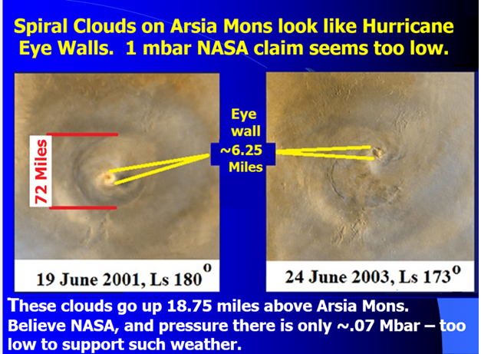
Figure 7-8 above: Spiral clouds over Arsia Mons and Olympus Mons adapted from:
http://photojournal.jpl.nasa.gov/catalog/PIA04294 and http://mars.jpl.nasa.gov/mro/multimedia/images/?ImageID=894&NewsInfo=59C884BFF2B8E0EDCEDF15F64B98BC57A54F95914A0576D9DF4145F3BFA98ECDCED7889AA9
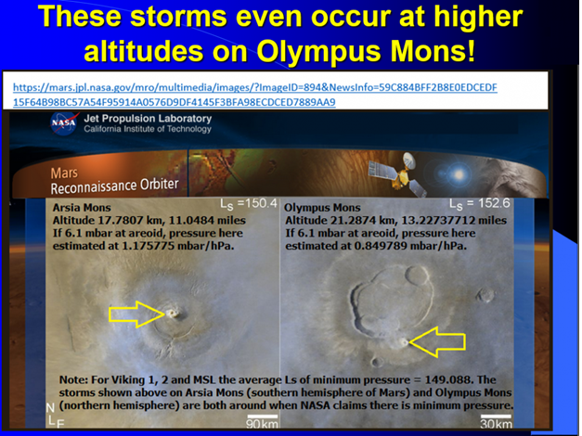
Figure 7-9 above: Comparison of alleged pressures at Arsia Mons and Olympus Mons on Mars.
Arsia Mons is at 9° South. With respect to the season, southern spring begins at Ls 180. It extends to Ls 270. Ls 90 to 179.9 is southern winter. These storms occur between Ls 150.4 and 180. They are therefore between the late winter and the first day of spring, but the storm over Olympus Mons in the northern hemisphere at Ls 152.6 is in late summer. Figures 7-8 and 7-9 show structures analogous to the eye walls of small hurricanes associated with the spiral clouds. They are about 10 km across and appear quite vigorous on Arsia Mons and about 7 km across at Olympus Mons. These pictures were taken just before planetary pressures should be near minimums. At such a high altitude, there shouldn’t be enough pressure differentials to drive these storms if NASA is right, but they are plainly wrong.
.
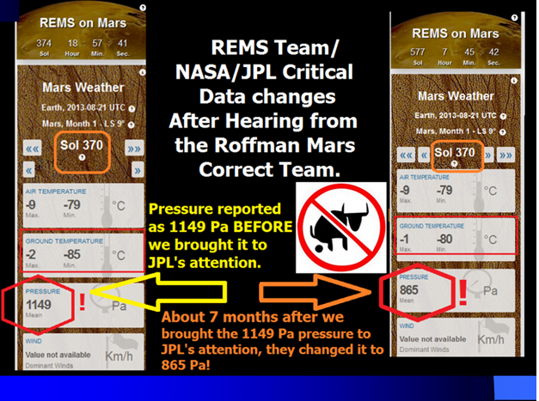
Figure 7-10 above: Sol 370 shows that the REMS Team and JPL's approach to problem-solving – they simply rewrite history and hope that nobody will notice it. The pressure the day before the 1149 Pa (11.49 mbar) spike was 865 Pa (8.65 mbar on Sol 369). After I called JPL about it, the pressure for the next day (Sol 371) returned to a more politically correct 865 Pa again.

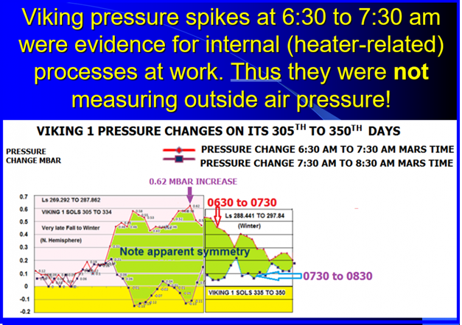
Figure 7-11 above. For VL-2 over 206 sols specified, pressure only decreased twice, each time just 0.01 mbar. The next time-bin (0.3-0.34) showed a much more varied pattern. Red lines show the first time-bin and blue shows the second time-bin on Figure 7-11.

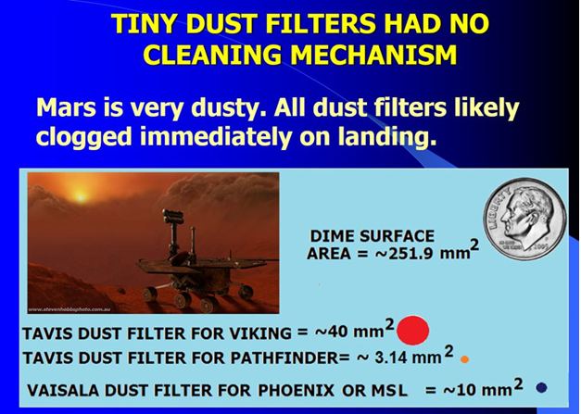
Figure 7-12 above: Relative size of dust filter for landers on Mars. 2 mm diameter of Mars Pathfinder (MPF) tubing from Seiff et al. (1997). On Figure 7-13 below, the top transducer is for Phoenix. Note the tiny dust filter shown under Praw (adapted from Doc. No: FMI_S-PHX-BAR-TN-00 FM-00 Revision 1.0 dated 2009-02-26). The report is entitled The Time Response of the PHOENIX Pressure Sensor. An area of concern for clogging by dust is highlighted. The photo on the right is adapted from http://www.space.fmi.fi/phoenix/?sivu=instrument. The bottom pictures are for MSL.
Issues Raised by the FMI. The FMI report by Kahanpää and Polkko (2009) discusses the Vaisala pressure sensor that it designed for use on Phoenix. It states, “We should find out how the pressure tube is mounted in the spacecraft and if there are additional filters etc.” The one and only filter for the Vaisala transducer is shown on the top of Figure 7-13 (with its near twin for MSL shown below it).
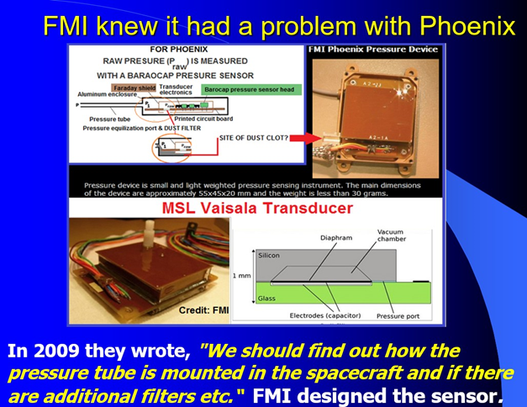
Figure 7-13: Phoenix and MSL pressure transducers.
I challenged the above statement on November 14, 2009, and published a criticism of it on my website on November 17, 2009. Kahanpää’s partial response from the FMI to my assertion that “something stinks” about his request for information on additional filters was as follows:
“Your nose smelled was also a real issue. The fact that we at FMI did not know how our sensor was mounted in the spacecraft and how many filters there were shows that the exchange of information between NASA and the foreign subcontractors did not work optimally in this mission!” (Kahanpää, personal communication, December 15, 2009).
In his e-mail of December 15, 2009, Kahanpää made clear that there was no extra filter. However, the confusion in his report highlights another possibility. As is shown in Figure 7-12, the filter is very small (~10 mm²).
A pressure calculator with entering arguments based on VL-1 and 2 Year 1 results showed the prediction was 98.19% in agreement with measured results for Viking 1, and 91.04% in agreement for VL-2.
Vikings, MSL, and Gay-Lussac’s Law.
Radioisotope thermoelectric generators (RTGs) may be at the root of problems with Viking and MSL pressure readings, which appear to vary inversely with outside temperatures. That is, when it gets colder outside and RTGs need to warm the inside of the landers, the pressure recorded inside goes up. Temperature and pressure variations seen for Viking 1 Year 1 almost exactly match what would be expected in accordance with Gay-Lussac’s Pressure Law (see Figures 7-13 A through 7-13 and 7-14). To counteract a minimum Year 1 temperature of 177.19K seen, and to raise internal temperatures to the maximum Year 1 external temperature seen (255.77 K), air caught behind a dust clog would experience a pressure rise. If Viking 1 sucked in enough dust and sand on landing to clog, but not enough to equalize the internal pressure with the air pressure outside, then whatever Year 1 minimum pressure seen inside the lander at the Tavis pressure transducer (6.51 mbar) would increase in pressure in accordance with Gay-Lussac’s Law. As shown in Figure 7-6, when the above two temperatures and 6.51 mbar are entered into the calculator, the expected pressure is shown to be 9.397 mbar. The actual maximum pressure recorded by Viking 1 was 9.57 mbar. That is a 98.19% agreement with the idea that the air access tube for the sensor was clogged. For Viking 2, the minimum and maximum temperatures were 152.14 K and 245.74 K. The minimum pressure found was 7.29 mbar. The maximum predicted pressure was 11.775 mbar. The maximum pressure recorded by VL-2 was 10.72 mbar, which is 91.04% of the predicted value.
The data points on Figure 7-13 are meant to get some sense of whether the pressure limits seen were roughly in line with expectations based on heat applied to a sealed space (behind the dust clots). They were, but obviously more so in Viking 1’s first year. By Year 2, overall predictions were off by 9 or 10 percent, but the calculations are less certain because of many incidents involving stuck pressure readings, sometimes for days on end. Annex C of our Mars Correct report supports this allegation, but Annex D also highlights stuck pressure readings for Viking 1. The old cliché “Garbage in, garbage out” sums up the problem. Temperature data seemed credible for the Vikings (except when reported as Absolute Zero). However, temperatures (in particular, ground temperatures) were problematic for MSL, as is detailed in Section 14.1 of the Mars Correct Report, which asserts that pressure data was not credible for any lander.
When comparing maximum air temperatures seen at MSL and Viking 1, we show in Annex M of our Mars Correct Report that the highest air temperature seen after JPL revised its Year 1 data was 4ºC (274.15K/39.2ºF). MSL sits at 4.59º South on Mars at an altitude of 4,400 meters below the areoid. Viking 1 was also in the tropics at 22º North. However, VL-1 was at an altitude of 3,627 meters below the altitude. R.M. Haberle at NASA Ames claims that the adiabatic lapse rate for Mars is about 2.5K km⁻¹. Using that rate, we would expect the maximum temperature at VL-1 to be about 1.9325 K lower than at MSL; however, the maximum temperature at VL-1 was only 255.77K/0.716K, while the maximum (revised) temperature for MSL Year 1 (on MSL Sol 227/March 2, 2013) was 274.15K/33.8ºF, a full 18.38 K warmer than at VL-1. Further, before JPL revised its MSL temperatures, it indicated a maximum air temperature at MSL of 8ºC (281.15K/46.4ºF) on MSL Sol 102 (November 18, 2012), but they later altered this temperature to -3ºC (270.15K). The high for MSL Year 2 was 11ºC (284.15K/51.8ºF) on Sol 760. So, it would appear that there is room to question the accuracy and consistency of air temperature sensors on these two missions.
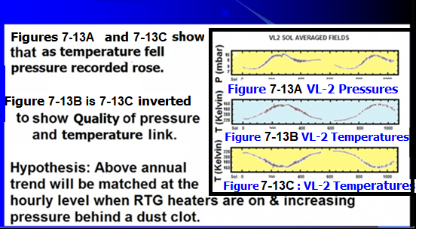
Figures 7-13A 7-13C are redrawn from Tillman and Johnson. Figure 7-13B inverts the direction of temperatures on the Y-axis to show how heating by RTGs to counter the increasing cold outside produces a curve very similar to the pressure curve.
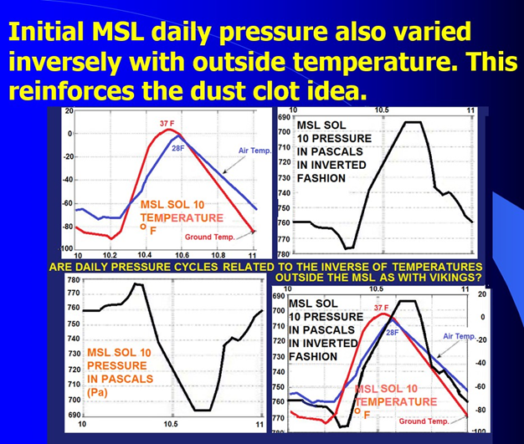
Figure 7-14 above: Daily pressure variation at MSL.
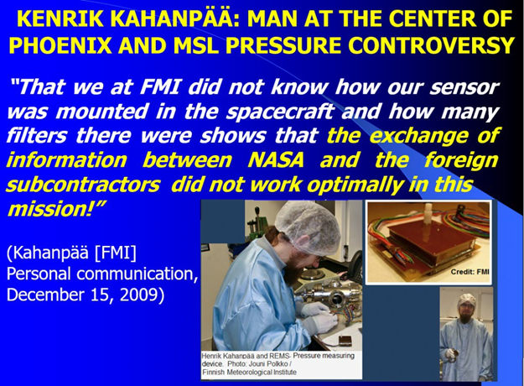
Figure 7-15 above: Cause of fatal flaws in spacecraft design.
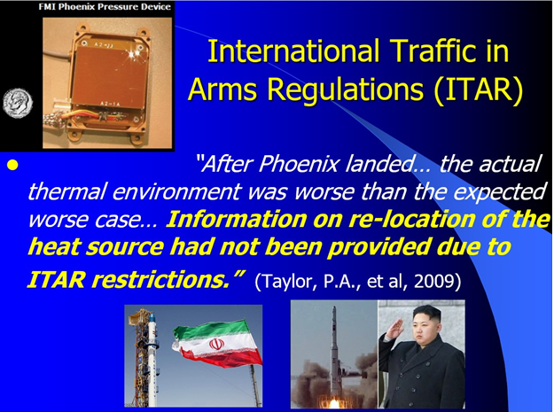
Figure 7-16 above: ITAR restrictions also lead to fatal design flaws.
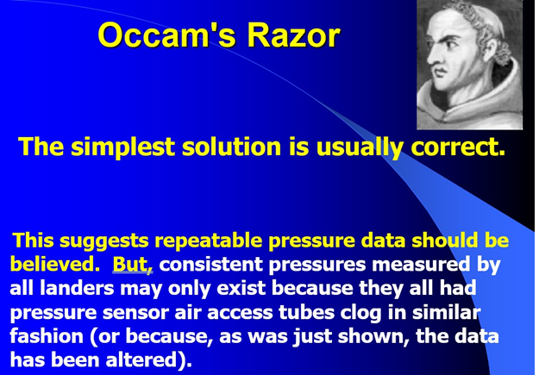
Figure 7-17 above: Unfortunately, the situation on Mars is more complex than Occam could imagine.
On July 24, 2017, we found that the REMS Team again altered the max pressure. On October 19, 2017, ESA reported that ExoMars had to raise its orbit. The move was mandated by “excessive density of Mars’ atmosphere.” We received notice of this from our partner Marco de Marco. Maximum pressure was raised to 1400 Pa (14 mbar). After they raised the maximum pressure from 1150 to 1400 Pa, they published a maximum pressure of 1,294 Pa for Sol 1784 on August 13, 2017. On the previous sol (1783), the pressure published was only 879 Pa. Yet even with the newer (likely false) upper pressure range of 1,400 Pa, when we challenged it with our colored spreadsheet and print-screen, the REMS Team dropped the 1,294 Pa for that sol to 883 Pa.
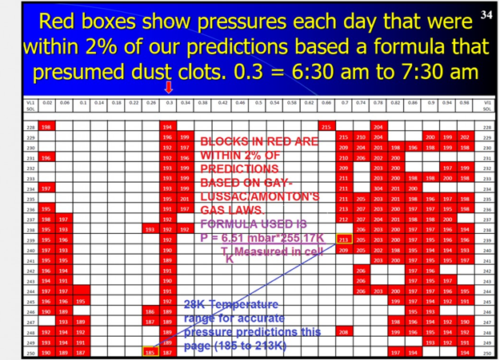
Figure 7-18 above: Sample of Annex F of Mars Correct: Critique of All NASA Mars Weather Data. Showing the times of day (for sols 228 through 250) when pressure predictions had less than a 2% difference from measured pressures at Viking 1. The formula used assumes that the pressure
transducer is no longer in contact with the ambient atmosphere on Mars.
NASA Orbiter Catches Mars Sand Dunes in Motion. The first startling confession was that:
“Mars either has more gusts of wind than we knew about Martian Bedforms – Too Much Movement of Sand Dunes and Ripples for 6.1 mbar.”
In November 2012, an article was published by Dwayne Brown of NASA Headquarters and Priscilla Vega at JPL. It said,
“The winds are capable of transporting more sand, said Nathan Bridges, planetary scientist at the Johns Hopkins University’s Applied Physics Laboratory in Laurel, Md., and lead author of a paper on the finding published online in the journal Geology. We used to think of the sand on Mars as relatively immobile, so these new observations are changing our whole perspective.”
It states that wind-tunnel experiments have shown that a patch of sand would require winds of about 80 miles/hour (128.7 km/hour) to move on Mars compared with only 10 mph (16 km/hour) on Earth. It then makes the understatement that measurements from the Viking landers, in addition to climate models, showed such winds should be rare on Mars.
The word "rare" was too generous. How does the above required 128.7 km/hour compare with winds observed on Mars? The set of graphs on Figure 7-19 below shows how wind speed varied at Viking 1 between its sols 1 and 350 (with the exception of sols 116 to 133 because data was missing then). The maximum wind recorded was 57.9 miles/hr. At no measured point over 8,331 measurements did the wind ever reach 128.7 km/hr. Average winds for Viking 1 were about 9.85 km/hr during sols 1 to 199, and 19.08 km/hr during its sols 200 to 350. All wind data was obtained from the Tillman Viking data.
For Viking 2, the maximum wind recorded was at 51.9 miles/hr which was still short of the speed required to move the sands.

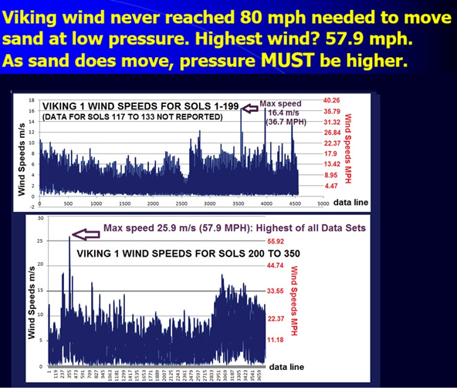
Figure 7-19 above: Wind speeds recorded at Viking 1 for its sols 1 to 116 and 134 to 350.
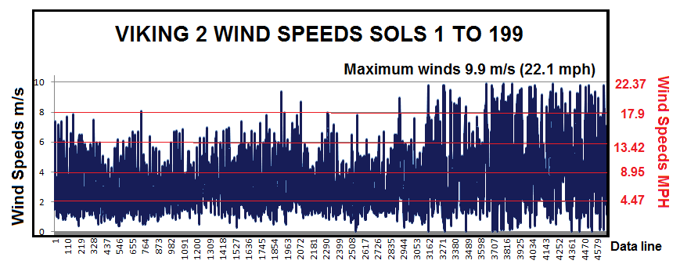
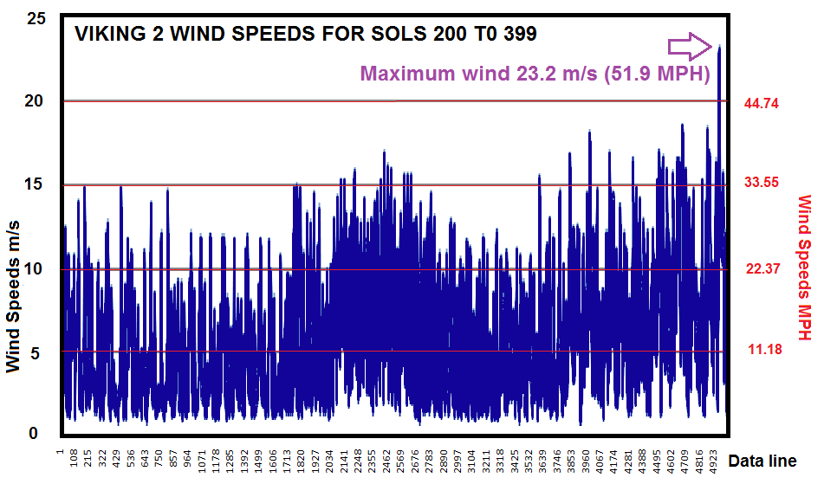
Figure 20 – Wind speeds recorded at Viking 2 for its sols 1 to 399

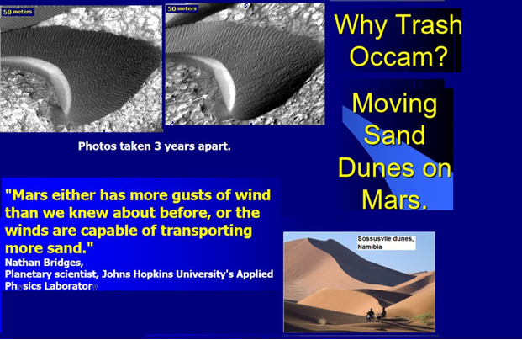
Figure 7-21 above: By NASA standards, the Martian atmosphere is too thin to move sand dunes, and for years, they claimed to find nothing solid that was moving around. But they were wrong again, as Figure 7-21 shows.

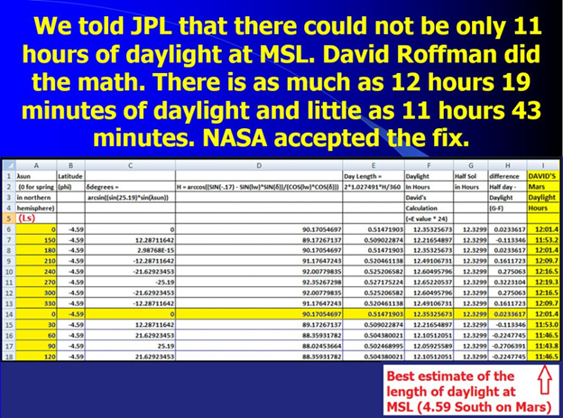
Figure 7-22 above: Calculating daylight length on Mars.

Figure 7-23 below: Stratus clouds on Earth are found up to altitudes of 13,000 meters, where pressures are about 163.33 mbar. They are not found on Earth at pressures below this level. The same kind of clouds are found on Mars. If the same minimum pressure is required on Mars, where these clouds were seen 16 km above Mars Pathfinder, which was 3.682 km below the areoid, it means that the stratus clouds were about 12.318 km above the areoid. Based on an accepted scale height of 10.8, this implies a pressure at the areoid of about 511. Further evidence that NASA is wrong is that the photo of clouds glowing red was taken an hour and 40 minutes before sunrise. This implies that the atmosphere is much denser than the near vacuum that NASA advertises for Mars.
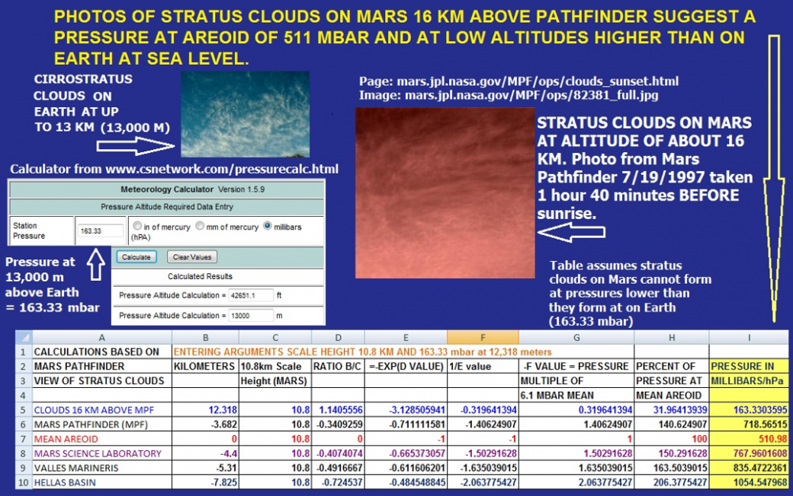
Figure 7-23 above. Stratus clouds on Mars at 13,000 meters above the areoid suggest a higher pressure than what NASA admits to.

Figure 7-24 below shows NASA publishing wrong Martian temperatures.
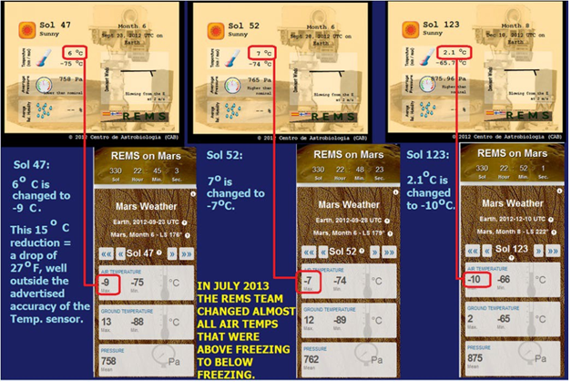
Figure 7-24 above: The REMS Team here appears to purposely sabotage all of its remaining credibility by going back and dropping very nearly all of its above-freezing air temperatures to below freezing. The question which has not yet been answered by JPL (or by anyone else) – Who ordered these changes, and why did they do so?

Temperature Measurement Concerns
Until July 3, 2013, we knew that over the first 11 months of operation, the REMS Team and Ashima Research had put out clearly erroneous winds, sunrise and sunset times, pressure units, dates on their reports, months, and claims about relative humidity that were not reflected on their reports. We (wrongly) assumed, however, that at least the temperature reports were reliable. That assumption was demolished on July 3, 2013, when they revised all temperatures back to the landing, wiping out scores of days where they had claimed air temperature highs above freezing. Some of these revisions are visible on Table 7-1.
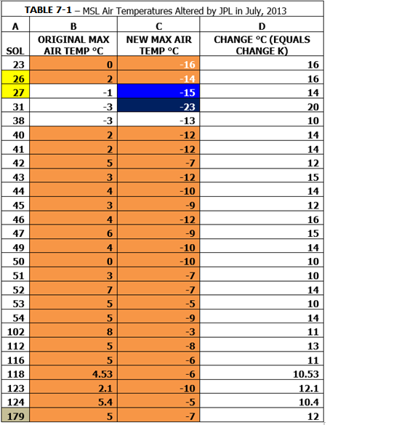
Table 7-1 above: For some unexplained reason, JPL dropped many Martian air temperatures for Curiosity on July 3, 2013, nearly 11 months after the landing.
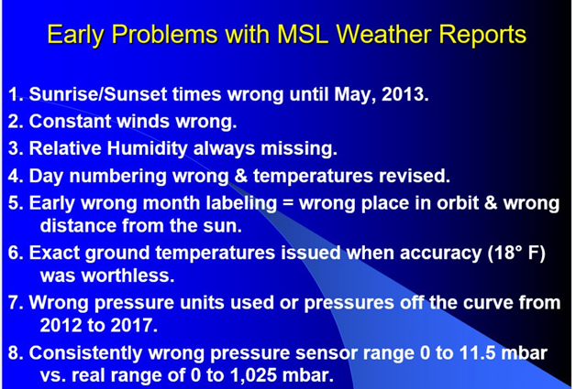
Figure 7-25 above: Problems with MSL weather reports.
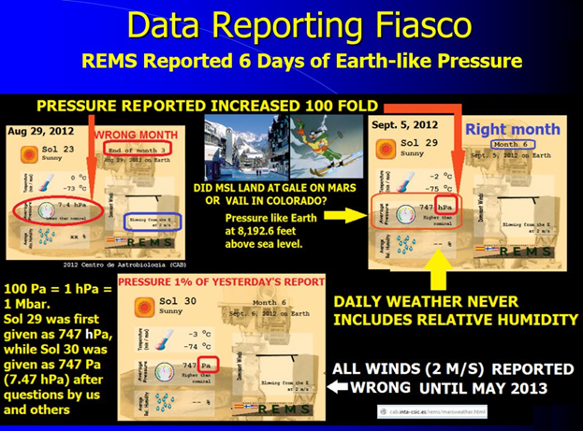
Figure 7-26 above: Data reporting fiasco by REMS.

MSL Weather Reporting Fiasco. The MSL REMS Team initially put out continually flawed data at http://cab.inta-csic.es/rems/marsweather.html. The REMS Team went from listing the pressure on August 28, 2012, as 7.4 hPa (mbar) and the month as 3 when it was really month 6; to a September 1, 2012, pressure of 742 hPa (Earth-like, seen in much of the U.S. West every day) in month 3 to 743 hPa pressure for September 2, 2012, which was correctly listed as month 6. Between September 5 and 6, 2012, reported pressures dropped from 7.47 hPa to 1% of that – 7.47 Pa. See Figure 7-26.
Figures7-27 and 7-28 below: Why Trash Occam.

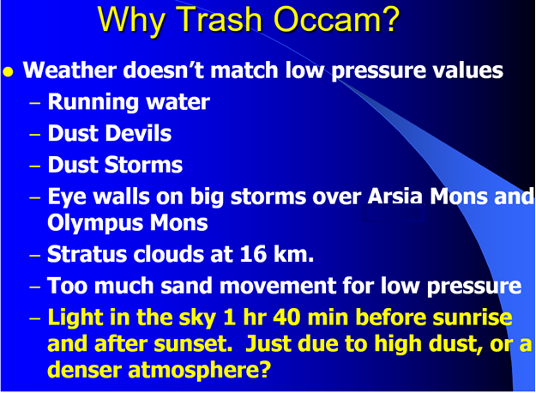
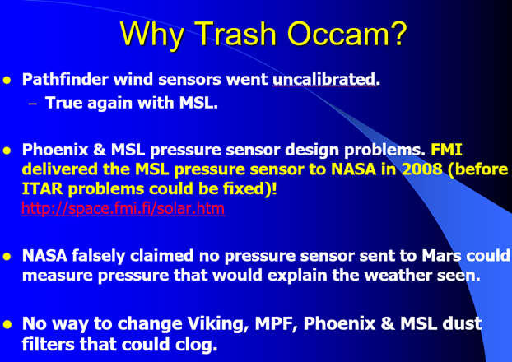
Figure 7-28 above: More reasons to trash Occam.

CRASH OF THE EXOMARS 2016 SCHIAPARELLI LANDER

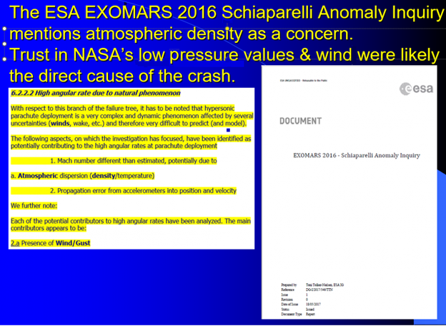
Figure 7-29 above: Critical portion of the ExoMars 2016 – Schiaparelli Anomaly Inquiry that backs our contention that NASA is underestimating Martian air pressures and wind speed. Their incorrect guidance caused this crash.
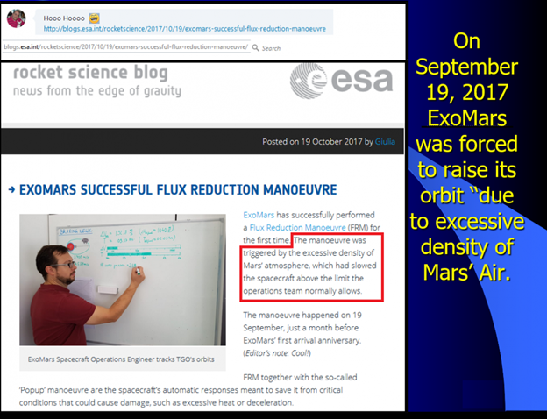
Figure 7-30 above: On October 19, 2017, ESA reported that ExoMars had to raise its orbit. The move was mandated by “excessive density of Mars’ atmosphere.” We received notice of this from our partner Marco de Marco.
On May 18, 2017, ESA published its ExoMars 2016 – Schiaparelli Anomaly Inquiry. While our research was not directly cited, we maintain a log of significant IP addresses and readers who access this report and our Mars-related websites. One of our most frequent readers is traced to Thales Alenia Space Italia S.p.A. in Milan, Italy. They built the Schiaparelli lander. In reading through the Inquiry, the following sections were of particular note:
Inquiry paragraph 6.2.2.2 High angular rate due to natural phenomenon. With respect to this branch of the failure tree, it has to be noted that hypersonic parachute deployment is a very complex and dynamic phenomenon affected by several uncertainties (winds, wake, etc.) and therefore very difficult to predict (and model).
The following aspects, on which the investigation has focused, have been identified as potentially contributing to the high angular rates at parachute deployment:
Mach number different from estimated, potentially due to atmospheric dispersion density/temperature
Propagation error from accelerometers into position and velocity
We further note:
Each of the potential contributors to high angular rates has been analyzed. The main contributors appear to be:
2.a. Presence of Wind/Gust
Of course, with respect to atmospheric density, we argue for air pressure at the areoid that is about 85 times higher than NASA asserts. As for wind/gusts, if NASA was right about a low atmospheric density and pressure, winds aloft would probably be insufficient to cause the loss of the lander. ESA is likely right about correcting the problem with the IMU (Inertial Momentum Unit). Perhaps that will be enough to overcome the density problem, but we challenged the wisdom of their statement that ExoMars 2020 was planned to proceed with models of atmosphere and winds as per 2016. In reality, looking back now from 2025, we see that there was no launch of an ExoMars 2020. The next planned launch of an ESA Mars mission has been put back until 2028.
It is still important to understand that a full-blown rejection of NASA and JPL without an in-situ ESA lander measuring pressures is problematic. ESA still depends upon NASA/JPL experience for advice on a number of space-related matters. If the IMU is fixed, it should not, as apparently happened in 2016, go into something akin to a nervous breakdown when the parachute is deployed and runs into much greater atmospheric density than expected. The specific final sequence of events in this “nervous breakdown” is spelled out as follows in ESA’s Inquiry:
f) Parachute deployment time (time from mortar firing to peak load factor) was circa 1 sec (in line with the predictions).
The parachute was deployed, and the parachute inflation triggered some oscillations of Schiaparelli at a frequency of approximately 2.5 Hz.
About 0.2 sec after the peak load of the parachute inflation, the IMU measured a pitch angular rate (angular rate around Z-EDM axis) larger than expected.
The IMU raised a saturation flag.
During the period the IMU saturation flag was set, the GNC Software integrated an angular rate assumed to be equal to the saturation threshold rate. The integration of this constant angular rate, during which the EDM was in reality oscillating, led to an error in the GNC estimated attitude of the EDM of about 165 degrees. This would correspond to an EDM nearly turned upside down with the front shield side pointing to quasi-zenith.
After the parachute inflation, the oscillatory motion of Schiaparelli under its parachute was mostly damped, and Schiaparelli was descending at a nominal descent rate, with very small oscillations (< 3 degrees) around the pitch and yaw axes.
After parachute inflation, the angular acceleration around the spin axis changed again.
g) The Front Shield was jettisoned as planned 40 seconds after parachute deployment (timer-based command) at 14:46:03.
h) The RDA (Radar Doppler Altimeter) was switched on at 14:46:19 (15s after Front Shield separation acknowledgment) and provided coherent slant ranges, without any indication of anomalies;
Once the RDA is on, RIL (Radar in the Loop) mode, “consistency checks” between IMU and RDA measurements are performed. The parameters checked are: delta velocity and delta altitude. The altitude is obtained using the GNC estimated attitude to project the RDA slant ranges on the vertical.
Because of the error in the estimated attitude that occurred at parachute inflation, the GNC Software projected the RDA range measurements with an erroneous off-vertical angle and deduced a negative altitude (cosines of angles > 90 degrees are negative). There was no check on board of the plausibility of this altitude calculation.
i) Consequently, the “consistency check” failed for more than 5 seconds. After which, the RDA was forced anyway into the loop based on the logic that landing was impossible without the RDA. The correctness of the other contributor to the altitude estimation, i.e., the attitude estimate, was not put in question. The RDA was put in the loop (event signaled by RIL time-out flag at 14:46:46).
The GNC (Guidance, Navigation and Control) mode entered was TERMINAL DESCENT, where the altitude is scrutinized to release the Back-Shell and parachute if the altitude is below an onboard calculated limit.
Because of the incorrect attitude estimation leading to an estimated negative altitude, the GNC Software validated the conditions for separating the back-shell and parachute.
j) Back-shell separation at 14:46:49.
k) Switch-on of the Reaction Control System (RCS).
First RCS thruster operation was at 14:46:51 (no backshell avoidance maneuver).
l) Switch-off of the RCS 3 seconds later at 14:46:54.
The criterion for the RCS switch-off was based on the estimation of the EDM (Entry Demonstrator Module) energy (as a combination of the altitude and vertical velocity) being lower than a pre-set threshold. Since the estimation of the altitude was negative and very big, the negative potential energy was much higher than the positive kinetic energy (square of the velocity), and this criterion was immediately satisfied, the RCS was commanded off as soon as allowed by the thruster modulation logic. This occurred just 3 seconds after the RCS switch-on command when the capsule was at an altitude of about 3.7 km, leading to a free fall of Schiaparelli and the impact on Mars surface about 34 seconds later.
m) The touchdown occurred at 14:47:28, corresponding to the crash of the surface platform on the surface of Mars at an estimated velocity of ≈150 m/s (about 335.54 miles per hour). The expected landing time was 14:48:05 (some 37s later).
At some point, hopefully in 2028, ESA will succeed. But here we must caution NASA. There is an old cliché:
“Fool me once, shame on you. Fool me twice, shame on me.”
NASA has fooled ESA once. But ESA is on to the problem and should not be fooled again. If NASA announces that they have come to understand that air pressure is much higher than they previously announced, there may be room for plausible deniability with respect to issues related to liability.
Whether NASA blames mistakes on unit conversion, or failure to allow for dust filter replacement on transducers, or inability to provide critical design information with respect to heat sources near the Vaisala pressure sensor due to ITAR, NASA can still preserve some of its respect if they publicly abandon their loyalty to a 6.1 mbar pressure at the areoid in time to ensure a successful ExoMars 2028 mission. The Chinese Tianwen-1 lander in 2021 safely arrived on the Martian surface. They had five years to read the ExoMars 2016 – Schiaparelli Anomaly Inquiry and make adjustments. I certainly caught them reading my website for my earlier discussion of the ESA crash. But they did not reveal ongoing fraud on a massive basis. They want Mars for themselves and, perhaps, they are not anxious to get mired in controversy about life (including Americans) being on Mars now. There appears to be a race forming to get people there. At his 2025 Inauguration, President Trump announced his intention to (publicly) plant our flag on Mars.
ESA gets smarter – Raises ExoMars orbit due to excessive density of Mars’s atmosphere. See Figure 7-30. This is similar to what was seen with the Mars Global Surveyor and also with the Mars Reconnaissance Orbiter. With the loss of the Schiaparelli lander and now this public ESA statement about excessive density of Martian air, the question remains as to when NASA will reach and publish the same common-sense conclusion. But we would be surprised if it occurs as a result of observations made by Perseverance, because again it apparently carries a pressure sensor that can only measure up to 11.5 mbar. In the Chinese Tianwen-1, the sensor can measure up to 20 mbar. If NASA is close to being right about air pressure on Mars, the Chinese sensor will be better for measuring pressure increases during major global or regional dust storms. But if my son and I are right about average pressure being about 511 mbar, neither the U.S. nor the Chinese sensor will be good for anything other than continuing disinformation.

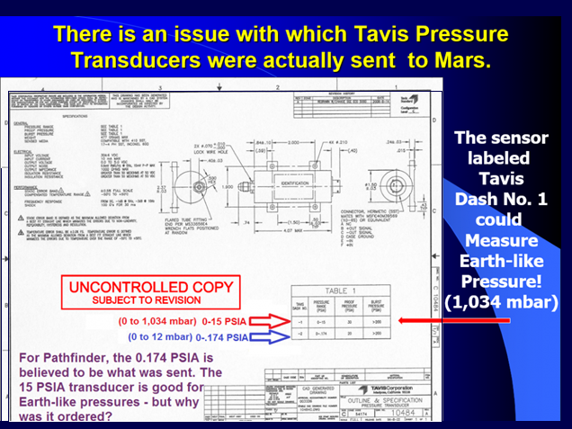
Figure 7-31 above: Reproduced from Tavis CAD Diagram 10484. For Mars Pathfinder, Tavis Dash No. 2 had a 0.174 PSIA limit (12 mbar), but Pathfinder Tavis Dash No. 1 had a 15 PSIA limit (1,034 mbar – best suited for Earth-like pressures). Source: Personal communication, Tavis Corporation 10/29/2009.
Which Transducers were used? A Tavis spokesman (Marty Kudella) thought Pathfinder used Part 10484 (Tavis Dash No. 2). The red words, uncontrolled copy subject to revision on both CADs, shown allow for a possible need in the future to alter the transducer pressure range.
Figure 7-31 lists it as having a 0.174 psia limit (12 mbar), the same limit later imposed by Vaisala on Phoenix. It first appeared that NASA also ordered a Tavis transducer that could measure from 0 to 15 psia (1,034 mbar): Part 10484, Tavis Dash No. 1 – see Figure 7-31 again. For 9 years, we believed that it supposedly remained on Earth and wrote that if, for classified reasons, a decision was made to send it in place of the 12-mbar transducer, none of the pressure data published by NASA for Pathfinder would be reliable. If there was a separate transducer that could measure Earth-like pressure, its final disposition still isn’t clear at this time, but based on information from the InSight Mission that landed on Mars on November 26, 2018, it seems possible that the same Tavis transducer could operate in either the low- or high-pressure range. Our Italian partner, Marco de Marco, called Tavis Corp. for clarification. They knew who he was, but wouldn’t answer his questions. We should look at the evidence for one physical transducer rather than two, but first, let’s discuss Tavis transducers in general.
Apparently, similar-looking and sized Tavis transducers could measure up to 0.1 psia (6.9 mbar), 0.174 psia limit (12 mbar), 0.2 psia (13.79 mbar), 0.26 psia (17.9 mbar), 0.36 psia (24.82 mbar), or 15 psia (1,034 mbar). Given their outward similarity and the enigma of Martian weather, the possible installation of the wrong Tavis sensor cannot be overlooked. Perhaps somebody wanted a 15-mbar sensor and mistakenly chose the 15-psi transducer. People made mistakes back then, and they still do today, as is apparent when we examine REMS (Rover Environmental Monitoring Station) data for MSL. For five days straight from September 1 to September 5, 2012, they published Martian pressures of over 740 hPa (Earth-like), when they supposedly meant 740 Pa. A pressure of 740 hPa = 740 mbar, while 740 Pa = 7.4 mbar. They published numerous other similar questionable items or obvious errors (see Section 2.7 and Figures 17A and 17B in our Mars Correct Basic Report).
We only learned one night before InSight reached Mars that there are also meteorological sensors aboard, including the same Tavis sensors above. With respect to the dual pressure range, Tavis states, “Tavis specializes in custom configurations and capabilities for your specific application. Discuss your application requirements with our engineers for your exploration science needs” (http://pressure-transducers.taviscorp.com/item/all-categories/pressure-transducers-for-interplanetary-exploration/10484). Could a radio signal cause the sensor to toggle from the low range to the high? Again, Tavis wouldn’t tell us, but it’s quite possible.
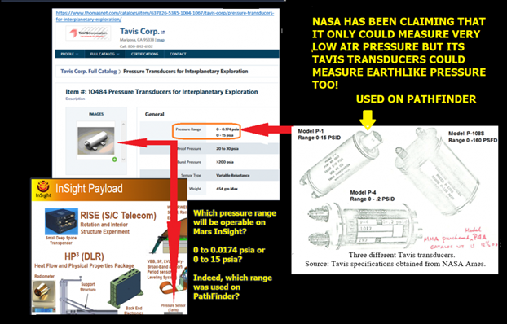
Figure 7-32 above – Tavis pressure sensors had the ability to measure Earth-like pressures on Mars, but it took years for me to learn this sensitive information.
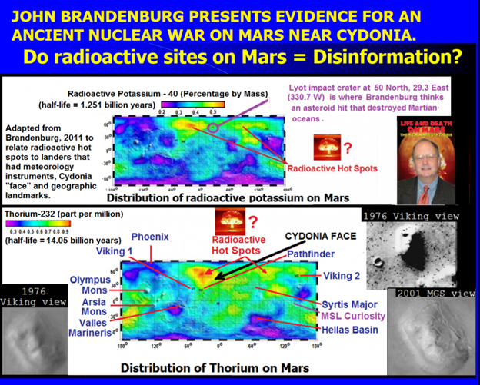
Figure 7-33 above: Dr. John Brandenburg claims there is evidence for an ancient nuclear war on Mars. The still radioactive bomb sites are shown here, as is the “face” at Cydonia, which looks like ruins from that war.
So, what difference does all this make? The human race is suffering from a massive case of amnesia. Setting aside religious claims about the age of mankind, a quick online search for the time when homo sapiens first arose indicates a time at least 100,000 to 200,000 years ago. Yet we know very little about our ancestors from before about 5,000 years ago, and there is even controversy about the age of the Sphinx in Egypt.
Is there a link between our ancestors and any civilization that might have existed on the Red Planet? When the Viking 1 Orbiter observed Mars on July 25, 1976, it sent us the famous image of what looked like a face at Cydonia on a 2 km mesa situated at 40.75° North latitude and 9.46° West longitude. At the time, Viking chief scientist Gerry Soffen dismissed the “Face on Mars” in image 035A72100 as a “trick of light and shadow.” However, a second image, 070A13, also shows the “face,” and it was acquired 35 Viking orbits later at a different sun angle from the 035A72 image. This latter discovery was made independently by Vincent DiPietro and Gregory Molenaar, two computer engineers at NASA’s Goddard Space Flight Center. DiPietro and Molenaar discovered the two misfiled images, Viking frames 035A72 and 070A13, while searching through NASA archives. Images taken decades later did not back the original ones, and the belief in an alien origin of the face-like mesa has been used to mock and dismiss the work of scientists who backed what was first seen.
Analysis of the face is beyond the scope of this work, but it is tempting to match what looks like disinformation about Martian air pressure to Cydonia. Why would the Government hide the truth about Mars? One only has to look at the panic that ensued when Orson Welles gave his War of the Worlds radio broadcast in 1938. Combine that with reports of radioactive isotopes found on Mars that match what is seen at nuclear detonations on Earth (Brandenburg, 2011), and it’s easy to understand why the Governments might want to keep the public from knowing the truth about Mars. While Brandenburg’s paper, Evidence for a Large, Natural, Paleo-Nuclear Reactor on Mars, only discusses a natural cause for an ancient nuclear explosion there, his 2011 book, Life and Death on Mars, The New Mars Synthesis, on page 179, forwards the idea of an airburst caused by a great intelligence with great malice.
Do I believe Brandenburg? I originally wrote that, “It’s not important.” But now, as old age begins to set in on me (I went through cancer last year), I think it’s important to take a stand. The portrait of Mars given to our world by NASA is so wrong that I don’t think all the mistakes are coincidental accidents. NASA is hiding something, and I think it’s likely to be Brandenburg’s war. If true, he thinks it was likely to occur hundreds of millions of years ago. If the warriors of that past era were not exterminated in a nuclear blaze, then they had time to evolve or advance themselves into a time-traveling race advanced enough to write something like the Torah. But there are “ifs” attached to this thought, and it ignores the personal aspects and experiences in relationships between God and people. I have had such experiences. (see https://biblio.ie/9780935834550). The story is an entirely true account of the landmark interfaith custody battle for my older son, Rabbi Robert Altair Roffman. It resulted in Archbishop McCarthy’s annulment of Robert’s Catholic Baptism. The news coverage is at 1984 Miami Herald Press Coverage (https://arkcode.com/images/herald_001.png).
Do I believe in the literal word of the Torah? There are other ways to interpret it (metaphorical, allegorical, and mathematically encoded). However, there are intriguing hints in the Bible about contact between someone not human (Nephilim/giants – possibly Reptilians, and the daughters of man in Genesis 6:4). These ideas can be looked at as distractions, but the reality is this: Martian weather does not match NASA-backed low Martian air pressure. Both science and religion stress the importance of our past and our fate in the future.
It’s generally accepted in science that Mars was once a warmer, wetter world with oceans. If the air pressure remains high, there is still the question of what happened to its seas. Indeed, to have a sea suddenly appear there today, all that would be necessary would be to melt the frozen freshwater sea in Utopia Planitia.
If Mars had life, did it all die, or merely move underground? Did bacteria ever travel from Mars to Earth after an asteroid impact there? We’ll examine this evidence for that in Chapter 8. Did it play a role in our evolution? Did something much higher up the evolutionary scale make it from there to here, and was it linked to Cydonia or the Bible’s Nephilim? Did they influence or color any of mankind’s religious experiences or doctrines? These are questions of fundamental importance. The human race often uses religious doctrine to justify wars. However, the Government might worry that data supporting a past not generally in line with the Bible would lead to anarchy and chaos.
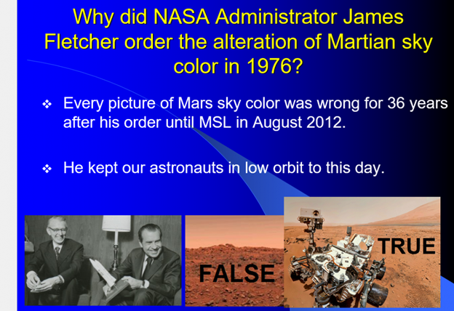
Figure 7-34 above: NASA Director James Fletcher ordered the sky color seen by Viking 1 to be changed from blue to red, thus hiding green patches (possible lichens) seen on some rocks to look brown. He took the lead in covering up life on Mars. President Nixon shut down the Apollo moon program early. Supposedly, according to Jackie Gleason, Nixon and Gleason once were shown four alien corpses being kept at Homestead Air Force Base. See https://www.kpl.gov/catalog/item/?i=ent://ERC_215_8682/0/215_8682:HOOPLA:16226931.
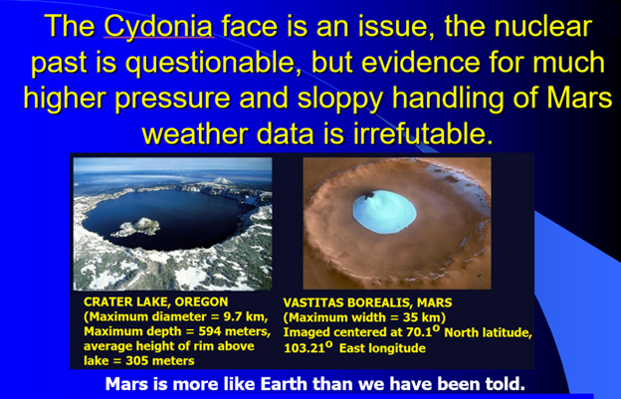
Figure 7-35 above: Place a nuclear heater in Vastitas Borealis, and you might just create a good fishing hole and place for a base. If we ever do it, we might want to cover the lake with a transparent tarp so it could hold some extra atmosphere. A hundred years in the future, and this place could be functioning as a fantastic resort.

