# **Chapter 6**

**Emails to & from ET Ebrahimi**

This chapter reveals all emails to and from a man who claims to be an extraterrestrial alien. It also focuses on whether or not he is the source of COVID-19. It documents everything he wrote to me by email or said to me for over a year. His claim is related to remnants of life on the 27-pound meteorite that he recovered from the seafloor in the Strait of Juan De Fuca off his current hometown of Sooke, British Columbia, Canada, between March 1 and March 6, 2018.

The email source material is for the period February 16, 2019, until December 25, 2022, with Craig Ebrahimi below being audited to just deal with issues related to why Craig is suspected of having spread COVID-19 around the Earth. There were also frequent phone calls that I discussed, but they were not recorded by me, so their accuracy is related to how good my memory is.

**EMAILS**: Times given are for different time zones. I gained access to some mails written by Craig before January 26, 2020, because he forgot to delete them. He was quite angry when he realized what he had done, but the cat was out of the bag. While they didn’t speak with me about any of them, I could trace many (if not almost all) of my readers to DOD. Hopefully, the Trump Administration can use some of what is included below to go after Anthony Fauci, a criminal who had to be pardoned by the false President Biden in the last 15 minutes while he illegally occupied the office of President.

**On Sat, Feb 16, 2019, at 2:52 PM, Craig Ebrahimi craigebrahimi@hotmail.com wrote to Naveen Jain:**

Yes, it is fossil E.T.

Who is Naveen Jain? Wikipedia says:

Naveen K. Jain (born 6 September 1959) is an Indian-American business executive, entrepreneur, and the founder and former CEO of InfoSpace. InfoSpace briefly became one of the largest internet companies in the American Northwest, before the crash of the dot-com bubble and a series of lawsuits involving Jain. In 2010, Jain co-founded Moon Express where he was the Executive Chairman, and in 2016, he founded Viome, where he is the CEO.

***From: Naveen Jain naveen@viome.com***

***Sent: February 16, 2019 3:36 PM***

***To: Craig Ebrahimi craigebrahimi@hotmail.com***

***Cc: Naveen.jain@gmail.com Naveen.jain@gmail.com***

***Subject: Re: Fw: Fw: Discovery in a Meteorite uvic bc***

*Interesting. I will love to see it. Are you selling it?*

*Naveen*

*Naveen Jain*

*Founder & CEO, Viome, Inc.*

*M: 425-830-6556*

**MAY 10, 2019, 4:23 pm from Dr. Humphrey to Craig, later forwarded to Barry on Thu, February 6, 2020.**

***BARRY, THIS FOSSIL INVISIBLE TO MOST MICROSCOPES.***

*From: Elaine Humphrey ech@uvic.ca*

*Sent: May 10, 2019 4:23 PM*

*To: Craig Ebrahimi craigebrahimi@hotmail.com*

*Subject: sem today.*

*Hi Craig. I managed an hour or so on the SEM today under my own time to look at the brown rock. I consolidated the files I have on Dropbox into one folder. The May 10, 2019 folder is all I took today. [Dropbox link] The iPhone pictures show the white spots, and the SEM pictures do not. The SEM (note: SEM means scanning electron microscope) pictures with PDBSE in the baseline are backscattered images showing the different grains in the rock. The attached and the EDS images of the same spot seem not to correlate at all. Rock is interesting! I think I may have mentioned this before! Best wishes for your help.*

*Elaine*

*PS: There was no waiting for the SEM to pump down. I’ve returned the rock to the vacuum.*

**Fri, 17 May 2019 at 00:13.**

*Hi Chandra (Wickramasinghe). I have a client, Craig Ebrahimi, who brought in a meteorite. At first, it looked like gabbro, but the chemical analysis (by Act Labs) proved it to be a meteorite. I understand that he sent you thin sections, outside crust, a piece of th****e rock with an embryo fossil in a white circle.*** *I have a very small sample for SEM and EDS*

(Note: EDS means Energy-dispersive X-ray spectroscopy (EDS), It is a technique used in geology to analyze the chemical composition of rocks, minerals, and soils. It's also known as EDX or XEDS.) Dr. Humphrey continues:

*Craig suggested that if you have finished with his samples, is it possible to send them to me? Since I will be in the UK at the end of June for a month, I could pick them up. If you are still working with them, please keep us in the loop. Many thanks for your help.*

*Best wishes*

*Elaine*

*Dr. Elaine C. Humphrey*

*Fellow of the Microscopy Society of America*

*Past President Microscopical Society of Canada*

**The plot thickens:**

*May 20, 2019*

*Dear Elaine*

*Unfortunately, the meteorite package was left in a shed near our house, and it appears to have been stolen. I do not have it anymore.*

*Sorry about this.*

*Sincerely*

*ChandraProf.*

*Chandra Wickramasinghe*

*Honorary Professor University of Buckingham, Buckingham, UK*

*Honorary Professor University of Ruhuna, Matara, Sri Lanka*

*Honorary Professor Sir John Kotelawala Defence University, Sri Lanka*

*Buckingham astrobiology website: [link]*

*Ruhuna astrobiology website: [link]*

*Personal website:* [*www.profchandra.org*](http://www.profchandra.org)

**As will be shown later, Wickramasinghe is a liar. He continues below:**

*May 20, 2019, at 1:15:13 PM PDT*

*From: Chandra Wickramasinghe ncwick@gmail.com*

*Date: May 20, 2019, at 1:15:13 PM PDT*

*To: Elaine Humphrey ech@uvic.ca*

*Subject: Re: meteorite*

*Reply-To: ncwick@gmail.com*

*Hi Elaine. Our house was in chaos after some international travel, so I stored all valuable things in an outhouse. Some months back, I discovered that many things including the box with the meteorite had disappeared. I was waiting to get a colleague to handle the experiments on this, but it never happened. Sorry about this – not my fault.*

*Best Chandra*

*Prof. Chandra*

***May 20, 2019, 1:32 PM***

From: Elaine Humphrey ech@uvic.ca

Dr. Humphrey responded as follows onMay 20, 2019, 1:32 PM:

*To: Craig Ebrahimi craigebrahimi@hotmail.com*

*Subject: Fwd: meteorite FYI. Sent from my iPhone*

*Mon, 20 May 2019 at 18:15, Elaine Humphrey ech@uvic.ca wrote:*

*Chandra. Oh dear, that’s too bad. Did you get any information out of them before they were stolen? If so, have you published them?*

*Elaine*

*Sent from my iPhone*

*From: Jerzy Sawicki jasawicki@shaw.ca*

*Sent: July 15, 2019, 2:54 PM*

*To: Craig Ebrahimi*

*Subject: Re: raman This was a forwarded e-mail originally from someone named George.*

*DEVIANT OFFWORLD FILM CLIP.*

**The date of the film is uncertain.**

*From: Karen Ziegler kziegler@unm.edu*

*Sent: September 6, 2019, 1:08 PM*

*To: Craig Ebrahimi craigebrahimi@hotmail.com*

*Subject: Oxygen isotope analyses of your rocks*

*Hi Craig,*

*No, we can’t do organics here. Sorry. In terms of oxygen isotopes, definitely neither one of your rocks is definitely Martian. Based only on my results, they could be: lunar (or E-chondrites, but they don’t appear to be chondrites, D17O values are typical for the moon. You need to know the mineralogy and the mineral chemistry in order to determine which of these types they could be. Do you have EMPA analyses of the minerals?? Mn/Fe ratios (see attached figure)?*

*Let me know what you think.*

*Cheers,*

*Karen*

**NOVEMBER 25, 2019 CORRESPONDENCE PUBLISHED BY WICKRAMASINGHE…**

*There have been many claims that the occurrence of pandemic influenza and other viral outbreaks is correlated with the well-known 11-year sunspot cycle1–3, although the precise mechanism for such a causative connection had remained unclear… The next minimum between the current cycle 24 and cycle 25 was predicted to occur between July 2019 and September 2020 (Figure 1). Perhaps, we have now approached the deepest sunspot minimum for a century, with more ‘spotless’ days per week than in previous minima. On the basis of this data, there appears to be a prima facie case for expecting new viral strains to emerge over the coming months, and so it would be prudent for Public Health Authorities the world over to be vigilant and prepared for any necessary action. We need hardly be reminded that the specter of the 1918 devastating influenza pandemic stares us in the face from across a century.*

**NOTE:** 15 days later, the first known coronavirus patient (Wei Guixian) started feeling ill.

On December 22, 2019, Craig is interviewed about his meteorites. The link for the 14-minute show is at <https://disclosurechronicles.com/2019/12/22/major-discovery-nasa-test-crystallized-humanoid-in-moon-meteorite-2020-2021/>. It’s worth seeing and hearing it. Craig claims that the rocks have a lot of uranium and elements not from this world. It took six diamond blades to cut the rock.

Craig claims in the interview that there are 16 embryos and that the origin of the rocks is likely the moon, 4 Vesta, or beyond. This would appear to contradict a later claim that the non-Martian origin was due to a fight and personality conflict with Dr. Karen Zieglerat the University of New Mexico.

**Temperature:** Craig says the rock was in a room that was 25 degrees (C), but the rock in one section is 14 degrees (7:13 to 7:17). The embryonic section is 6 degrees, and it pulses to 12 degrees (7:20). I listened to this video again on July 11, 2025 during the final editing of this book and heard him say something major that he never discussed with me – namely that there was altered DNA found in the rock! He said the DNA was mostly human, but that a section had been spliced into it from some other life form. I know that I asked him several times about testing for amino acids (and DNA), but he never verbally let me know that he had this kind of finding. The video wants all kinds of identity verification. The show was on a site known as *thirdphaseof moon*.

Craig states that he found a second rock like it, but that one when cut open had something like dragon inside. I was aware of this second meteorite but he never told me about anything inside that resembled a dragon. He also said that the second rock had something like “swirled insectoid in it.” Exactly how he found the first rock, even with extraterrestrial contacts, is not clear because he states that it was not just on the sea floor. Instead, it was buried under 12 feet of mud.

In January 2020, Craig was communicating with someone at NASA named Emery Smith (see an article about him at <https://historycollection.jsc.nasa.gov/JSCHistoryPortal/history/oral_histories/SmithEE/SmithEE_2-28-06.htm>).

**JANUARY 5, 2020**

**From:** Emery Smith **emerysmith28@gmail.com**

**Sent:** January 5, 2020 10:07 AM

**To:** Craig Ebrahimi **craigebrahimi@hotmail.com**

**Cc:** Olivia Smith **oliviasmithh33@gmail.com**

**Subject:** Re: ET EMBRYO

Biotechnology

Dear Craig,

Yes, I have lots of ideas. We need to get a CAT scan of it first, and then we can stereotactically, under fluoroscopy, make a small drill hole, utilizing a Midas REX High-Speed Neuro drill, into the meteorite where the being is. We can then extract some particles we can run the DNA test on, and any additional tests. The procedure should be quite easy with the right tools. I would also like to film the procedure as well and document it. Would you be interested in flying to Colorado to be on my show Cosmic Disclosure on GAIA TV to talk about the find first? All travel and expenses will be paid for. Let me know if this appeals to you. I am also filming a small series called The Beings, we could interview you as well for. Regardless, I am interested in seeing the specimen in BC, and thank you for the invite. I also want to be part of the analysis team and help in any way possible. I have a film production team as well at your disposal called ZeroCross Productions.

Sincerely,

Emery Smith

202-999-6871

**INITIAL EBRAHIMI-ROFFMAN CONTACT**

**From:** Craig Ebrahimi craigebrahimi@hotmail.com

**To:** BarrySRoffman@gmail.com

**Date:** Jan 26, 2020, 12:55 PM (Saturday)

**Subject:** Fw: Extraterrestrial embryo discovered in meteorite UVIC BC

My name is Craig Ebrahimi, research scientist/Founder of Deviant Off-World Technology

Barry, would you be interested in the research and biotechnology opportunity of the only pristine extraterrestrial embryo on the planet at the University of Victoria, BC?

­­­­­­­­­­­­­­­­­­­­­­­**From:** Craig Ebrahimi **craigebrahimi@hotmail.com**

**To:** BarrySRoffman@gmail.com

**Date:** Jan 28, 2020, 12:08 PM

**Subject:** Fw: #2 HED meteorite with crystallized reptilian.

Oxygen isotopes d17 HED Meteorite discovered in Sooke, BC. Raman data supports that the top center grain is an organic reptilian converted to diamond.

Craig

**Comment by Roffman added on December 25, 2022:**

Craig’s January 28, 2020, email identifies the apparent embryo way before it is established that the fossil is from a living creature. In several conversations and emails up through today, Craig claimed to be an alien with the power to put me down just with his eyes.

While I initially assumed that Craig is a Nordic or other species related to humans, in different photographs that I have of him he has a different-looking face/shape. His lower legs seem too small for a human or a Nordic. A Nordic should be tall. This guy may be a shape-shifter, which Reptilians are said to be. The fact that he claims to have 16 Reptilian embryos may point to him being a Reptilian. They are generally hostile to humans, although our military is alleged to work with them. Craig is suspected by me as being the individual who brought COVID-19 to Earth.

The next Figure shows alleged alien Craig Ebrahimi shortly after we had a verbal fight. The remarks about alien uniforms seen by President Eisenhower on February 20, 1954, are taken from page 202 of the book BEHOLD A PALE HORSE by William Cooper. They were found by me after I caught an intelligence agent checking out a link on this site to the book, but before I was aware of the uniform remarks. If Craig is indeed wearing an alien military uniform here, then our military forces should look for others like it. In checking my website statistics on June 17, 2025, I have the Pale Horse book posted at <https://arkcode.com/A%20Pale%20Horlse.pdf>. Is anyone reading it? Yes. This month I see eight readers.

[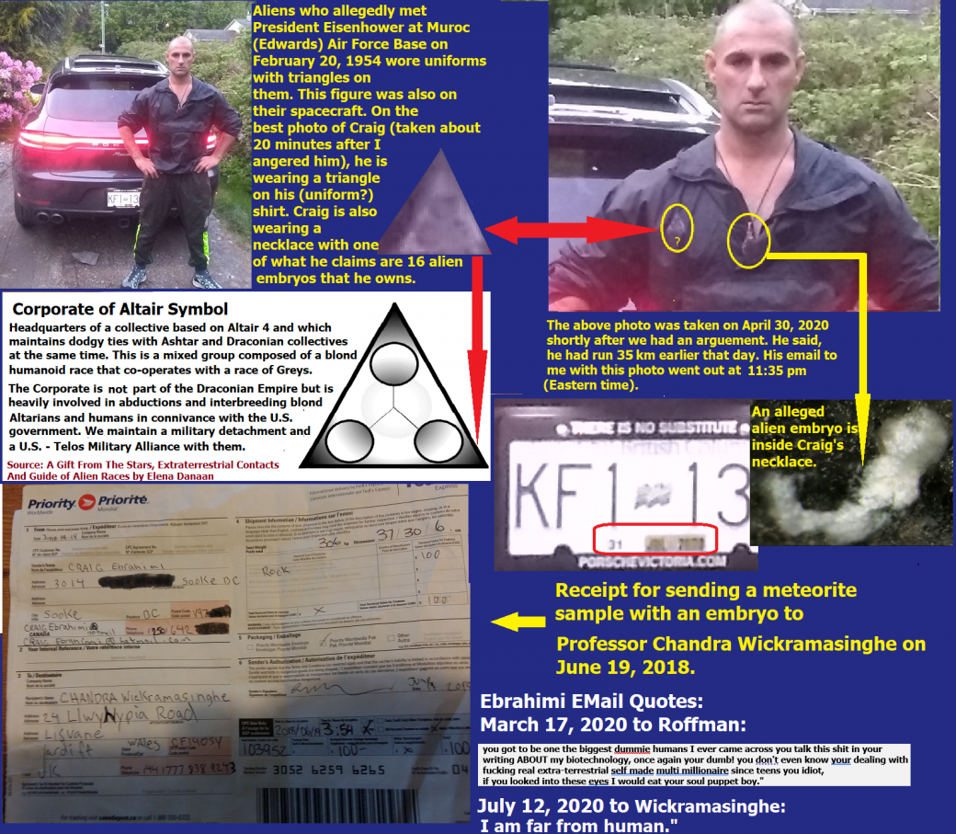](https://roffmanmarsresearch.com/wp-content/uploads/EBRAHIMI-PHOTOS-AND-EVIDENCE4.png)

**Figure 6-1 above.** The photo was taken on April 30, 2020, a few minutes after Craig and I had an argument.

During our argument, Craig told me, “Listen, that virus only works on weak humans. Bill Gates patented this coronavirus strain in 2013; the documents are available. You just gotta dig. All this has been a plan since the 1950s.”

I saw those documents when COVID was ravaging the world.

**E.T.s live in Sooke, BC, Canada?** Elon Musk visited the area on August 6, 2019. He was seen in Metchosin, just a few miles from Sooke, but he vanished from there for a day. He may have met with Craig elsewhere – either at the home of an E.T. or aboard an E.T. ship. This was at a time between when Craig had sent a meteorite sample to Professor Chandra Wickramasinghe (June 19, 2018) and when COVID-19 broke out in China (December 2019).

***From:*** *Craig Ebrahimi craigebrahimi@hotmail.com*

***To:*** *BarrySRoffman@gmail.com*

***Date:*** *Feb 2, 2020, 3:59 PM*

***Subject:*** *The cure for diseases.*

*Thank you, Barry, for your insight! Did you ever think I could be a walking, talking prophet who holds the medicine that will solve world diseases? And extend human longevity.*

**COMMENT BY ROFFMAN:**

The above response from Craig was apparently his reaction to seeing his name encoded in the Torah. Attached to my previous e-mail to him were the matrices at <http://arkcode.com/images/eaten_meteorites.png> and <http://arkcode.com/images/cure_man.png>.

I cautioned Craig about claims to prophecy. However, it remains unclear who the voice was that told Craig where to look for the meteorite on the seafloor. I think it was other aliens, likely members of Craig’s species.

Craig was told that I will not endorse him until I got answers in writing to my concerns about security. Our military is following this article closely. I said I would advise them or our government to consider buying the rock from him, but only if I think the thing is a legitimate security concern. For something this important, I said I don’t want to rely on my memory. I needed answers in writing without any exaggeration or hyperbole.

**COMMENT BY ROFFMAN FEB 3, 2020:**

Craig claimed to hear a voice that told him exactly where to look for the meteorite. This raises the possibility that telepathic aliens directed the epidemic. How many people did it kill? On January 24, 2025, I found the following figures online:

***COVID-19 Global Death Toll Estimate Is Three Times What Records Indicate. In this Lancet study, investigators estimate an excess mortality of 18.2 million deaths worldwide due to the COVID-19 pandemic between 2020-2021, although just 5.9 million are reported.***

It should be assumed that we were and are under a hostile biological attack by aliens. The U.S. Space Force must come up to speed quickly to respond. Frankly, since I know what is going on, the military should call me back to active duty ASAP to help them deal with the threat.

**February 3, 2020 @ 11:20 am** Craig wrote:

*I intended to help humanity. Sincerely. I know I hold unimaginable biotechnology to help and advance humankind. Yes, it should be sold to the Institute of Disease Control in Atlanta or the Wyss Institute* [*https://wyss.harvard.edu/*](https://wyss.harvard.edu/) *in the control of George Church at* [*https://en.wikipedia.org/wiki/George_Church_(geneticist)*](https://en.wikipedia.org/wiki/George_Church_(geneticist))*. For 2+ years, I have been stressing about the pristine extraterrestrial embryo while now 2mm from the exposed surface. We should be meeting and going over the data, and then you fly home and put together a report for the sale.*

***Craig Ebrahimi***

The following is Craig’s reply to an email that I sent to him on or before February 3, 2020.

**From:** Craig Ebrahimi craigebrahimi@hotmail.com

|  |  |  |
| --- | --- | --- |
| to: BarrySRoffman@gmail.com | |  |
| date: Feb 3, 2020, 4:19 PM | |  | |
| Subject: Re: answers |  | |

1. Do you think an alien was communicating with you? Have you ever had a UFO encounter or a possible abduction experience?

Aliens communicate with telepathy.

1. *Response: I have B- blood, which is from the Persian royal bloodline, and so do my two baby boys. My wife is O-. I have always been in communication with something, but humans would classify me as just crazy. So, to answer your question, I do not believe I was abducted, but I have many pictures of a green orb that follows my family and me around. When you zoom in to the amazingly clear pictures, it seems to resemble Ezekiel's wheel.*
2. Do you still hear voices? *Response: YES.*
3. How did you know to contact me? *Response: IT HAPPENED.*
4. Are you now saying that you have no measured speed increase and that all enhanced effects are mental? Can you name any positive physical changes? *Response: PHYSICAL AND MENTAL, YES.*
5. All uranium is radioactive, but not all uranium is fissionable. I need to know which isotopes were found before I fly out there. Please look at the chemistry report and tell me what elements and/or isotopes are mentioned there. *Response: I HAVE ONLY HAD THE OXYGEN ISOTOPES DONE (OXYGEN 17 HED). THE CHEMISTRY WAS JUST A BASIC METEORITE TEST. 5 GRAM SAMPLES WERE PROVIDED. I WILL SEND YOU THE REPORT.*

*From: Craig Ebrahimi craigebrahimi@hotmail.com*

*To: <BarrySRoffman@gmail.com>*

|  |  |
| --- | --- |
| *from:* | *<craigebrahimi@hotmail.com>* |
| *to:* | *“BarrySRoffman@gmail.com” <* |
| *date:* | *Feb 3, 2020, 11:17 pm* |

*“I have not told you that the first scientist to work on this meteorite was Chandra Wickramasinghe. I sent him an embryo. There is more than one, and he emailed Dr. Elaine (Humphrey) and told us someone broke into his house and stole my samples.*

*I have all the emails.*

On February 4, 2020:

|  |  |
| --- | --- |
| *from:* | *Craig Ebrahimi <craigebrahimi@hotmail.com>* |
| *to:* | *“BarrySRoffman@gmail.com” <BarrySRoffman@gmail.com>* |
| *date:* | *Feb 4, 2020, 11:17 AM* |
| *subject:* | *ET HOLDING TECHNOLOGY* |

*Barry, you asked about VOICES. I would answer that as they’re not loud yelling voices, more like telepathy voices/ideas/direction. My pictures of the orb WE DID NOT WANT TO MENTION.*

*While I will show in person while my children are in the pictures, Barry, to understand the chemistry, just read the final report.*

*This is the ET holding some type of technology! If you were looking at it in person, it looks like it will come out of the rock. I have many. Dr. Elaine (Humphrey) is holding a sample that she is guarding with her life; it seems to have an elongated head. I will send pictures when she gives me permission.*

*SINCERELY,*

*Craig*

**Dr. Humphrey chimed in next:**

*From: Elaine Humphrey ech@uvic.ca*

*Sent: February 7, 2020 11:56 AM*

*To: Craig Ebrahimi craigebrahimi@hotmail.com*

*Subject: EDS report 2.*

*Hi Craig,*

*Looking through our old data, I notice that several of our spectra show relatively high amounts of iridium. It is interesting to note that this is not consistent over all the surface. Only some of the grains contain iridium.*

[***https://www.dropbox.com/sh/ud476i4c1pe5jx2/AABn1w2aGFHe2u54evJCxB5Da?dl=0sample b spectrum 2b.doc***](https://www.dropbox.com/sh/ud476i4c1pe5jx2/AABn1w2aGFHe2u54evJCxB5Da?dl=0sample%20b%20spectrum%202b.dochttps://www.dropbox.com/sh/ud476i4c1pe5jx2/AABn1w2aGFHe2u54evJCxB5Da?dl=0sample%20b%20spectrum%202b.doc) *shows relatively high amounts of iridium.*

*Best wishes, Elaine*

*From: Elaine Humphrey ech@uvic.ca*

*Hi Craig,*

*I put the pictures into a Dropbox so you can look at them.*

[***https://www.dropbox.com/sh/nyxnvggkfiy8fds/AABNdL7uQsN1Xu4uvQSuufVoa?dl=0***](https://www.dropbox.com/sh/nyxnvggkfiy8fds/AABNdL7uQsN1Xu4uvQSuufVoa?dl=0)

*Best wishes, Elaine*

On Wed, Feb 12, 2020, at 6:20 PM, Craig Ebrahimi

*Subject: (Interesting read) My blood B-Anunnaki* ***craigebrahimi@hotmail.com*** *wrote:*

[***https://www.gaia.com/article/rh-negative-blood-type-alien***](https://www.gaia.com/article/rh-negative-blood-type-alien)

*Craig raises the issue of whether he has alien blood. The article cited includes the following text:*

*The Nephilim of biblical lore are responsible for Rh-negative blood types. In the Book of Enoch, the Nephilim, also known as the Watchers, descend from the heavens and mate with humans, creating a human-angel hybrid. This group of angels and their offspring were wiped out in the great biblical deluge, though some were said to have survived, leaving the Rh-negative blood distinction.*

Note: Figure 3-5 in Chapter 3 of this book offers reason to believe that Nephilim are Reptilians. This may be evidence that Ebrahimi is at least a human-reptilian hybrid.

Craig continues:

*Another otherworldly theory is that the Anunnaki, the extraterrestrial race that helped establish ancient Mesopotamian civilizations, engineered or crossbred with humans, and that some part of this process created the Rh-negative blood type. It’s alleged that people with Rh-negative blood have distinct physical features paired with a predilection for psychic phenomena and alien abductions. Some of those features are:*

*Sensitive vision and particular sensitivity to sunlight*

**Extra vertebrae**

A human typically has 33 vertebrae, while most mammals have a similar number of cervical (neck) vertebrae, usually seven, with the total number of thoracic and lumbar vertebrae varying depending on the species, but generally totaling around 19-20 vertebrae across most mammals.

The *Journal of Human Evolution* (Volume 179, June 2023) states, “ancestral primates were characterized by 29 precaudal vertebrae, with the most common formula being seven cervical, 13 thoracic, six lumbar, and three sacral vertebrae. Extant hominoids evolved tail loss and a reduced lumbar column via sacralization (homeotic transition at the last lumbar vertebra). Our results also indicate that the ancestral hylobatid had seven cervical, 13 thoracic, five lumbar, and four sacral vertebrae, and the ancestral hominid had seven cervical, 13 thoracic, four lumbar, and five sacral vertebrae. The last common ancestor of humans and chimpanzees likely either retained this ancestral hominid formula or was characterized by an additional sacral vertebra, possibly acquired through a homeotic shift at the sacrococcygeal border.”

Lower body temperature. On April 30, 2020, I was told by Craig that he originally wanted to hire me to understand why the meteorite pulsed by coldness. He also told me that he and his wife had eaten a little of it.

* High intelligence
* Higher blood pressure
* Red or reddish hair

[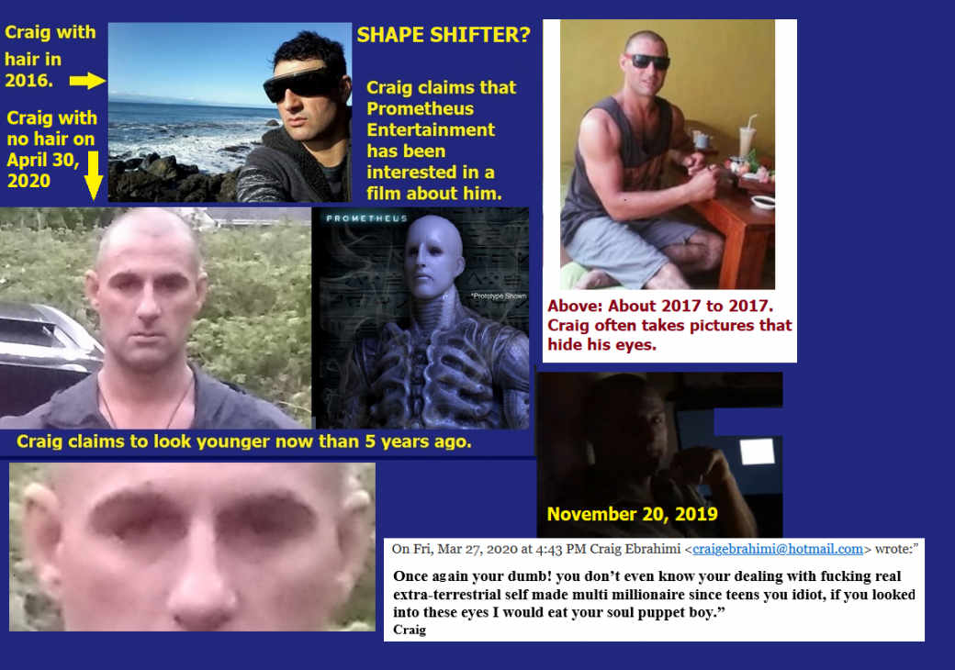](https://roffmanmarsresearch.com/wp-content/uploads/REPTILIAN-SHAPE-SHIFTER2.png)

**Figure 6-2.** With respect to sensitive vision, the two pictures above (2016 to 2017) show Craig wearing sunglasses. While the top-left photo shows Craig outside on a sunny day, the top-right photo has him still wearing them indoors. In the photo labeled November 20, 2019, the picture was taken in a dark room where it is hard to see important facial features. At one point, Craig mocked me for not knowing that it was NOT him in the November 20, 2019 photo, but my overall impression was that he was trying to cover up the mistake of letting me know what he looks like. Other photos led me to believe that we are dealing with a possible shape-shifter.

I have no data on the number of vertebrae that Craig has. However, the first thing that I noticed upon seeing the April 30, 2020 photo in Figure 6-1 was how wide his chest was and how small his legs were. His physique seemed to suggest a potentially different skeletal frame. See Figure 6-3.

**Extra vertebrae?** See Figure 6-3 above.

I next heard from Craig in March, 2020:

***March 2, 2020.***

*Hello Barry,*

*I have been advised legally not to give any more data to anyone. But I will say that I have a lot of interest from leading international biotechnology companies. I am dealing with the Canadian government and CEOs of international space agencies. If this is a hoax, I would be charged with fraud. In Canada, what would I gain? Maybe 3 square meals a day in confinement? Your flight from Florida direct is still on the table if you want to see the ET embryo in person before it’s sold.*

In response, I discussed my reluctance to fly anywhere until the Wuhan coronavirus is under control. I also pointed out that no known scientist has concluded that there is, in fact, an embryo in his meteorite. If they have detected any amino acids, I have not yet seen proof of that either. Later on 3/2/2020, Craig wrote me saying,

*“Barry, when I receive new data of organic extraction in the UK, I will keep you updated.*

Aaron Burton is a PhD at the Johnson Space Center in Houston. This email shows that he had meteorite samples.

***From:*** *Burton, Aaron (JSC-XI311)* [*aaron.burton@nasa.gov*](mailto:aaron.burton@nasa.gov)

***Sent:*** *March 10, 2020 6:22 AM*

***To:*** *Craig Ebrahimi craigebrahimi@hotmail.com*

***Subject:*** *RE: organic extraction*

*Hi Craig,*

*It doesn’t look like my lab will be functional any time soon. I’ll get the samples sent back to you this week. Sorry!*

Note: Although Craig told me that Burton’s lab was shut down due to the COVID-19 plague, on the thirdphasemoon video back on December 22, 2019 Craig discussed Burton. He said that the scientist was in charge of Mars rovers and that he was excited about the rock for four months. Then he told a colleague about it and that that was why his lab was shut down for no apparent reason. The implication was that NASA did not want the public to know about such life in space. Craig bragged about gaining new physical abilities, like running 35 km every day. He boasted about the rock being able to extend lifespans. Along this line, the email record shows the following:

Chandra Wickramasinghe says Craig has the cure from space.

***From:*** *Chandra Wickramasinghe ncwick@gmail.com*

***Sent:*** *March 15, 2020 10:46 AM*

***To:*** *Craig Ebrahimi craigebrahimi@hotmail.com*

***Subject:*** *Re: longevity vaccine from space*

*Hello Craig,*

*Yes, I would much like to help. I believe you have the cure from space, but I don’t have the institutional resources available to me.*

***cc*** *Personal website:* [*www.profchandra.org*](http://www.profchandra.org)

*Buckingham astrobiology website:* [*https://www.buckinghtionsam.ac.uk/research/bcab*](https://www.buckinghtionsam.ac.uk/research/bcab)

*Ruhuna astrobiology website:* [*http://physics.ruh.ac.lk/astrobiology/*](http://physics.ruh.ac.lk/astrobiology/)

*ISPA website:* [*www.ispajapan.com*](http://www.ispajapan.com)

**ROFFMAN COMMENT:** Craig claims to be an alien below, threatens me with his eyes. I have no idea about who my “Hebrew follower” is. It could be Mossad, but they never show up on an IP address check. So far, all my intelligence followers are with DOD, largely through Fort Huachuca, or with the UK MOD. They probably have people who are Jewish and read Hebrew as well as Arabic, but I haven’t met anyone like that.

**On Fri, Mar 27, 2020 at 4:43 PM, Craig Ebrahimi craigebrahimi@hotmail.com wrote:**

*“Guy, your dumb ass shit keeps getting sent to me by one of your Hebrew followers. You got to be one of the biggest dummy humans I ever came across. You talk this shit in your writing ABOUT my biotechnology. Once again, you're dumb!* ***You don’t even know you're dealing with fucking real extraterrestrial self-made multi-millionaire since teens, you idiot. If you looked into these eyes, I would eat your soul, puppet boy.”***

|  |  |  |  |  |
| --- | --- | --- | --- | --- |
| |  | | --- | | Barry Roffman <barrysroffman@gmail.com>Apr 1, 2020, 1:13 PM | | | |  |
|  |  |  |  |
|  |  |  |  |

From: Barry

To: Craig

April 1, 2020

TYPO CORRECT Apology

*Hello Craig,*

*This e-mail serves as a partial apology. Yesterday, I created a new folder on Gmail that contains 48 of your previous e-mails in chronological order, received. This made it much easier to start at the beginning on January 26 and go through everything you sent me sequentially. I am finding answers to many of my questions. If you want to know why I missed a lot before, it is for the following reasons:*

1. *Some of your attachments came up as possibly infected with malware and thus were not opened by me before.*
2. *There was nothing like a cover letter to tell me what to pay attention to.*
3. *Some were nothing more than links to Alex Jones videos that were not of interest to me or thought to be germane.*
4. *There were stories that I was working on that were of greater interest, like the impeachment of President Trump.*
5. *I was getting a mixture of truth and exaggeration from you.*

*I am now slowly going through each item that you sent. Meanwhile, I strongly suggest that you and everyone WHO handled the rocks be tested for the COVID-19 virus.*

*It remains true that my primary interest in what you have found is related to national security. My reports, published on my site, will continue to be updated with a goal of providing maximum clarity and accuracy. I realize that you have financial interests here, but what you found might be killing tens of thousands of people and possibly millions of people in the near future. (Note: That prediction came true.) So, while you are understandably pissed at me for publishing everything you send me, sorry, but millions of lives trump profit for you. It may be that you have antibodies that will be profitable for you, but the longer you wait, the more there will be antibodies in recovered patients that may work as well.*

*Finally, you have played with the implications that you are an alien. If you believe this, you are either crazy or (if it’s true) a real danger to our planet. You need to get sober and send me a clear statement about your identity.*

*Barry*

That Craig sent me copies of so many highly sensitive emails between himself and extremely rich or famous people is evidence that he is not smarter than people like myself are. His reaction to what I sent him is given below:

|  |  |  |  |  |  |
| --- | --- | --- | --- | --- | --- |
|  | Apr 2, 2020, 2:54 PM | |  |  | |
| |  |  | | --- | --- | | |  | | --- | | *To* [***BarrySRoffman@gmail.com***](mailto:BarrySRoffman@gmail.com) |   *Ba* |   *WTF* *I DID NOT SEND YOU THAT OR ANYTHING!*  Roffman response to Craig’s denial and a warning about the  possible consequences of not cooperating with DoD or the  UK MoD. EDX = energy-dispersive microanalysis. See  CRISTOBALITE AND HEMATITE PARTICLES IN THE HUMAN BRAIN  (By M. Kopani et al., 2016) at [**http://www.arkcode.com/photo5_76.html**](http://www.arkcode.com/photo5_76.html)  for what might be in Craig’s brain. | | |

My response to Craig was as follows: APR 4, 2020

|  |  |  |  |
| --- | --- | --- | --- |
| from: | | Barry Roffman <barrysroffman@gmail.com> | |
| to: | | Craig Ebrahimi <craigebrahimi@hotmail.com> | |
| date: | | Apr 3, 2020, 11:22 AM | |
| subject: | | Re: BARRY EDX DATA OF #2BR SMALLER EURCRITE HED | |
|  | |

*Ah, but you did. I have enough from you to see that the thief is almost certainly your “friend” Wickramasinghe in the UK. I don’t know if they’ll do it, but I’m asking the UK MOD to pick him up for interrogation. I’m pretty sure that he stole your sh*t, sold it to the Chinese lab in Wuhan, and started the current plague. That would make him guilty of infecting over a million people so far and killing at least 54,000 people.*

*This apparent *sshole has destroyed the world economy and taken at least one U.S. aircraft carrier out of service. If he is not guilty, then he can start with lie detectors to prove it. If you warn him or discuss this with him, that could be seen as collaborating with the enemy. While I cannot be certain, it’s wise to assume that my phone is bugged by my Intel friends. Therefore, assume that if you call me to help in the investigation, Uncle Sam will hear you and your point of view.*

Craig continues,

*“In no way should you view the Government here as your enemy.”*

**ROFFMAN COMMENT**: The Obama and Biden administrations have shown themselves to be the enemy of America and all humanity. That was not yet clear to me when I wrote the above. Indeed, there are many Torah Code matrices that insinuate that both Obama and Biden are alien infiltrators. See Chapter 3 of this book, and in particular:

* Figure 3-1 (axis term ALIEN IN OUR GOVERNMENT at the same skip as BIDEN),
* Figure 3-4 (axis term OBAMA IS REPTILIAN),
* Figure 3-5 (axis term CHUCK SCHUMER at the same skip as REPTILIAN and UFO),
* Figure 3-6 (MARK MILLEY at the same skip as GENERAL and UFO with REPTILIAN at skip -1),
* Figure 3-8 (with GENERAL, TO HYBRIDIZE and UFO all at the same absolute skip and GENERAL at skip -1),
* Figure 3-9 (with REPTILIAN GOVERNMENT and INVASION at the same skip),
* Figure 3-10 (BIDEN [is] AN ALIEN as the axis term, where UFO and MARS are at the same absolute skip),
* Figure 3-11 (with axis term CHRIS WRAY as the axis term with FBI and UFO at the same skip),
* Figure 3-12 GARLAND FROM AN ALIEN LAND,
* Figure 3-13 (ALVIN BRAG is at the axis term with REPTILIAN at the same skip),
* Figure 3-14 (with A. MAYORKAS as the axis term touching REPTILIAN at skip -1),
* Figure 3-16 (with CIAKAHRR, a synonym of REPTILIAN as the axis term at the same absolute skip as GRAY, HITLER, C. WRAY, HOOVER, CONSPIRACY, BUSH, USA, and GAZA),
* Figure 3-17 (with HITLER in sequence with HARRIS),
* Figure 3-18 with (Governor and VP candidate TIM WALZ sharing a letter with REPTILIAN at skip -1),
* Figure 3-19 (with former Director KIM CHEATLE, responsible for Trump’s security on the day he was shot and wounded, at the same skip as BIDEN, ALIENS, PLEIADES, and UFO),
* Figure 3-20, JOHN DURHAM with REPTILIAN, and
* Figure 3-21 HAKEEM JEFFRIES with REPTILIAN.

Later in Chapter 3 I added two matrices that pointed to A. (Adam) Schiff as being reptilian.

Extraordinary claims require extraordinary evidence. I submit that the above Torah Code matrices are extraordinary evidence that the Torah is encoded with a warning about hostile Reptilian aliens running much of our government.

I continued my response to Ebrahimi on April 3, 2020, as follows:

*“They are trying to keep the Chinese from killing us all. What is out there is a threat to all humanity. If this guy sold your stuff to Wuhan, he may turn out to be one of the biggest killers in history. You do not want to be seen backing him. He had your stuff for a long time, did not safeguard your property, and did not finish the analysis. It made no sense that you would eat the stuff unless Chandra did a study that showed improved life expectancy in animals.*

*I have asked you to call me several times. You have chosen to ignore me or send silly stuff, but some of that silly stuff had meaningful email trails (which I am still going through). Frankly, at this time, I would just prefer to turn over the investigation to DoD or the UK MOD. Bottom line – at any other time in history, this would all be an academic question, but now there is no difference between trying to get the full truth here and trying to find a nuclear bomb buried under one of our cities by the Chinese, North Koreans, or (other) crazies. There is still time for you to come out of this with money, fame, and a good place in history. But if you hesitate and try to back your thief buddy, your fate will likely not be so good. I am not your average investigator.*

*I can read the Code, I’ve found you in it, and Wickramasinghe.*

*Barry”*

**Response from Ebrahimi:**

***BARRY, NOW YOU'RE ON THE RIGHT TRACK.***

**ROFFMAN COMMENT**: This was after Craig read my appraisal that the thief was likely

Wickramasinghe.

|  |  |
| --- | --- |
| from: | Craig Ebrahimi <craigebrahimi@hotmail.com> |
| to: | “BarrySRoffman@gmail.com” <BarrySRoffman@gmail.com> |
| date: | Apr 7, 2020, 12:52 AM |

**ROFFMAN COMMENT:** Naveen Jain claims to be a billionaire with the world’s largest private collection of meteorites that are worth millions of dollars. **COSPAR** = Committee on Space Research. This is the first time that Craig said his wife also ate some of the material. Note that he says nothing about her reaction to it. The meaning of "seed balls" is unclear unless it is a reference to puffball “fungi” seen on Mars. These are discussed in Section 15.3.1 of the Roffman Mars Correct Basic Report and Chapter 8 of this book. Some of Craig’s ideas seem to be based on the Alex Jones Radio Show. On his show on April 12, 2020, Jones claimed that not only is Obama a communist, but that the NIH under Dr. Fauci, at Obama’s direction, supervised experiments in Wuhan on COVID-19.

**2025 Note:** This is likely why Biden gave Fauci a pardon on January 20, 2025.

Craig did not point to any specific plan since the 1950s. I gather that the reference is based on his understanding of common conspiracy beliefs.

Questions from Roffman to Ebrahimi on April 8, 2020, and his answers to Roffman on the same day.

|  |  |
| --- | --- |
| from: | Craig Ebrahimi <craigebrahimi@hotmail.com> |
| to: | “BarrySRoffman@gmail.com” <BarrySRoffman@gmail.com> |
| date: | Apr 8, 2020, 7:15 PM |
| subject: | Fw: Re: Answered |

**From:** Barry Roffman barrysroffman@gmail.com

**Sent:** April 8, 2020 6:30 AM

**To:** Craig Ebrahimi craigebrahimi@hotmail.com

**Cc:** davidaroffman@gmail.com DavidARoffman@gmail.com

**Subject:** Re:

OK. I saw the emails from the two Docs. I’ll work this into the record today. More dates would be helpful. Here Craig’s responses are shown in bold print.

When did you find the rocks? **March 01-06, 2018**

When did you mail him the sample? **June 19, 2018**

Do you have a copy of the shipping receipt? **Yes. SEE FIGURE 3 BELOW.**

When did he get it? Did he sign for it? **Yes.**

Did he report a theft to the police in Sri Lanka? A copy of the police report would help. The sample was supposedly stolen from his gated community in Car… (the next item was not saved).

**Naveen Jain was excited immediately when we were in contact, but then his dad passed away. After he found out that Chandra had an embryo fossil, Chandra flew here to California for the COSPAR MEETING in 2018. Chandra and Naveen met and planned to both screw me over, but they don’t know what they’re dealing with. Then, they were stolen from. Now they are trying to communicate with me now with seed balls.**

When did he suggest that you taste the sample? **No one told me to eat it. My wife and I ground it up and ate grams of it with bacon and eggs.**

When did you lose your hair?

Can you name any pharmaceutical companies involved? Craig did not answer this directly, but in an email from him to me on March 27 at 2:31 pm, he mentioned: **CEO of INOVIO, JOSEPH KIM (joseph.kim@inovio.com), founded by Bill Gates.**

Do you have any evidence for Chinese involvement?

At some point, a COVID-19 test will be needed for you and your Victoria partners.

**Listen, that virus only works on weak humans. Bill Gates patented this coronavirus strain in 2013; the documents are available, you just gotta dig. All this has been a plan since the 1950s.**

Note: A denial of this charge is posted at [**https://committees.parliament.uk/writtenevidence/2109/default/**](https://committees.parliament.uk/writtenevidence/2109/default/)**. See** [**https://patents.google.com/patent/US10130701B2/en**](https://patents.google.com/patent/US10130701B2/en)for a related patent that may be the source of confusion here.

Craig continues:

|  |  |
| --- | --- |
| *from:* | *Craig Ebrahimi <craigebrahimi@hotmail.com>* |
| *to:* | *“BarrySRoffman@gmail.com” <BarrySRoffman@gmail.com>* |
| *date:* | *Apr 9, 2020, 12:57 PM* |
| *subject:* | *Info wars have good investigative journalist like you! other than alex jones* |

*https://www.infowars.com/bill-gates-crosses-the-digital-rubicon-says-mass-gatherings-may-not-retu-without-global-vaccine/*

*https://www.infowars.com/censorship-extends-from-bill-gates-to-5g-can-trump-get-re-elected-in-this-environment/*

*https://www.infowars.com/shocking-historian-exposes-bill-gates-ties-to-nazis-and-more/*

**On 11 April 2020:** Why has Fort Huachuca’s Canadian liaison officer not yet removed the meteorite from the University of Victoria?

**PARTIAL ROFFMAN ANSWER ON DECEMBER 29, 2020:** Craig reports that the Canadian Royal Police are stopping him every week and that he is afraid to leave Canada for fear that they will not let him back in. I surmise that Fort Huachuca is likely keeping him under their thumb, but they have yet to contact me directly to confirm it.

To my readers there in January 2025: I’m now 77, but I am still willing to return to active duty (with Space Force) so we can work more freely together for a common goal – but I will not work toward any assault on our Constitution.

Craig’s ideology again seems to be in part taken from Infowars and Alex Jones videos.

**13 April 2020:** This list is first accessed by the United Kingdom Ministry of Defence (UK MOD) at 13/Apr/2020:05:43:29 MST7MDT and was again accessed at 13/Apr/2020:17:51:44.

**20 April 2020**

|  |  |
| --- | --- |
| from: | Barry Roffman <barrysroffman@gmail.com> |
| to: | “davidaroffman@gmail.com” <DavidARoffman@gmail.com> |
| date: | Apr 19, 2020, 1:16 PM |
| subject: | New connection between Wickramasinghe and China |

**ROFFMAN COMMENT:**

My son, Dr. David A. Roffman (PhD, physics), wanted to see proof of a connection between Wickramasinghe and China. It is established in the article by Wickramasinghe and (among others) Jiangwen Qu of the Department of Infectious Disease Control, Tianjin Centers for Disease Control and Prevention, Hedong Qu, Tianjin Shi, China. Further, there may be an effort by Gensuke Tokoro of the Institute for the Study of Panspermia and Astroeconomics, Gifu, Japan, to sell any cure developed from Craig’s meteorite. Tokoro is president and CEO of Kyoto Biopharma, Inc., and executive director of ISPA. He lives in Japan.

**Article:** Comments on the Origin and Spread of the 2019 Coronavirus

**Link:** <https://www.academia.edu/42041228/Comments_on_the_Origin_and_Spread_of_the_2019_Coronavirus>

**Citation:** Virol Curr Res, Volume 4:1, 2020, DOI: 10.37421/Virol Curr Res.2020.4.109

**Authors:** N Chandra Wickramasinghe1,2,3,4*, Edward J Steele2,5, Reginald M Gorczynski6, Robert Temple7, Gensuke Tokoro2,4, Jiangwen Qu8, Daryl H Wallis2,4, and Brig Klyce9

1 Buckingham Centre for Astrobiology, University of Buckingham, MK18 1EG, England, UK

2 Center for Astrobiology, University of Ruhuna, Matara, Sri Lanka

3 National Institute of Fundamental Studies, Kandy, Sri Lanka

4 Institute for the Study of Panspermia and Astroeconomics, Gifu, Japan

5 C Y O’Connor, ERADE Village, Foundation, Piara Waters, Perth 6112 WA, Australia

6 University Toronto Health Network, Toronto General Hospital, University of Toronto, Canada

7 History of Chinese Science and Culture Foundation, Conway Hall, London, UK

8 Department of Infectious Disease Control, Tianjin Centers for Disease Control and Prevention, Hedong Qu, Tianjin Shi, China

9 Astrobiology Research Trust, Memphis, TN, USA

**Abstract:**

We propose that the new coronavirus, which first appeared in the Hubei province of China, was probably linked to the arrival of a pure culture of the virus contained in cometary debris that was dispersed over a localized area of the planet, namely China. The sighting of a fireball some 2000 kilometers north of Wuhan on 11 October 2019, followed shortly after by the first recorded cases in Hubei, is suggestive of a causal link. Gene sequencing data of the virus that show little or no genetic variations between isolates, combined with available epidemiological data, point to the predominance of a transmission process directly from an “infected” environment, with person-to-person transmission playing a comparatively weaker secondary role. The facts relating to this epidemic are discussed and placed in the context of other pandemics that have been recorded throughout history.

**Issue:** 1, **Volume:** 4, **Journal Name:** Virology Current Research, **Page Numbers:** 1-4, **Publication Date:** 2020, **Publication Name:** Virology Current Research

|  |  |  |  |  |  |  |
| --- | --- | --- | --- | --- | --- | --- |
| from: | Craig Ebrahimi <craigebrahimi@hotmail.com> | | |  |  | |
| to: | “BarrySRoffman@gmail.com” <BarrySRoffman@gmail.com> | | |  |  | |
|  | | **Apr 30, 2020, 3:34 PM** |  |  | | |

**ROFFMAN COMMENTS ARE INSERTED IN BOLD FONTS**

Craig wrote:

Barry, the only reason I ever contacted you was regarding David Roffman’s website saying if you have a problem we can solve it. Then you started trying to get me to prove to you all about my work and getting no respect except fear-mongering bullshit.

I responded:

**We are solving your problem in that we present good evidence that shows Wickramasinghe is not the innocent victim of the theft of your sample while it was in his custody. Rather, he is the thief and, with his Chinese partner and the communist Chinese, he shares responsibility for the murder of over 230,000 people as of this date. I told you up front I am a retired military officer with direct contact with U.S. Intelligence, and that when you talk to me, you talk to U.S. military intelligence. David’s website is maintained by me. He does the math. I do the writing.**

*Craig then stated:*

*The first email I sent obviously had nothing to do with the real reason.*

**ROFFMAN:** **So what was the real reason?**

*CRAIG: There is a picture I sent that is a crystallized ET holding some type of technology.*

**ROFFMAN:** **You need to specify exactly what you mean by technology. Are you referring to a weapon on the attachment at** [**http://arkcode.com/images/figure_15_-looks_like_armed_man_running_20180610_140835(17)(1).jpg**](http://arkcode.com/images/figure_15_-_looks_like_armed_man_running_20180610_140835_(17)(1).jpg)**?**

**CRAIG**:

When a famous no-name US scientist flew to town last August, when he examined what the *ET was holding, it pulses, the hypothesis that’s what’s creating the coldness, so I wanted to hire a young, energetic new mind, David.*

**NOTE:** The famous scientist he refers to above is Elon Musk. He was close to Craig’s home on August 6, 2019. Further, I am proofreading this part of my manuscript on July 12, 2025. The statistics for my visitors this month up through this morning are as follows:

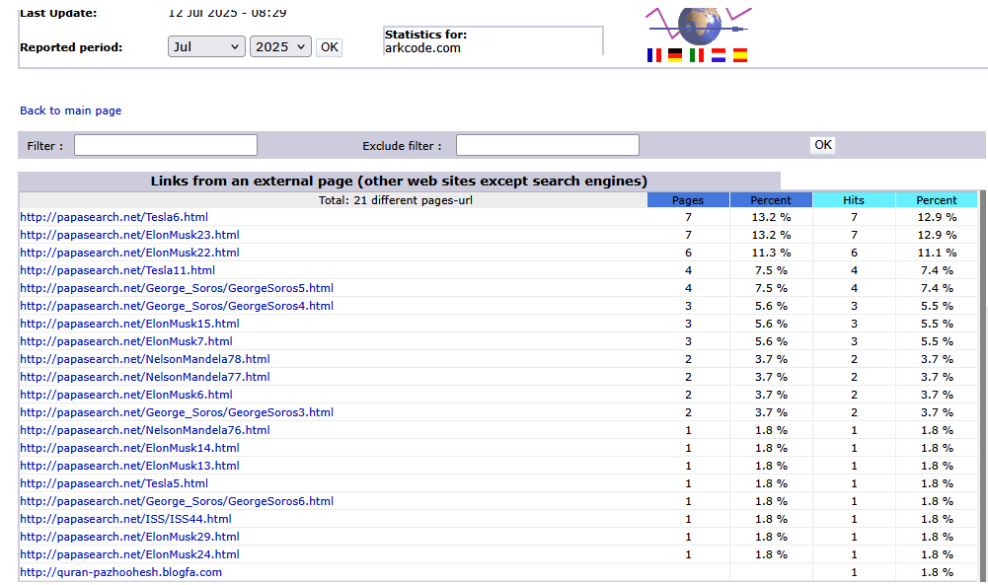  
Table 6-1 above showing visitors to one of my domains on July 12, 2025.

I have seen this combination of IP addresses before on my site on May 21, 2025. It looked as follows:

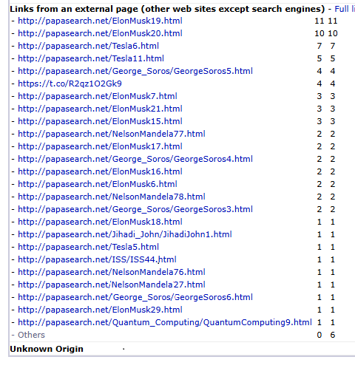

Table 6-2 above showing visitors to one of my domains on May 21, 2025.

**What is surprising is that on both Tables of visitors we have Elon Musk/Tesla representing the far right and George Soros and Nelson Mandela representing the far left. Mandella died On December 5, 2013, but the two tables in this chapter indicate that there was some kind of financial link that survived.** Mandela and Soros had a connection through Soros's philanthropy and advocacy for human rights and democracy, particularly in South Africa. Soros's [Open Society Foundations](https://www.opensocietyfoundations.org/newsroom/open-society-foundations-south-africa) played a significant role in supporting South Africa's transition from apartheid, including providing scholarships for Black students and funding civil society groups. Soros also met with Mandela, and they both shared a commitment to fighting for social justice and equality.

**Continuing, Barry wrote:**

**Then you should have made this clear. It’s the first time that I heard it’s pulsing. If that’s true, this thing may be much more hazardous than I imagined. This rock needs to be analyzed in a U.S. military lab because it has already killed at least 62,603 Americans. We have more deaths than any other nation, and if there is an ET plan to try to conquer our world, they will have to defeat the United States first. Reality is that you are either with us or against us. Do you want to take on the United States? We are not playing games here.**

Craig wrote:

*Before ever going to UVic, I contacted Chandra.*

**Barry *wrote:***

**That would be consistent with the limited emails that I have, although from a geographic point of view, it seems odd. Was there someone, an intermediary, anyone who introduced you to Chandra?**

Craig wrote:

*Then I researched out what needed to be done, so hired the labs equipment. And many PhD scientists you do not know far beyond UVic labs.*

**Barry wrote:**

**We are going to need the names involved and times of contact because this is not just a theft investigation. It’s likely to be a murder investigation and possibly the cause of a war.**

Craig wrote:

*I have told you before I have many organic embryo fossils. I have one around my neck in a necklace.*

**Barry wrote:**

**We need to see photos of clearly distinct embryos***.*

**Craig wrote:**

*I now have a Joint Venture, you will read about it.*

*Very powerful name R r*

**Barry wrote*:***

**I need the full name***.* ***NOTE:*** *Craig later said it was a Rockefeller.*

*Well done on the deuterium content.*

*Thanks.*

**Craig wrote:**

*I have not told you that I had oxygen done 3 times at different laboratories, and two said Martian, and only Dr. Zeigler's data was false from a personal reason that I have had with dumb director Carl Agee, he garbaged a sample in 2018, I swore at him and some.*

**ROFFMAN COMMENT:** Note Craig’s clarification that he contacted Dr. Wickramasinghe in the UK before Dr. Humphrey, who lives and works not too far from Craig in British Columbia. Also note the new PhD involved with handling the rocks: Dr. Carl B. Agee, Director, Institute of Meteoritics, Meteorite Curator Professor, Department of Earth and Planetary Sciences, MSC03 20501, University of New Mexico.

Carl Agee’s contact information is as follows:

Dr. Carl B. Agee, Director, Institute of Meteorites, Meteorite Curator, Professor, Department of Earth and Planetary Sciences, MSC03 2050, 1 University of New Mexico, Albuquerque, NM 87131-0001, Phone: 505-573-5131, Fax: 505-277-3577, Email: agee@unm.edu

**Barry wrote:**

**Can you back this up with emails or reports?**

**Craig wrote:**

*“There is a global cover-up with meteorite institutions, so their funding got cut a lot. They are all broke lifers that do not like the public owning these.”*

*I know about and have written about the cover-ups before, but for now, the issue is comparing the DNA and or RNA on your samples with current strains of the virus out there. Our survival depends on it.*

*Craig*

*Good investigative work with China and India.*

**Barry wrote:**

**You mean China and Sri Lanka. India intervened in the Sri Lankan Civil War in 1987. It suffered 1,138 killed and completed its withdrawal in 1990.**

**If you do not understand why I sent you those emails from CEOs and so on, maybe you knew at some level that it was the right thing to do. Left unchecked, whatever life form apparently is involved with the meteorite is a threat to all mankind. So are corrupt people in our government who have worked to impeach a legally elected President who actually cares about us. It remains to be seen if DoD and UK MOD can be trusted to get this right, but if they do, it will be in large part because you gave me critical information to pass on to them here. As for what you should do next, I would recommend you take that embryo off from around your neck and get me some good photos of it. You need to show at least photographic evidence of multiple embryos. This helps to establish that there has been reproduction rather than a simple geochemical process that produces similar intrusions.**

**It is also vital that you tell us what happened to your wife after she ate some of the rock content. Without this information, thousands of people may become infected, and doctors will misdiagnose thousands of people, who will then die because you did not tell our doctors what they need to look out for.**

**Craig wrote:**

*Start writing letters to write companies.*

**Barry wrote:**

**I’ll leave this to our government/s to do. However, I act like a government’s full intelligence agency. I’m not. There is an enormous amount of work required here. I need the DoD to do its job.**

From: [**craigebrahimi@hotmail.com**](mailto:craigebrahimi@hotmail.com)

To: [**barrysroffman@gmail.com**](mailto:barrysroffman@gmail.com)

Date: Apr 30, 2020, 11:35 PM

**[](https://roffmanmarsresearch.com/wp-content/uploads/EBRAHIMI-PHOTOS-AND-EVIDENCE3.png)**

|  |
| --- |
|  |
|  |
|  |

**See Figure 6-4 above of Craig with his car (April 30, 2020)**

On Fri, May 1, 2020, at 12:06 PM, Craig Ebrahimi craigebrahimi@hotmail.com wrote:

*Barry, I have three documentary offers: Prometheus Entertainment, Ancient Aliens, and some Will not. My Rockefeller partners would not approve. I will send you a picture when the laboratories open. My wife had two extremely healthy boys.*

*Craig*

**ROFFMAN COMMENT:** **Rockefeller partners involved!**

I asked this question because someone (Matthew Wilson) associated with the Rockefellers tried to recruit me for the Thule Society in 2013 to 2014. His motivation was not clear, but here is what survives in my records (just the e-mail address and the 500-page attachment: **Behold A PALE HORSE).**

From: Matthew Wilson matthewwilson888@gmail.com

To: Barry Roffman BarrySRoffman@gmail.com

Date: Apr 13, 2014, 7:37 PM

Note: I have only briefly skimmed through the above book for the first time on May 11, 2020.

**ROFFMAN COMMENT:** On hair length and resemblance to man-like alien in Prometheus

From: Craig Ebrahimi craigebrahimi@hotmail.com

Sent: May 1, 2020 1:36 PM

To: Barry Roffman barrysroffman@gmail.com

*Subject: Re: Re: My hair has been shaved #2 since teens. Must be a coincidence. I’ll find one and send you.*

**1 May 2020 @ 7:28 PM** and response from Barry Roffman **3 May 2020 @ 12:02 AM**

*From: Craig Ebrahimi craigebrahimi@hotmail.com*

*Sent: May 1, 2020, 7:28 PM*

*To: Barry Roffman barrysroffman@gmail.com*

*Di ribose increases stamina in my research. I found it pure in my meteorite sample. Enhancing performance is a side effect.*

**ROFFMAN COMMENT:** **This would imply that there exists a substantial organic chemistry analytic report.**

*From: Barry Roffman barrysroffman@gmail.com*

*To: Craig Ebrahimi craigebrahimi@hotmail.com*

*Cc: “davidaroffman@gmail.com” DavidARoffman@gmail.com*

*Date: May 3, 2020, 12:02 AM*

*Thanks Craig*

**ROFFMAN EMAIL COMMENT** On hair length and resemblance to man-like alien in Prometheus:

**I may not be working for you directly, but you are keeping me very busy. By Di ribose, I think you mean D-ribose. It’s also called ribose or Beta-D-ribofuranose. It’s a type of sugar that your body produces naturally and is readily available in supplement form. This is an organic molecule with great significance.**

**Who told you this is in the rock? How was it separated out, and what dose (milligrams or grams) do you take daily?**

**Whether you ate one or merely wear it around your neck, it may be able to control or affect your thoughts. If you ate it, it may be a parasite. If that’s the case, then like other parasites, if it reproduces inside a host and the host poops, the parasite can be put out into the environment that way. The only way to know if this is happening with you is for you to get a stool test.**

**Best regards,**

**Barry**

Craig on organics in his meteorite:

|  |  |
| --- | --- |
| from: | Craig Ebrahimi <craigebrahimi@hotmail.com> |
| to: | “barrysroffman@gmail.com” <barrysroffman@gmail.com> |
| date: | May 3, 2020, 12:24 AM |

*Barry, I have had the organics extracted and analyzed in the UK, not Chandra. But it's well known for meteorite organics analysis. His data and lab were shut down in December 2019. I was informed on just a little about Aminos and some type of Protein they discovered, but the data has been suppressed. But I will arrange it again.*

**Barry:** **Who suppressed the data?**

**Craig’s answer:**

*No, I have not extracted any out of samples to eat, come on, guy. D-ribose response. Someone suppressed organic chem data. See attachment.*

*From: Craig Ebrahimi craigebrahimi@hotmail.com*

*Sent: May 3, 2020, 2:34 PM*

*To: Barry Roffman barrysroffman@gmail.com*

*Subject: Re: Time of photo with the Porsche*

*I took that picture 20 mins before I sent you after I ran 25 km and haven’t eaten in days. The research will be conducted in the US soon.*

**CRAIG’S RESPONSE AT 8:19 PM ON MAY 3, 2020**

|  |  |  |  |  |  |
| --- | --- | --- | --- | --- | --- |
| *from:* | | | | [*craigebrahimi@hotmail.com*](mailto:craigebrahimi@hotmail.com) | |
| *to:* | | | | *Barry Roffman <barrysroffman@gmail.com>* | |
| *date:* | | | | *May 3, 2020, 8:19 PM* | |
| *subject* | | | *Re: Extraterrestrial ribose and other sugars in primitive meteorites PNAS* | | |
|  |  | |  | | |  |

**At 7:36 PM, Barry wrote:**

**Think quantitative. How fast do you run 25 km? The world record is 1:11:18.**

**At 8:19 PM, Craig wrote:**

*My trail runs are intense, a lot of hills. Yes, when running a flat course, easy peasy, I’d be able to keep close to 5-minute miles, but Eliud Kipchoge's marathon pace destroyed the record in 2019.*

**Barry then wrote:**

**Did your wife’s strength and speed also increase? I’m glad that she had two healthy babies, but it’s important to know if what she ate caused any unpleasant or unusual side effects.**

Craig wrote:

*She never had any negative side effects; we will not comment on her.*

**Barry wrote:**

**David thinks you look like you’re about 38 in 2020, around 50 back in 2016. I agree, but with the sunglasses, it’s hard to get an accurate estimate.**

**I asked David about the pulsation. He wants to see pictures (iPhone) or video if you have any. Are you talking about light pulsation? How long did this go on, and was there any pattern to it? Geiger?**

Craig wrote:

*The ribose article (*[*https://www.pnas.org/content/116/49/24440*](https://www.pnas.org/content/116/49/24440)*) was published when your (our?) sample was in China, but also when the Japanese Pharma CEO likely had access. I’ll see if I can find a connection.*

*Chandra is an honorary professor with JAXA, Japan. The ribose in the meteorite is to the embryos as yolk in an egg is to the embryo in it.*

**Barry wrote**

**The article is a great find that does much to increase your case. But to close the loop, we need something in writing about ribose being in your rocks.**

Craig wrote:

*The science data I do not have access to because of a lack of trust in me. And their data is theirs. And I would be a complete idiot to have their names mentioned.*

*Geiger meter cold pulse.*

**Barry wrote**:

**It sounds like it could be some kind of communication.**

**Craig wrote***:*

*My typing mistakes are because of emailing with one hand using a cell phone and a baby 1-year-old boy in the other hand.*

*Geiger meter cold pulse and Dr. Jerzi Sawicki…*(missing end of the mail)

|  |  |
| --- | --- |
| from: | Craig Ebrahimi <craigebrahimi@hotmail.com> |
| to: | barrysroffman@gmail.com” [**barrysroffman@gmail.com**](mailto:barrysroffman@gmail.com) |

|  |  |
| --- | --- |
| date: | May 4, 2020, 11:59 PM |

*Elon’s pissed with me because… (I’ve censored the reason.)*

*My embryo is in my necklace. I’ll send ya a picture, but it’s hard to make out unless using the lab’s LM. The embryo-like structure is so visible in the br that it looks like it’s gonna jump out of the rock. Everyone and anyone can make it out. One day it will come to you. Top right curled with tail with spikes, really amazing when looking through the AMF LAB equipment on the big screen.*

PARTIALLY CENSORED AT CRAIG’S REQUEST

br refers to one of the meteorite samples. Intel IP checks:

47.202.113.176 = 176.113.202.47 = 6.113.202.47 (Fort Huachuca Army Intelligence Base);

192.19.231.250 = 25.231.19.192 (UKMOD);

58.109.207.225 = 225.207.109.58 = 25.207.109.58 (UKMOD)

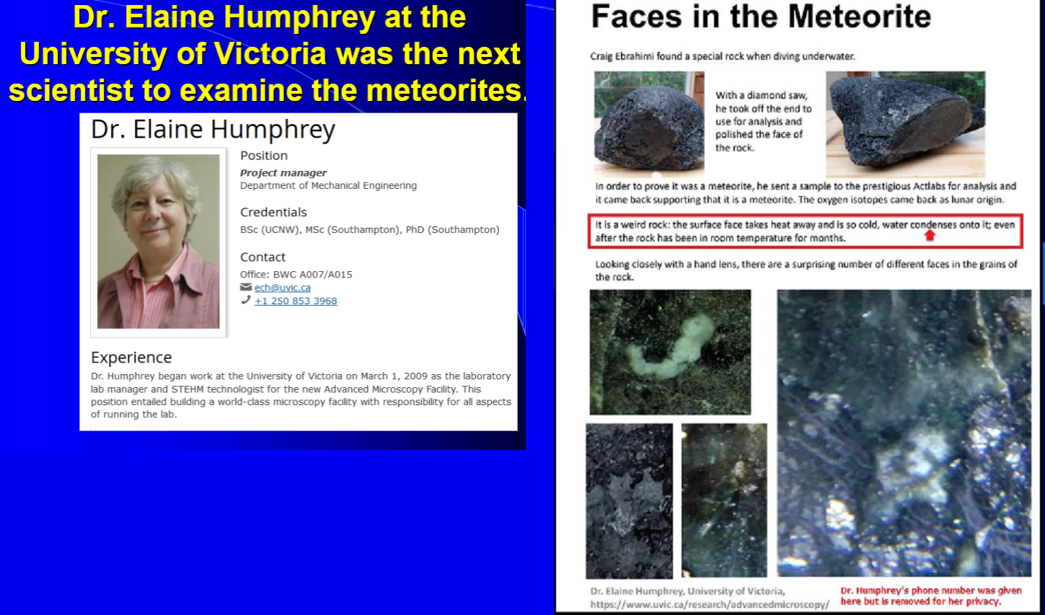

**Figure 6-5** above: Photos of the meteorite and remarks by Dr. Elaine Humphrey at the University of Victoria in Canada.

**NOTE:** Emails published from May 4, 2020, through 2022 are posted at <https://roffmanmarsresearch.com/?page_id=6035>. The following communication, apparently from Craig, was received on January 29, 2025.

**Barry wrote:**

**JANUARY 29, 2025. The following voicemail text was found in my Message Box at 10:04 AM while I was on the phone with Express Scripts (a pharmaceutical company). The return number only took me to my doctor’s office rather than to Craig in Canada. I left a message on Craig’s mobile phone that answers his questions. It remains to be seen if he answers it. The mysterious text appears to suggest that he monitors what I write on this, and he has the ability to monitor what I write to the Trump National Committee or the Republican National Committee.**

**Craig wrote:**

*So, do you believe that Musk and Trump are sitting around Mar-A-Lago talking about me? So they must be discussing which job they would offer me. What does he think about Ebrahimi?*

**First comment by Roffman:**

The question marks were added by me. I have noticed that Craig’s grammar is not always top of the line.

**Second comment by Roffman:**

This is a rough summary of what I think likely provoked the above January 29, 2025, voicemail message. On January 29, 2025, I did not discuss Musk, Ebrahimi, Mar-A-Lago, or a job with anyone before reading the text apparently composed by Ebrahimi. However, I did discuss all these things on the day before (January 28, 2025) with the Republican National Committee or whoever runs the Trump website that constantly requests donations from me. Over Trump’s three elections, I estimate that I have donated about $2,000.

What I wrote in response to their latest request for money was that they have written to me in Trump’s name before (daily), asking questions about my political opinions, but always followed up with another request for a donation (often with a suggested donation amount). However, I would not send more unless somebody called me to tell me what Musk said about me and to ask if Trump was really communicating by considering offering me a paid position. I have asked about this before, but never received a direct answer.

The man who promised to get an answer at the RNC, but failed to live up to his promise, is Adam Felty. As I have told the Secret Service, if Felty cannot account for exactly what happens to donations that go to the RNC or its partner, Trump National Committee (TNC), we probably need to rule out embezzlement of the hundreds of millions of dollars donated to the RNC in 2024. **Note:** On April 4, 2025, I filed a request for an internet fraud complaint against Felty. Four hours later, I received a text from someone claiming to be Trump. It had my complaint on it with a statement that he was trying to call my mobile number, but still, I could not hear his voice to verify that it really was the President. I advised him to borrow somebody else’s phone because the intel base Fort Huachuca might be blocking his calls here.

**Based on Elena Danaan’s writings, Huachuca is suspected of a criminal relationship with reptilians, delivering hybrid children to the reptilians (for slavery or food).** If this is true, they likely want to keep it hidden from the President. Consider **Figure 6-6 and 6-7**. On **Figure 6-6**, the axis term is **HUACHUCA** at skip +1,465. At the same absolute skip (opposite direction) are **REPTILIAN**, **UFO**, and **CHINA**. **REPTILIAN** touches **BARACK H.**, and he touches **FROM A NAZI** which touches **SONS OF ANAK** (giants). Odds against this matrix are about 477,922,797 to 1. Danaan says on pages 163-164 of A GIFT FROM THE STARS, Extraterrestrial Contacts and Guide of ALIEN RACES that, “Fort Huachuca: Here is one of the underground hangars for spaceships. This facility is a landing point for incoming **Ciakahrr** (Reptilian) contingents and a central hub deserving of a vast amount of other facilities.” An even darker portrait emerges with **Figure 6-7** which addresses the question of whether children are sent from there to Reptilians for purposes or food (as was alleged by Rebecca).

Fort Huachuca is the most common visitor to my website so they will quickly become aware of what I am, at great risk, writing here. But, as I will make clear below, there are signs of hope from the Fort.

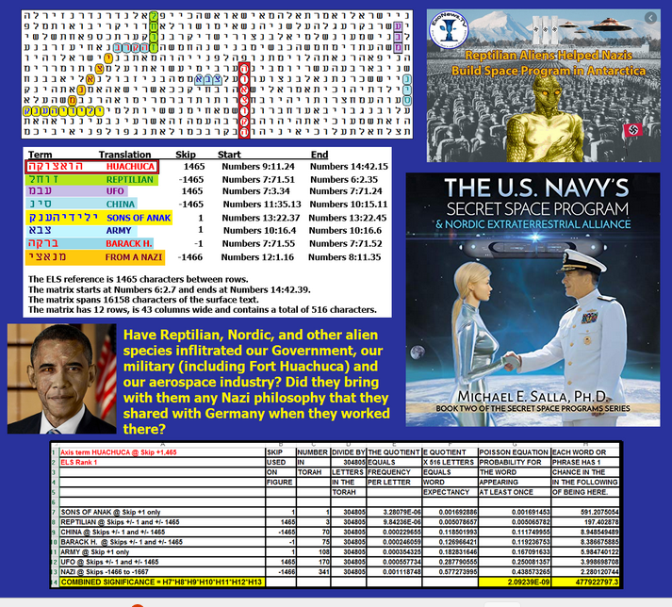

**Figure 6-6 above**

When Craig first contacted me (January 26, 2020), he described the view I had out my living room sliding glass door in Cape Canaveral, Florida. He also claims to have telepathic abilities. Somehow, it appears that he accessed what I said to Trump’s people in March 2025. I am sure that he reads my website, which includes this email and phone record. But the contents of my remarks about donations should not have been available on my website in my outgoing mail because they did not go out via email. They were sent in response to the Trump National Committee website, and it was on their program.

If Craig calls me back, I will discuss his concerns, but to try to help him understand what I think or know is going on, let me be clear. I wrote Craig and told him that,

**“Your decision to pull the plug on our communications before was not wise. There are likely many species of aliens visiting Earth. You likely represent one of them, or at least you claim that this is so. Some of them (Reptilians, Greys, etc.) are hostile. I have broken the Torah Code and published the names of the top alien spies who have fought to prevent Trump from winning the election in 2024. They are named in Chapter 3 of this book, and the last two presidents are among the suspects revealed by the Torah Code.**

**Craig, you asked whether President Trump and Elon Musk are discussing you now or not. IF they are talking about me, the answer is likely yes. However, I have not investigated this fully yet. I’m trying to discern IF they are really talking about me.**

**Until you are investigated, you must be seen as a threat unless proven otherwise. The only way that I can see anything positive coming out of this for you and your family is if President Trump remains our President AND you cooperate with a full and honest disclosure. Even if you do this, there will be people who believe you may be the antichrist (not me, but Jews do not believe in Jesus as the Messiah or divine). You will likely have to find a new, secure home. But yes, your books and movies would make a lot of money. You once wrote about our doing a joint book. From this book and my website, you can see what my knowledge is about your life. A joint book would allow you to formally correct any errors I make in my writings about you. If I have made any significant mistakes and you point them out, I will immediately correct my work. For the most part, I think profits from such a book should go to you so long as you cooperate. My main interest remains in protecting the United States, and indeed our species.”**

COVID-19 killed about 18,000,000 people worldwide. In our first phone conversation back in 2020, Craig offered me a trip up to his home in Sooke, B.C., so that I could examine the embryo. At that time, just days before COVID-19 was named a pandemic, I declined his offer, and I told him why. I was afraid that I would bring this disease back to Florida. Despite my caution, within a year, my wife and I both caught COVID-19. Fortunately, it was a mild version of the disease, but COVID killed our family doctor, Dale Adamson.

**FIGURE 6-7. THE DEPTHS OF EVIL?** I first noticed Fort Huachuca back in 2014 when they became a top reader of my website. I first encountered Fort Huachuca when an agent (referred to as Joseph *Sapphire*) who worked there threatened to do to me what he said they had done to someone like me. He said they loaded child pornography onto the guy’s computer and then brought charges against him. I’ll write about him more in reference to **Figure 9-20** in Chapter 9 and **Figure 10-1** in Chapter 10, but his words indicated that, at least in the past, Fort Huachuca was operating outside of the law.

With regards to **Figure 6-7** below, as a retired Coast Guard officer with 24 years in the Coast Guard and ten years of service as a Naval officer before that, the last thing that I want to do is to paint an Army intelligence base as a criminal organization. I started studying the Torah Code 28 years ago to help U.S. intelligence operations! So, what can I say about **Figure 6-7**? While the combined odds are somewhere between one chance in 75,193 (532-letter matrix) and one chance in 268,456 (868-letter matrix), because of high frequency at skip +1, neither **FOOD** nor **CHILD** is statistically significant. But what if it was true? My study indicates that a substantial number of Democratic politicians are either aliens or humans who have been abducted and had their brains scrubbed by ET. An alien invasion is not just something that might occur. It is, instead, something that has already occurred. As such, just like there is an unprecedented division between right- and left-wing voters, so too does this division exist in our military. The matrices that I have done on General Milley provide an example. Was *Sapphire* a bad guy? I don’t think so. Although our encounter went from strange to hostile initially, and although he said he was Catholic, to show him who he was dealing with, I told him the story of how I forced the Catholic Church to annul the baptism of my older son (now, Orthodox Rabbi Robert Altair Roffman) who goes by his Hebrew name, Moshe,

He seemed somewhat shocked by the incident, which was covered on the front page of the Miami Herald (see <https://www.arkcode.com/photo4_85.html>) and other major newspapers.

What startled me most about our meeting was that when it turned to my studies of the Martian atmosphere, his admiration of me apparently quickly grew. I offered him my calling card, which had a picture of the Mars Science Laboratory Curiosity Rover and some words about my specialty being Martian meteorology. He asked, “Can I keep this?” I said, “Sure,” or something like that. He then acted like I had given him something precious, like a copy of our Constitution or the British Magna Carta! Next, he let me know something about my younger son’s near future. Even his initial greeting of me seemed to indicate that he knew which book I had just checked out from the library (Slant, by Greg Bear – which deals with nanotechnology and artificial intelligence). He had not been in the library when I selected it. My son (David) had just earned his PhD in nanotechnology, but we didn’t know then that four months later he would learn how to do A.I. while doing his post-doc at Yale. In short, in acting like he had library records from the future, and being so grateful for my card, he left me with the impression that he supported my efforts to find and publish the truth. More, he seemed to indicate that this book would eventually make the world a better place. As such, *Sapphire* seemed to indicate that the white hats will, under Trump and with his Space Force, win this *War of the Worlds*. As I write these words, my computer began to read them back to me! That is a function that I never choose to use. It can only mean one thing. Fort Huachuca is following every keystroke that I make. Joseph, if you’re still alive and reading this, thanks for inspiring me to reach my destiny.

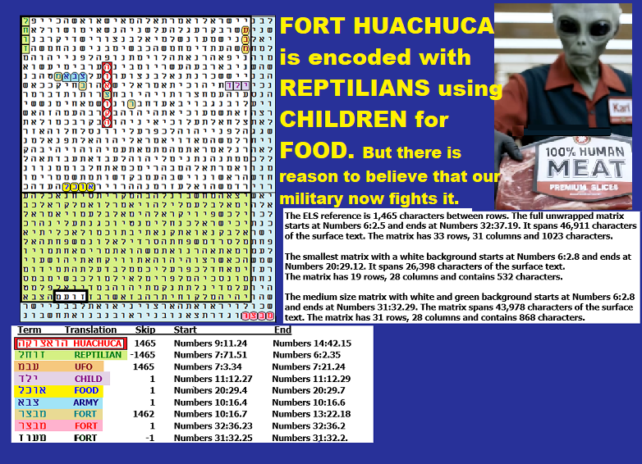

Figure 6-7 above. Its spreadsheet follows below.

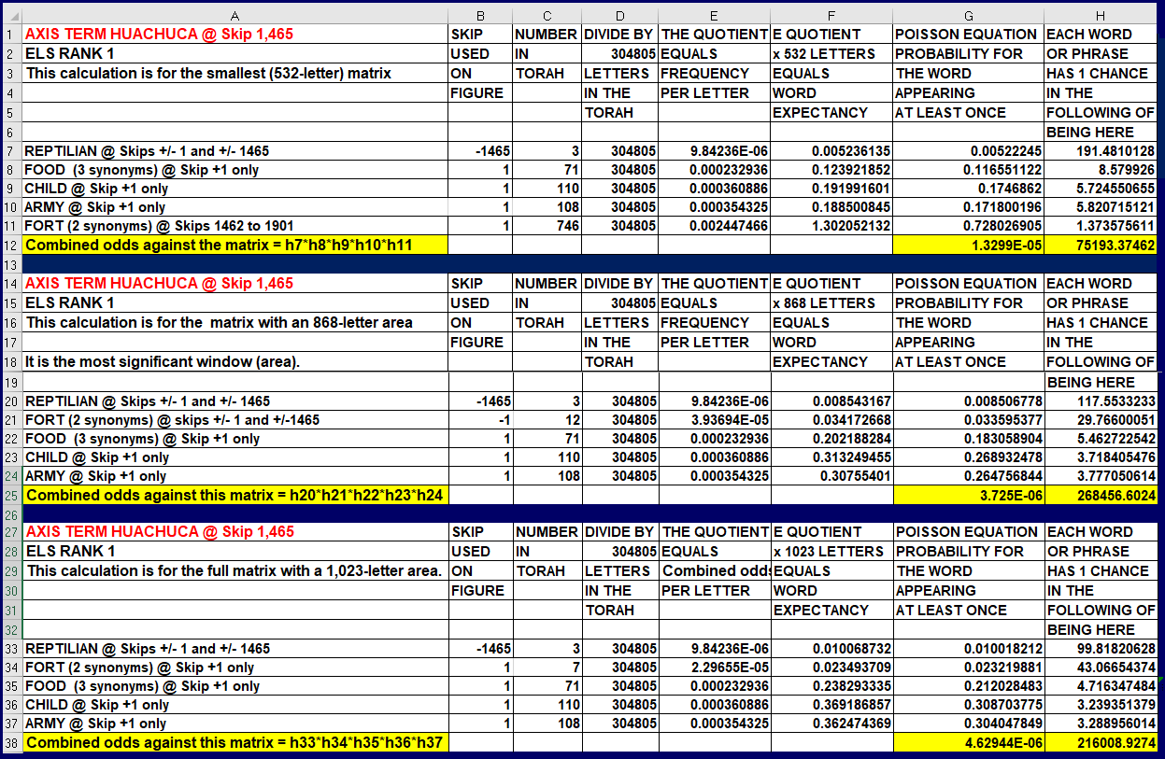

Above: Spreadsheet for Figure 6-7. The 868-letter matrix area (green and white background) was most significant. **REPTILIAN** was the most significant term.