Chapter 5
First Contact with an ET
This chapter examines the claim by CRAIG EBRAHIMI that he is an alien. It will also examine evidence that I have (since January 26, 2020) suggesting that Craig is responsible for bringing COVID-19 to Earth and, with Chinese and American help, spreading it around our planet. Craig is shown on data-packed Figure 5-1 below. The chapter will also examine evidence that the vector of the contamination was a 27-pound meteorite that he recovered from the seafloor off his current hometown of Sooke, British Columbia, in the Canadian waters of the Strait of Juan De Fuca.
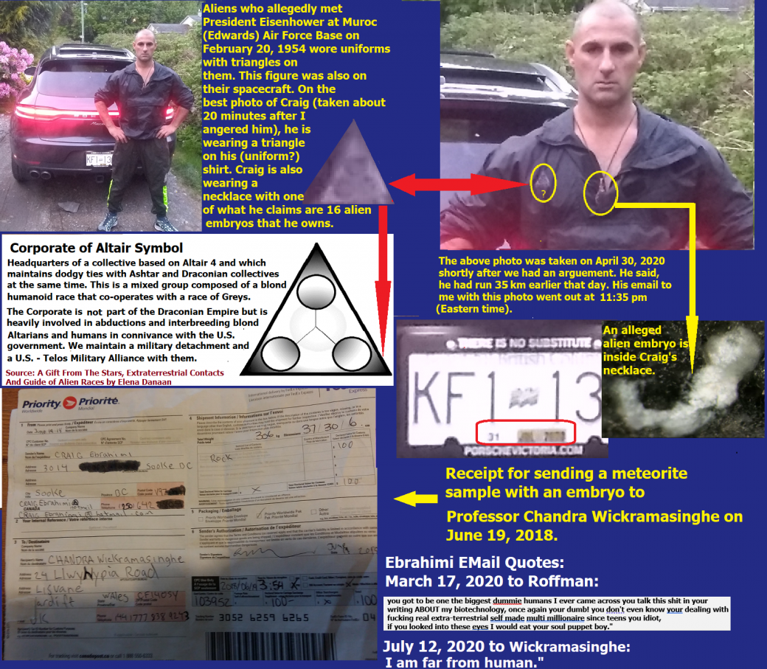
Figure 5-1 – Craig Ebrahimi, possible alien.
Source material: This chapter includes a scientific analysis of Craig’s unusual meteorite. While Chapter 6 details our e-mail record for more than a year, Chapter 5 includes Torah Code matrices that relate to Craig.
INITIAL CONTACT WITH CRAIG: I received the following email on January 26, 2020:
My name is Craig Ebrahimi, research scientist/Founder of Deviant off-world technology. Barry, would you be interested in the research and biotechnology opportunity of the only pristine extraterrestrial embryo on the planet at the University of Victoria?
In the two months that followed, I grilled him often and hard. I also angered him a lot. Eventually, he sent me the photo shown in Figure 5-1, but before doing so, he sent me the following e-mail on March 17, 2020, when he was angry with me, in which he wrote that he is himself an alien:
On Fri, Mar 27, 2020 at 4:43 PM Craig Ebrahimi craigebrahimi@hotmail.com wrote:
“Guy, your dumb ass shit keeps getting sent to me by one of your Hebrew followers. You gotta be one of the biggest dummy humans I ever came across. You talk this shit in your writing ABOUT my biotechnology. Once again, you're dumb! You don’t even know you're dealing with a fucking real extra-terrestrial self-made multi-millionaire since teens, you idiot. If you looked into these eyes, I would eat your soul, puppet boy.”
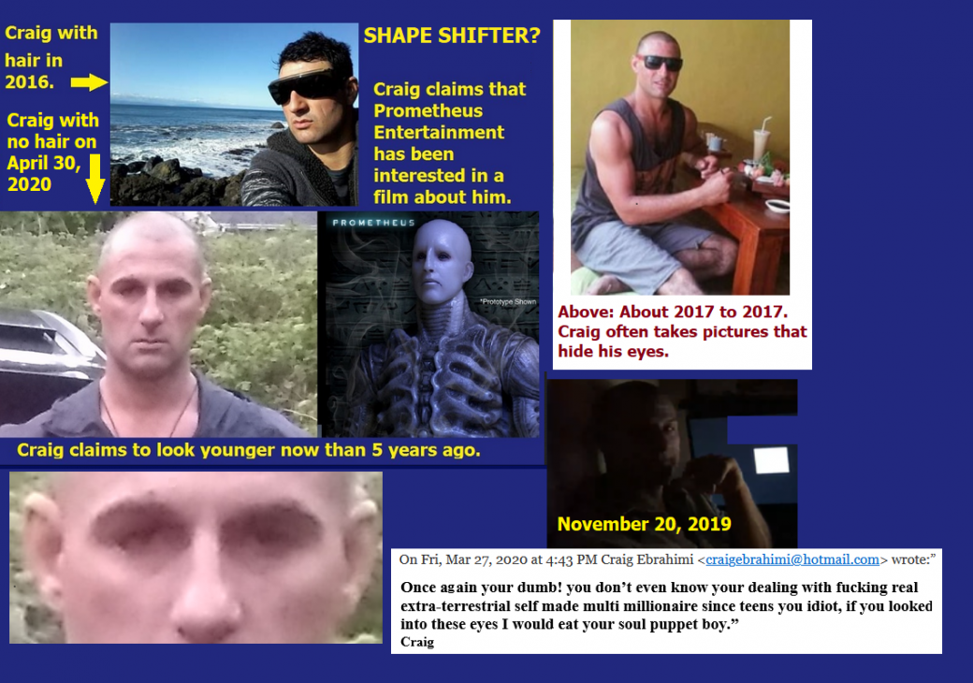
Figure 5-2 above: Is Craig a shape-shifter?
EXTRACTS OF MY POWERPOINT ABOUT EBRAHIMI:
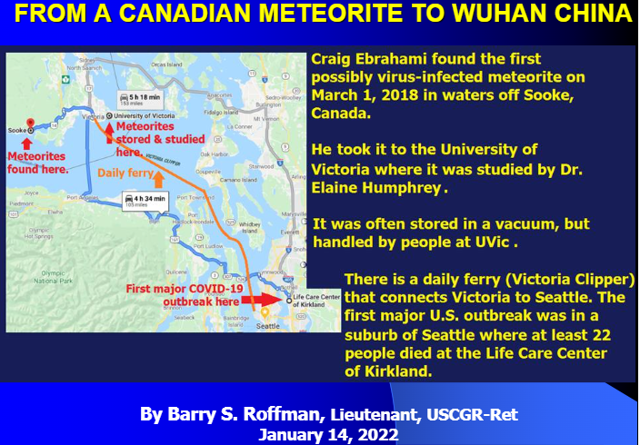
Figure 5-3 above: When the U.S. suffered its first major COVID-19 outbreak in Seattle, there was a daily ferry that connected Seattle with the University of Victoria, where one of Craig’s meteorites was being studied for its weird properties.

Figure 5-4 below: Craig with alien embryo and shipping receipt.

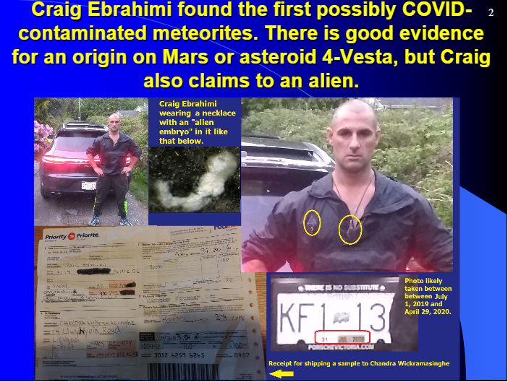
Figure 5-4 above: Craig with an alleged alien embryo around his neck and the receipt for shipping a sample of his meteorite to Professor Chandra Wickramasinghe in England. The professor apparently delivered the sample to the Chinese Army for development as a biological weapon.

Figure 5-5 below: Ebrahimi’s body proportions appear to be out of the normal human range. His chest is quite large, perhaps hinting at an extra rib, and his legs seem too short.
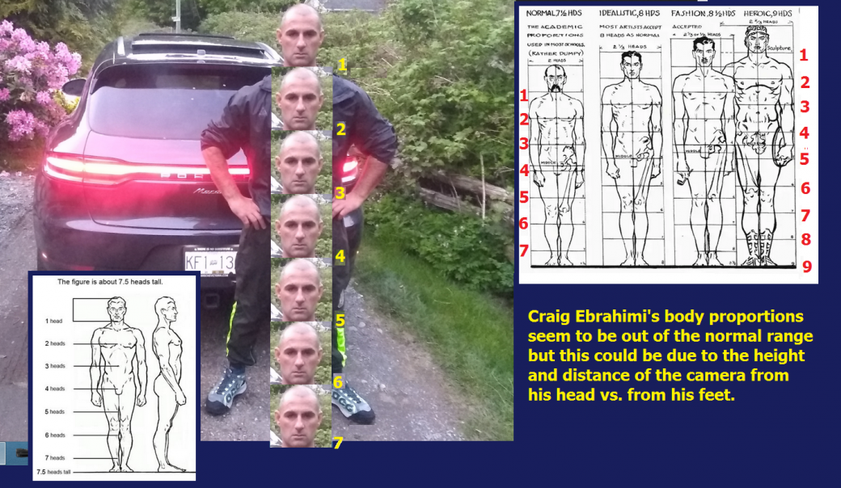

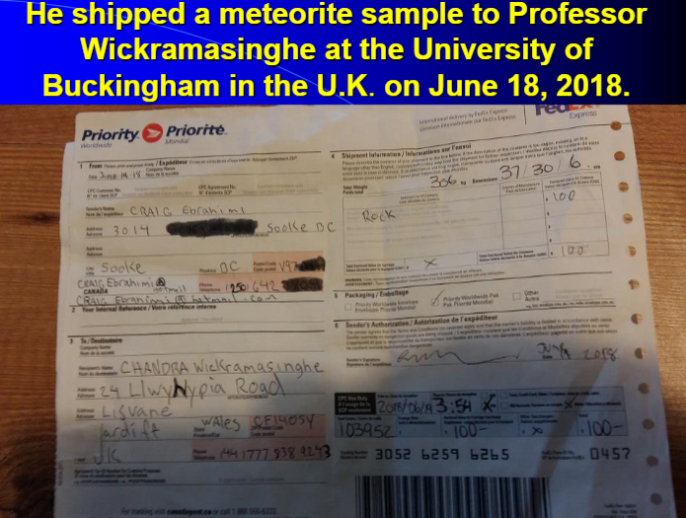
Figure 5-6 above: This receipt marks the beginning of the transfer of Craig’s contaminated meteorite sample with alien embryonic samples and possible surviving viruses to Professor Wickramasinghe in the UK and to Chinese Professor Jingwen Qu, at the Center for Infectious Disease Control in Tianjin, China, and its parent Chinese Army.
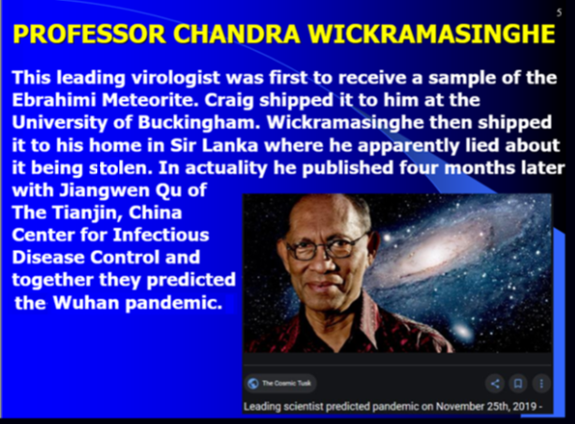
Figure 5- 7 above: Arch-villain Wickramasinghe is among the most guilty when it comes to the murder of millions of people via COVID-19.
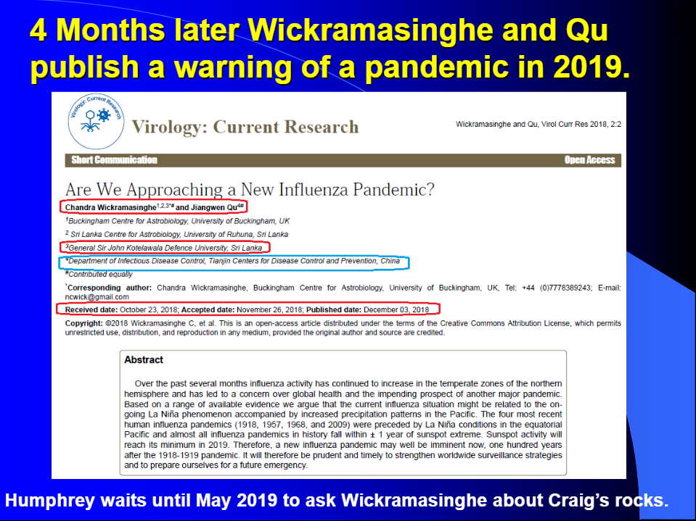
Figure 5-8 above: There is a clear publication record that allows us to learn that this disease was deliberately spread.
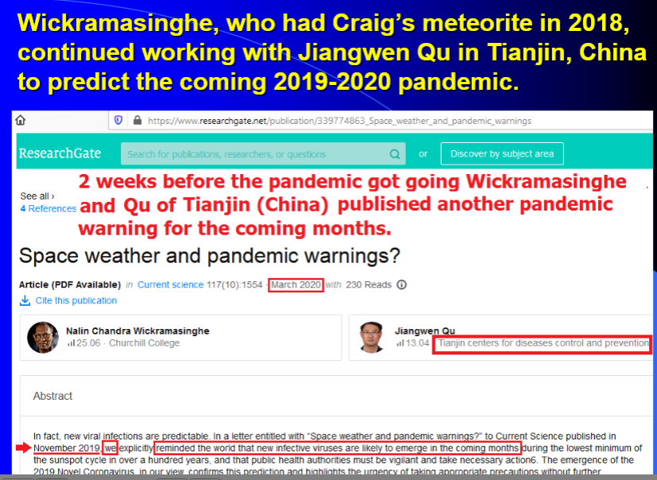
Figure 5-9 above: Hidden warnings about Craig’s unusual rock spread quickly in China.
Figure 5-10 above – China quickly weaponized the virus and incorporated it into its naval war plans. They actually attacked our ships with it!
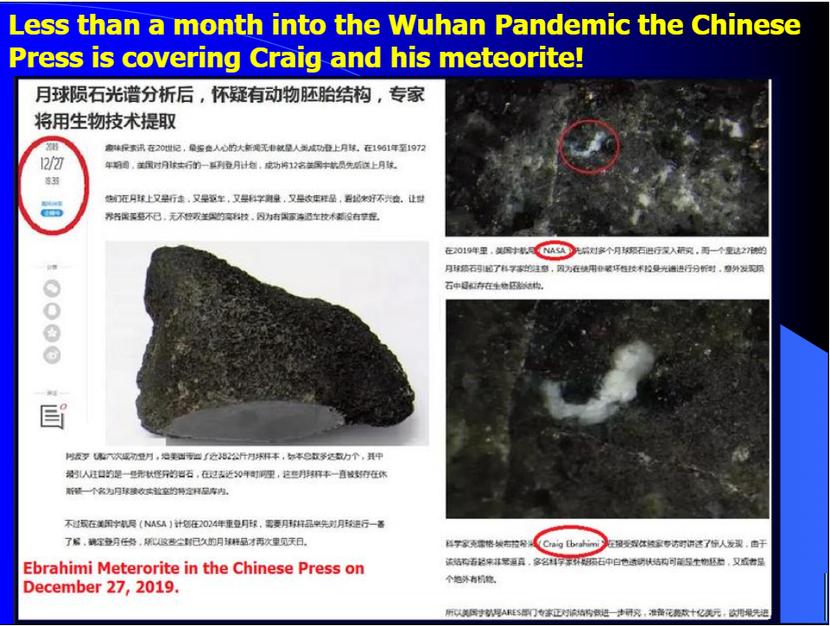
Figure 5-11 above: The plague was just getting going in China when this story about Craig and his meteorite was published on December 27, 2019.
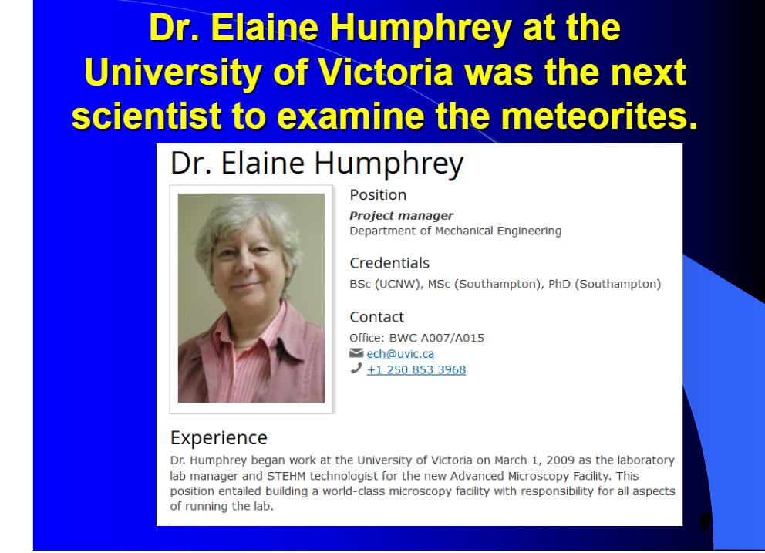
Figure 5-12 above: Dr. Elaine Humphrey was the next major scientist to study Craig’s meteorite. I interviewed her several times. She was somewhat nervous about what she was finding, because, as Figure 5-12 shows, weird things were happening with the temperature of the rock. In fact, the temperature fluctuations are suggestive of viral activity.
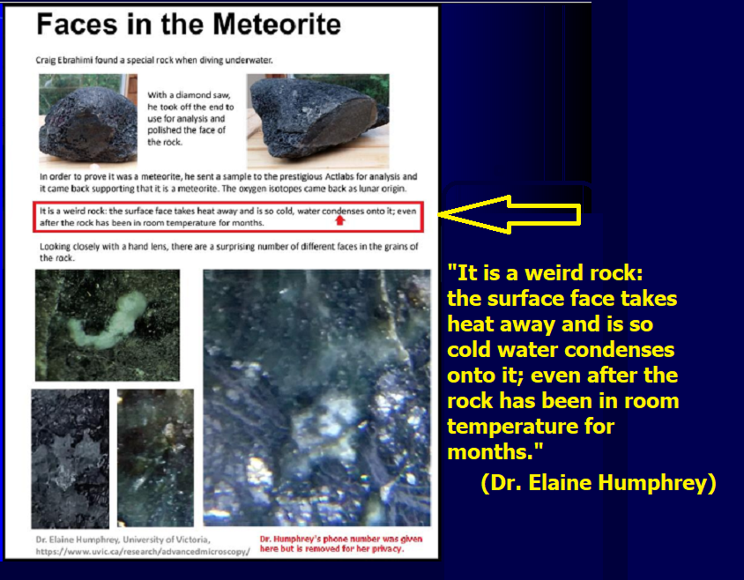
Figure 5-13 above: Dr. Humphrey noted the unusual heat (really, cold) properties of the meteorite. This may suggest that living viral processes are at work in the rock.
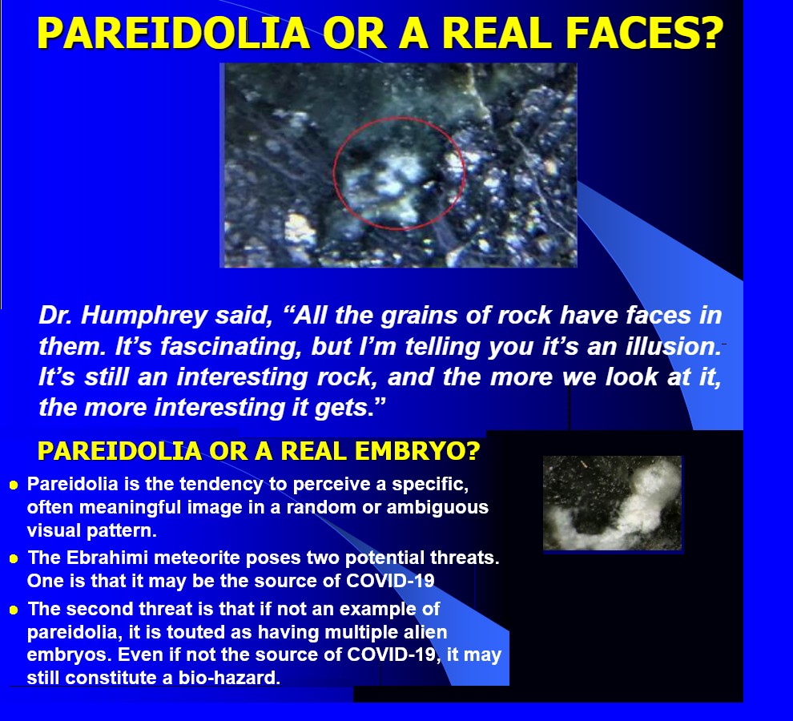
Figure 5-14 above: Pareidolia does not explain temperature fluctuations. My experience in interviewing Humphrey leads me to believe that she is very much aware of, and afraid of, the consequences of having alien life or proof of alien life in her laboratory.

Figure 5-15 above: This claim of Wickramasinghe’s lack of resources does not stack up well with his claim later that somebody broke into his outhouse in Sri Lanka, where he stored the meteorite, and somebody stole it! Know that Wickramasinghe is one of the world’s leading advocates of panspermia, which states that things like meteorite impacts and solar wind can transfer life from one world to another. He knew a meteorite with proof of life embedded in it would be worth billions of dollars. And yet he says he just left the sample in outhouse? That is utterly unbelievable!
From the moment I met Craig, he worked hard to try to convince me to help him sell his rock to biopharma. When he finally saw (after COVID-19 started killing so many of us) that I could not be swayed to help him enlist Elon Musk or Bill Gates to produce a vaccine, that’s when he boasted about his wealth while cursing me out and bragging that he is an ET:
“…You got to be one of the biggest dummy humans I ever came across. You talk this shit in your writing ABOUT my biotechnology, once again you're dumb! You don’t even know you're dealing with a fucking real extra-terrestrial self-made multi-millionaire since teens, you idiot. If you looked into these eyes, I would eat your soul, puppet boy.”
When following the money to the wealth involved with Craig’s acts, we need to keep an eye on Craig and all his associates and follow the money. This includes joint publishers Wickramasinghe and Gensuke Tokoro, shown on the slide below.
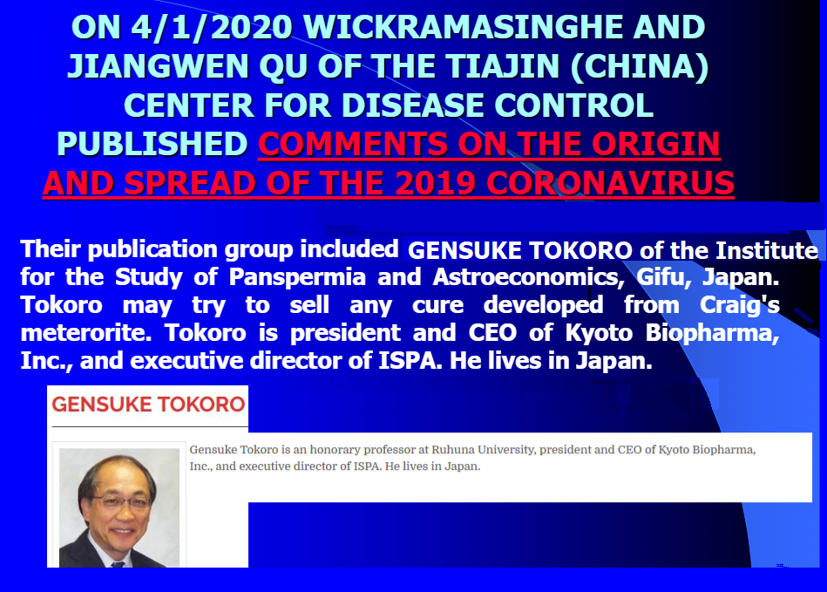

Figure 5-16: There was a widespread interest in what Craig was offering, but a great need for them not to go public about it. Craig even reached out to Elon Musk before he turned to me. However, once I angered him with demands for loyalty to the scientific method, he offered changing stories. He altered his story about an early meeting with Musk. But photographic evidence suggests that Craig’s original boast was correct.

Jerzy Sawicki and Elon E-Mails Accidentally Transmitted to Me:
The Geiger meter was when Dr. Jerzy (Sawicki) was involved. He is a Polish senior who went absolutely crazy with this project. He would never sleep and started drinking vodka. We had a falling out when he randomly asked me for $100,000 immediately when he heard I was meeting with Elon.
The instrument the US scientist used, I have been looking for notes on what it was called. I will contact him.
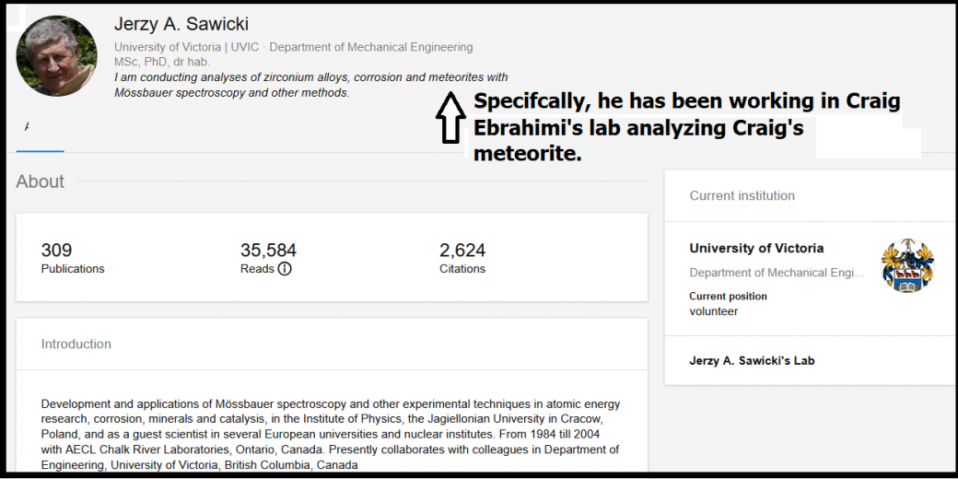
Figure 5-17 above: At one point, Dr. Sawicki quit working for Craig. However, I convinced Craig to repair their rift. My concern was that Sawicki was vital for determining the origin of the meteorite. Craig claimed that “voices he heard in his head” gave him the exact coordinates of the meteorite. That sounds a lot like how aliens are believed to communicate by telepathy. Prove that the meteorite has life or remains of life, and you go a long way toward proving that Craig is also an alien (as he claims to be). Sawicki published a joint paper with Ebrahimi about the meteorite in question. See their paper here and below as Figure 5-18.

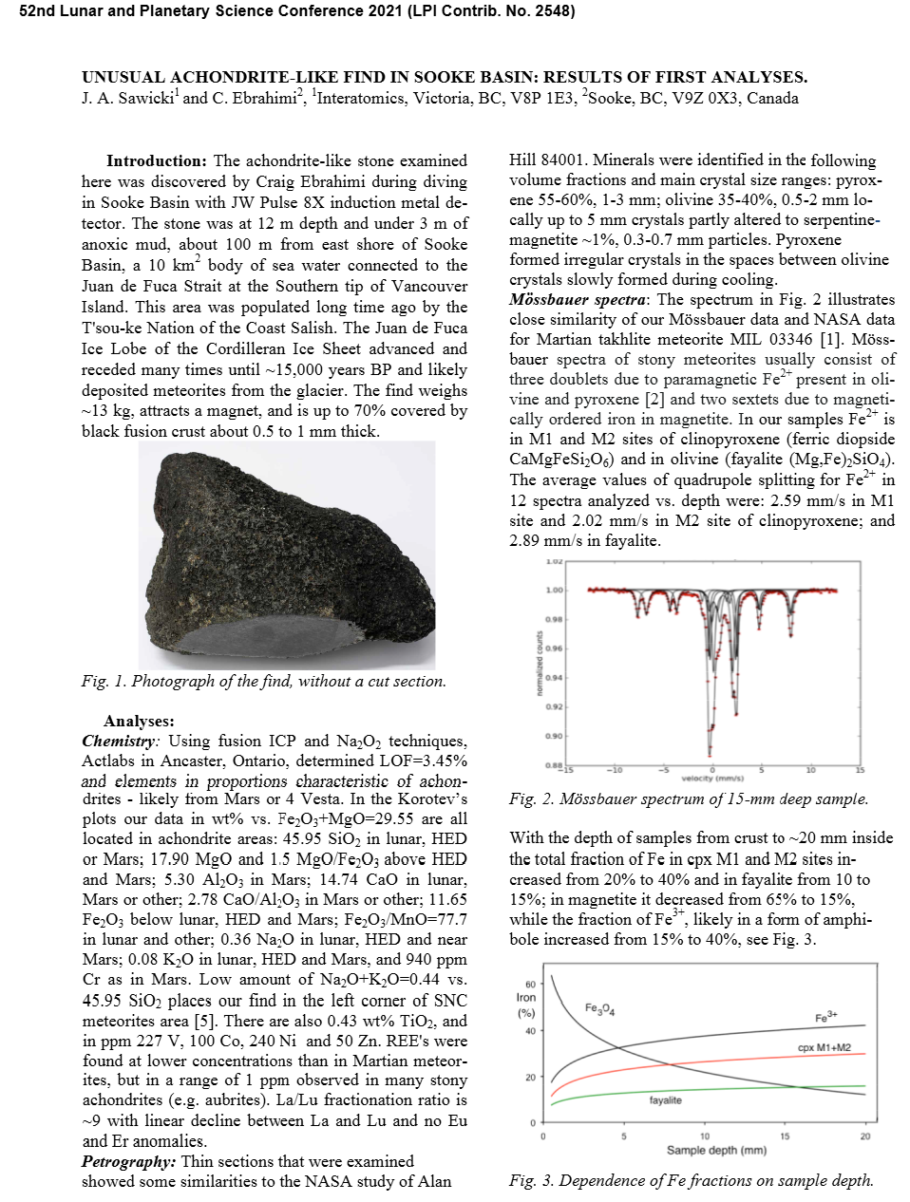
Figure 5-18 above and below.
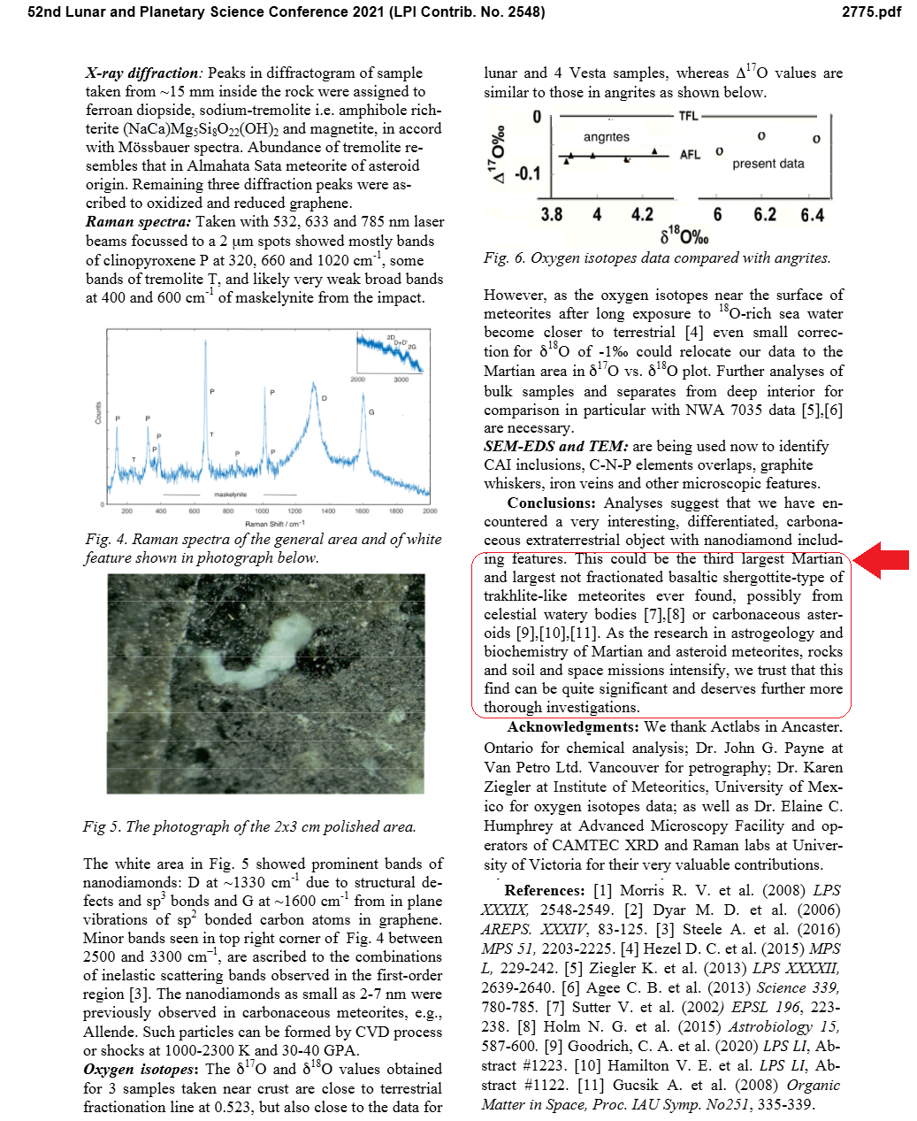

Figure 5-18 continued above: the Sawicki - Ebrahimi Paper
There are many pictures taken by our Mars landers that suggest primitive life growing on them, but the best photo that I have seen from there, showing both growth and reproduction, is Figure 5-19.
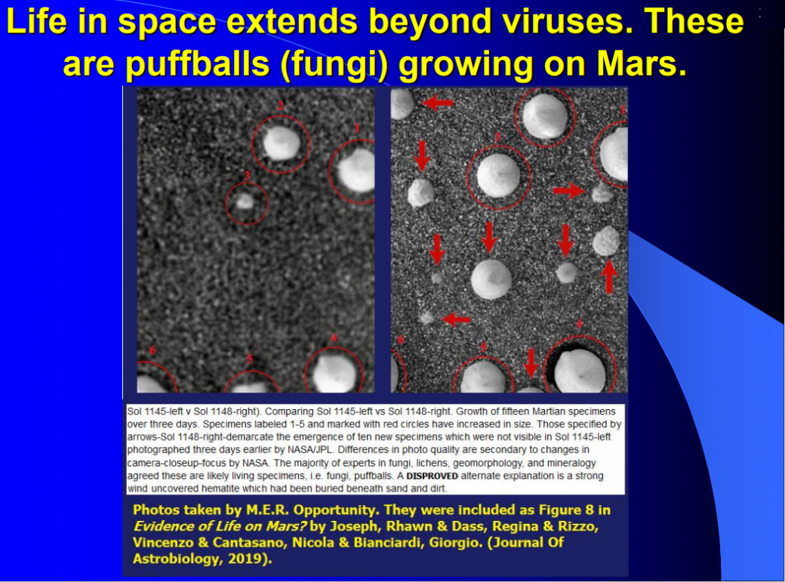
Figure 5-19 above: Probable life (puffballs, a type of fungus) growing on Mars. The alternate suggestion that we are seeing hematite buried by sand and uncovered by wind has been disproven.
The relationship between Wickramasinghe, Dr. Humphrey, and Ebrahimi becomes clear when reading the following emails.
Fri, 17 May 2019 at 00:13:
Hi Chandra,
I have a client, Craig Ebrahimi, who brought in a meteorite. At first, it looked like gabbro, but the chemical analysis (by Act Labs) proved it to be a meteorite. I understand that he sent you thin sections, outside crust, and a piece of the rock with an embryo fossil in a white circle. I have a very small sample for SEM and EDS. Craig suggested that if you have finished with his samples, is it possible to send them to me? Since I will be in the UK at the end of June for a month, I could pick them up. If you are still working with them, please keep us in the loop.
Best wishes,
Elaine
Dr. Elaine C. Humphrey, Fellow of Microscopy Society of America, Past President Microscopical Society of Canada

May 20, 2019 from Wickramasinghe:
Dear Elaine,
Unfortunately, the meteorite package was left in a shed near our house, and it appears to have been stolen. I do not have it anymore.

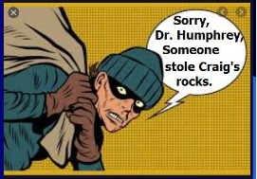
Sorry about this.
Sincerely,
Chandra Wickramasinghe
Honorary Professor, University of Buckingham, Buckingham, UK
Honorary Professor, University of Ruhuna, Matara, Sri Lanka
Honorary Professor, Sir John Kotelawala Defence University, Sri Lanka
Buckingham astrobiology website: http://www.buckingham.ac.uk/research/bcab
Ruhuna astrobiology website: http://physics.ruh.ac.lk/astrobiology/
Personal website: www.profchandra.org
ISP
May 20, 2019 at 1:15:13 PM PDT
From: Chandra Wickramasinghe ncwick@gmail.com
Date: May 20, 2019 at 1:15:13 PM PDT
To: Elaine Humphrey ech@uvic.ca
Subject: Re: meteorite
Reply-To: ncwick@gmail.com
Hi Elaine,
Our house was in chaos after some international travel, so I store all valuable things in an outhouse. Some months back, I discovered that many things, including the box with the meteorite, had disappeared. I was waiting to get a colleague to handle the experiments on this, but it never happened. Sorry about this – not my fault.
Best,
Chandra
Prof. Chandra
May 20, 2019, 1:32 PM
From: Elaine Humphrey ech@uvic.ca
Sent: May 20, 2019 1:32 PM
To: Craig Ebrahimi craigebrahimi@hotmail.com
Subject: Fwd: meteorite FYI. Sent from my iPhone
On May 20, 2019, at 18:15, Elaine Humphrey ech@uvic.ca wrote:
Chandra,
Oh dear, that’s too bad. Did you get any information out of them before they were stolen? If so, have you published them?
Elaine
I don’t have his direct response to her last question, but he was publishing up the kazoo in conjunction with what he learned from the meteorite. He just forgot to include Craig Ebrahimi’s name as the owner of the rock.
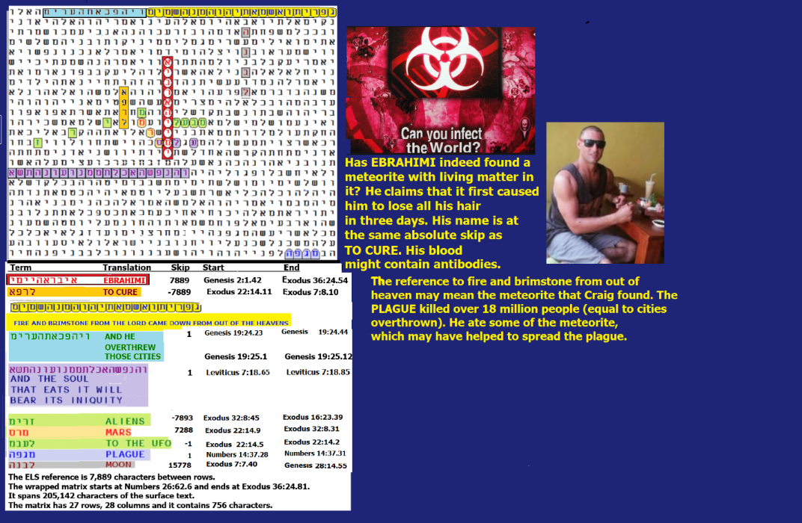
Figure 5-20 above: Ebrahimi has eaten some pretty unusual food. He claims to have lost hair after ingesting small amounts of dust from his meteorite. On the matrix above, the axis term is a long (10-letter) spelling of his last name. When we think about a meteorite, we envision something hot. If that something is carrying a virus like COVID-19, it could cause a PLAGUE. PLAGUE is on the matrix in the open text, but of more interest with respect to his diet are two phrases: BRIMSTONE AND FIRE FROM OUT OF HEAVEN, plus AND THE SOUL THAT EATS IT WILL BEAR ITS INIQUITY. ALIENS is on the matrix, but not at a special case skip. However, a short transliteration of MARS touches both ALIENS and EBRAHIMI. TO THE UFO at skip -1 touches EBRAHIMI. While ROCK is only three letters in Hebrew, two of them touch EBRAHIMI. In looking for who wrote the Codes, this matrix can be used to argue for God or aliens; however, it does not exclude the possibility that God employed aliens as his assistants, much the way He did with three angels (messengers) that He sent to report on behavior in Sodom and Gomorrah before He destroyed them.
There are three significant terms on the matrix above. Both BRIMSTONE AND FIRE FROM OUT OF HEAVEN, plus AND THE SOUL THAT EATS IT WILL BEAR ITS INIQUITY were each found against odds of about 321 to 1. PLAGUE was found against odds of about 36 to 1. Overall, this matrix was found against odds of about 2.09 trillion to 1 without allowing statistical credit for the long spelling of the axis term EBRAHIMI. If we count the 10-letter axis term, the odds against finding this matrix grow to over 19.90 trillion to 1. Clearly, the Author of the Torah knew all about this alien over 3,000 years ago.
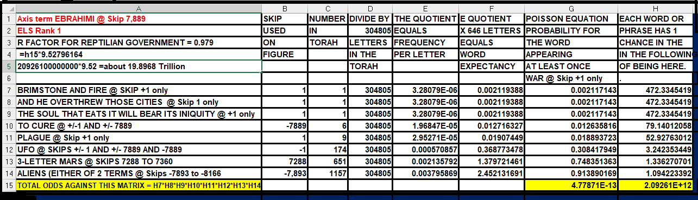
Above: Spreadsheet showing the odds against finding Figure 5-20.
There are many more examples in the Torah Code that describe the COVID-19 plague. Below the axis term is WUHAN, the city where the virus was modified at the Institute of Virology to be more lethal. INSTITUTE is at the skip of WUHAN. No specific date is given, but in the open text is IN THE END OF DAYS. PLAGUE is also in the open text. More profound, in the open text is IT SEEMS TO ME THERE IS A PLAGUE IN THE HOUSE. There is more about death.
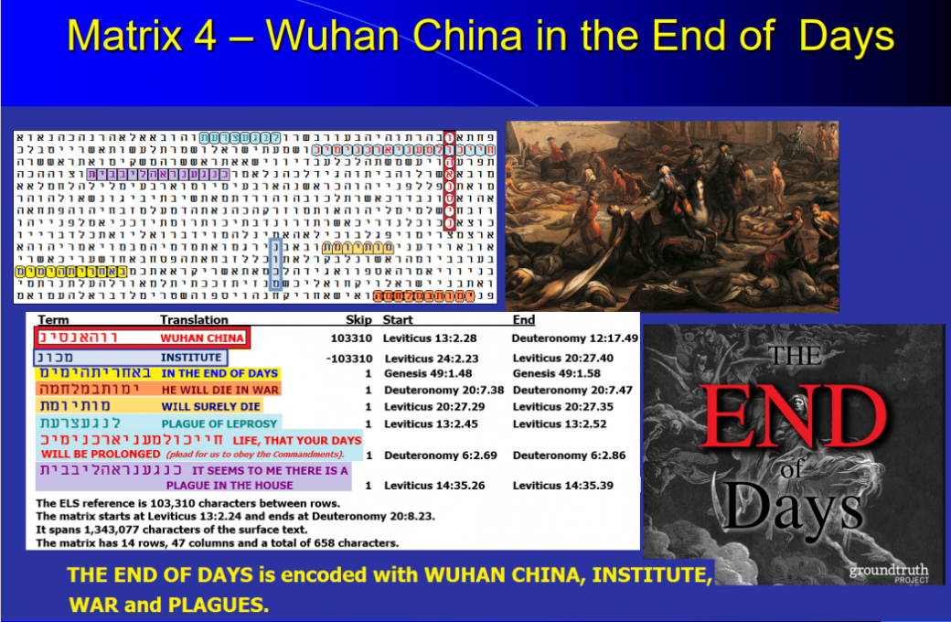
Figure 5-21 above: WUHAN and a PLAGUE IN YOUR HOUSE in the Torah Code. By the time it calmed down, my wife and I both tested positive for it. Fortunately, we recovered. Odds against this matrix are about 935,195,904 to 1.
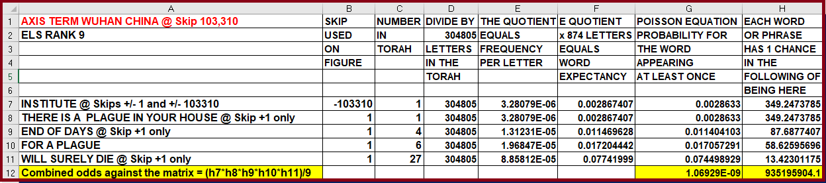
Figure 5-22 below: The axis term is LIVE ALIEN EMBRYO. At the same skip is WUHAN. CHINA is at skip +1, UFO is at skip -1 sharing a letter ayin with LIVE ALIEN EMBRYO. GILEAD is at skip +1. It makes remdesivir, a treatment for COVID-19 The virus caused some starvation in Wuhan when the city was shut down. Odds against this matrix were over 1.8 million to 1.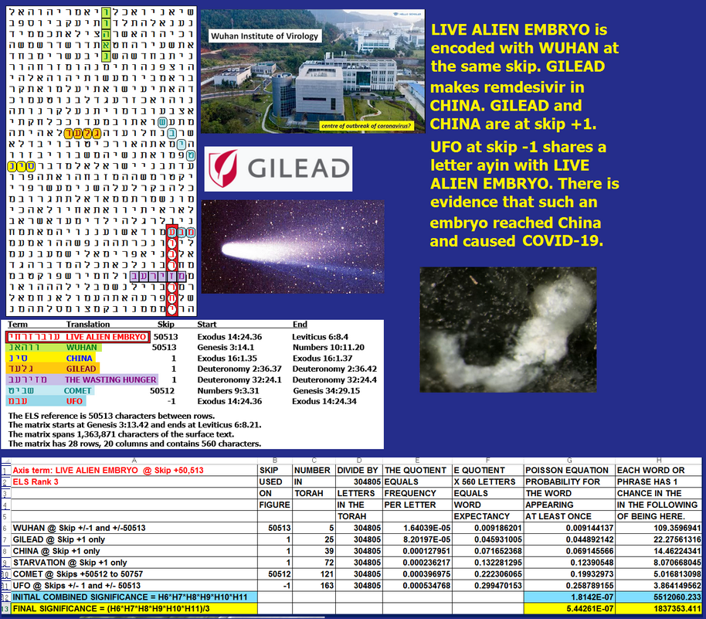
DID ELON MUSK VISIT EBRAHIMI AND HIS METEORITE?
Here we examine email, local news coverage, and Torah Code evidence that on August 6, 2019, Elon Musk traveled to Sooke, BC, Canada, or within a few minutes of it, to meet Craig Ebrahimi, an alleged alien, who tried to sell him a meteorite. It supposedly contains 16 fossils of alien (possibly Reptilian) embryos.

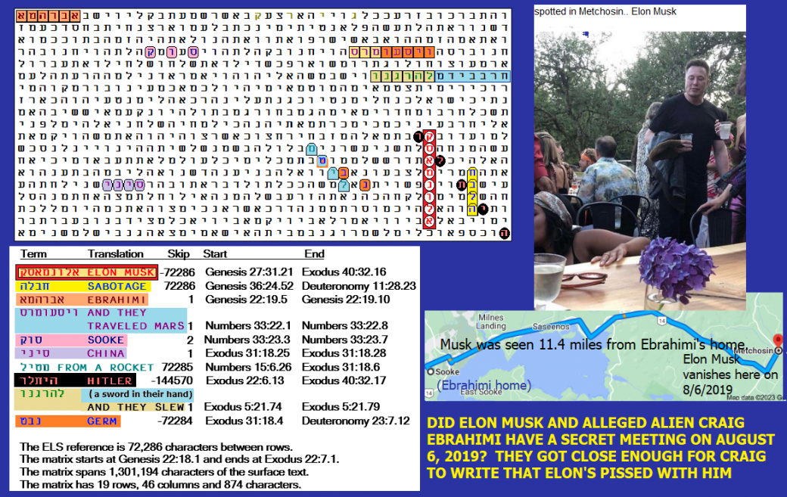

Figure 5-23 above: This is the only matrix that I could find with ELON MUSK on it (as the axis term) and a transliteration of EBRAHIMI that was formed with Abraham in the open text, followed by a letter alef (yud would also work) that can be read as a hard e when a dot (chiriq) is assumed to be implied under the alef. Vowel signs are not included in a hand-written Torah scroll but are included in book versions.
Terms (found a priori) on the matrix that were worthy of a statistical calculation start with a short transliteration of MARS. The planet is not only on the matrix at skip +1 against odds of about 174 to 1. It has an interesting location. It’s in sequence with and after AND THEY TRAVELED…(MARS). Musk not only wants to live there but to die there (just not on the landing). If, as I suspect based on remarks by Israeli Brigadier General Haim Eshed, it’s true that we have a joint top-secret U.S.-alien base on Mars, Musk may have to worry about his mission with respect to SABOTAGE by a Deep State/Fourth Reich government. SABOTAGE is four columns directly to the right of and at the same absolute skip as ELON MUSK. A transliteration of HITLER touches two letters of ELON MUSK. The same HITLER also touches two letters of SABOTAGE. CHINESE is also on the matrix at skip +1. The CHINESE will be our primary competition unless we are already there. Further, on December 27, 2019, the Chinese press covered the story of Craig’s meteorite.
The importance of Sooke is twofold. It’s the town that Craig lives in, and, since his photo shows him wearing something like military insignia allegedly seen on aliens in the 1954 meeting between Eisenhower and ETs, Sooke might be the home of more aliens than just Ebrahimi. I could not find COVID, plague, or virus on the matrix, but GERM is there. Musk is a rocket man, and ROCKET is there. However, it’s easier to find ROCKET than to call a coin toss correctly. As for EBRAHIMI, he had to be on the matrix for me to publish it. He was found at skip +1 again, odds of about 7.35 to 1. I would have thought that the name would be more significant, but in Hebrew, the first five of the six letters of his name are simply ABRAHAM. He is a major focus of Torah. His name appears at skip +1 some 151 times. His earlier name, ABRAM, also appears 60 times, but that 4-letter name lacks the letter hey necessary to form EBRAHIMI. Overall, odds against this matrix were about 31,253,037 to 1. This does not factor in the axis term (Elon Musk). The Codefinder software that I use indicates an R-factor of 0.061. This means that it only had about an 86.9% chance to be found at least once at an ELS in Torah. In fact, there is just one ELS of the name in the wrapped Torah. It’s at a skip of -72,286, which means that the computer had to make more than one pass through the 304,805 letters of Torah to find Sooke.
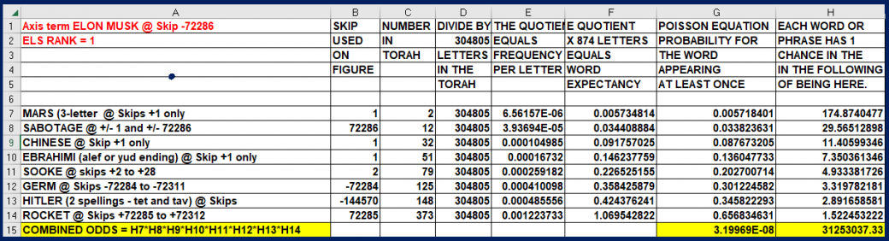
Above: Spreadsheet showing odds against Figure 5-23.

IS CRAIG EBRAHIMI A CANADIAN REPTILIAN? See Figure 5-24 and its spreadsheet below.

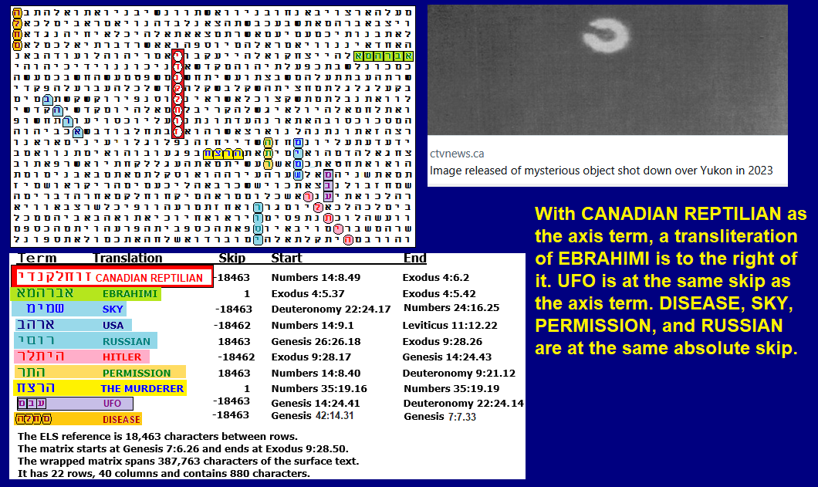

Figure 5-24 above. CANADIAN REPTILIAN is the axis term. First, let’s look at an 18-row by 24-column (432-letter) area including and around CANADIAN REPTILIAN. Terms at the same absolute skip of CANADIAN REPTILIAN include UFO, SKY, and RUSSIAN. I have no evidence that Ebrahimi was working with the Russians, so this term requires its own spreadsheet to analyze. It is noted just because the Code may be warning us about them here. Also at the same skip is PERMISSION, which shares a letter resh with THE MURDERER (open text). I have evidence that Craig was involved with spreading the COVID DISEASE, which killed at least 18 million people. He basically claims that other aliens sent him directions (coordinates) for finding his 27-pound meteorite, which appears to be the source of the virus. DISEASE is also at the same absolute skip of CANADIAN REPTILIAN, but it only shows up on the larger, 880-letter matrix. USA and HITLER are both one skip off that of the axis term.
If we just look at the 432-letter matrix without RUSSIAN, it was found against odds of about 5,265,921 to 1. If RUSSIAN turns out to be a valid term (against odds of about 101 to 1), then odds for this matrix grow to about 1.6 billion to 1 if we include the 8-letter axis term. On the larger, 880-letter matrix, with no Russian, total odds against it are about 19.2 million to 1. This axis term, and what I heard from Craig, seems to indicate that there is a colony of Reptilians living near or around Craig. The picture shown on Figure 5-24 shows a UFO that was shot down by a U.S. aircraft over Canada. Is there any evidence to support the claim that there is a reptilian colony in Canada? On May 9, 2025, I got a print-screen of the Table below. It revealed that in all the world so far that month, Canada ranked number 2 with 1,538 pages of my research read. Only the U.S. had read more so far, with 6,443 pages. It might turn out that many of my readers there are ETs who are worried about me revealing their identity.

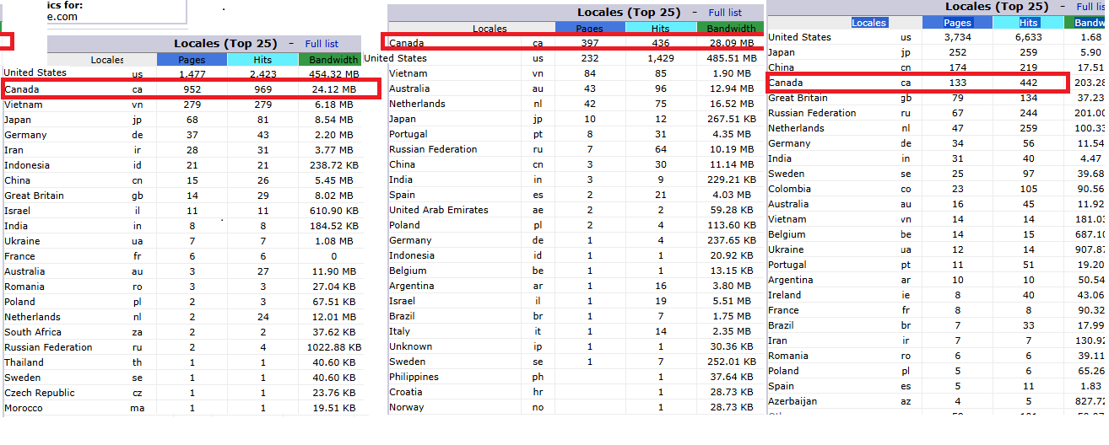
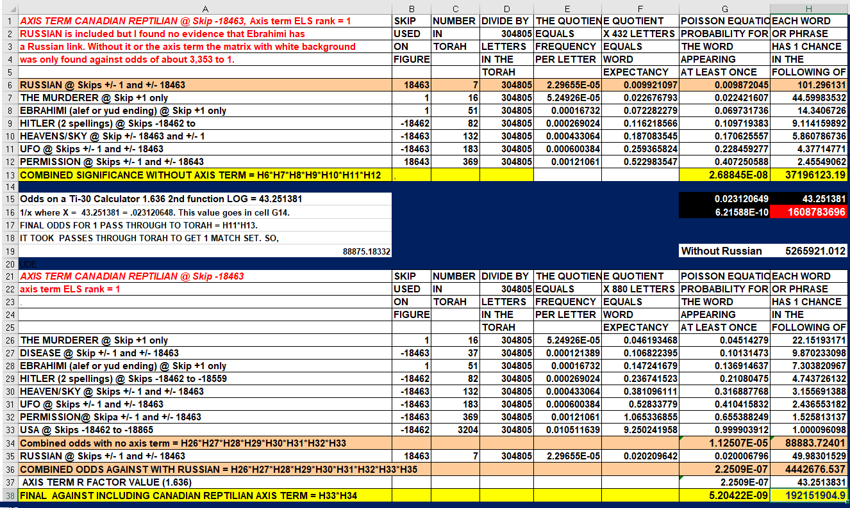
Craig Ebrahimi, as noted above, claimed to be an alien. Specifically, after an argument with me, he sent me this email on March 27, 2020:
On Fri, Mar 27, 2020 at 4:43 PM Craig Ebrahimi craigebrahimi@hotmail.com wrote:
“Guy, your dumb ass shit keeps getting sent to me by one of your Hebrew followers. You got to be one of the biggest dummy humans I ever came across. You talk this shit in your writing ABOUT my biotechnology, once again you're dumb! You don’t even know you're dealing with fucking real extra-terrestrial self-made multi-millionaire since teens, you idiot. If you looked into these eyes, I would eat your soul, puppet boy.”
How does the Canadian government view Craig? I had a phone conversation about it on or around December 29, 2020. In checking my email record with him (in chapter 6), I see:
“Craig reports that the Canadian Royal Police are stopping him every week and that he is afraid to leave Canada for fear that they will not let him back in. I surmise that Fort Huachuca is likely keeping him under their thumb, but they have yet to contact me directly to confirm it.”
Hostile reptilians in Canada may be the real reason why President Trump wants to acquire Canada.
Additional Sources:
SEE THE POWERPOINT AT https://roffmanmarsresearch.com/?page_id=2467
.
The record of the matrices that I have found relating to him and Mars and posted on my website (RoffmanMarsResearch.com) is as follows:
- Alien COVID Origin 7/24/2024 – Page Alien COVID Origin 7/24/2024. Menu item 5 of 114.
- Meteorological Implications: Evidence of Life on Mars? (14-page Roffman review of Joseph) – Page Meteorological Implications: Evidence of Life on Mars? (14-page Roffman review of Joseph). Menu item 9 of 114.
- Israel’s top scientist, Eshed, reveals that people are on Mars. 12/12/23 – Page Israel’s top scientist, Eshed, reveals people on Mars. 12/12/23. Menu item 89 of 114.
- WHAT OTHER WORLDS MAY HAVE VISITED US OR INFILTRATED OUR GOVERNMENT? Alien Base in Jupiter’s Clouds? (7/7/2022) – Page Alien Base in Jupiter’s Clouds? (7/7/2022). Menu item 56 of 114.
- ISAAC & AN INTELLIGENCE ESTIMATE (12/22/2022). Sub item number 2 under Nazi/Alien Plan to Conquer the U.S. (12/19/22).
- TIC TAC UFOs – Page TIC TAC UFOs. Menu item 23 of 114.
- Part 1- Gilbert Levin Found Life on Mars – Page Part 1- Gilbert Levin Found Life on Mars. Menu item 10 of 114.
- Brandenburg & Martian Nuclear War. 3/22/2023 – Page Brandenburg & Martian Nuclear War. 3/22/2023. Menu item 76 of 114.

