# **Chapter 2**

**ET Infiltration in the Vatican**

If you follow my work closely, you know that I strongly believe that Reptilians have taken over control of much of the U.S. Government. This suspicion is backed by many Torah Code matrices in Chapter 3. One of the better ones is on my matrices about Chris Wray of the FBI. But in glancing through my articles about Reptilians, I have seen suggestions that another Reptilian power center is in the Vatican. Figure 2-1, and the photos of the Paul VI Audience Hall at the Vatican, seem to back this idea.

[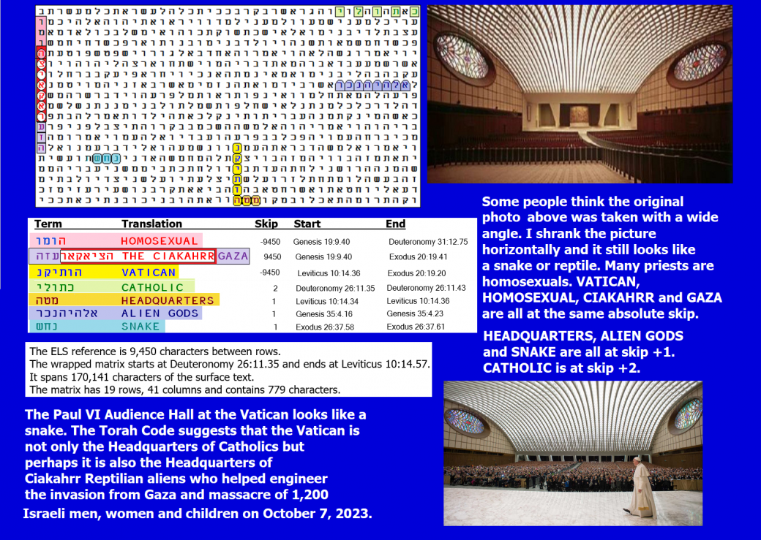](https://roffmanmarsresearch.com/wp-content/uploads/VATICAN-AND-CIAKAR.png)

**Figure 2-1** above: What leaps out at us with Figure 2-1 is that we have what at first looks like a 13-letter ELS. An ELS that long is almost never found. However, what we are really looking at are three terms that were all found in the same column. They are composed of 14 letters, but there is a one-letter overlap. This matrix was found against odds of 55,288 to 1.

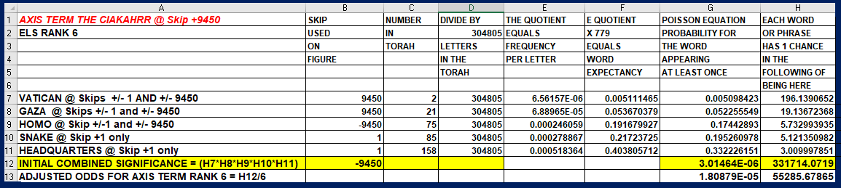

The first term sought was a variety of Reptilian known as **THE CIAKAHRR** (7 letters if we include an initial letter of *hey* for **THE**). The next term sought was **THE VATICAN**. This was 6 letters at the same absolute skip (opposite direction) as **THE CIAKAHRR.** But **THE VATICAN**, while at a special case skip, is not in the same column as **THE CIAKAHRR.** When I asked my son what he thought I should look for next, he suggested **HOMO** because of all the criminal cases of pedophilia associated with the Catholic priests. However, if his reasoning was fully correct, we might expect **HOMO** to touch **THE VATICAN**. In reality, it is found touching and overlapping **THE CIAKAHRR** with the letter *hey* being shared with **THE CIAKAHRR**. This might actually suggest that **THE CIAKAHRR** do not follow what we consider to be normal sexual practices on Earth.

The next term sought was **HEADQUARTERS**. It would work with either **THE CIAKAHRR** or with **THE VATICAN** if we are talking about the Catholic Headquarters. If we are concerned about ETs controlling us by shaping our main religions, then that would also be a major concern. **HEADQUARTERS** was found at skip +1, sharing the letter *hey* with **THE VATICAN**. Next, I sought something to link the Ciakahrr Reptilians with something ALIEN. I then found **ALIEN GODS** in the open text. Finally, I have often written that I thought Hamas was given some alien technology to help them break through the wall around Gaza, giving them almost instant access to over 1,200 Israelis that they could rape and or murder while the victims were home in their beds. So, I sought **GAZA.** It was right there in sequence with **THE CIAKAHRR**. This gave me **HOMOSEXUAL, THE CIAKAHRR,** and **GAZA** all in one column.

Figure 2-1 also shows the PAUL VI Auditorium at the Vatican. Typically, Catholic churches are in the shape of a cross. The rooms are full of statues of Jesus, or Mary, or saints. None of these are in this auditorium. Instead, the room is shaped like a snake head complete with fangs on stage. The word **SNAKE** is also on Figure 2-1 at skip +1. Very oddly, when you look up how the Biblical Being (the Serpent) associated with evil came to be the image that the Church wants to put out in association with the Pope, you often find excuses that demand you to forget what your eyes are plainly seeing. In fact, the image is serpent-like when looking from the back of the room to the stage at the front, and from the stage looking backward. It is often reinforced with the sculpture shown on Figure 2-2.

**[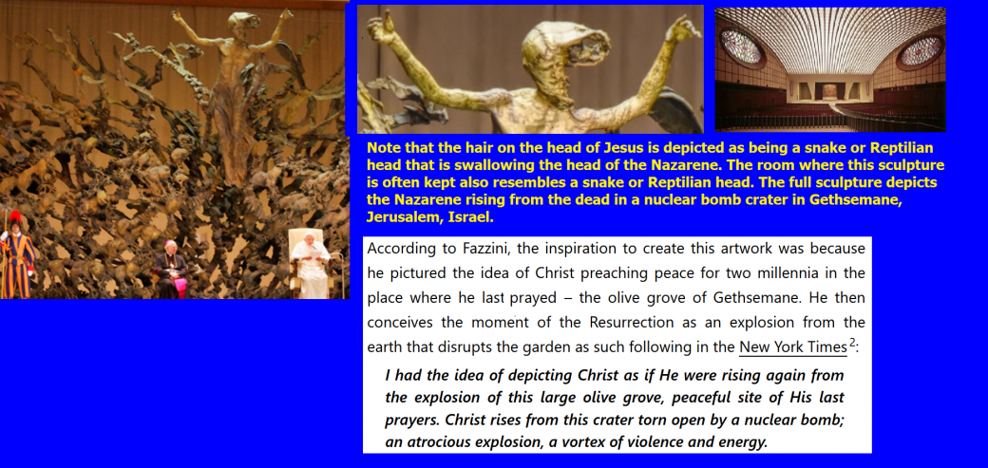](https://roffmanmarsresearch.com/wp-content/uploads/POPE-AND-REPTILIAN.png)**

Figure 2-2 above: The idea that the Vatican is the Headquarters for Reptilian aliens is supported by the facts that the Vatican has built an enormous auditorium partly in Vatican City and partly in Rome – in the shape of a snake or Reptilian head, lacking all normal Catholic statues or crosses. Instead, it shows what happens after Jerusalem gets nuked. If this “artwork” shows a risen Nazarene, he is rising inside that head of a snake or reptilian creature that has just destroyed Jerusalem. As the Vatican allied with Nazis during World War 2, and as it helped Nazi war criminals escape via ratlines after World War 2, its choice of artwork here shows that its policy is still one of extermination for all Jews.

Reptilians have, quite possibly, served as the inspiration for gargoyles in Catholic churches in Europe. Wikipedia states, “*During the 12th Century, when gargoyles appeared in Europe, the Roman Catholic Church was growing stronger and converting many new people. Most of the population at this time was illiterate, so images were very important to convey ideas. Many early gargoyles depicted some version of a dragon, especially in France. In addition to serving as spouts for water, the gaping mouths of these gargoyles evoked the fearsome destructiveness of these legendary beasts, reminding the laity of the need for the church's protection*.” The reason why many gargoyles are depicted as these dragon-looking, unidentifiable monsters is because it is said the founding bishops of churches would rid their respective towns of these kinds of beasts. What does the Torah Code say about this? See Figure 2-3. Against odds of about 178 to 1, **GARGOYLE** is encoded in a 28-letter matrix with **REPTILIAN** at skip -1. The full matrix includes **FROM A STAR** and **FROM THE PLEIADES** at the same absolute skip as **GARGOYLE. UFO** is at skip -1. **PRESIDENTS** at skip +1 overlap **UFO** (two presidents are discussed in Chapter 3 as possibly being reptilian or abducted and programmed by reptilians – Obama and Biden). **GRAY** is one skip less than **GARGOYLE.** Grays supposedly help reptilians by abducting people for them. Against odds of about 23,038,267 to 1, this matrix tells us that this love of reptilians seen in the Pope John VI Auditorium is not new.

Based on Figure 2-3, it is likely that reptilians, always out to rule worlds, infiltrated the Catholic Church. Hitler was their natural (Satanic) ally during and after the Holocaust. Gargoyles are also found in Europe with the Church of England and the Episcopal Church.

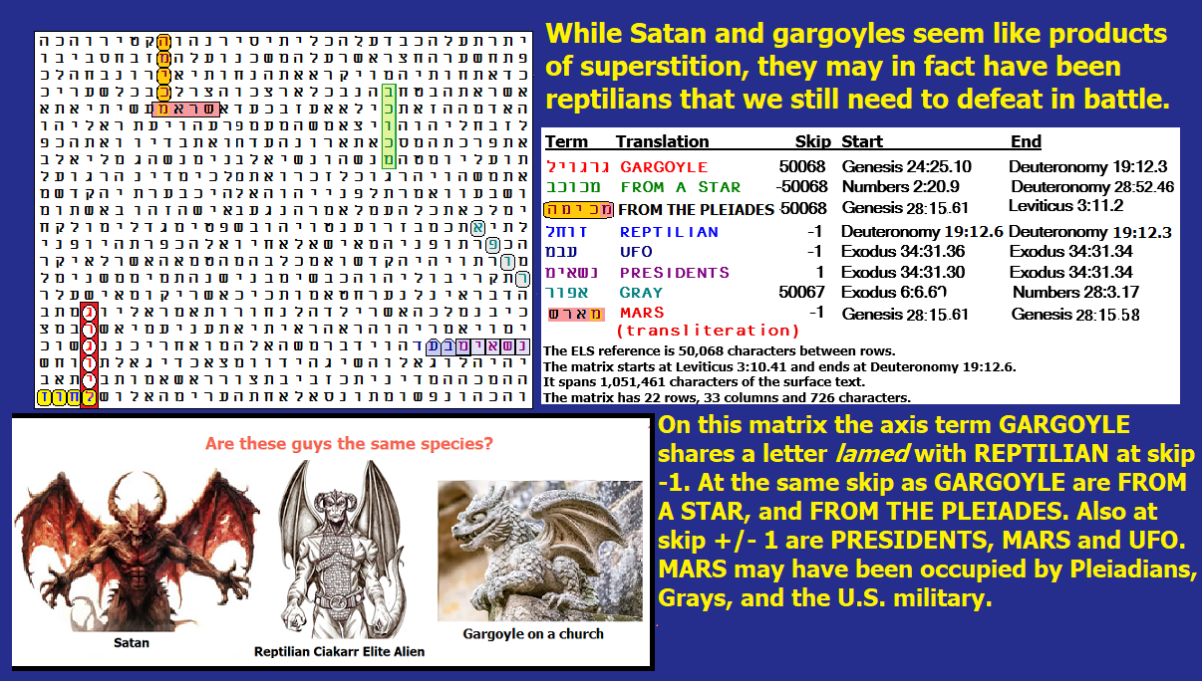

**Figure 2-3**. The Code gives us reason to believe that **REPTILIANS, GARGOYLES,** and **SATAN** all represent the same or related species. **REPTILIANS** and **GARGOYLES** met in 28 letters against odds of about 178 to 1.

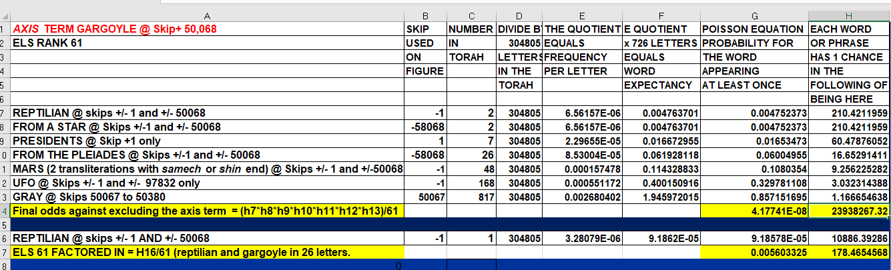

Spreadsheet for Figure 2-3 above. Odds against this matrix were about 23,938,267 to 1. Although the match against **GARGOYLES REPTILIAN** at first seemed truly exceptional (10,886 to 1), this was without considering ELS rank 61 of the axis term (**GARGOYLE**). When the ELS rank of 61 is factored in, the match was actually against odds of about 178 to 1. That is still outstanding. The general structure of the full matrix argues in favor of deliberate encoding, even though I generally look for axis terms that are 7 or 8 (really 8) letters long. Where I make exceptions, the axis term has Hebrew letters that are relatively rare. **GARGOYLE** has two letter *gimel*s. This is the 3rd rarest letter in Hebrew. Out of 304,805 letters in Torah, there are only 2,109 *gimel*s. The only letters that are fewer in number are *tet* and *samech.*