# **Chapter 1**

**Jewish ET connection?**

This chapter was inspired by a 2023 book (US Army Insider Missions: Space Arks, Underground Cities & ET Contact) by Dr. Michael Salla, in which he interviews a young, Hispanic member of the U.S. Army who goes by the pseudonym J.P. He claims to be allowed to disclose great secrets about alien life so long as he does not reveal his real name. The link to buy the book is at <https://www.amazon.com/US-Army-Insider-Missions-Underground-ebook/dp/B0C53DPZJC>. The description of an alien flag may point to what I suspect about a link between Israel and ET. The ET flag is described on page 293. J.P.’s English (his third language) is not the best. It states:

*It was like a blue and white flag; it was kind of weird, but it was similar to the Israeli flag, but it was different. It had two gold angels by the Star of David, but the flag was different; it was blue, white, and gold. The two angels were gold, and they were like (it) … looks like the ark of the covenant type.*

[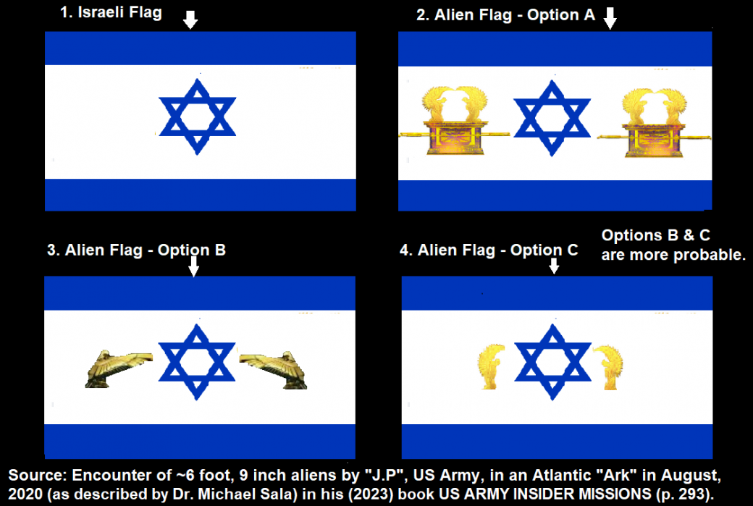](https://roffmanmarsresearch.com/wp-content/uploads/JP-ALIEN-JEWISH-FLAGS.png)

**Figure 1-1** above. The Israeli version of their flag is shown with three versions of the alien flag seen. It is believed that the ark of the covenant shown in Option A is only shown due to less than perfect phrasing in J.P.’s description. Thus, Option B or C is more likely what was supposedly seen, but a photo or better description is needed to accurately describe the exact shape of the two angels depicted.

[](https://roffmanmarsresearch.com/wp-content/uploads/SALLA-BOOK-8.png)

Figure 1-2 above – cover on Salla’s *INSIDE US ARMY INSIDER MISSIONS*.

**QUESTION: Were the ten lost tribes of Israel taken by aliens who then interbred with them?**

Even before the Jewish tribes came into existence, by the 6th chapter in the book of Genesis, there are references to beings who intermingle with — OK, who interbreed with — human beings, including “b’ney Elohim” and “Nephilim.” While again, we are instructed not to belabor the meaning of these beings and incidents, lest our minds grow fuzzy and our teeth fall out, it isn’t lost on some scholars that “Nephilim” means “fallen,” as in “fallen from the sky.” Either or both of these non-human species could well be our brothers from another planet (they are referred to as males).

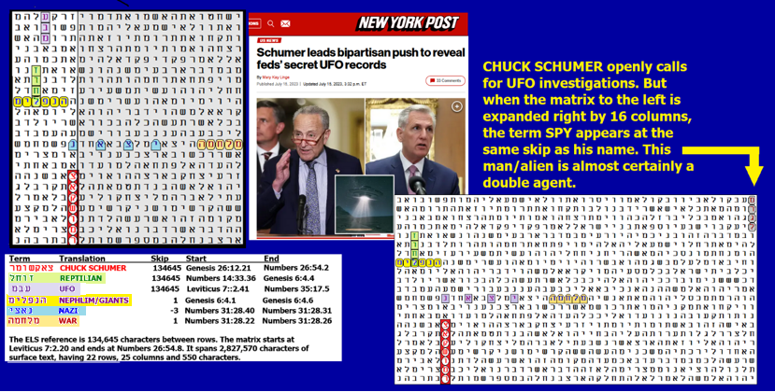

Figure 1-3 above: **CHUCK SCHUMER, REPTILIAN,** and **UFO** are all at the same skip. **REPTILIAN** also shares a letter *lamed* with **NEPHILIM** in the open text. If this matrix was deliberately encoded, it was likely done so to warn us about Schumer and to inform us that the Nephilim found in the Bible were really Reptilians.

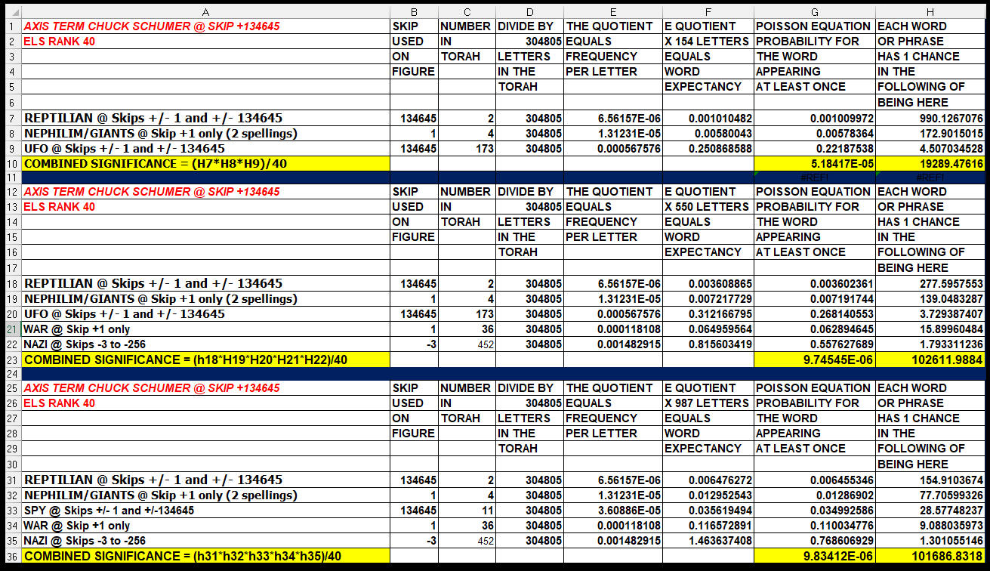

The ten lost tribes were exiled from the Kingdom of Israel after its conquest by the Neo-Assyrian Empire c. 722 BCE. They were named as follows: Reuben, Simeon, Dan, Naphtali, Gad, Asher, Issachar, Zebulun, Manasseh, and Ephraim; (all but Judah and Benjamin, as well as some members of Levi, the priestly tribe, who did not have their own territory).

QUESTION: Does Judaism require belief in extraterrestrials? The Forward, a Jewish magazine, writes,

*“Contemporary Rabbi Benjamin Blech once wrote,*

*“What is fascinating … is that a significant body of opinion in traditional sources not only validates the possibility for alien life on other planets but actually finds biblical and midrashic confirmation for this view, even as it suggests that belief in an all-powerful God forbids placing any limitations on the extent of his creative powers.”*

In other words, a strong belief in an omnipotent God cannot logically exclude the possibility of other worlds populated by other creatures.

Blech’s colleague David Weintraub, professor of astronomy at Vanderbilt University and the author of Religions and Extraterrestrial Life: How Will We Deal With It?, posits that Jewish theology may actually require a belief in extraterrestrials since there are no limits on the power of the Creator. He writes,

*“[F]or Jews to say that no life beyond the Earth could possibly exist would be unacceptable, as such an idea would appear to place shackles on God’s creative power. The universe belongs to God, and God can do what God wishes to do with the universe.”*

According to the Jewish sage, God draws the line at playing dice.

The Forward once ran a short piece entitled “Putting Israel’s UFO Frenzy Into Historical Perspective,” after videos surfaced purporting to show UFOs hovering over the Jerusalem skyline. Unidentified flying objects are no stranger to the Holy Land. The Bible is full of accounts of sightings of heavenly beings. Indeed, a cornerstone of Jewish liturgy is the line from Psalms 19:2 — “The heavens declare the glory of God”— which some sages read to mean that we earthly inhabitants are not alone among the creatures in the universe who praise Hashem.

In the Book of Judges (5:23), a passage reads,

*“Curse Meroz, said the angel of the Lord, curse bitterly its inhabitants.”*

The 18th-century sage Rabbi Pinchas Eliyahu Horowitz claimed to have found Talmudic backing for his belief that Meroz was another planet, just one of many other worlds that God created.

Mid-20th-century kabbalist Aryeh Kaplan was also a professor of physics, and he often sought to find common ground between the two disciplines. For Rabbi Kaplan, there was no question that extraterrestrial life existed and that it was discussed in the Zohar. Kaplan wrote,

*“The Midrash teaches us that there are seven earths. Although Ibn Ezra tries to argue that these refer to the seven continents, the Zohar clearly states that the seven are separated by a firmament and are inhabited. Although man does not inhabit them, they are the domain of intelligent creatures.”*

Israel’s top scientist, Haim Eshed, reveals that people are on Mars. **HAIM ESHED** is encoded at the same skip as **MARS** (best spelling), **LIFE, ALIEN,** and **GRAY. PLEIADES** is one skip away, with **UFO** at the same absolute skip. See Figure 1-4. Odds against this matrix are about 22,162,538 to 1. The most significant *a priori* term is the best (5-letter) spelling of **MARS**, which was found at a special case skip against odds of about 411 to 1.

[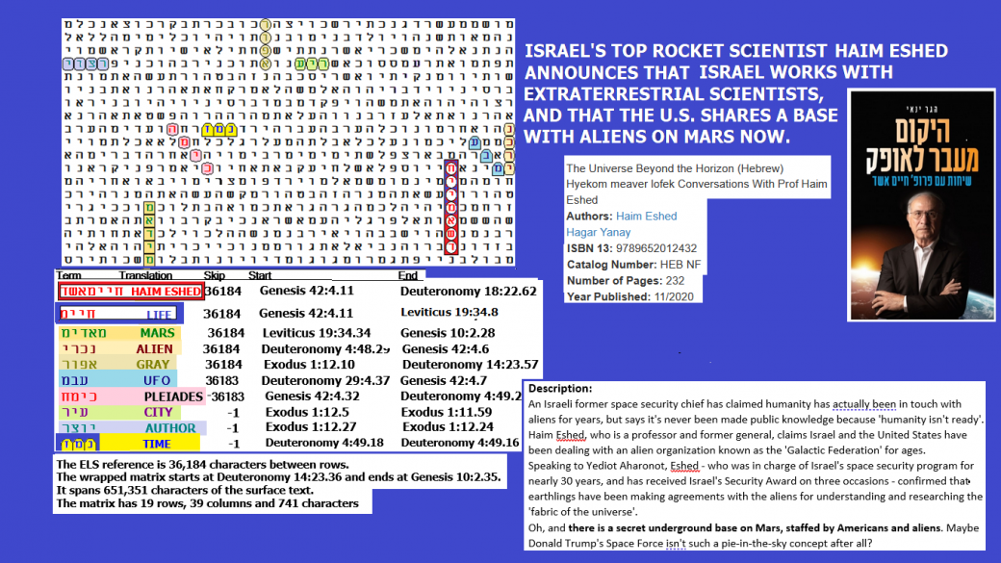](https://roffmanmarsresearch.com/wp-content/uploads/ESHED-LIFE-ON-MARS1.png)

Figure 1-4 above: I have published information before about Haim Eshed. As head of the Israeli Space Agency for about 30 years, he really surprised the rest of the world when he announced that the Israelis are working with aliens. Still, when aliens start showing up elsewhere on Earth with a version of the Israeli flag to represent their nation, it’s time to start asking some serious questions.*What, exactly, is the relationship of Israel with ET?* I have long suspected a link between our people and ET that began with the predicted conception and birth of Isaac, the first known human to be born into Judaism.

[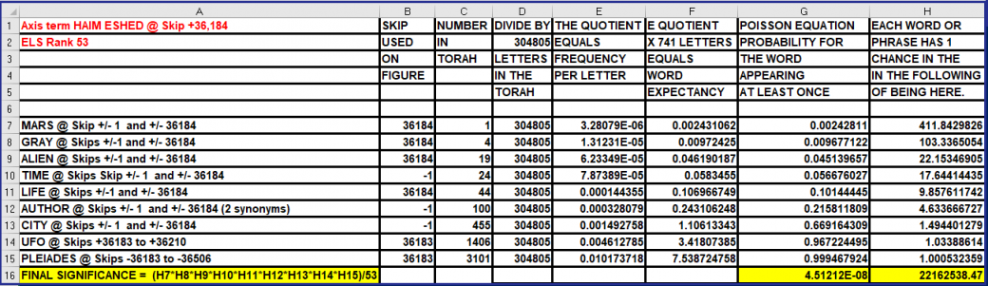](https://roffmanmarsresearch.com/wp-content/uploads/ESHED-TIME-ODDS1.png)

Who were the three men who visited Abraham and Sarah to predict the birth of Isaac? Were they angels or aliens? Let’s examine the text.

## **The Three Visitors of Genesis 18:1-18:5**

*18 1 The Lord appeared to Abraham near the great trees of Mamre while he was sitting at the entrance to his tent in the heat of the day. 2 Abraham looked up and saw three men (shelosha anashim = 3 men) standing nearby. When he saw them, he hurried from the entrance of his tent to meet them and bowed low to the ground.*

*3 He said, “If I have found favor in your eyes, my lord do not pass your servant by. 4 Let a little water be brought, and then you may all wash your feet and rest under this tree. 5 Let me get you something to eat so that you can be refreshed and then go on your way, now that you have come to your servant.”*

The word for *men* is used again in Genesis 18:16 and 18:22 when they started again to walk toward Sodom. It is also used in Genesis 19:5, 19:10 through Genesis 19:14. There it is in conjunction with the angels outside and inside of Lot’s house. HaShem (The Name) is also intermittently used (in Genesis 18:1, 18:13, 18:17, 18:19, 18:20, 18:26, 18:33) to indicate God who is employing the landing party and who is also in direct contact with Abraham.

## **The Birth of Isaac (Genesis 21:22:1-7)**

*1 Now the Lord was gracious to Sarah as he had said, and the Lord did for Sarah what he had promised. 2 Sarah became pregnant and bore a son to Abraham in his old age, at the very time God had promised him. 3 Abraham gave the name Isaac[a] to the son Sarah bore him. 4 When his son Isaac was eight days old, Abraham circumcised him, as God commanded him. 5 Abraham was a hundred years old when his son Isaac was born to him.,*

*6 Sarah said, “God has brought me laughter, and everyone who hears about this will laugh with me.” 7 And she added, “Who would have said to Abraham that Sarah would nurse children? Yet I have borne him a son in his old age.”*

With regards to this “landing party” of three, the initial use of the word men may indicate that if they were alien, they were likely a humanoid species like the Nordics or Pleiadians. The term for *angels* is used for two of them in Genesis 19:1 and Genesis 19:35. There are six other uses of the term for *angels* (*malachim*) in Torah; however, all of them (in Numbers 32:4, 32:7, Numbers 20:14, Numbers 21:21, Numbers 22:5, and Deuteronomy 2:26) are translated as *messengers.* Could the correct interpretation for Genesis 19:1 and 19:15 really be *messengers* rather than *angels*? Yes. Sodom was destroyed because of its incredible immorality. Genesis 19:6-9 reads as follows:

*Lot went out to them to the entrance and shut the door behind them, and he said, “I beg you, my brothers, do not act wickedly. See, now, I have two daughters who have never known a man. I shall bring them out to you and do to them as you please; but to these men do nothing inasmuch as they have come under the shelter of my roof.” And they said, “Stand back!” Then they said, “This fellow came to sojourn and would act as a judge? Now we will treat you worse than them!” They pressed exceedingly upon the man (Lot), and they approached to break the door.*

The message here to the world (especially to liberal, Democrat Americans) is clear. There will be consequences for sick behavior, be it bringing drag queens into kindergarten or enforcing transsexual actions on children even when their parents object. In Genesis, the punishment was sulfur and fire raining from heaven (Genesis 19:23), not unlike a weapon being dropped from orbit. On Earth, Putin (who hates homosexuals) threatens to use nuclear weapons against their supporters. Whatever wiped out Sodom and Gomorrah, the weapon was clearly dropped from above, and it was controlled via surveillance in Sodom. Given that the translation "*angel*" is not certain, and that "messenger" works just as well, there is a high probability that the event is at least partially extraterrestrial in nature, even if the ETs here are (or think they are) working directly for God.

It seems like a high percent of reported abductions by aliens involve some type of reproductive probe or intrusion. The most humorous one that I ever heard involved my good friend, U.S. Navy Commander C. B. Scott Jones. Scott was the top aide of Senator Claiborne Pell (elected in 1960 for six terms, Chairman of the Senate Foreign Relations Committee for 17 years). In 2007, Scott invited me into his home in Kerrville, Texas, for two days and one night for an interview about what he knew about UFOs. He also wanted to know if the Torah Code was written by ETs. Scott said he represented the U.S. at UFO-related meetings with Chinese and Russian Government officials.

During our talks, he mentioned a MUFON meeting in which two women told him that they saw him on a UFO with a huge number of abductees. Scott didn’t remember the incident, but he asked about what happened.” Well, they said, “*You were naked, on a table, with a hybrid female alien over you, having sex with you!” Scott laughed and then told them, “I sure wish I could remember that, but the joke was on the ET. If she wanted to get pregnant, I was shooting with blanks because a few weeks before, I just had a vasectomy!”*

While Scott laughed at hearing the story from MUFON, Sarah laughed at hearing the report on her upcoming pregnancy. In fact, her son was named Yitzchak (Isaac), which means “One who laughs or rejoices.” But there are serious implications of the event here.

1. If both Sarah and Abraham were abducted, then Abraham’s sperm could have been put into Sarah’s egg in a lab. In this case, God’s promise to give Abraham a son was fully carried out (with the help of medical technology).
2. If Sarah’s egg was fertilized, but by an alien sperm, then Isaac was a hybrid – Sarah’s true son, but not the true son of Abraham. This would make Ishmael not only still Abraham’s first-born son, but the only child with a legitimate claim to rights associated with being directly descended from Abraham. This route tends to back Muslim theology. But it also decreases the chance that the ELS Torah Code could survive changes to the Torah text made by Jews. For example, Isaac is only four letters in Hebrew, while Ishmael is five. Very large skips of the axis term, and just about all wrapped text matrices requiring more than one computer pass through the 304,805 letters of Torah, would be destroyed by making such switches. And yet I have found many thousands of matrices. This fact argues for Option 1, which fully fulfills the promises made.
3. An entirely alien embryo was implanted into Sarah. Again, the Torah Code would likely be destroyed, but it really doesn’t do much for Islam because the Quran mentions Isaac 15 times and all in a positive light. If it turns out that Isaac had this kind of conception, then all Western religions are likely based on alien hoaxes designed to help them manipulate humans to serve alien agendas. I think that Option 1 here is correct, but largely based on my experience with the Torah Code since 1997. Unfortunately, there are few (possibly no) people on Earth who are experienced enough with the Code to move it into the realm of evidence that will be universally accepted by science. Short of a full disclosure, we will need either a time machine or software like that proposed in PROJECT CREATOR DECODER to arrive at a true answer. The software is described on my website **at** <https://www.arkcode.com/photo4_113.html>.

## **A First Look at Netanyahu and Aliens in the Torah Code.**

There are times when I’m not sure if the Code is trying to say that Netanyahu is an enemy of aliens or their friend. It can be both ways, depending on whether there is more than one species of aliens involved. Israeli Brigadier General Haim Eshed (who ran the Israeli space program for 30 years) said that aliens work alongside Israelis. If true, Netanyahu certainly knows about the presence of ETs here (and in Israel), and, like President Trump, he is keeping their presence secret. In a way, the situation may be like stories that Franklin Roosevelt knew about Japan’s plans to attack Pearl Harbor but did nothing to prevent it because he wanted to get into the war. With Netanyahu, he might have known about Hamas' plans to attack on October 7, 2023, but did nothing about it because he wanted an excuse to obliterate Hamas (and Gaza).

Figure 1-5 has an axis term that reads **CONQUEST OF GAZA**. The term **ALIEN** is on the top row with **NETANYAHU** three rows right under it, and **ISRAEL** is five rows directly under that. **FROM A UFO** is at the absolute skip of **CONQUEST OF GAZA**. What kind of aliens are alluded to? I don’t see reptilians, but they are allegedly shape-shifters, and **SHIFTER** is at skip -1. The matrix was found against odds of about 337,331 to 1. The anti-Semitic poster alleging a link between Reptilians and Jews was published by none other than Yair Netanyahu in 2017. He is Prime Minister Netanyahu’s son!!!!!!!!!

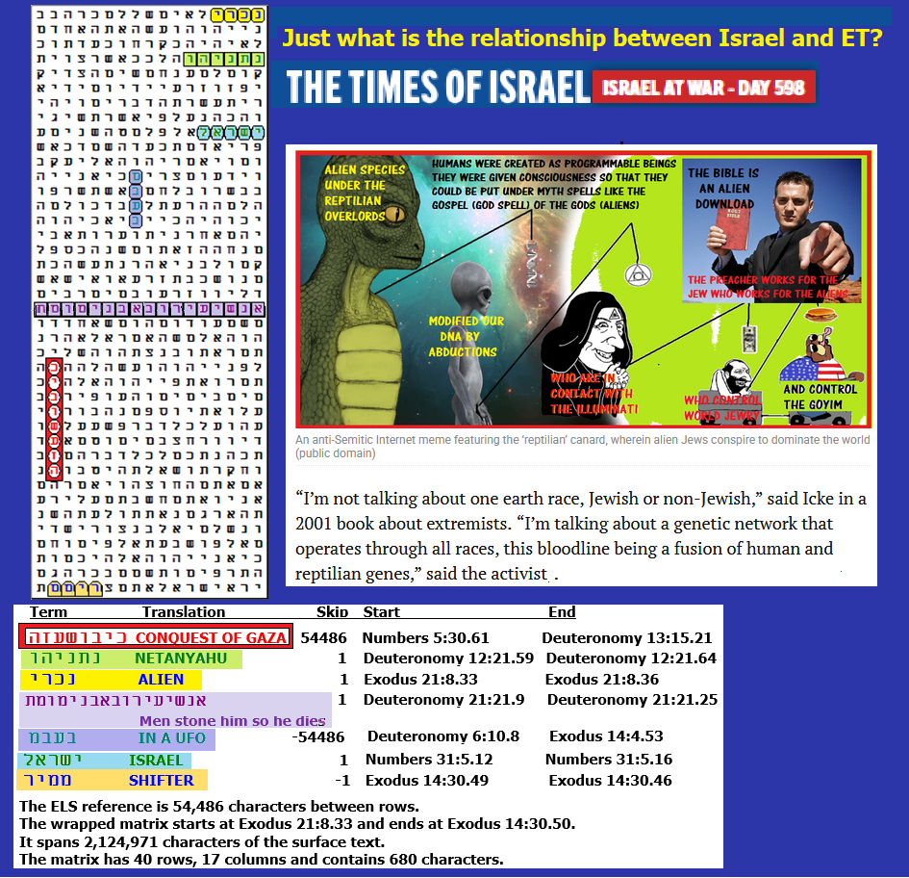

**Figure 1-5** above includes a screenshot of a portion of the cartoon posted by Yair Netanyahu, September 8, 2017 (Facebook). Its spreadsheet is below. I suspect that the cartoon represents a leak in the Israeli Government, but as I make clear in Chapter 9 (Fighting radical Islam and ET), I think the Reptilians supplied Hamas with the technology to move so many troops (undetected and unopposed for many hours) into Israel. Probably, when General Eshed says that aliens work with the Israeli government, he meant Pleiadians, Nordics, or some other race that is basically human and at war with Reptilians.

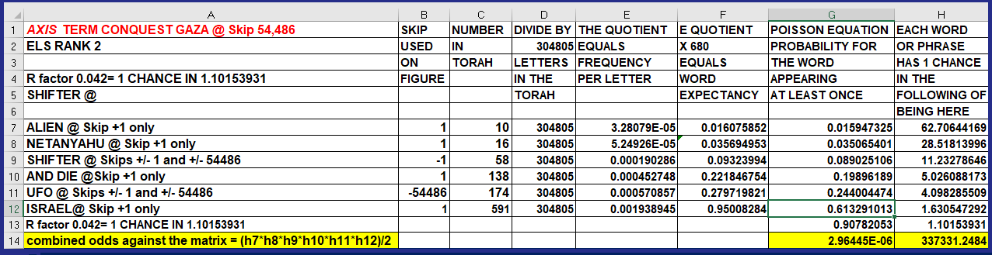

What does the Times of Israel say about Yair Netanyahu’s 2017 publication? Other than the cartoon, this is what they wrote:

*‘Alien reptile’ and cloaked figure in Yair Netanyahu’s meme have old-new origins,*

*To demonize his father’s political enemies, PM’s son posted a meme ‘rife with anti-Semitic themes’ hidden in plain view*

By Matt Lebovic

11 September 2017, 1:13 pm

*The cartoon posted to Facebook by Yair Netanyahu on Friday contained no Stars of David, no swastikas, and no anti-Jewish text. However, hidden in plain sight within the since-removed meme were two of the most potent anti-Jewish narratives: the colonizing alien-lizard Jew and the scheming Illuminati Jew.*

*The portrayal of Jews as other-than-human and engaged in a global conspiracy is not new, and can be traced to the notorious canard,* “The Protocols of the Elders of Zion.” *More recently minted is the Netanyahu meme’s green reptile-man, a stand-in for Jewish aspirations popularized by British conspiracy theorist David Icke.*

*Since the early 1990s, Icke has regaled fellow travelers with tales of shape-shifting reptiles who dominate global affairs. The reptilian takeover is understood to be about Jews, who are capable of inhabiting and controlling people’s minds. In recent years, Icke has packed stadiums across Europe with this mash-up of sci-fi horror and old-fashioned anti-Semitism.*

*“People know how to decode the code about reptilians — whether Icke means it or not, it doesn’t change that fact,” said Jan Rathje of the Amadeu Antonio Stiftung, an anti-racism group in Germany. “It seems ridiculous, but the conclusion that Icke draws is that because he thinks the reptilians are pulling the strings behind it, therefore the Holocaust didn’t happen – that’s anti-Semitism,” said Rathje.*

*In the realm of reptilian domination, leaders ranging from the British royal family to Egypt’s pharaohs have been used by Jews as “elite corporal hosts,” also known as “reptilian overlords.” In this “New World Order” conspiracy theory, gentile proxies — ranging from Jeb Bush to Kris Kristofferson — are foot soldiers in Jewry’s quest for domination.*

*“I’m not talking about one earth race, Jewish or non-Jewish,” said Icke in a 2001 book about extremists. “I’m talking about a genetic network that operates through all races, this bloodline being a fusion of human and reptilian genes,” said the activist, who also believes the moon is hollow.*

# One of Icke’s main targets is George Soros, the Hungarian-born Holocaust survivor and billionaire who, in the meme posted by Yair Netanyahu, dangles our planet as bait. Soros is positioned as the ultimate “feeder” of humanity to the extra-terrestrial Jew, that green alien holding an Occult symbol in front of the meme’s third boogeyman.

In his native Hungary, where Soros survived the Nazi occupation, the 95-year-old investor (in 2025) is seen as the proverbial “evil frog in the well,” a demon bent on erasing borders and flooding the country with immigrants, drugs, and homosexuality.

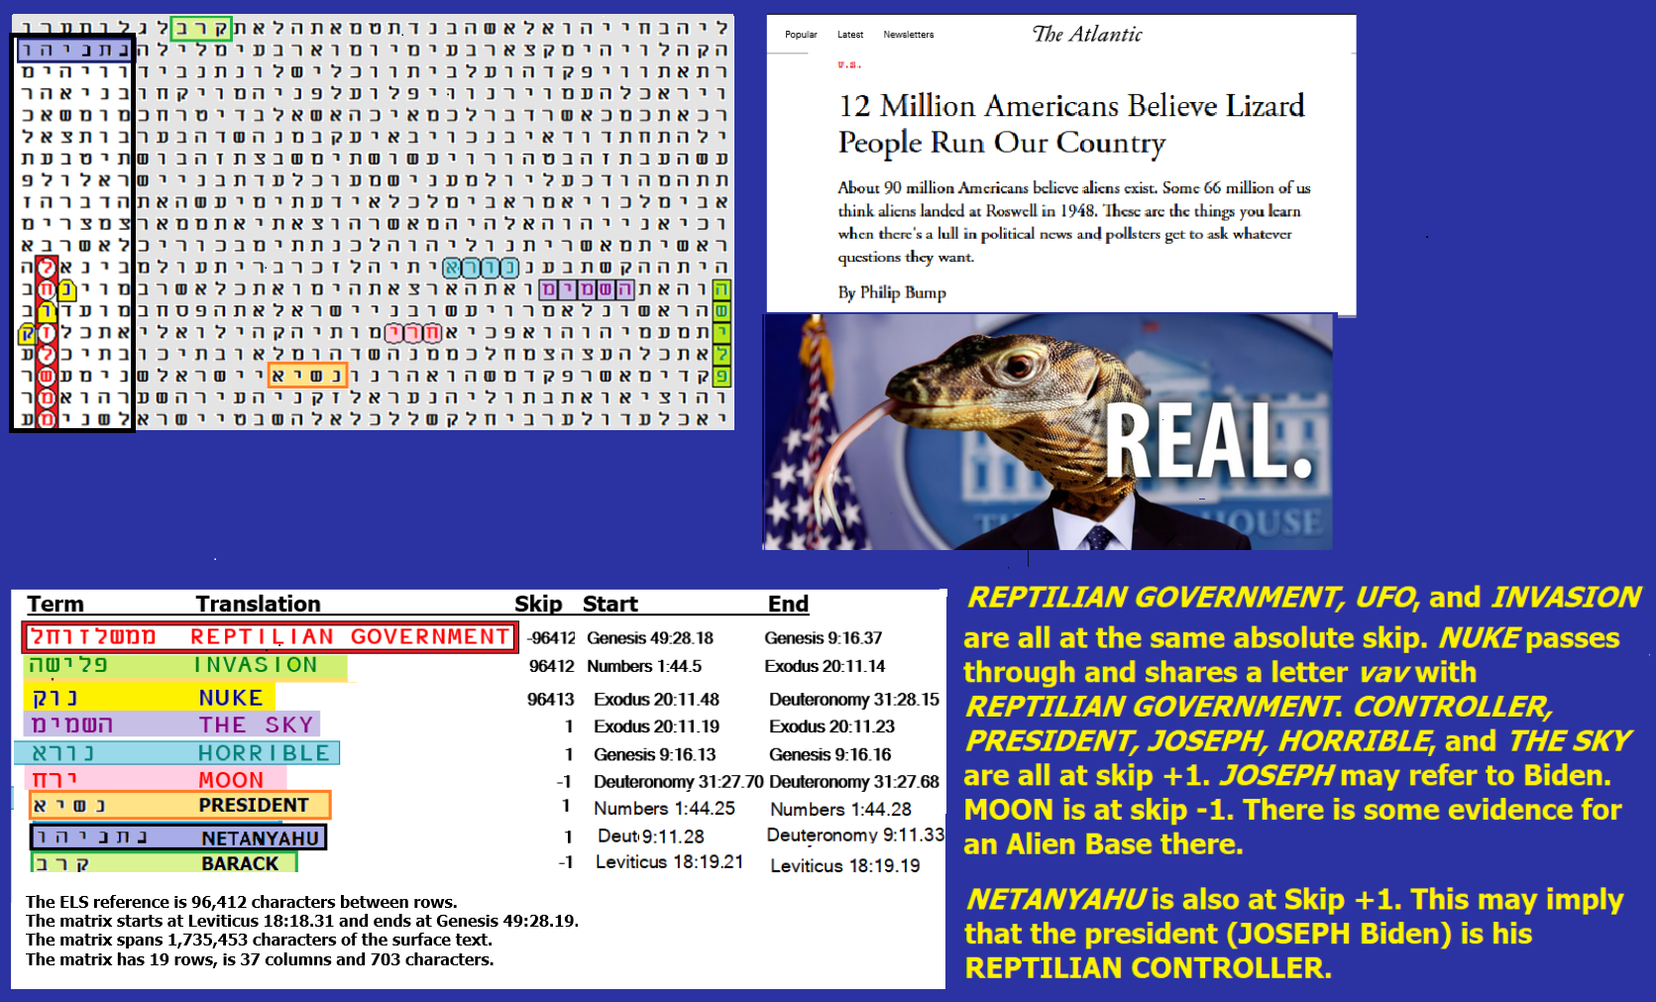

**FIGURE 1-6** above: The axis term is **REPTILIAN GOVERNMENT**. It only took 18 rows and six columns (108 letters) to link **REPTILIAN GOVERNMENT** with **NETANYAHU. REPTILIAN GOVERNMENT** is at the same absolute skip as **INVASION**. Like **NETANYAHU**, **THE SKY, HORRIBLE,** and **PRESIDENT** are all at skip +1**.** **BARACK** and **MOON** are at skip -1. Total odds against this matrix are about 17,385,542 to 1 but it’s probably best just to look at the odds of **INVASION** to be at the same absolute skip as **REPTILIAN GOVERNMENT**. Odds against this match were about 434 to 1.



**On Figure 1-6**, the odds against **NETANYAHU** being anywhere on the 703-letter matrix were about 27.6 to 1. The odds against **NETANYAHU** being in a 108-letter box with **REPTILIAN GOVERNMENT** were about 177 to 1.

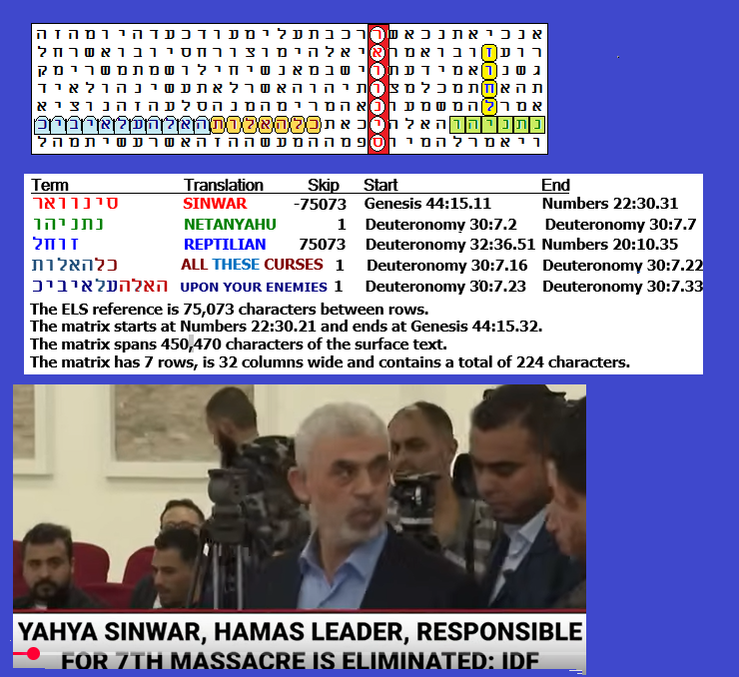

Figure 1-7 above: Axis term **SINWAR** paired with **REPTILIAN** and **NETANYAHU**.

**SINWAR** and **REPTILIAN** are at the same absolute skip. **REPTILIAN** touches **NETANYAHU at** skip +1. **SINWAR** and **REPTILIAN** are named as **YOUR ENEMIES**. Odds against Figure 1-7 existing are about 7,690 to 1.

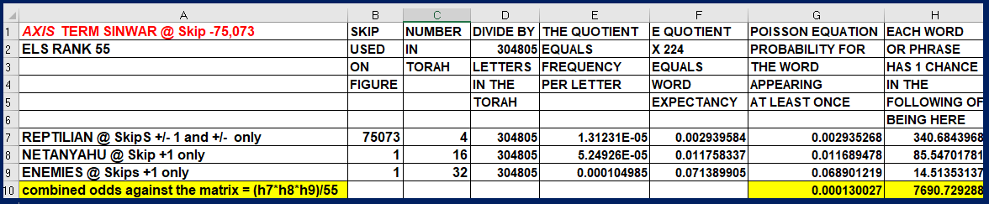

Spreadsheet for Figure 1-7 is above. As a Jew, I am horrified to find any link between my people and reptilians. I would say that I never heard anything about it from any other Jew in my 78 years of life, but the truth is that my (now deceased) Uncle Eugene, shown on the top of all my website articles (along with my son and me), caused me to start all my Mars research. This was ten years after I started my Torah Codes research. My uncle let me know that he back-engineered UFOs for our government, and he asked me to find proof. He also gave me the list of all major scientists from around the world who (in 1960) worked with him on this project, including three from the (former) Soviet Union and one from Poland. See <https://arkcode.com/photo5_29.html> for the full list. From the U.S.S.R. were Dr. Alexander Ivanov (engineer, Radio Research Institute in Leningrad), Prof. Dr. Michael N. Micheev (Director, Physics Metal Institute in Moscow), and Pavel G. Miknevitch (from the All-Union Material Institute in Moscow). This revelation started on December 24, 1997, and continued in early June 2007 when I visited him after retiring from the Coast Guard (at the age of 60) and taking my family around the world. If my uncle did in any way work with ETs, I am sure that as a Jew, he was one of the few exceptions. I have never heard of any Jew who wants to control the world. Even in Israel, what people want is to live a simple life in an area about the size of New Jersey. In comparison, Muslims control most land from Morocco to Indonesia, and many of them are not satisfied with that.

Figure 1-8 below: Eugene Roffman (UFO back-engineer & mentor for this investigation).

