Chapter 4
Nazis in the U.S. Government

Decades of Torah research has taught me an unusual view of history. For starters, Germany was working
on UFOs before World War II but was not quite able to produce them in significant numbers before the war
ended. Of the aliens who helped the Nazis, the Reptilians were the worst. Just before the war ended, Hitler
escaped alive, and he reached South America in a submarine (probably U944, but U977 was also suspected).
Eisenhower stated his belief that Hitler survived, but he failed to track him down. In the 1950s, Ike got to
meet and make some deals with more than one species of aliens. In exchange for humans and cattle that the
aliens were allowed to take, our government received advanced military technology. By the end of his
second term, Eisenhower was disgusted with how the aliens were handling people and cattle. He made an
effort to warn the public about the alien threat, but he was not specific enough. He said:
"A vital element in keeping the peace is our military establishment. Our arms must be mighty, ready for
instant action, so that no potential aggressor may be tempted to risk his own destruction... American makers
of plowshares could, with time and as required, make swords as well. But now we can no longer risk
emergency improvisation of national defense; we have been compelled to create a permanent armaments
industry of vast proportions... This conjunction of an immense military establishment and a large arms
industry is new in the American experience... Yet we must not fail to comprehend its grave implications...
In the councils of government, we must guard against the acquisition of unwarranted influence, whether
sought or unsought, by the military-industrial complex. The potential for the disastrous rise of misplaced
power exists and will persist."
His warning about the military-industrial complex was (fatally) too vague. He should have told us about the
military-industrial-extraterrestrial complex. Many human members of this group were Nazi war criminals
brought to the United States under Operation Paperclip. This was a secret United States intelligence
program in which more than 1,600 Nazi German scientists, engineers, and technicians were taken from
former Nazi Germany to the U.S. for government employment after the end of World War II in Europe,
between 1945 and 1959. Conducted by the Joint Intelligence Objectives Agency (JIOA), it was largely
carried out by special agents of the U.S. Army's Counterintelligence Corps (CIC). Many of these personnel
were former members, and some were former leaders, of the Nazi Party. During the 1950s, quite a few
Nazis rose to high positions in the U.S. government. Eisenhower went from being begrudgingly in control
while meeting with combined Nazi-alien crews to having to threaten to attack Area 51 with the First Army
if the base did not come clean with him regarding what research was being conducted there.
Key Recruits for Operation Paperclip – Advisors brought into the United States. This list is found at the end
of this chapter. Many were members of the Nazi Party, and quite a few, including Wernher von Braun, were
war criminals. Von Braun designed the Saturn V that took American astronauts to the moon.
President Kennedy was concerned about the secret Nazi-alien influence. He wanted to warn us about what
was going on, but that idea was shut down by his assassination. Presidents after him were well aware of the

54

price of giving us too much truth. Eventually, much of what was left of American morality became Nazi
philosophy. President Trump, who established a new branch of our military—Space Force—is trying to
reverse that, but he has already survived three assassination attempts (a bullet fired through his bedroom
window at Mar-a-Lago was the first), which are likely related to the military-industrial-extraterrestrial
complex.

The rest of this chapter will highlight Torah Code matrices and New York Times articles meant to support
and highlight the above altered view of recent world history.
What Happened to Hitler After World War II?
An April 27, 1945, New York Times article (dated April 26, 1945) was entitled Hitler Imitator Reported
Ready to Die in His Place. I followed the story via the Times as far as 1949. Briefly, a former grocer,
August Wilhelm Bartholdi, was a double for Hitler. He was poised to "die on the barricades" while the real
Hitler escaped. Two days later (just after midnight on April 29, 1945), Hitler married Ava Braun. Germany
had time to prepare the Hitler swap, whether by switching dental records or drilling Bartholdi’s mouth to
match Hitler’s. But they didn’t have time to properly prepare a duplicate for his bride. The following day
(April 30, 1945) was the alleged suicide. Russian troops found two bodies burned beyond recognition. They
were supposed to be Hitler and Eva Braun. Later, we learned that there was a match with Hitler’s dental
records. But once in my life, I heard (but could never confirm) that the female corpse found did not have a
match with Eva Braun’s dental records; however, this aspect of the story does not match what Wikipedia
writes. They indicate that, "by 11 May 1945, the Soviets had already had Hitler’s dentist, Hugo Blaschke,
and his dental technician confirm the dental remains found were Hitler’s and Braun’s. However, Wikipedia
often lies when political opinions are involved."
When the American troops arrived in Berlin, they questioned the staff. All, except for two, said that it was
Hitler who had died, but the New York Times reported that the maid and the chauffeur claimed it was the
cook. However, as I recall, no name was given for the cook, and it was unclear as to whether he was
Bartholdi. By July of 1945, the Times was writing about unaccounted-for U- boats that might be carrying
Hitler, and by August of 1945, there were stories of U-977 being searched by U.S. Marines in Buenos Aires,
Argentina. There was also a story of people seeing what looked like Hitler and Eva Braun coming ashore
from U-944 elsewhere in Argentina, with them heading for Patagonia. Does the Code discuss any of this?
Yes.

55
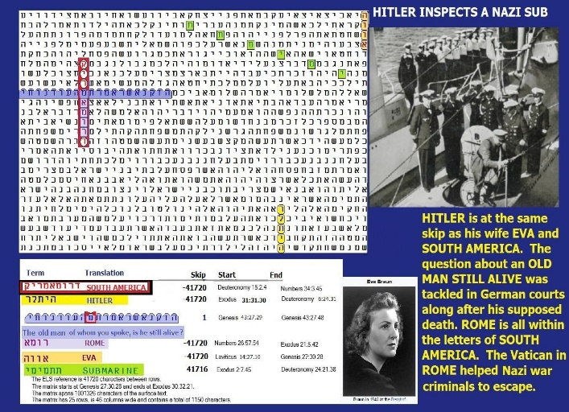
Fig. 4-1 Hitler flees to South America matrix

Figure 4-1 above: The axis term is SOUTH AMERICA (Hitler's hideout after World War II). ROME (who
helped him get there), HITLER, and his bride (EVA) are all at the same skip. The odds against finding the
matrix were about 20 million to 1 if we do not count the axis term, and about 100 million to 1 if we use the
R factor to count South America.

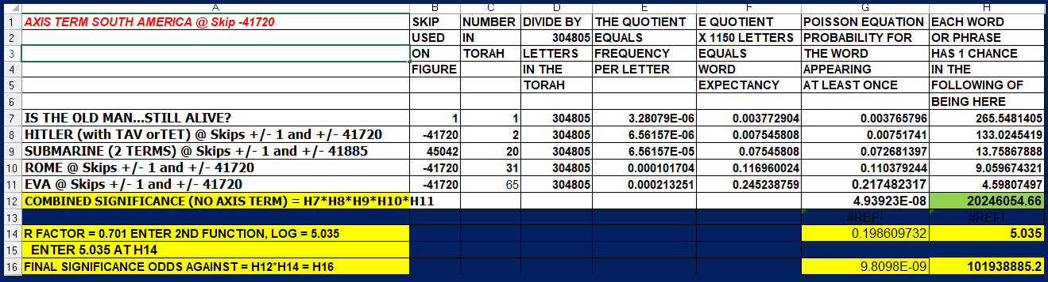

Fig. 4-2 FBI Files on Hitler after WW2

Figure 4-2 shows alleged FBI files that point to Hitler in South America after World War II.

56

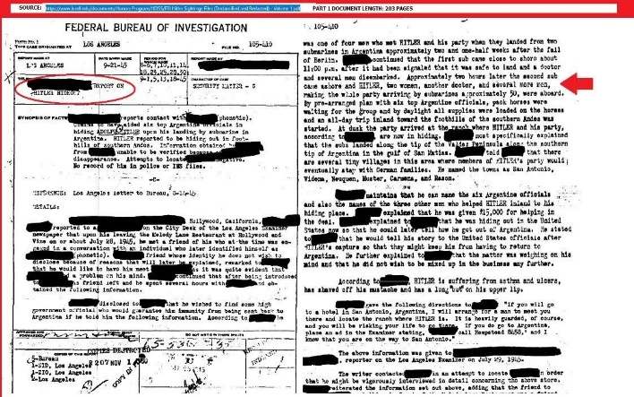

Figure 4-3 left below: Torah Code matrix about Hitler in Tunja, Colombia. The matrix was found against odds of about 26,077 to 1.

Fig. 4-3 Hitler flees to Tunja,

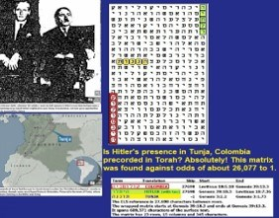

Fig. 4-4 Hitler in Colombia State Department document

57

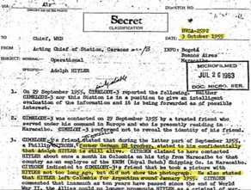

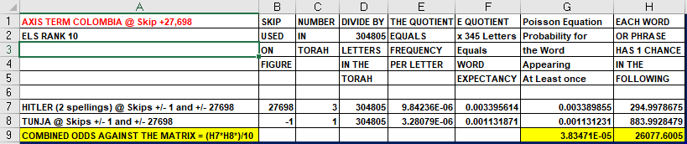
Figure 4-4 above: State Department document related to Figure 4-3.

Figure 4-5 below. This matrix names many of the key players in the Hamas/Hitlerian/ Ciakahrr Gaza
War.

Fig. 4-

58

ARE THERE ET COMMUNITIES ON EARTH?

As part of my investigation into possible ET links to Rebecca, I took my wife and son to Rebecca's hometown
in Lakeland, Florida. There, my son was tested by a local doctor who specialized in holistic medicine.
Although the test results did not lead to a cure of his rare condition (erythromelalgia), which can painfully
affect feet, hands, ears, and other areas, they were of use in reaching a proper diagnosis. After the test, the
two were nice enough to take us out to lunch. It was then that I was given some of the other information that
I sought. Rebecca said she had seen shape-shifter Reptilians emerge from a Publix Supermarket. She also
said that a 20-year-old man had approached her in a panicked state right after David Gruth testified before
Congress. Gruth’ topic, and that of two Navy FA-18 fighter pilots, was UFOs held by the Pentagon or tracked
by the Navy. Apparently, the three witnesses were frightening to the young man because he now had reason
to believe that a growing, rapidly more aware Congress might have reason to go after him and his type. The
implication of what Rebecca told me could be that there was a colony of ETs, possibly shape-shifters, in her
town that could encounter problems for the security of every ET in town. Discovery and disclosure of such
a group might be catastrophic for her genetic brethren. I have also spoken to an Andrew Basiago and his
wife about Reptilians. Andrew has weird stories about alien experiences. He is discussed elsewhere in this
chapter. I only mention him here because both he and his wife claim to have witnessed reptilians morphing
in Vancouver, Washington. Ignoring these reports may expedite the way to the end of our species. We need
responsible leaders to make such decisions, but we will not find them in the Democratic Party. Nor do all
Republicans have clean hands here.
Ebrahimi, the alleged ET that I met, is from Sooke, B.C. Canada. It is possible that his hometown is also an
ET nest. A very high percentage of my readers are from Canada.
Why are Congressman Posey & Conspiracy also at the same absolute Skip on Figure 4-4? As I
continue to study Figure 4-4, I have now identified nine terms that are at skips +/- 16,627 (and one,
GRAY at skip -16,626, touching the Ciakahrr axis term at skip -16,627). They are as follows:

1.

CIAKAHRR. Synonymous with Reptilian. When not shape-shifted to look human, they are
somewhat Satanic-looking creatures, often with Satanic values. See the top-right creature on
Figure 4-4.

2.

HITLER. Hitler is one column left of GAZA, USA, and CIAKAHRR. The Ciakahrr
Reptilians, like their Nazi-leaning forefathers and Hitler, would have relished the chance to
massacre Jews.

3.

GRAY. Grays are said to often provide crews for Reptilian ships. They are commonly cited as
abducting massive numbers of humans to satisfy Reptilian needs, doing so out of fear of
Reptilians who, in the distant past, blew up at least one Gray world. On Figure 4-4, GRAY at
skip-16,626 touches the bottom of CIAKAHRR at skip-16,627. It almost suggests that the
GRAYs kiss the butts of the CIAKAHRR.

59

4.
POSEY (Congressman, R, FL). I made a presentation about UFOs to Congressman Posey on
August 7, 2023, at his Brevard County, Florida office. At the end, he handed me a copy of his
1997 book, THE HANSON CONNECTION – The book they don’t want you to read.

Previously, I had asked Posey’s aide, Patrick Gavin, if the Congressman had any background or opinion
papers about UFOs. He said, “No,” but for some reason, Gavin was not truthful with me. A week after I
finished reading the book, it was clear that the work was about the U.S. Government not only hiding what
they knew about ETs, but they had even imprisoned or killed folks who knew too much for their own good.
On a late fall, 2023 day, several congressmen publicly called for the release of major UFO secrets. On the
same day, for some unexplained reason, Posey sent me a second copy of his book along with copies of
reviews for it that were written back in 1997. The book was mailed from his house, and he addressed it in his
own handwriting. All the mystery about his book may have been an attempt to warn me that there was a threat
that I should take personally, but this is just a guess. If I suffer an untimely death, the congressman should be
interrogated about why he sent me the second copy, which, unlike the first copy, was autographed. Posey
is shown on the extreme right side of Figure 4-4.

5.

GOVERNMENT. A major issue under study here is whether with Operation Paperclip, the
GOVERNMENT of the USA came under the control of the CIAKAHRR and those who are
loyal to HITLER. These terms and CONSPIRACY are all at the same absolute skip of 16,627
and spell out the scope of the conspiracy.

6.

USA. USA overlaps and shares two letters with CIAKAHRR. The most serious aspect of this
investigation is whether there is any truth to the allegation that the Ciakahrr not only have
occupied other worlds through use of their alleged shape-shifting abilities, but they have also
taken over some GOVERNMENTs on Earth, including that of the USA.

7.

CONSPIRACY. At a minimum, the CONSPIRACY to break through the wall around Gaza
likely had Ciakahrr's support. A few months before the attack, the president of the USA tried to
transfer another $6 billion to Iran. Previously, the Obama-Biden GOVERNMENT had
transferred over $100 billion to Iran. In both cases, Biden and his cohorts encouraged ALIENS
and Iran to make war on Israel.

8.

THE ALIENS. The axis term on this matrix is the CIAKAHRR (at the same absolute skip)
and the GRAYs who touch them.

9.

GAZA. GAZA is not only at the same absolute skip as CIAKAHRR and the USA, but it's also
in the same column. We think the matrix supports the idea that the Ciakahrr used their advanced
technology to break through the wall around Gaza. While teleportation might be one way to
accomplish this, holes could have been quickly cut with the use of nuclear technology.

10.

BUSH. The Bush family, and especially the grandfather of President George H. W. BUSH, have
a broad history of support for the Hitler regime. The Guardian begins its account as follows:

60

Rumours of a link between the US first family and the Nazi war machine have circulated for decades.
Now the Guardian can reveal how the repercussions of events that culminated in action under the Trading
with the Enemy Act are still being felt by today's president.
George Bush's grandfather, the late US senator Prescott Bush, was a director and shareholder of companies
that profited from their involvement with the financial backers of Nazi Germany.
The Guardian has obtained confirmation from newly discovered files in the US National Archives that a
firm of which Prescott Bush was a director was involved with the financial architects of Nazism. The whole
story is at The Guardian article.

FIGURE 4-5 - THE EMPHASIS SHIFTS TO THE DEEP STATE/ FOURTH REICH. There are a lot of
names that could be sought as secret members of the Fourth Reich or leaders of organizations that are loyal
to the Fourth Reich. Figure 4-4B shifts the focus up from Figure 4-4A, allowing us to see the FBI's first
director (J. Edgar HOOVER) and the director under Biden until January 19, 2025, Chris WRAY. Hoover
was involved in a dispute with the Army over UFO wreckage (more likely from a Los Angeles and Long
Beach engagement in 1942 than Roswell in 1947), but it could be both. Chris Wray did his best to try to
remove Trump from office based on trumped-up Russia collusion charges, but he was also opposed to UFO
disclosure. Both C. WRAY and HOOVER are again at the absolute skip of the axis term, THE CIAKAHRR.
Another Deep State member, James CLAPPER, was also found while researching this matrix. He was
Director of National Intelligence. The H. BUSH on the matrix (President George H.W. Bush) was Director
of the Central Intelligence Agency. Allegedly, he refused to brief President-elect Carter on UFOs. The
loyalty of the CIA is in question because one of its directors, John Brennan, voted for a Communist for
President in 1976 (Gus Hall). In July 2025 he is under investigation along with former FBI director, James
Comey. However, I could not find Brennan encoded at special case skip +/- 16,627 of Ciakahrr. Alas, there
is never a shortage of items to explore in the Torah Code. The second lowest ELS of THE CIAKAHRR is
at skip +1,986. There is an ELS of BRENNAN at skip -1,986. That matrix is 15 columns by seven rows
(105 letters in area). Even better, there is an ELS of BRENNAN with REPTILIAN at skip -34,626. See
Figure 3-22.

61

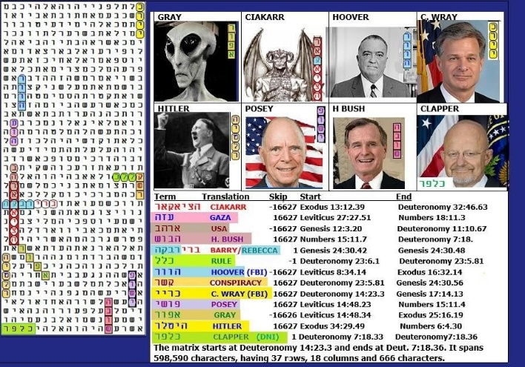
Fig. 4-6 Refinement of Figure 4-4 matrix

Figure 4-6 is above. Its spreadsheet indicates it was found against odds of over 217.9 trillion to 1.

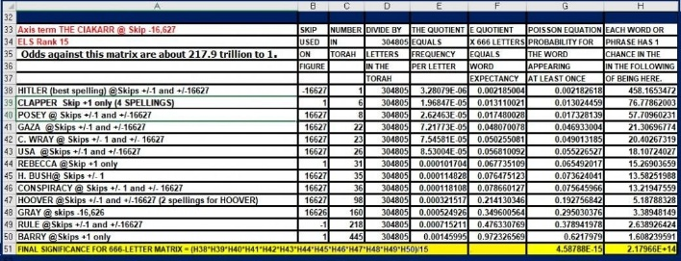

Above: Spreadsheet for Figure 4-6. The most significant term matching CIAKAHRR was HITLER
which was found at a special case skip against odds of 458 to 1.

62
Franklin Roosevelt supposedly chose to fund our atomic bomb technology because he thought it was a faster route to victory. While our government kept the lid on UFOs through November 1944, in that month, our planes over Germany saw lights following them at night. The crews of the 415th (Bristol) Night Fighter Squadron reported seeing (and dog fighting with) 8 to 10 bright orange lights. In the summer of 1945, LT (jg) John F. Kennedy accompanied James Forrestal (later our first Secretary of Defense) to Germany, where they both examined Germany’s advanced technology (UFOs). After the Roswell Incident in July 1947, President Truman put together the Majestic-12 Group to oversee the cover-up starting on 24 September 1947. Forrestal was a member. On May 22, 1949, Forrestal either committed suicide or was murdered. His body was thrown out of a window at Walter Reed Hospital. There was no suicide note. Both Kennedy and Forrestal were allegedly in favor of the disclosure of the Roswell Incident. Wikipedia says the following individuals were described in the Majestic-12 documents as “designated members” of Majestic12 (Note: Although the George Bush Presidential family did much to control the Roswell secrets, they were not related to Vannevar Bush).

Lloyd
Berkner Detlev
Bronk
Vannevar
Bush James
Forrestal
Gordon Gray
Roscoe H.
Hillenkoetter Jerome
Clarke Hunsaker
Donald H. Menzel

Robert M. Montague
Sidney Souers
Nathan F. Twining
The men listed above were American scientists, leaders, and military officers.

THE FOURTH REICH ACCORDING TO DR. MICHAEL SALLA. The following information is taken from Salla’s 2018 book, ANTARCTICA’S HIDDEN HISTORY, Corporate Foundations of Secret Space Programs. It states that in 1955, as a result of a secret agreement reached between the Eisenhower Administration and a German breakaway group in Antarctica, a transnational corporate space program began to emerge. Personnel from US

contractors in Antarctica allowed this transnational corporate program to steadily grow into a major space power,
which would eventually surpass and eclipse the secret space programs run by the US military, and the classified space programs of other nations.

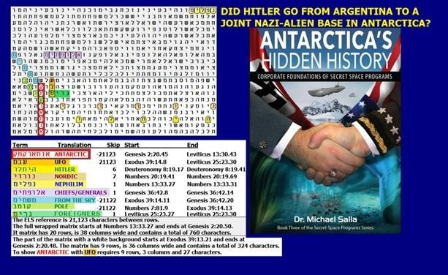

Fig. 4-7 Antarctica matrix
Figure 4-7 above: The axis term is ANTARCTIC. Admiral Richard Byrd lead an expedition there
(Operation High-jump) in 1946-1947. After taking a beating from UFOs/USOs he published a warning in
a Spanish newspaper (El Mercurio) on March 5, 1947 that described a new threat to the U.S. from hostile
aircraft quickly attacking the U.S. by flying in over the North or South Pole. The matrix has UFO at the
same absolute skip as ANTARCTIC. NEPHILIM (believed to be Reptilians) are in the open text. FROM
THE SKY and POLE are at one skip less than ANTARCTIC and UFO.

64

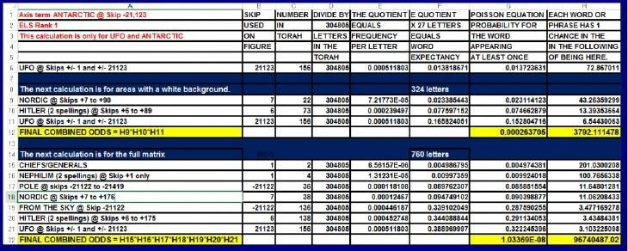

Figure 4-7 spreadsheet above. Odds against the full matrix are about 96,740,487 to 1.
“U.S. Military-Industrial Complex works with Antarctic-based Fourth Reich. The role of the Dulles brothers in the secret negotiations that culminated in the emergence of the Fourth Reich during the Eisenhower administration cannot be overestimated. Both John Foster and Allen Dulles had much experience working with German industrialists whose companies they represented when they were employed at Sullivan and Cromwell. The Dulles brothers played an important role in Hitler’s ascent to power by advocating the interests of German industrialists who were united in their opposition to Communism and advocacy of a strong nationalist leader.”
While Eisenhower was annoyed with the idea that he had to threaten to invade the Area 51/S-4 Area with
the First Army to find out exactly what the Deep State/Fourth Reich was up to, the relationship between
them and Kennedy was worse. In Salla’s (2013 book), KENNEDY’S LAST STAND (page 95), Salla writes,
“Forrestal had gone on to become a founding member of Majestic- 12 (MJ-12) while Kennedy became a
congressman.” It would have been easy to share classified information about UFOs, and extraterrestrial
concerns were likely a direct factor in his sacking as Secretary of Defense and his death two months later.
Why was Kennedy killed, and who ordered it? Salla provides some answers, but his proof is not solid
enough to take into a court, especially in a country as corrupt as ours. Salla contends that the main players
were members of MJ-12, Project Paperclip, the State Department, and the CIA. On May 28, 1963, Kennedy
visited Forrestal’s grave. Eleven days before Kennedy’s assassination, Soviet Premier Khrushchev accepted
Kennedy’s offer to share CIA files about UFOs with other U.S. agencies and the Soviet Union. A rice-bowl
fight! The top-secret order was issued to CIA Director James McCone. It was designed to block Kennedy
from UFO files. The collective files were known as “Project Environment.”
Salla hypothesizes that in 1961, the MJ-12 members to approve the Directives were Allen Dulles (MJ-2),
Dr. Edward Teller (MJ-2), LT General Marshall Carter (MJ-3), General Curtis LeMay (MJ-4), LT General
Gordon Blake (MJ-5), Dr. Detlev Bronk (MJ-6), and Dr. Jerome Hunsaker (MJ-7). Salla believes that Vice-

65


President Johnson was privy to the operation since at least 1949. The Directive that Kennedy sent to McCone
was seen as a direct threat to MJ-12. Salla names CIA Director James Jesus Angelton as the man who gave
the order to kill Kennedy. Despite this alleged cabal, Russia largely cooperated with the U.S. in space until
2022. Now they are threatening not only nuclear war but also to bring down the International Space Station
(ISS). What’s changed? Apparently, until 2022, there was some kind of understanding that preserved the
peace between America, Russia, and some extraterrestrial species working with us. Perhaps the ETs have
decided that it’s more in their interest to go back to China. A limited war between us and the Russians will
simplify that goal while reducing our population to make more room for the visitors who are really calling
the shots. But a new wildcard is President Trump.

Members of Operation Paperclip.
I believe that I originally found the following names in Wikipedia, however when I checked the list
during proofreading the manuscript it appeared that the original list had been altered. The reference
numbers that I initially had after each name did not match. If I can locate the correct or original
source I will add it to a future edition of this book. I have noticed that Wikipedia often censors or
tries to discredit articles backing the existence of UFOs, but I cannot say anything about that here
other than note that my traditional readers are often in U.S. or British Intelligence.
Aeronautics and rocketry: Hans Amtmann, Herbert Axster, Erich Ball, Oscar Bauschinger, Hermann
Beduerftig[, Rudi Beichel, Anton Beier, Herbert Bergeler, Magnus von Braun, Wernher von Braun, Ernst
Czerlinsky, Theodor Buchhold [de], Walter Burose[, Adolf Busemann, GN Constan, Werner Dahm, Konrad
Dannenberg, Kurt H. Debus, Gerd De Beek, Walter Dornberger – head of rocket programme, Gerhard
Drawe, Friedrich Duerr, Ernst R. G. Eckert, Otto Eisenhardt, Krafft Arnold Ehricke, Alfred Finzel, Edward
Fischel, Karl Fleischer, Anton Flettner, Anselm Franz, Herbert Fuhrmann, Ernst Geissler, Werner
Gengelbach, Dieter Grau, Hans Gruene, Herbert Guendel, Fritz Haber, Heinz Haber, Karl Hager, Guenther
Haukohl, Karl Heimburg, Emil Hellebrand, Gerhard B. Heller, Bruno Helm, Rudolf Hermann[Bruno
Heusinger, Hans Heuter, Guenther Hintze, Sighard F. Hoerner, Kurt Hohenemser, Oscar Holderer, Helmut
Horn, Hans Henning Hosenthien [de], Dieter Huzel, Walter Jacobi, Erich Kaschig, Ernst Klauss, Theodore
Knacke, Siegfried Knemeyer, Heinz-Hermann Koelle, Gustav Kroll, Willi Kuberg Werner Kuers, Hermann
Kurzweg, Hermann Lange, Hans Lindenberg, Hans Lindenmayer, Alexander Martin Lippisch
(Aeronautical Engineer), Robert Lusser, Hans Maus, Helmut Merk, Joseph Michel, Hans Milde, Heinz
Millinger, Rudolf Minning, William Mrazek, Hans Multhopp], Erich Neubert, Hermann Oberth, Hans von
Ohain (designer of German jet engines), Hermann Oberth, Robert Paetz, Hans Palaoro, Kurt Patt, Hans Paul, Fritz Pauli, Arnold Peter, Helmuth Pfaff, Theodor Poppel, Werner Rosinski, Heinrich Rothe, Ludwig Roth, Arthur Rudolph, Friedrich von Saurma [de], Edgar Schaeffer, Martin Schilling, Helmut Schlitt, Albert Schule, August Schulze, Walter Schwidetzky, Ernst Steinhoff, Wolfgang Steurer, Heinrich Struck, Ernst Stuhlinger, Bernhard Tessmann, Adolf Thiel, Georg von Tiesenhausen, Werner
Tiller, JG Tschinkel, Arthur Urbanski, Fritz Vandersee[, Richard Vogt, Woldemar Voigt (designer of
Messerschmitt P.1101), Werner Voss, Theodor Vowe,

66

Herbert A. Wagner, Hermann Rudolf Wagner, Hermann Weidner, Georg Rickhey – director of the slave labour
Mittelwerk factory, Walter Fritz Wiesemann, Philipp Wolfgang Zettler-Seidel, (see List of German rocket
scientists in the US).

Architecture: Heinz Hilten and Hannes Luehrsen
Electronics – including guidance systems, radar and satellites: Wilhelm Angele [de], Ernst Baars [de], Josef
Boehm, Hans Fichtner, Hans Friedrich, Eduard Gerber, Georg Goubau, Walter Haeussermann, Otto
Heinrich Hirschler, Otto Hoberg, Rudolf Hoelker, Hans Hollmann, Helmut Hölzer, Horst Kedesdy, Kurt
Lehovec, Kurt Lindner, JW Muehlner, Fritz Mueller, Johannes Plendl, Fritz Karl Preikschat, Eberhard Rees,
Gerhard Reisig, Harry Ruppe, Heinz Schlicke, Werner Sieber, Othmar Stuetzer, Albin Wittmann, Hugo
Woerdemann. Albert Zeiler, Hans K. Ziegler
Material Science (high temperature): Klaus Scheufelen [144] and Rudolf Schlidt.
Medicine – including biological weapons, chemical weapons, and space medicine: Theodor Benzinger [de],
Rudolf Brill [de], Konrad Johannes Karl Büttner, Richard Lindenberg, Ulrich Cameron Luft [de], Walter
Schreiber, Hubertus Strughold, Hans Georg Clamann, and Erich Traub.

Physics: Gunter Guttein, Gerhard Schwesinger, Gottfried Wehner, Helmut Weickmann and
Friedwardt Winterberg.

Chemistry and Chemical engineering: Helmut Pichler, Leonard Alberts, Ernst Donath, Josef Guymer,
Hans Schappert, Max Josenhaus, Kurt Bretschneider,Erich Frese
Similar Operations

● APPLEPIE: Project to capture and interrogate key Wehrmacht, RSHA AMT VI, and General

Staff officers knowledgeable of the industry and economy of the USSR.

● DUSTBIN (counterpart of ASHCAN): An Anglo-American military intelligence operation

established first in Paris, then in Kransberg Castle, at Frankfurt.

● ECLIPSE (1944): An unimplemented Air Disarmament Wing plan for post-war operations in

Europe for destroying V-1 and V-2 missiles.

● Safehaven: US project within ECLIPSE meant to prevent the escape of Nazi scientists from

Allied-occupied Germany.

● Field Information Agency; Technical (FIAT): US Army agency for securing the “major, and

perhaps only, material reward of victory, namely, the advancement of science and the
improvement of production and standards of living in the United Nations, by proper exploitation
of German methods in these fields”; FIAT ended in 1947, when Operation Paperclip began
functioning.

67

● On April 26, 1946, the Joint Chiefs of Staff issued JCS Directive 1067/14 to General

Eisenhower instructing that he “preserve from destruction and take under your control records,
plans, books, documents, papers, files and scientific, industrial and other information and data
belonging to … German organizations engaged in military research”; and that, excepting war-
criminals, German scientists be detained for intelligence purposes as required.

● National Interest/Project 63: Job placement assistance for Nazi engineers at Lockheed, Martin

Marietta, North American Aviation, and other airplane companies, whilst American aerospace
engineers were being laid off work.

● Operation Alsos, Operation Big, Operation Epsilon, Russian Alsos: Soviet, American, and

British efforts to capture German nuclear secrets, equipment, and personnel.

● Operation Backfire: A British effort at recovering rocket and aerospace technology, followed

by assembling and testing rockets at Cuxhaven.

● Fedden Mission: British mission to gain technical intelligence concerning advanced German

aircraft and their propulsion systems.

● Operation Lusty: US efforts to capture German aeronautical equipment, technology, and

personnel.

● Operation Osoaviakhim (sometimes transliterated as “Operation Ossavakim”), a Soviet

counterpart of Operation Paperclip, involved German technicians, managers, skilled workers,
and their respective families who were relocated to the USSR in October, 1946.

● Operation Surgeon: British operation for denying German aeronautical expertise to the

USSR, and for exploiting German scientists in furthering British research.

● Special Mission V-2: April–May 1945 US operation, by Maj. William Bromley recovered parts

and equipment for 100 V-2 missiles from a Mittelwerk underground factory in Kohnstein within
the Soviet zone. Major James P. Hamill coordinated the transport of the equipment on 341
railroad cars with the 144th Motor Vehicle Assembly Company, from Nordhausen to Erfurt, just
before the Soviets arrived. (See also Operation Blossom, Broomstick Scientists, Hermes project,
Operations Sandy and Pushover)

● Target Intelligence Committee: US project to exploit German cryptographers.

Nazi /Alien Plan to Conquer the U.S.
When I went looking for a picture to add to Figure 4-8, I had not yet heard of the book Alien World Order, or
of its author, Len Kasten. First, I found the matrix, then I found Kasten’s book and saw that it described
most of my beliefs about UFOs and Nazis. That’s not to say that I agree with everything that he says. He

68

blames Reptilians for just about every evil act that anyone ever did. He offers no proof of the claim. He
needs to supply it.



Fig. 4-8 United State matrix

Figure 4-8 above. The axis term UNITED STATE does not bode well for America.
When you look at the spreadsheet for Figure 4-7, notice that the two most significant keywords are
PERVERTER and LITTLE ONES. The fact that UNITED STATE, USA, GOVERNMENT,
PERVERTER, and UFO are all at the same absolute skip probably is not an accident. We need to eliminate
the gay/transgender leadership from our government. President Trump began to do just that almost
immediately by declaring that our government will (under his term) only recognize two genders – male and
female.
The word SKY touches UFO. A hard-to-accept truth is attached to the use of UFO here. Aliens are here
now. They work with Nazis or their descendants who, via Operation Paperclip, have penetrated our
government. Based on two people that I have met who claim to be aliens (one of them, Craig Ebrahimi,
claims it directly, with the other – (Rebecca in Lakeland, Florida), we need to be very careful about what
her presence implies. While the woman seemed innocent enough, I have a lot of evidence in this book that

69

points to Craig as the original source of COVID-19. There is evidence that suggests aliens have infiltrated
our government, but it is easier to show that Nazis have played major roles there too. While not statistically
spectacular, the word NAZI is parallel to the five terms at a skip of +/- 17,000. Two of its letters are found
inside the UNITED STATE, which may be singular to tell us that the states will eventually dissolve,
leaving us with one Nazi state. The leaders work with Nazis or their descendants who, via Operation
Paperclip, have penetrated our government. Odds against finding Figure 4-8 by chance are over 1.7 million to 1.
The most significant a priori term was PERVERTER at the skip of the axis term against odds of about 95 to 1. LITTLE ONES was found against odds of about 41 to 1 and GOVERNMENT was found against odds of about 16 to 1.
The first thing you’ll probably notice about the 4-8 axis term (the first term found encoded) is that it is a
transliteration for UNITED STATE instead of UNITED STATES. While it really pains me to say it, after
34 years of military service in the U.S. Coast Guard and Navy, I believe that the United States was almost
killed when Biden was elected President. If you voted for him or any Democrat legislators, you were part
of the conspiracy to murder America. Hopefully, you have learned from your mistake and President Trump
can resurrect it. What am I talking about?
Think about it. Nations go to war over energy, especially oil. On Biden’s first day in office, he killed the
Keystone Pipeline and America’s energy independence. Biden then stopped construction of our border wall.
The Chinese, who helped bring us COVID, also mass-murder Americans by mass-producing Fentanyl.
They ship it to the drug cartels in Mexico, who then smuggle it into what was the United States.
Specifically, they brought it in via holes in the unfinished wall that were unfinished because of all the
Trump haters who were more interested in throwing out Trump than in electing someone who is loyal to
America. The result is that if you voted for Biden, you voted to poison and, in most cases, kill over 100,000
Americans per year – about twice as many Americans as were killed in the entire Vietnam War.
Is the Code’s Author trying to tell us anything else by using the absolute skip of the axis term? Yes.
GOVERNMENT is also at skip -17,000. This is also true for PERVERTER and UFO. What is our
government perverting? Our LITTLE ONES, which are in the open text of a line that has the first letter of
PERVERTER. The reference to LITTLE ONES is from Deuteronomy 21:12. Looking at several different
translations with options capitalized, this verse begins with:
Gather together the people – the men, the women, and the LITTLE ONES, SMALL CHILDREN or
CHILDREN, and the ALIEN, STRANGER, SOJOURNER, or FOREIGNER who is WITHIN YOUR GATES,
IN YOUR TOWNS or IN YOUR CITIES.

70

REVIEW OF ALIEN WORLD ORDER.
When looking for a relevant picture to add to Figure 4-1, I came across Len Kasten’s book. It seemed to fit
my findings and beliefs at the time exactly, so I ordered the book and doubled my efforts to find a complete
matrix that summarized the situation. That’s Figure 4-1 above. It may grow in size. My summary of
Kasten’s book is below. It is based on what is found on the back cover of his book, although there seems to
be a chapter missing or expunged (by the CIA?). I have written to the publisher to ask for clarification. The
book should discuss the assassination of President Kennedy, but he is missing except for on the back cover.
My comments are given in italics. As of August, 2025, the publisher has not responded to my 2022 email or
phone calls.

Summary by Len Kasten and Barry Roffman:

PUBLISHER: Shares new documents to expose the sinister alien influence in world governments, financial
systems, and scientific institutions throughout history.
ROFFMAN: Attention needs to be paid to which governments besides our own have contact. If we don’t
know who does, we don’t know who could gain nuclear weapons or other WMD from ETs. We could
experience a false flag war where we would make an incorrect choice and be wrongly dragged into World
War 3. This was apparently actually attempted on January 13, 2018, when, on their cell phones, Hawaiians
received warnings of inbound missiles. It took 38 minutes to tell them that they would survive what they
were then told was a false alarm; however, according to Michael Salla, there were many who said that they
actually saw the inbound missile or missiles shot down. Allegedly, the attack was initiated by a Nazi-
Reptilian Dark Fleet Alliance.
PUBLISHER: Shows how Eisenhower’s treaty with the Greys, signed at Holloman Air Force Base in 1954,
gave the aliens authority to abduct humans for “research.”
ROFFMAN: That research, allegedly, included how to make hybrid-humans. I have met two people (Craig
Ebrahimi and Rebecca in Lakeland, Florida) who claim to be from other worlds. The woman said that in
Earth orbit, she personally was permitted to see a spaceship carrying small
grays and hybrids. They were screaming in panic. Tall grays told her that their behavior was due to the
knowledge that Reptilians would use them for food.
PUBLISHER: Reveals how Reptilian-influenced ex-Nazis infiltrated the U.S. government.
ROFFMAN: This began with Operation Paperclip, which brought 1,600 Nazi scientists to America. The
top ones are listed above in this chapter. It included Wernher Von Braun, who built America’s Saturn 5
moon rocket. We are going to need definitive evidence about how this infiltration impacted the Kennedy
assassination. President Trump signed an Executive Order to release classified information about the

71

Assassination. Trump said he thinks Lee Harvey Oswald killed former President John F. Kennedy, but he
didn’t act alone. While he said that more than one person participated in the assassination, he didn’t link it
to UFOs.
PUBLISHER: Explains how the Reptilians have created alien-human hybrids under their control to replace
the human population.
ROFFMAN: Aside from using some of these hybrids for food, the important thing to understand is that
there are aliens on Earth now who are working to replace/murder us. While it may be true that not all aliens
are hostile, this assumption must be proven. Of the two likely aliens that I know personally, the woman
seems very friendly, but the other one (Craig) has given me evidence that suggests he is responsible for
getting the COVID-19 virus to the Chinese Army. The evidence is well-documented on my website and in
this book. So far (in August, 2025), this has cost over 18 million human lives. More than a million of them
were Americans. For us to accept the “good” ETs, they need to identify themselves and register with their
local governments. If they accept these conditions, laws need to be enacted to protect them. But if large
numbers ignore these requirements, I suspect that the number of ETs on Earth will be well above a million.
Due to the large number of people who go missing here every year, we’re also going to need honest
information about previous and recent or current abductions.
PUBLISHER: Long ago, the Galactic Federation sent the Atlans, a fierce group of humans from the
Pleiades, to Earth to confront the newest colony of the combative, ever-spreading alien race known as the
Reptilians. The ensuing battle sank the continent of Lemuria and drove the Reptilians underground beneath
the Indian subcontinent as well as to Antarctica. Able to shapeshift to appear human, the Reptilians then
infiltrated the Atlantean civilization, abducting humans and creating Reptilian hybrids. Len Kasten contends
that infiltration and hybridization prior to an all-out attack have been the hallmark of Reptilian conquest
throughout the galaxy.
Chronicling the history of the Reptilian Empire’s influence on Earth and their conquest of 21 star systems,
Kasten reveals how the human race is enmeshed in a skillfully concealed plot to enslave humanity and
exploit our planet’s physical and biological resources. Revealing Hitler’s pact with extraterrestrials and
the Reptilian influence on the Nazi state, he shares new documents that disclose the rescue and
rehabilitation of Nazi war criminals to assist in the Cold War, which then corrupted many U.S. government
institutions. Focusing on crucial events in the decade after World War II, he examines the Reptilians’
human allies, the Illuminati, who control the levers of
financial, technological, and military power throughout the world through various secret societies. He shows
how Eisenhower’s treaty with the Greys, signed at Holloman Air Force Base in 1954, gave the aliens
permission to take humans up to their spaceships, ostensibly for genetic study, in return for alien
technology, and how these abductions led to the creation of a hybrid race under Reptilian mind control.
ROFFMAN: Here, Kasten touches on my greatest concern. For most of my 78-year life in presidential
elections, I see-sawed back and forth between our two major parties. But then Obama was elected, and the

72

Democrat Party took an extreme hard left turn.
When Biden ended the sanity that had made an all-too-brief return under Trump, it was obvious to anyone
with half a brain that from Day One (January 20, 2021) when Biden took over and destroyed our energy
system, thus ensuring insane inflation, Biden had a single goal – to destroy the United States. Over and over
again, this nutcase idiot destroyed our Southern Border, let in an estimated minimum of 21,000,000
unknown people, including criminals, terrorists, and people infected with COVID, and he surrendered in
Afghanistan for no reason. He armed the Taliban with
$85 billion in arms so they could slaughter the allies (like translators) and hundreds of Americans that he
left behind. We all watched as those abandoned climbed onto the sides of jet transports during takeoff
efforts. We saw them fall to their deaths as the planes tried to flee the hell Biden had created. I could go on,
but there was no concern by Biden for the demonic world that he rushed to make worse on a daily basis. And
yet… most Democrats showed zero comprehension of what was going on. Worse still, somehow America
managed to temporarily increase the strength of Democrats controlling the Senate, although (thank God)
we were able to vote Pelosi and her Democrat/Communist comrades out of control of the House. Even
better, Vice President Harris was squashed in he 2024 election.
About half of America has plainly lost its mind. You cannot reason with them. A symptom of their illness is
that they refuse to debate anyone who doesn’t agree with their extremist positions. They cannot begin to
comprehend the word patriotism. If you try to use the term to justify any Republican point of view, they
will only hear the word fascism.
I know that the knee-jerk response to my charge (and Kasten’s, too) that the Democrats have lost control of
their minds is that we are the crazy ones. In fact, the idea that people who see UFOs are crazy is a policy that
the CIA came up with in 1947 to suppress the Roswell event and similar events later. The CIA was formed
on September 18, 1947 (less than 3 months after Roswell).
A more critical analysis of the Kasten ideology is that there is no accepted geological evidence of the
existence of a sunken continent named Lemuria.
PUBLISHER: He also explains how Kennedy was assassinated by the CIA because of his plans to rout
out this Nazi–Reptilian presence.
ROFFMAN: Something appears to be very wrong here! I received my copy of Alien World Order on
December 8, 2022. Other than the above exact words on the back cover, I did NOT see any reference to
Kennedy in the Table of Contents, Index, or anywhere else in the book after reading
it. Is it possible that the CIA could have printed their own censored version of the book and then substituted
it for the real deal??? Or are we just dealing with a publisher who accidentally cut out a chapter, or fraud
by someone who wanted to increase sales via a little false advertising?

73

There was a lot of talk about how the CIA became overrun by Nazis. Pages 255 to 256 quote Eisenhower’s
farewell address on January 17, 1961. In it, he harshly condemned the military- industrial complex. But he
never spoke about who it was in them that constituted the threat to our liberties or democratic processes.
After quoting the alarming part of Ike’s speech, Kasten writes,
“What Ike didn’t say, and what he couldn’t say, but what he probably knew, was that the military- industrial
complex was now riddled with ex-Nazis with an agenda in service to the Fourth Reich!”
That’s how Chapter 20 ends. Chapter 21 is entitled The Fourth Reich. The CIA is in it. Both Allen Dulles
and his brother John Foster Dulles are in it, too. But there is no mention of Kennedy or James Jesus Angleton
in it. I actually looked for Angleton first because in Kennedy’s Last Stand (2013), author Michael Salla
named him as the man who ordered the assassination. What positions did the characters above hold? Allen
Dulles was Director of the CIA from February 26, 1953, to November 29, 1961. John Foster Dulles was
Secretary of State from January 26, 1953, to April 22, 1959. James Jesus Angleton (December 9, 1917 –
May 11, 1987)[1] was chief of counterintelligence for the CIA from 1954 to 1974. His official position
within the organization was Associate Deputy Director of Operations for Counterintelligence (ADDOCI).
The failure to mention Kennedy looks like a crime (fraud), but it remains to be seen whether it was committed
by the publisher to sell more books, or by the CIA or FBI to hide the truth about the Kennedy Assassination.
I attempted to call the publisher (Bear & Bear in Rochester, VT) about seven times. Tracy took calls before
2 PM at an answering service. Calls after 2 PM were taken by Cindi, who works for the publisher. She first
gave me an email address for Jon, who would know what happened. But when I wrote to him, all I got was
a Delivery Status Notification (Failure). On December 19, 2022, I spoke to Cindi again about this problem.
All she would do about it was to promise to forward a letter about the problem to the author, Len Kasten.
As for Jon, she said that since the COVID-19 pandemic struck, he worked from home, as did most company
employees. My letter went unanswered, and Cindi would not discuss the matter anymore.
As the government has part of the Kennedy investigation classified as TOP SECRET since 1963, I bet that
they have committed this crime to protect the assassins and keep the cover-up about aliens going, but this
remains to be proven. The initial finding comes at a time when Elon Musk is exposing how Twitter lied to
us to protect government criminals (including senile President Biden, who should have been impeached).
The Smithsonian Magazine on December 16, 2022, reports that, “The government is still withholding 515
full (classified) documents, as well as parts of 2,545 documents… Officials were supposed to review the
remaining records and determine whether anything else could be released by June 2023, reports the Hill’s
Zach Schonfeld. A 1992 law required the release of all government records pertaining to the assassination
by October 2017, but Biden and President Donald Trump
pushed that deadline back.” When information was finally released during Trump’s second term, there was
nothing sensational exposed.

74

PUBLISHER: Contrasting the Reptilians with the benevolent Ebens, the aliens from Zeta Reticuli who
crashed at Roswell, Kasten exposes the stealthy tactics of the Reptilians, their relationship with the Greys,
and their advanced genetic bio-technology and teleportation abilities, as well as what we need to do to
defeat their plans.
ROFFMAN: Evidently, our government also has teleportation abilities. See the U.S. Air Force
Teleportation Physics Study (AFRL-PR-ED-TR-2003-0034) by Eric W. Davis.
It sounds like the woman in Lakeland claiming to be an alien has experience with teleportation, though it
was instituted by ETs rather than human Earthlings (Pleiadians are also allegedly human). She spoke about
people fleeing a planet destroyed or about to be destroyed in the Pleiades. The star she referred to is Miai,
which is about 380 +/- 10 light years from Earth. She did not know the name of the planet or who destroyed
it. Len Kasten names three planets that were destroyed in the Lyran star system: Bila, Teka, and Merok. The
brightest star in the Lyran system is Vega, which is only about 25.04 +/- 0.07 light years from Earth.
Referring to the work of Stewart Swerdlow, Reptilians get the blame for destroying not just Bila, Teka, and
Merok, but also in our solar system, a planet (Maldek) between Mars and Jupiter that subsequently formed
the asteroid belt, plus enough of the Martian atmosphere to drive people there underground.
Kasten claims the Reptilians have the capability and have used it to hollow out a planet and turn it into a
death star complete with its own biosystem. Dinosaurs were brought along as food. For what it’s worth,
Andrew Basiago claims to have been a time traveler for the U.S. Government’s Project Pegasus and a
passenger to Mars via so-called “jump rooms.” Basiago also claims that he saw at least one astronaut eaten
alive by a dinosaur (about 16 feet tall) on Mars. The belief that there is a common human-alien base on
Mars is widespread throughout the UFO believers’ community.
The idea of Reptilians taking dinosaurs to Mars – a huge version of panspermia – is consistent with
NASA/JPL photographs of primitive life taken on Mars and seen by MSL Curiosity and MER Opportunity.
What we see looks like bacteria, algae, fungi, including puff balls, lichens, and stromatolites. For proof of
this, see the 2019 R. Joseph article: EVIDENCE OF LIFE ON MARS? The Journal of Astrobiology asked
my son (David Altair Roffman, PhD, physics) and me to write a review of the article. It is
METEOROLOGICAL IMPLICATIONS: EVIDENCE OF LIFE ON MARS. See Chapter 8 of this book.
It might be possible for one form of primitive life to make it from Earth to Mars via an asteroid impact on
ancient Earth and an assist from solar wind. But for multiple primitive species to make it there, an assist by
intelligent life is almost certainly needed. Basiago spoke about something like cows being there, too. For
that (and dinosaurs), a spacecraft or a jump room to get there would be an imperative. The jump room spoken
about by Basiago was, she says, also used by the Lakeland lady. Reptilians (and Grays) get a lot of credit for
this technology. But Reptilians, who supposedly work with our government now, once worked for Hitler. It
appears that via the Fourth Reich, they still serve evil. That evil includes blowing up civilizations. The only
way to keep them in place is to inform our people of the truth, right up to and including the Kennedy
assassination. But this may mean that we have to pay for it with a civil war.

75

The FBI is not the only force in our government that has been out of control. But, along with the IRS, which
was expanded by Biden's addition of 87,000 more agents who will only serve to further all corruption in our
government, they are the best place to start in the effort to drain the Swamp. However, know this: on Figure
4-8 below, the term UFO touches TRUMP RAIDED. Trump supposedly wanted to disclose their presence
on Earth, but listened to their pleas to continue the cover-up. That was a fatal mistake. The UFO cover-up
is at the core of the rot in our government. It allows the Fourth Reich, enabled by Operation Paperclip in
1947, to continue its Nazi infiltration and control of everything our nation did under Biden and Obama.
By the way, more study is needed, but there are 9-letter ELS trains in Torah meaning "Nazi Obama" (skips
-52,940, 57,940, and 126,613), plus ELS trains meaning "Obama (is) Nazi" at skips 15 and 11,340, but I only
saw some of them pair well with Reich. No such match existed between Biden and Nazi, but there are a few
matrices in Chapter 3 pointing to Obama and Biden being aliens or being brain washed by them (see Figures
3-1, 3-4 and 3-5). Figure 3-1 has an axis term of "alien in our government" at skip -81,218. This is at the
same absolute skip as Biden and UFO. Figure 3-4 has the axis term "Biden (is) alien" at skip -97,832, which
is the same absolute skip as Mars, enemy, and UFO. Figure 3-5 is based on Obama is reptilian. The code is
quite dependable when you know how to read and use it. From his birth on, Obama’s youth is clouded in
mystery. It would not be too hard to believe that he was a reptilian who slipped in through our defenses. But
Biden was well known for at least 50 years. In the White House he seems to have come down with a case of
scrambled brains. He often looked and acted like he didn’t know what planet he was on. This may indicate
that he was a human who was abducted and subjected to mind control. He wasn’t always like this. In fact,
when he sounded more conservative, I think I actually briefly supported him when he was a candidate for
president in 1987. But while he was regarded as potentially one of the strongest candidates in the field, in
September 1987, reports emerged that he had plagiarized a speech by the British Leader of the Opposition
and Labor Party Leader, Neil Kinnock. Other allegations of past law school plagiarism and exaggerating his
academic record soon followed and Biden withdrew from the race later that month.
NAZI RAID ON MAR-A-LAGO. The date 8-8-2022 will go down in history like 9-11-2001. It was the
day that the Nazis (Fourth Reich) felt secure enough in running our government to storm President Trump's
house. They stole the 2020 election. The raid was a follow-up exercise aimed at ensuring that Trump would
neither get nominated nor elected. It will be discussed in greater detail after analyzing Figure 4-8 and its
probability spreadsheet.

76

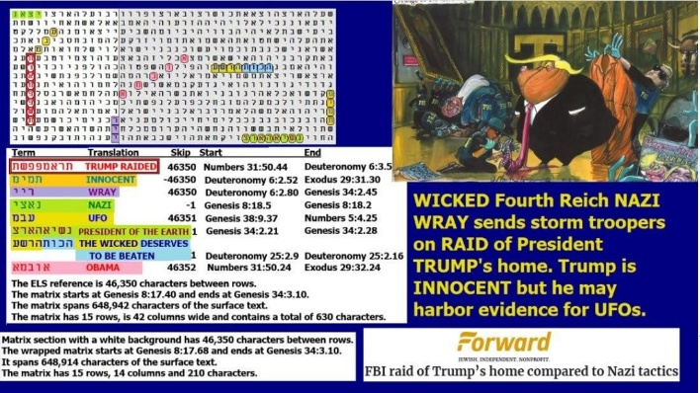
Fig. 4-9 Trump raided matrix

Figure 4-9 above. The spreadsheet for it is below. The axis term is TRUMP RAIDED. Odds against finding this
matrix were about 333,345 to 1 for the full (638-letter) matrix but just 5,210 to 1 for the 210-letter portion that
includes NAZI at skip -1 above Trump, WRAY at the same skip as (but opposite direction to) TRUMP RAIDED,
and UFO at the same skip as TRUMP RAIDED. Here's the spreadsheet:

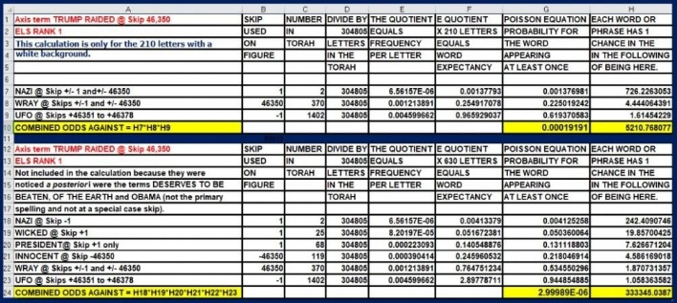

What did the then-corrupt FBI gain by its robbery of Trump’s house? Before their crime, although I had
twice voted for Trump, I wasn’t thrilled with his performance on January 6, 2021, but I thought Biden stole
the 2020 election from Trump. Although I once admired the FBI, I came to view them as a Fourth Reich

77

asset, loyal to all things Nazi (and/or Communist or Reptilian). I am pleased to see President Trump replace
Wray with Kash Patel in 2025. I hope he will totally clean house.
The FBI is not the only force in our government that has been out of control. The IRS was expanded by the
addition of 87,000 agents who only serve to further all corruption in our government. Trump fired
many of the worst in his first two weeks back in office.
On Figure 4-9 above, TRUMP RAIDED is encoded with INNOCENT and (Chris) Wray. Trump
supposedly wanted to disclose their presence on Earth but listened to their pleas to continue the cover-up.
That was a near-fatal mistake. The UFO cover-up is at the core of the rot in our government. It allows the
Fourth Reich, enabled by Operation Paperclip in 1947, to continue its Nazi infiltration and control of almost
everything our nation does. There were two attempts to assassinate Trump in 2024 and one in 2021 at Mar-
A-Lago. He must wipe these people out before they can try to get to him again.
REAL FATE AND OUR OWN DESTINY. One of the major concerns that I have deals with the outcome
of World War II. There is no question that the U.S. defeated Japan. A Hitler who committed suicide would
also imply that we defeated Nazi Germany as well. But since 1981, I have believed that that the man who
shot himself in the head in Hitler’s bunker was not Hitler. As I wrote earlier, instead, it was his duplicate
and cook, August Wilhelm Bartholdi.
Now, returning to 2025, all of my research has led me to believe that Hitler not only survived World War
II, but he led a very productive (although quiet) life in South America and Germany’s underground
fortifications in Antarctica. In conjunction with over 1,600 German/Nazi scientists brought to the United
States under Operation Paperclip between 1945 and 1959, they slowly took over control of the American
government. Many were familiar with aliens and alien technology, and some likely contributed to our
research into time travel. It was, if we believe Michel Salla’s book Kennedy’s Last Stand: Eisenhower,
UFOs, MK-12, and JFK’s Assassination (2013), a Fourth Reich American working for the CIA (James
Jesus Angleton, Chief of Counter- Intelligence) who ordered the assassination of President Kennedy because
the President wanted to disclose the presence of aliens on Earth.
Three days before Kennedy was sworn into office, President Eisenhower made his farewell speech on TV.
In it (on January 17, 1961), he said:
“In the councils of government, we must guard against the acquisition of unwarranted influence, whether
sought or unsought, by the military-industrial complex. The potential for the disastrous rise of misplaced
power exists and will persist. We must never let the weight of this combination endanger our liberties or
democratic processes. We should take nothing for granted. Only an alert and knowledgeable citizenry can
compel the proper meshing of the huge industrial and military machinery of defense with our peaceful
methods and goals, so that security and liberty may prosper together.”
The above speech should be compared with that of Secretary of Defense Donald Rumsfeld on September
10, 2001. In the building that would be attacked the following day, along with the World Trade Center

78

and four airliners, he identified our greatest adversary as the Pentagon bureaucracy! The full 11-minute 42-
second speech is at https://www.youtube.com/watch?v=MfMjdKElgqY. His identification of this enemy

comes at 1 minute 34 seconds into the video. Meanwhile, if we believe Andrew Basiago, when Rumsfeld
made his 2001 speech, he actually knew of the upcoming attack, and not just by a few hours before the planes
smacked into their targets. Rumsfeld, we are told, knew about the pending disaster and its date – in 1971,
30 years before the disaster! When he issued his critique, Rumsfeld was not on active duty. He was the
Pentagon’s highest bureaucrat – the Secretary of Defense.
The current Democratic bureaucrats are so evil that they can’t even call what they did at Trump’s home on
August 8, 2022, a raid. They prefer us to stay stupid by simply saying that we're enforcing a warrant or
conducting a search.
Previous Articles Published by Me on this Topic:
NOVEMBER 20, 2020: FACEBOOK AND TWITTER ARE TOOLS OF THE FOURTH REICH.
OCTOBER 29, 2020: HITLER, 4TH REICH, and the UFO are encoded with COVID-19. Why? The
highway to hell was paved with good intentions. What is new today is the BOTTOM LINE and Figure 4-
4, an update of the matrix AMERICA FALLEN.
OCTOBER 26, 2020: QUESTION: ARE OBAMA AND HITLER RELATED? Claims that
Hitler was Obama’s grandfather seem absurd, but there is at least one matrix that strongly points this way.
However, it’s easier to simply accept that the real father of Obama was Malcolm X.
OCTOBER 1, 2020: JOHN DURHAM REFUSES TO RELEASE FBI-RUSSIAN COLLUSION
HOAX PROBE RESULTS BEFORE THE ELECTION. Does Durham serve a Fourth Reich?
COMMENT FROM LISTENER: Each time I hear about Antarctica and UFOs, I think of what my dad
shared. He was in the navy on a transport ship; he said crafts or UFOs did come out of the water during
WW2 along their ship, and also he said they did take officers to Antarctica to drop off there during WW2.
He never said why. He may not have known why. He worked gunnery control fire unit coordination for
gunnery. I believe I shared this before with you a while back. He also later worked for the state education
department and made many trips to Fort Huachuca. Very interesting—who knows. God bless. Debra
SEPTEMBER 20, 2020: HITLER AND THE 4TH REICH. There is photographic, documentation, and
Torah Codes evidence that Hitler faked his death and lived on in Antarctica, Argentina, and Colombia. His
4th Reich likely played a major role in the American Government up to the present. His followers are likely
to be a major factor in the effort to bring down President Trump.
AUGUST 21, 2020: U.S. NAVY, ALIENS, HITLER, ARGENTINA & ANTARCTICA.
A fragment of World War 2 may have continued well past 1945 with Hitler very much alive. Dr. Salla

79

believes aliens continued to work with Nazis hiding in a massive base in Antarctica. Hitler
may have still been around to command UFOs overflying Washington from July 12, 1952, to July 29, 1952.
AUGUST 16, 2018: Deputy Democratic National Chairman Keith Ellison, Hitler and Israel to Die.
DECEMBER 4, 2018: German Chancellor Angela Merkel, Like Chancellor Hitler, Chooses Islam over Israel.
JANUARY 29, 2017: For the past 2 years, NASA has closely followed my research about Mars, especially the Report and PowerPoint listed below for today’s date. But around December 2016, one NASA site in California shifted its emphasis to track my ArkCode site in an obvious effort to understand the Torah Code and perhaps to examine the hypothesis that the Code might be an alien language. They were back again today, looking at (among other things) whether Hitler survived World War 2. Although I last updated that article on 9/21/2014, it’s worth a look if you missed it before. Be sure not to miss the film clip from the Jerusalem Post that supports my findings.
SEPTEMBER 21, 2014: Hitler Escaped?
FEBRUARY 11, 2013: POPE BENEDICT XVI IN NAZI UNIFORM
SEPTEMBER 18, 2008: VATICAN AND ROME

80

