Chapter 11
The Obama/Biden Years
When I started this chapter, I had at least 179 articles about Obama on my website (many with more than one matrix) and another 13+ about Biden. My website still provides a wide number of peeks into just about every aspect of his life, but after 28 years of study, 23 matrices begin to make clear that the Encoder had plenty to tell us (really everything) about Obama and his sick VP (Biden). Perhaps there is also more to tell us about Obama due to the fact that he served two terms while “Hiden’ Biden” largely spent his one term in his basement or on vacation (on a Delaware beach), using the rest of his time (about four hours per day) to try to destroy America.
I have such a large number of matrices to choose from because I spent most of my 18 years of retirement doing Torah Codes research. I started almost each day by first searching the news and then the Code to see how much of it (which was most of it) I could find encoded in the Torah. A few aspects of Obama’s life shown on matrices in this chapter include his antisemitism with respect to a deli massacre in Paris, his hatred of Israel, the Rodney King riots, views on homosexuality, technological efforts to control the minds of our population, treasonous behavior, his communist leanings, marijuana usage and policy, questionable country of origin, development of identity chips, loyalty to the Illuminati and Hitler, lack of a plan for dealing with the ISIS terrorist group, failure to stop North Korea’s development and testing of nuclear bombs, surrender on dealing with Iran’s nuclear plans, Obamacare, and concerns that his weakness (and Biden’s) may eventually cause New York to be nuked.
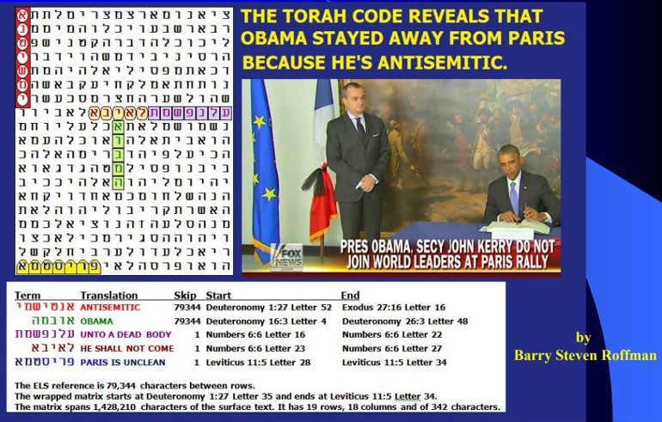
.

Figure 11-1 above. The axis term is ANTISEMITIC, and it’s at the same skip as OBAMA. On January 9, 2015, Amedy Coulibaly, armed with a submachine gun, an assault rifle, and two Tokarev pistols, entered and attacked a Hypercacher kosher supermarket in Paris, France. There, he murdered four Jewish hostages and held fifteen other hostages during a siege while demanding that the perpetrators of the Charlie Hebdo shooting, the Kouachi brothers, be released. The siege ended when police stormed the supermarket, killing Coulibaly. Obama refused to attend or send a high dignitary to the service, calling the attack random rather than antisemitic. On the matrix, PARIS IS UNCLEAN is at skip +1. HE (Obama) SHALL NOT COME is on the matrix and so is UNTO A DEAD BODY with both phrases also at skip +1
I learned almost two decades ago that there is no question about the Code being real. The only question is who wrote it.
It should be obvious to all thinking people that Joe Biden is a small, senile man who has always been anxious to destroy Israel. But is it as obvious when we read the words of his Creator? Does the Author of the Torah Code warn us about Israel’s great enemy? The answer is most definitely yes. On Figure 11-2, the axis term is BIDEN ENEMY. Its ELS appears only once in the Torah. I hoped that it would be directly crossed by ISRAEL, and it didn’t disappoint me.
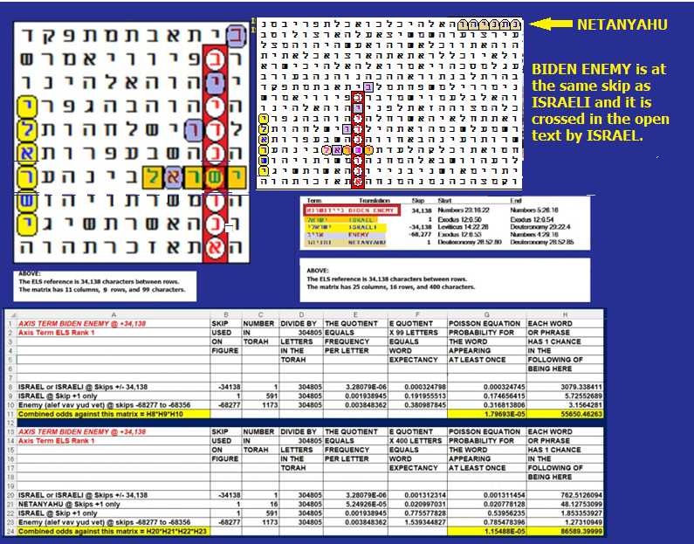
Figure 11-2 above. The axis term is BIDEN ENEMY. The matrix shows that Israel is Biden’s enemy. It took just 45 letters in 5 columns and nine rows to show the five letters of ISRAEL in the open text with the nine letters of BIDEN ENEMY.
However, Figure 11-2 was insufficient to show intent, because Israel occurs 591 times in the open text of the Torah, so close matches are easy to find. Odds against this match were about 5 to 1. A better test is to look for matches with ISRAEL at the absolute skip of the axis term: ±34,128. Such a match (with ISRAELI) occurs only once in the Torah, on the smaller, 99-letter matrix in Figure 11-2.
Also, on the 99-letter matrix is another ENEMY that shares a letter with BIDEN ENEMY. Odds against this matrix are 55,650 to 1.
The larger matrix includes NETANYAHU at skip +1. While this decreases the value of the terms just discussed, the overall significance of the matrix increases. Odds against finding this matrix are over 86,589 to 1.
Figure 11-3. MAY 20, 2016: Obama picks a homosexual as Secretary of the Army. Republican Senate caves in to Democratic agenda.
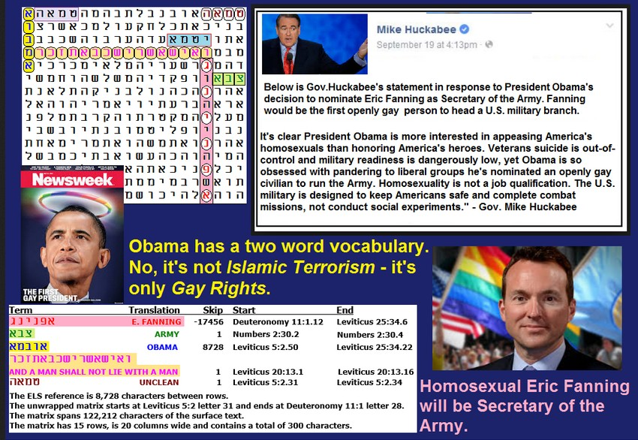
On May 17, 2016, the last Senate opposition (Senator Pat Roberts, R-Kansas) to Obama’s homosexual choice for Secretary of the Army folded. Obama’s pick was Eric Fanning. On Figure 11-3, E. FANNING is the axis term. An ELS of OBAMA is vertical, though only half the skip of E. FANNING. ARMY touches E. FANNING. Obama is shown touching AND A MAN SHALL NOT LIE WITH A MAN in Leviticus 20:13. The full verse for Leviticus 20:13 states, “‘If a man lies with a male, as with a woman, both of them have committed an abomination: they shall surely be put to death; their blood shall be upon them.” While one open text hit is shown on the report for UNCLEAN, a term which refers to a spiritual state that can have many causes (including homosexual acts), the term is actually seen three times on the matrix.
Figure 11-4. As can be seen below, OBAMA chose a homosexual to pervert our Army because OBAMA IS SATANIC.
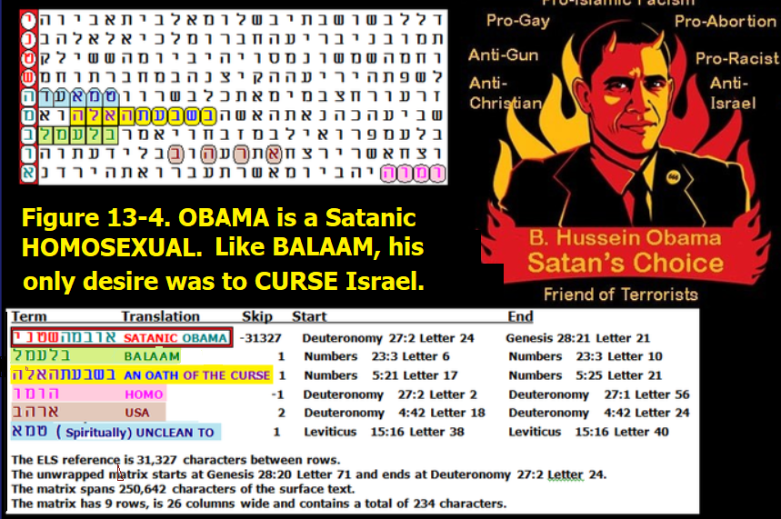
Figure 11-5 The video link to this site is https://giphy.com/gifs/xThuWbSB7BfPugnzQk?utm_source=iframe&utm_medium=emb ed&utm_campaign=Embeds&utm_term=
As Castro closed off the volley of questions about human rights issues in Cuba, he grabbed Obama's hand in a bizarre photo flop. Castro raised Obama's hand and it looked like he broke Obama's wrist as OB's hand went limp. UFO is at the same absolute skip as OBAMA IN CUBA. Does this show that Obama is not human?
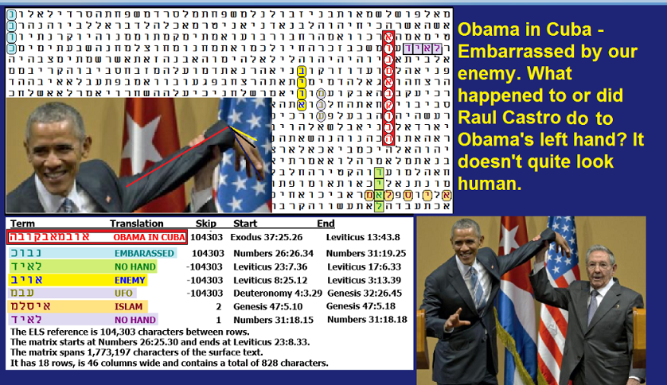
Figure 11-6 above: A little slip up in Cuba appears to show that Obama does not have normal human hand bone structure. The spreadsheet for this matrix is given below.
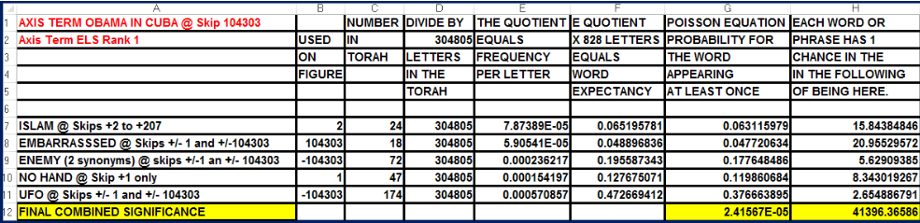
Figure 11-5 Odds. As you can see above, the odds against Figure 11-5 were about 41,396 to 1. The terms at the same absolute skip as OBAMA IN CUBA were EMBASSASSED (the most significant a priori term), ENEMY, and UFO. However, the odds just quoted do not include the relatively rare 10-letter axis term, OBAMA IN CUBA. CodeFinder software assigns this term an R factor of 1.044, which translates to only one chance in 46.23318249 that it would be found in the Torah at least once. The true odds against this matrix existing are thus 46.23318249 × 41,396 = 1,913,868 to 1.

Figure 11-6 below. Worldwide HYPNOSIS, REPTILIAN, OBAMA, and the GOVERNMENT.
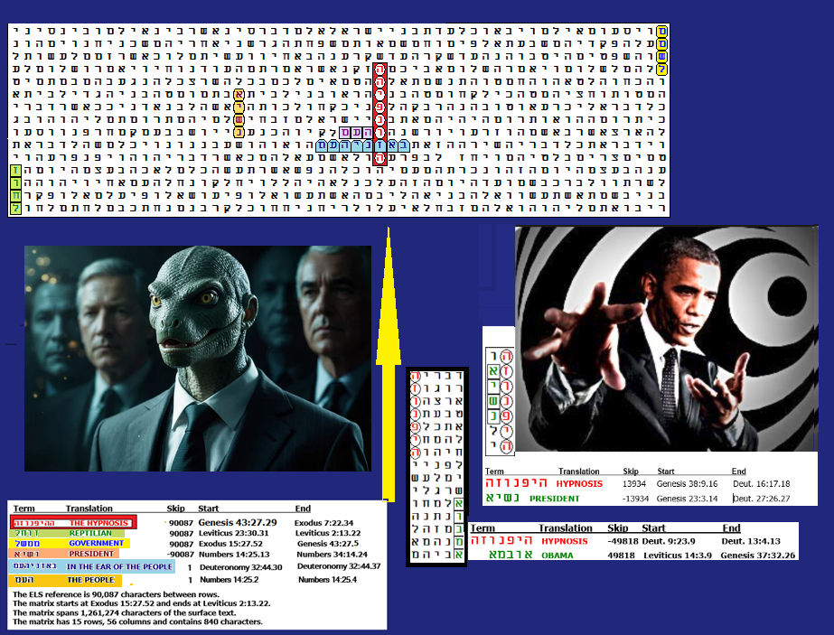
Figure 11-6 has an axis term of THE HYPNOSIS with REPTILIANS, GOVERNMENT and PRESIDENT all at the same absolute skip. It is a major find in that many liberal government officials are, in fact, shape-shifting reptilians who have successfully invaded our world. There are many people like Tampon Tim Walz, who may act like aliens because, although they were not born alien, they were abducted by aliens and hypnotized or brainwashed in an effort to keep them from having children. If ET can sterilize us, our population will shrink. That means we will be easier to conquer.
Online, I found this statement:
While there are no credible estimates of the number of people abducted by aliens, a 1991 Roper Poll found that 2% of those surveyed reported having experiences interpreted as indicating abduction, which extrapolated to approximately 3.7 million Americans. However, this interpretation and the validity of the poll results have been heavily criticized. Other researchers suggest that thousands or even millions of people across the world believe they have been abducted by aliens, according to ResearchGate and ScienceDirect.com. For a more detailed understanding of these results, see
https://www.researchgate.net/publication/33363035_A_Report_on_the_Demographics_and_Beliefs_of_Alien_Abduction_Experiencers.
At one point in my life, I was a registered Democrat. But by the time Obama was elected, I saw Democrats as suffering from mass insanity – so much so that President Trump had to remind us that there are only two genders – male and female. Why does Governor Tim Walz think that boys need to insert tampons?
A former Olympian running for the Senate has warned that Supreme Court nominee (now Supreme Court Justice) Judge Ketanji Brown Jackson’s refusal to define a woman “could set the women’s rights movement back decades.”
Eli Bremer insisted that serious issues were raised by Jackson’s insistence that she could not define a woman because she is “not a biologist.”
“Judge” Ketanji Brown Jackson was confirmed. “I have no confidence in her ability to protect women,” Bremer told Fox News Digital. “After all, how can you protect something that you cannot define?”
On Figure 11-6, the main axis term on the largest matrix is THE HYPNOSIS. At the same absolute skip are REPTILIAN, GOVERNMENT, and PRESIDENT. Both Obama and Biden are encoded in such a manner as to suggest that they are reptilian aliens, but Figure 11-6 appears to clarify the issue by linking them to successful efforts to hypnotize or brainwash people. Figure 11-6 also shows matches between HYPNOTIZE and OBAMA plus PRESIDENT. Of 33 encodings of HYPNOTIZE in Torah, three are encoded with OBAMA or PRESIDENT. Figure 11-6 was found against odds of 2,114 to 1.
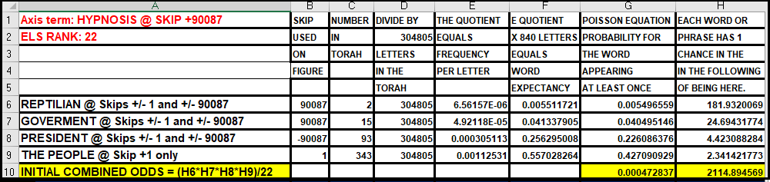

Figure 11-7: OBAMA KILLS OUR MANNED SPACE FLIGHT PROGRAM. “When I became the NASA administrator, Obama charged me with three things,” NASA head Charles Bolden said in a recent interview with the Middle Eastern news network al-Jazeera. “Help me to help re-inspire children to want to get into science and math; to expand our international relationships; and perhaps foremost, he wanted me to find a way to reach out to the Muslim world and engage much more with dominantly Muslim nations to help them feel good about their historic contribution to science, math, and engineering.” Why did he sabotage our space program? Figure 11-7 gives us some hints about his likely (Reptilian) motives. The axis term is MARS DELAY at skip +70,216. Two terms immediately jump out at us. The first is ALIEN at the absolute skip of the axis term. The second is the only ELS of B. OBAMA at skip +/-1. This matrix also includes NAZI at skip -1, HITLER at skip 70,215, WAR in the open text, HIS ARMY at skip +1, DUST FROM THE SKY (dust plays a major role in weather on Mars), and (separately) both HAIM and ESHED. HAIM ESHED is the retired Israeli Brigadier General who ran Israel’s space program for 30 years. He claims that the U.S. military has a joint base underground on Mars with aliens. When we include the axis term, odds against this matrix are about 156 billion to 1.

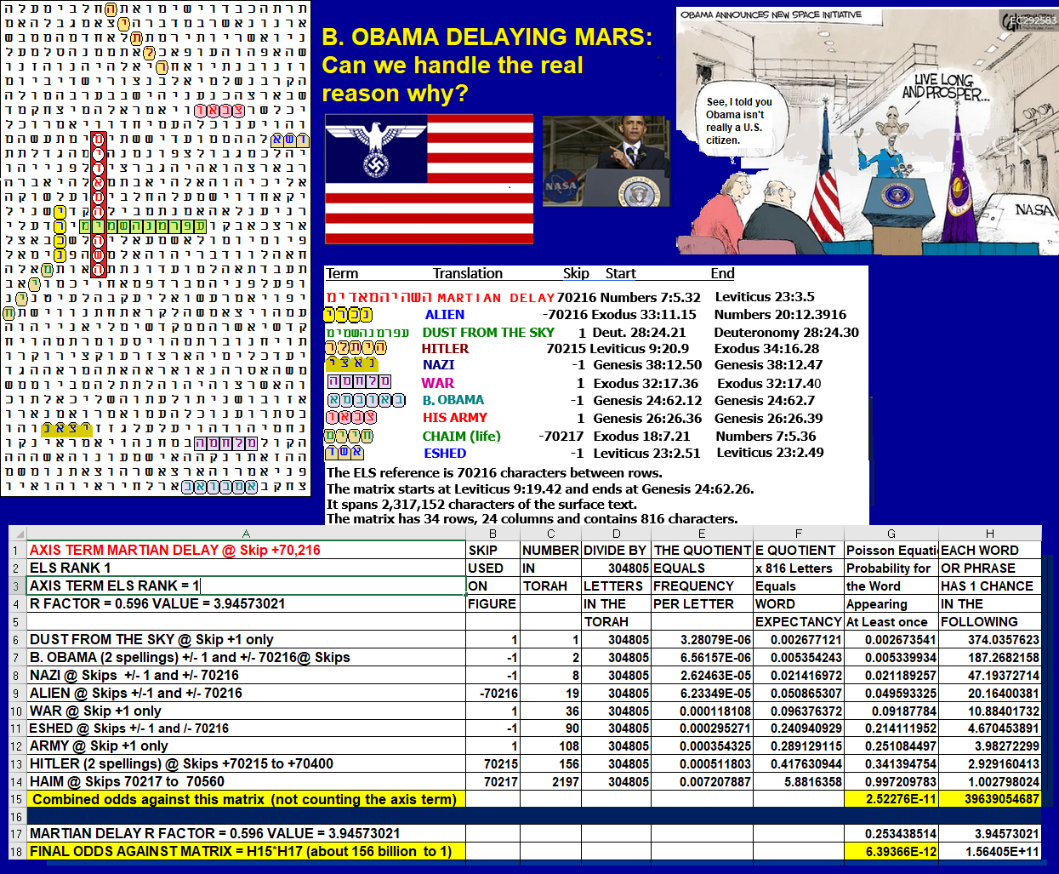
.

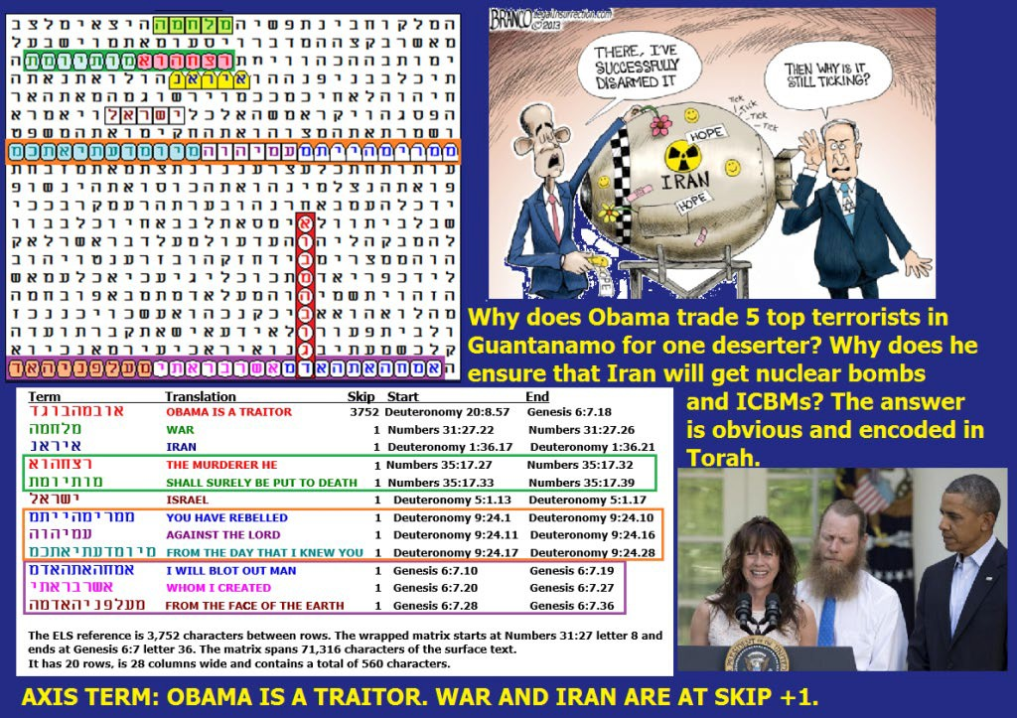
Figure 11-8. OBAMA IS A TRAITOR is the axis term. Obama used his power to betray the U.S. and Israel by reaching a bad nuclear deal with Iran. One of two Torah occurrences of IRAN at skip +1 is on the matrix. Obama tried to force Israel to go to war with Iran, and WAR is shown in the open text. On the line above, OBAMA is a TRAITOR runs into I WILL BLOT OUT MAN. In this phrase, BARACK is at skip -1. Sharing letters with AND PUT AWAY is USA. Obama wants Israel to return to its pre-1967 borders, and he wants Israel in Muslim-terrorist hands. On the matrix is AND THEY ALSO POSSESS THE LAND, right under IRAN, FOR ALL ISRAEL is under that. Obama spent millions of dollars trying to defeat Netanyahu.

Figure 11-9 below. JULY 6, 2015: Obama, Gay Marriage, Iran (4-letter transliteration), and An Atomic Holocaust.
Figure 11-9 WORLD WAR, the Hebrew year (5775) and OBAMA are encoded at the same absolute skip. So is THE FOOL IRAN, although the transliteration of IRAN is not the most commonly used one. YOU SHALL SURELY DESTROY ALL THE PLACES in the open text crosses WORLD WAR. On the line below is I WILL SEND MY TERROR. Secretary of State KERRY (who worked hard to ensure that Iran would get the Bomb) has his name at skip +1. On the line above, KERRY is THERE IS A HOMOSEXUAL, but it isn’t at a special case skip. However, in the open text on the matrix is FOR ADAM (MAN) THERE WAS NOT FOUND A HELPER FIT FOR HIM. This phrase in Genesis 2:2 refers to the idea that after Adam named all the animals, he didn't find one who could be his mate.
Running through the letter vav in OBAMA is Genesis 2:3, which describes God taking a rib from Adam so He could create a woman (Eve) as Adam's partner. But Obama, who Newsweek magazine described as America’s first gay president, has pushed hard for gay marriage, and when a perverted court has backed him, he's defiled the White House by bathing it in gay movement rainbow colors. In Iran, gay behavior is a capital crime. American support for gay marriage provides an incentive for Iran and Islam to want us dead.
Note: 5775 did not necessarily imply that nuclear war would actually break out before the start of that Hebrew year on the night of September 13, 2015. More likely, 5775 was the year of the causes of the eventual war—Obama agreeing to a nuclear deal allowing Iran 24 days to move to nuclear material before inspectors could get there, and the legalization of gay marriage. Overall, after factoring in ELS rank 2 of OBAMA TRAITOR, this matrix was found against odds of about 16,405 to 1.
Figure 11-9 JUNE 14, 2015: Obama again says he has no strategy for ISIS. On August 28, 2014, when the president was asked if he would seek Congressional approval for U.S. attacks on ISIS targets in Syria, he responded, "I don't want to put the cart before the horse. We don’t have a strategy yet." On June 8, 2015, he again admitted that we don’t yet have a complete strategy. While these statements dumbfounded most Americans, and, of course, his decision to release five top Taliban terrorists from Guantanamo in exchange for a known deserter (Bergdahl) was really weird, there really was no mystery here.
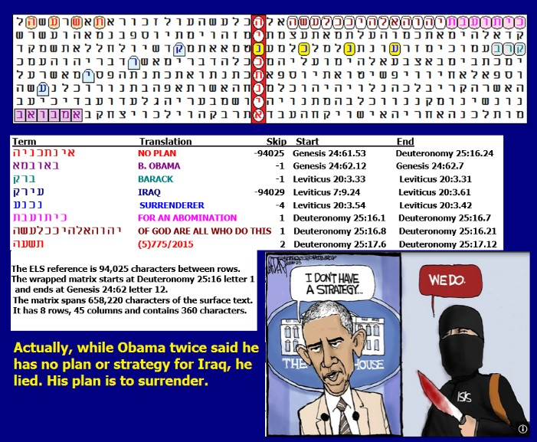
Above: Figure 11-10. The axis term is NO PLAN. The best a priori term found with it was B. OBAMA.
Obama was a traitor who truly hated America, and his strategy was to use the race card to ensure the defeat of the United Stated on all fronts for as long as he was President. Overall, after factoring in ELS rank 21 of the axis term, the matrix was found against odds of about 52,946 to 1. The two most significant terms were B. OBAMA at skip -1 against odds of about 847 to 1, and ABOMINATION found in the open text against odds of about 106 to 1.
Figure 11-11: APRIL 6, 2015: OBAMA SURRENDER IN NUCLEAR NEGOTIATIONS WITH IRAN
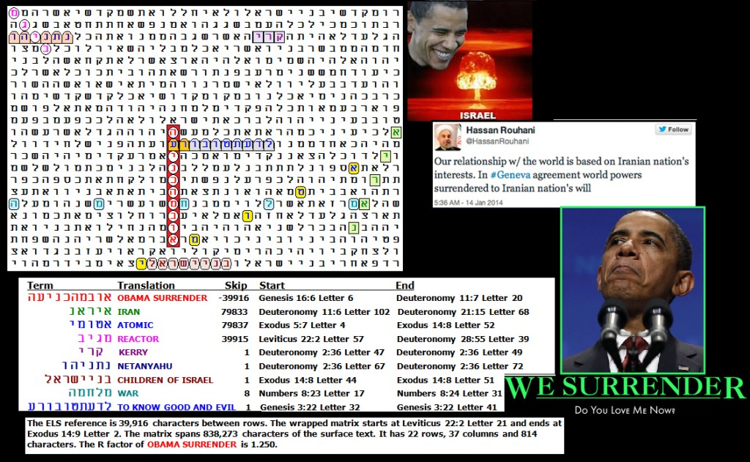
Figure 11-11 above. The deadline for an interim nuclear agreement with Iran was on March 31, 2015. That date came and went without an agreement, but Obama’s hatred of Israel and, in particular, of Israeli Prime Minister Netanyahu did not pass. So, Obama kept Secretary of State Kerry in Switzerland until he got an agreement that will almost certainly lead to an Iranian bomb. This put pressure on Israel to use tactical nuclear weapons against Iran unless the U.S. took care of the problem for Israel. Fast forward to June 21, 2025, and seven American B-2 bombers dropped twelve 30,000-pound GBU-57A/B bombs at the Fordow Iranian nuclear facility deep underground, and two more at Netanz. At Fordow twelve bombs times 30,000 pounds each equals 360,000 pounds of explosive force. There are 2,000 pounds in a kiloton. Dividing 360,000 by 2,000 equals 180 kilotons, which is the size of a tactical nuclear weapon. The atomic bomb that destroyed Hiroshima had the force of only 13 kilotons. Nagasaki was destroyed with a 21-kiloton bomb. In February, 2026 Iran was working had to rebuild its nuclear bomb program, so with C.I.A, help Israel wiped out the entire Khamenei government.
On the matrix above, the axis term is OBAMA SURRENDER. It’s 10 letters in Hebrew, which is long for an axis term. In the open text, the expression TO KNOW GOOD AND EVIL runs into it, with EVIL sharing a letter ayin with SURRENDER. KERRY and NETANYAHU are both at skip +1 and on the same line. REACTOR is at an ELS, crossing and sharing a letter with NETANYAHU. ATOMIC is at an ELS touching the last letter of CHILDREN OF ISRAEL. WAR is also at an ELS. Normally, I would just combine all the odds and state that the matrix was found against odds of about 27,915 to 1. But normally, I don't assign any value to the axis term. Where I make exceptions to this rule, the axis term must be at least 9 letters long. Again, here it’s 10 letters. This term, OBAMA SURRENDER, only had about one chance in 17.782 to be found at all in the wrapped Torah. So, if we consider this fact, then we arrive at odds against the matrix really being about 497,415 to 1.
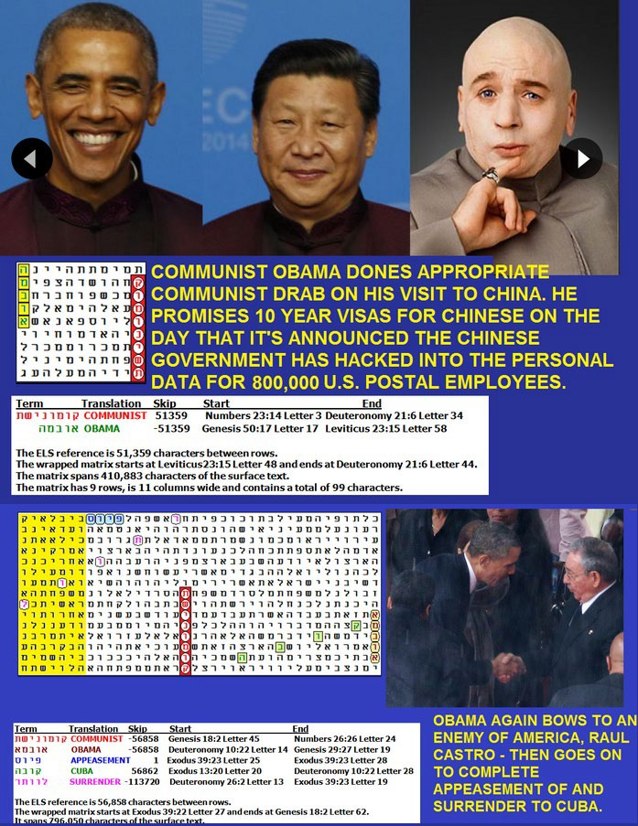
Figure 11-12: The Axis term A COMMUNIST is found twice in Torah Code. This one is at the same skip as OBAMA. APPEASEMENT is at skip +1.
Figure 11-13 below SEPTEMBER 10, 2014: A nuclear nightmare is found in the Code. But is it just a dream? Once again, B. Obama is strongly encoded with it.
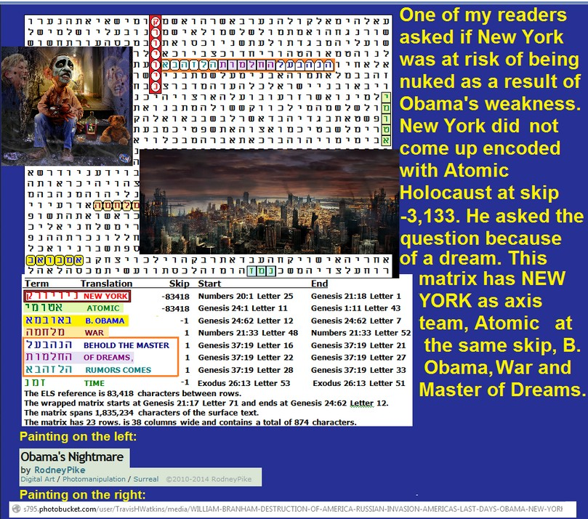

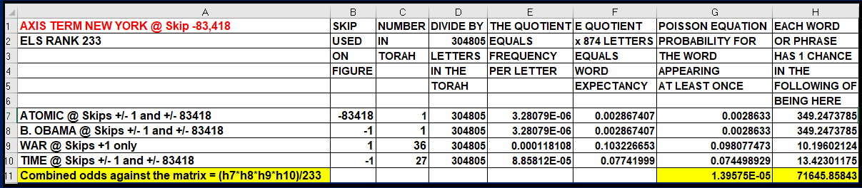
Figure 11-13 above: NEW YORK is at the same skip as ATOMIC, with WAR in the open text. Sometimes a matrix looks beautiful, sometimes frightening. Normally, I don’t make predictions based on the Torah Code; I just like to show how history has been pre-recorded in the Code. The matrix was shown earlier as Figure 9-26 and is repeated here as Figure 11-12. It was found after I received a request on my blog to look at an atomic threat to New York that might result from Obama’s weakness, or immigrants who had vanished from the public radar. Odds against this matrix were about 71,645 to 1.
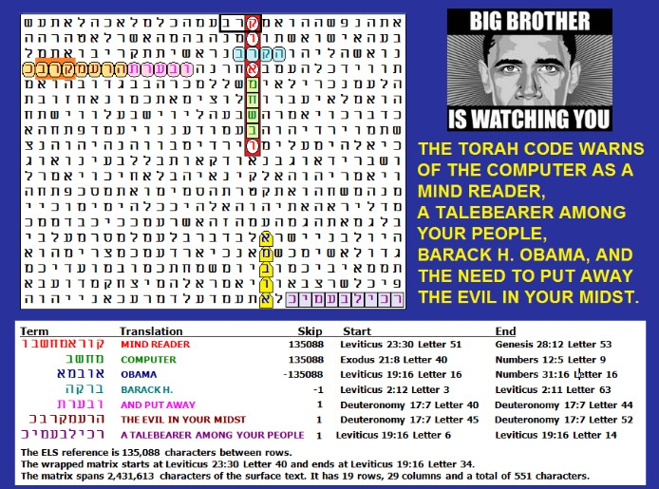
Figure 11-14 above: AUGUST 28, 2014: Mind Reading Computer and Obama. MIND READER, COMPUTER and OBAMA are all at the same. Skip. The matrix also has AND PUT AWAY THE EVIL IN YOUR MIDST and warns about A TALEBEARER AMONG YOUR PEOPLE.

Figure 11-15 November 8, 2013: Obama apologizes for broken promise to keep your healthcare plan.

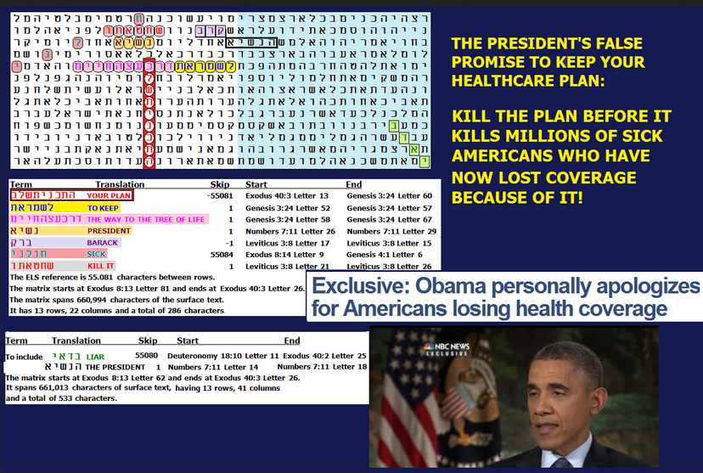
Figure 11-15 Axis term: YOUR PLAN.

Figure 11-16 April 7, 2013: Atomic holocaust, Obama, and North Korea.
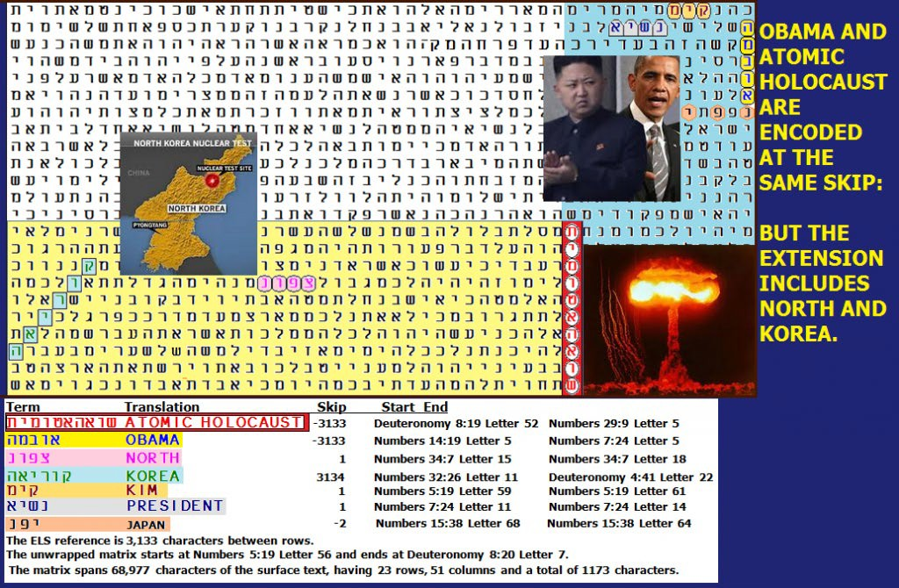

FIGURE 11-16. Axis term ATOMIC HOLOCAUST. OBAMA is at the same skip.

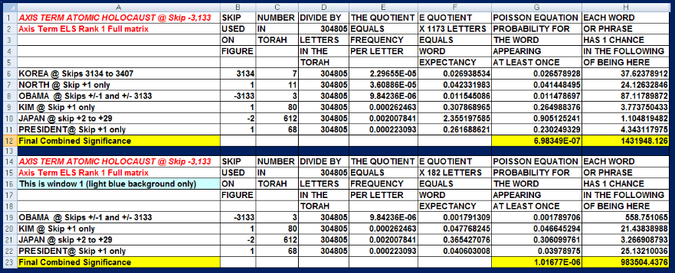
Figure 11-16 above: Ever since Michael Drosnin published his first best-selling book (THE BIBLE CODE) in 1997, we have known that there is a 10-letter ELS for ATOMIC HOLOCAUST in the Code at skip -3,133. But what we did not know is that OBAMA is very close by, at the same skip. PRESIDENT is at skip +1. NORTH and KOREA are also on the matrix. The matrix has 23 rows, 51 columns, and 1,173 letters.
On January 1, 2012, I published a matrix with these terms and Iran. But I did not look for Korea. On the matrix above, we again have ATOMIC HOLOCAUST and OBAMA at the same skip, but we also have KIM (as in Kim Jong Un) at skip +1, and NORTH in the open text with the best spelling of KOREA very near it. Kim Jong Un has promised to attack the U.S. with nuclear weapons. JAPAN is also on the matrix at skip -2, touching PRESIDENT. North Korea threatened Japan with Tokyo being "consumed in nuclear flames." We don't yet know the year when the Korean threat might come to fruition. Dates, however, are rarely reliable on a matrix. As for odds, the full matrix (1,173 letters) was found against odds of about 1,431,948 to 1, with ATOMIC HOLOCAUST encoded with PRESIDENT, OBAMA, NORTH, KOREA, KIM, and JAPAN.
Figure 11-17 September 28, 2012: Will the government force us all to have identity chips implanted?
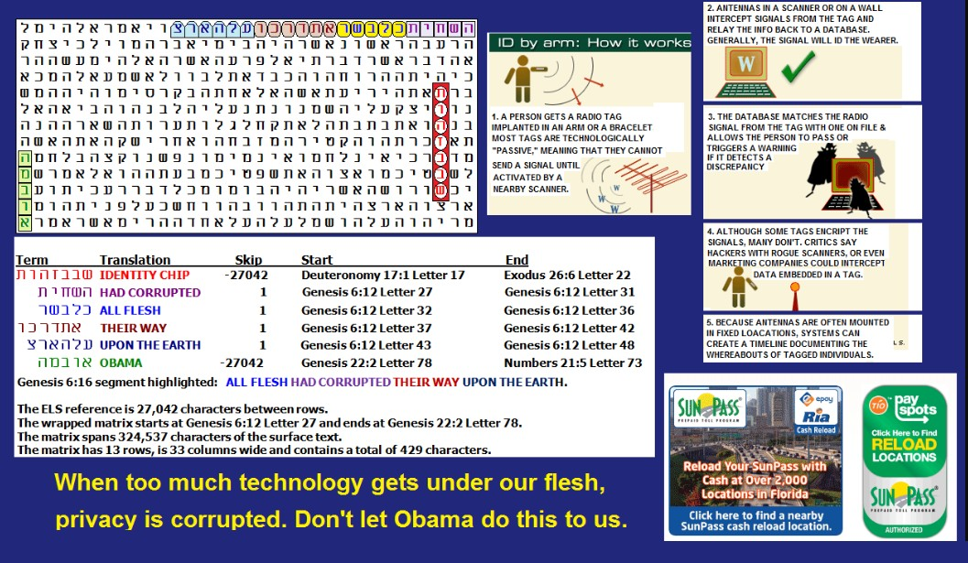
I once received a question from one of my readers about the possibility that President Obama would, if re-elected, ask U.S. military forces to have identity chips embedded in their skin. Before examining the matrix below, let me state that in attempting to look for any possible relationship in the above, because Obama is such a high-frequency term, I would only accept his name when it appears at skip +/-1 or the same skip as the axis term, here IDENTITY CHIP. On the matrix above, both IDENTITY CHIP and OBAMA are at skip -27,042. This match occurs at the 10th lowest ELS of the axis term. The reader's concern was that eventually all Americans (and in the end all of humanity) would be forced to have such a chip inserted into their flesh, thus making it easier for the leader of a world government to control all people. In the open text on this matrix is "ALL FLESH HAD CORRUPTED THEIR WAY UPON THE EARTH" (Genesis 6:12).
So, what is the status of identity chips in the U.S.? Elon Musk's company, Neuralink, has implanted brain chips in humans, and it's the first company to do so. The first human implant was performed in January, 2024 on a quadriplegic patient, and the patient was able to control a computer mouse using their thoughts. Neuralink is working to develop brain-computer interfaces that could potentially help people with paralysis or other neurological conditions regain lost function.
While no single country is officially implanting chips in humans, Sweden has seen a notable number of individuals voluntarily getting microchips implanted for various purposes, including gym access, e-tickets, and storing emergency contact information. Some Swedes have also used the chips to replace key cards and as a form of contactless payment. In 2024, it was estimated that between 50,000 and 100,000 people have been chipped.
Figure 11-18 September 13, 2012: Obama’s Kenyan birth. There is an abundance of evidence that Obama was born in Mombasa, Kenya. Even his own first book backs this idea on page 307. There is reason to believe that even though Obama is no longer in office, his crimes were so great that he could still be impeached, but the Code is clear that he was born in Kenya and was thus never eligible to be our president. The possibility that his parents were aliens in discussed in Chapter 3. On Figure 11-18 KENYA is intersected and shares a letter hey with HE WILL BE LIKE A FOREIGNER (alien). Also, in sequence right before OBAMA KENYA is the same word for FOREIGNER/ALIEN.
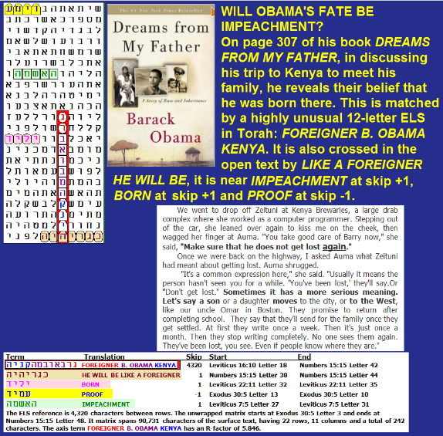
Figure 11-18 above: Proof that Obama was born in Kenya.
On Figure 11-19, the axis term is ILLUMINATI. OBAMA and HITLER are at the same skip, CLINTON and BUSH are both at skip -1, and KENNEDY is there too, but not at a special case skip. An Illuminati goal of one world law/order is hinted at in the open text. Without including CLINTON, the matrix was found against odds of about 26 million to 1. The larger matrix with CLINTON was found against odds of about 5.6 million to 1.
Statistical Significance of Figure 11-19. I don't like to publish matrices that are over 1,000 letters in area. If we just look at everything from BUSH down through KENNEDY, that's just 37 columns by 12 rows (a 444-letter area). This turns out to be the most significant cut. Odds against it are about 37.7 million to 1. The bulk of this number is due to HITLER and OBAMA. HITLER and OBAMA, and BARACK are found with ILLUMINATI in 297 letters against odds of about 427,522 to 1.
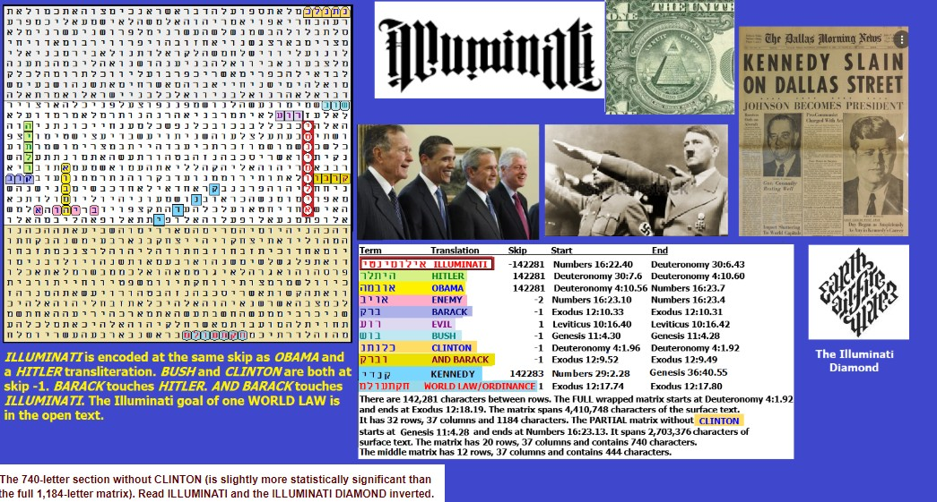
Figure 11-19 above. ILLUMINATI, HITLER, and OBAMA are all at the same absolute skip. Odds against this matrix are about 37,792,796 to 1.

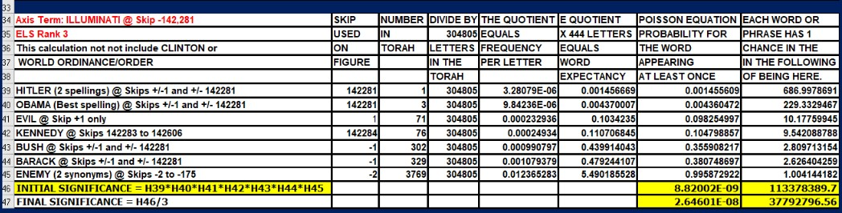

Figure 11-20 below: The beating of Rodney King.
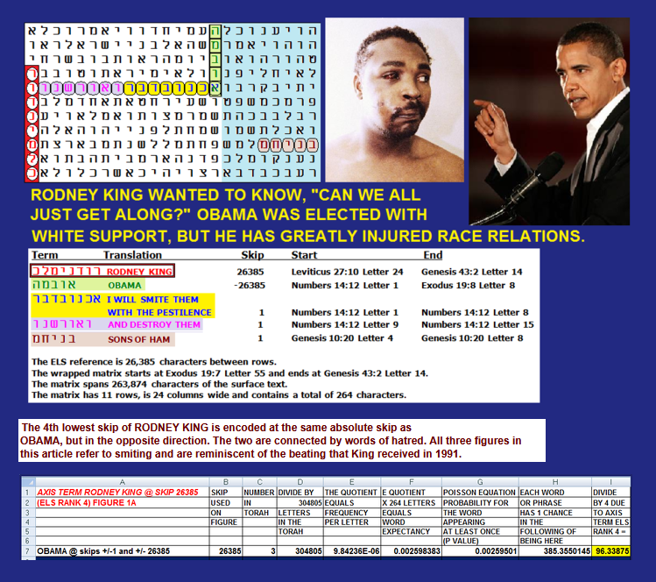
On March 2, 1991, police in Los Angeles arrested Rodney King for speeding while intoxicated. King resisted arrest, and then was shot with a taser, and repeatedly beaten and kicked while he was on the ground. The beating was filmed and broadcast on TV. On April 29, 1992, three police officers were acquitted of the beating, and nationwide rioting then ensued. My older son was walking home from Alameda High shortly after the riots began. A number of African Americans jumped him and started to beat him, but fortunately, some motorists stopped their cars and drove off the attackers. By the time it was all over, there were 53 dead, 2,383 injured, more than 7,000 fires, damages to 3,100 businesses, and nearly $1 billion in financial losses.
Mr. King then asked, "Can we all just get along?" In attempting to answer that question, many white Americans voted for Barack Obama in 2008, but after assuming office, he took racial relations to lows not seen since the start of the Civil Rights Movement.

Figure 11-21 May 14, 2012: Newsweek magazine cover portrays Obama as a gay president who supports gay marriage.

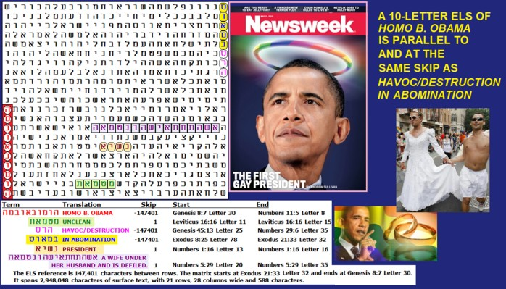

On Figure 11-21 the axis term is HOMO B OBAMA. At the same skip are HAVOC/DETRUCTION and IN ABOMINATION. Leviticus 18:22 states:
Thou shalt not lie with mankind, as with womankind: it is abomination.
Figure 11-21 also has PRESIDENT in the open text. UNCLEAN is at skip +1. A WIFE UNDER HER HUSBAND AND IS DEFILED is in the open text. This raises old questions about whether Michelle Obama was really a man.
At a Facts Check website (https://fullfact.org/online/michelle-obama-ex-boyfriend-man/) they state that:
Michelle Obama’s ex-boyfriend David Upchurch has come forward to reveal that she is actually a man named Michael Robinson and only became ‘Michelle’ after meeting Barack Obama. However, they continue to say
Our verdict
False. Mr Upchurch has always described Mrs Obama as female.
Claims that the former US First Lady, Michelle Obama, is a man, are recirculating on social media, with one post on X, formerly Twitter, viewed more than 6.9 million times.
Posts have also been shared to Facebook, claiming her “ex-boyfriend David Upchurch has come forward to reveal that ‘she’ is actually a man named Michael Robinson and only became ‘Michelle’ after meeting Barack Obama and having prospects of becoming First Lady”.
But there is absolutely no evidence for this claim, which appears to be part of a series of baseless theories that have been circulating doubting Mrs. Obama’s gender.
Is this topic discussed in the Code? Possibly. Figure 11-22 explores the issue:
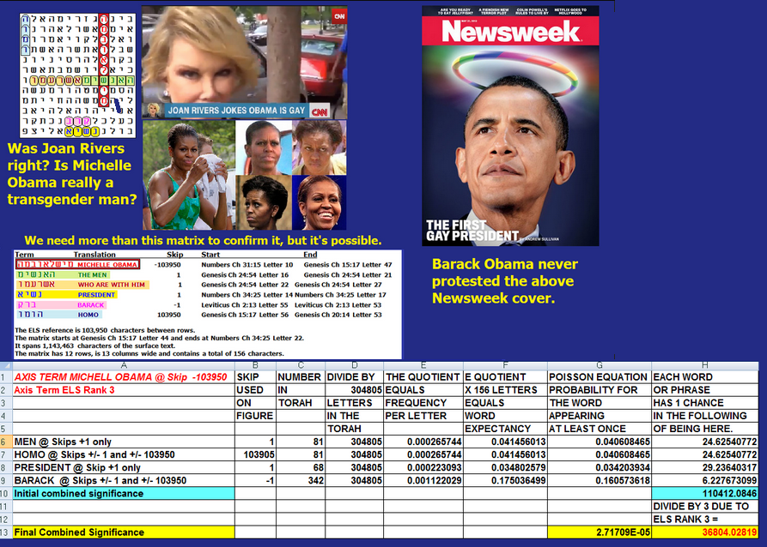
Figure 11-22 above: After conducting a homosexual marriage, comedian Joan Rivers made an accusation on TV that President Obama ia a homosexual, and Michelle Obama is transgender. Apparently the president (on at least two occasions) referred to his wife as Michael) rather than Michelle (see https://www.youtube.com/watch?v=sLiXFbht7s0). Films like this emphasize the length of the fingers, ratio of height (5'11") to head size, presence of an Adam's Apple, and ratio of head to shoulder size, plus an apparent bulge where a woman should not have one. A few pictures looked like they might have been photo-shopped. While it will take far more than the matrix above to prove this sort of thing, on Figure 11-22 MICHELLE OBAMA has her name directly crossed in the open text by THE MEN WHO WERE WITH HIM. At the same absolute skip as the name, but opposite direction, is HOMO. BARACK is at skip -1, and directly below it is PRESIDENT at skip +1. Odds against this matrix occurring by chance alone are about 36,804 to 1. The person who sent the request asked me to check on other key words including proportions, shoulders, fingers, Sasha and Malia. Of these only Sasha came up at a special case skip near Michelle Obama, but the name of a daughter near that of a mother is not proof that the mother is, in fact, a man.
Figure 11-23 below. February 3, 2011: Was Obama elected in Egypt, or does he see himself as a reincarnated pharaoh?

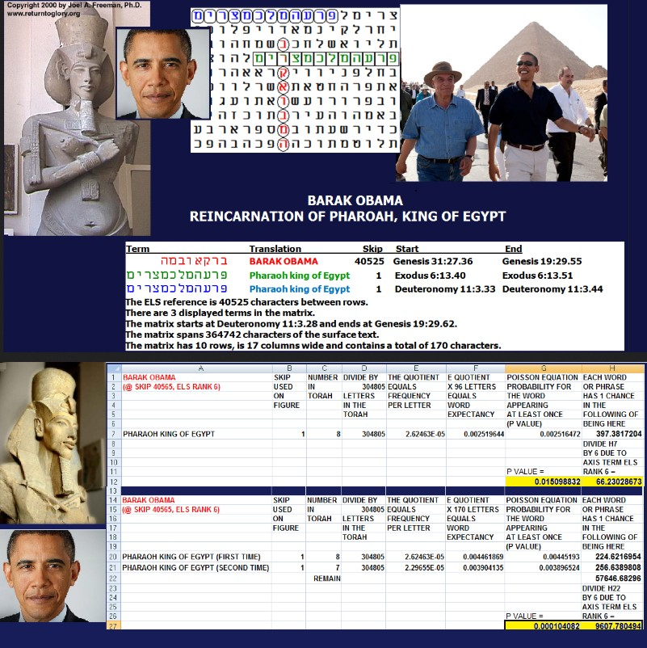
Figure 11-23 above was originally posted in conjunction with President Obama's overt hostility toward Israel. When the crisis arose in Egypt, where there was widespread opposition to President Mubarak, Obama declared, "What is clear — and what I indicated tonight to President Mubarak — is my belief that an orderly transition must be meaningful, and it must begin now."
The demands made by the U.S. President had a tone that made it sound like he was also elected as President of Egypt. There seemed to be no concept of Egyptian sovereignty or the need for Egypt to solve its own problems internally. On Figure 11-23 BARACK OBAMA is the axis term. His name is shown at its 6th lowest ELS in the wrapped Torah (which requires more than one computer pass through the 304,805 letters of Torah to find). It is directly crossed by one of the Torah’s eight uses of the term PHARAOH KING OF EGYPT. Perhaps President Obama has a distant memory of being Pharaoh, King of Egypt, in a past life. Indeed, there is a statue that backs this idea in the Egyptian Museum in Cairo, which was attacked in the rebellion and which was at the heart of the rebellion in Cairo's Tahrir Square! Mubarak was toppled and arrested. Pharaoh Obama had laid out his vision for more change and included what Mitt Romney calls throwing Israel under the bus by driving it back to the pre-1967 borders.
Figure 11-24 October 9, 2009: Obama Nobel Prize
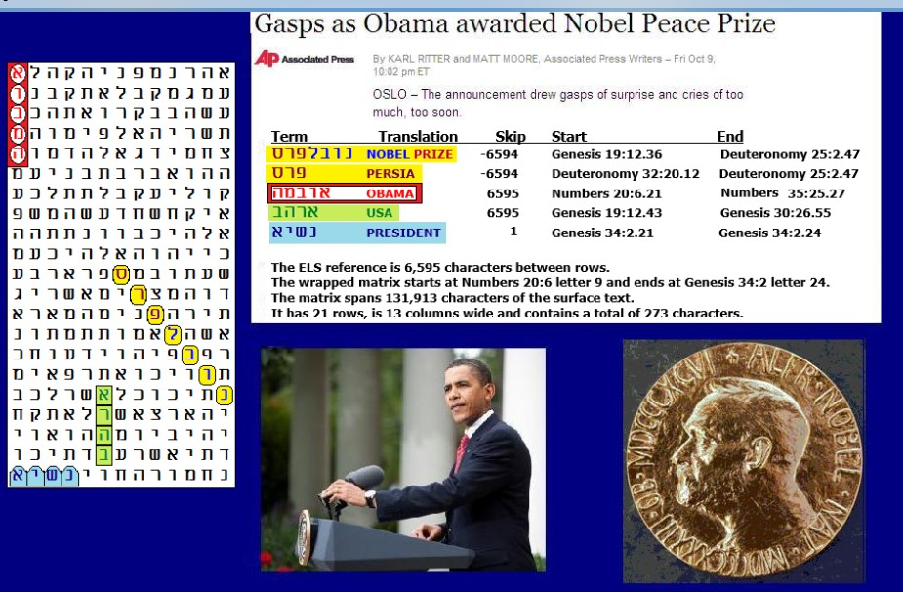
On Figure 11-24 above, the axis term was NOBEL PRIZE. It is shown at its minimum (most significant) ELS. In the 273-letter matrix, in addition to the axis term at skip -6,594, we find OBAMA at skip 6,595and also USA at skip 6,595. PRESIDENT was also on the matrix at skip +1. As the spreadsheet indicates, there was about one chance in 20 that OBAMA would be on the matrix at some skip, about one chance in 16 that PRESIDENT would be there at skip +1, and better odds than calling heads or tails (here about one chance in 1.8) that USA would be on the matrix. All combined, with no value at all assigned to the axis term, NOBEL PRIZE, the value of the matrix was computed at p = .00157 or about one chance in 634.
Using the 10 Haralick verse-permuted files, and just checking for Nobel Prize between skips -35,000 and 35,000, I was not able to come up with a match as good as that seen in the Torah, but I did get close with one matrix having all the terms in a 300-letter (25 row, 12 column) matrix where the axis term, Nobel Prize, was at skip 4,631.

POLITICAL ASPECTS OF MY 2009 ARTICLE
Obama himself admitted that he was unworthy of receiving the prize. As for why he was nominated for it only 12 days into his presidency and then selected in October 2009, the Jerusalem Post speculated, “If Obama was unlikely to okay any military activity against Iran to keep it from getting nuclear weapons capabilities before the award, giving him the award now seems an attempt to handcuff him even further.” I went looking for Iran on the Matrix and didn’t see it at first. But then I realized that a Biblical synonym for Iran is Persia. The Hebrew for Nobel Prize is Nun Bet Vav Lamed Peh Resh Samech. Curiously, the last three letters are not only Prize, but also PERSIA!

POLITICAL AND CODES UPDATE OF MAY 10, 2021
What we knew in 2021, twelve years after the Nobel Prize was awarded to Barack Hussein Obama, was that he gave $151.7 billion to Iran and guaranteed that they would acquire nuclear weapons or buy them from North Korea. The appraisal of the Jerusalem Post in 2009 was correct. Obama was and is a traitor. What remained to be seen was whether President Trump could undo the tremendous damage done. During my 2017 update, the United States had three nuclear aircraft carriers (Vinson, Reagan, and Nimitz) off the coast of North Korea, and the Japanese helicopter carrier Izumo had just joined them. Iran tried to fire a cruise missile from a submarine in the Persian Gulf, but it failed. The news about the confrontation in the United States was tightly controlled (loose lips sink ships), but there was certainly no sign that anything done by Obama ever brought or contributed to peace. He made a disaster out of Iraq, giving birth to ISIS in the process. He did not get the U.S. out of Afghanistan. He gave up control of terrorist prisoners at Guantanamo, and in return got back a deserter traitor—Robert "Bowe" Bergdahl. Obama was a terrorist's dream come true, and Biden, Harris, and Pelosi continued to work against all U.S. military interests. Much of the Torah Code appears to have been written as a warning about him.
LIST OF LINKS TO OLD OBAMA CODE ARTICLES (2009 to 2016). The older the article, the less refined my techniques were. The links listed in the section should work, but you may have to access them via my https://roffmanmarsresearch.com website and the PDF version of this chapter.
- MARCH 17, 2016: Obama nominates Garland for Supreme Court. Oppose it.
- NOVEMBER 3, 2015: Is Obama only a Kenyan-born Muslim, or a Reptilian Alien?
- JULY 6, 2015: Obama, Gay Marriage, Iran, and An Atomic Holocaust.
- MARCH 4, 2015: NETANYAHU GOES AFTER THE ENEMY OF ISRAEL – AND AMERICA – (OBAMA) IN HIS THIRD SPEECH BEFORE A JOINT SESSION OF CONGRESS.
- FEBRUARY 19, 2015: JOHN PODESTA, OBAMA, BUZZ ALDRIN, AND UFO DISCLOSURE.
- FEBRUARY 9, 2015: NANCY PELOSI PROPOSES DEMOCRATIC BOYCOTT OF NETANYAHU’S SPEECH BEFORE A JOINT SESSION OF CONGRESS.
- JANUARY 23, 2015: BOEHNER INVITES NETANYAHU TO JOINT SESSION OF CONGRESS.
- DECEMBER 7, 2014: OBAMA UFO DISCLOSURE UPDATE.
- NOVEMBER 5, 2014: REPUBLICANS MAY FILE IMPEACHMENT CHARGES AGAINST OBAMA IF HE USES EXECUTIVE ACTION TO KEEP MILLIONS OF ILLEGAL ALIENS.
- SEPTEMBER 23, 2014: EBOLA AND OBAMA. It seems like this plague is well described in the Code.
- SEPTEMBER 5, 2014 (Updated 9/11/2014): September 4 Bill O’Reilly show discusses if Obama is the enemy. The Torah Code suggests an answer.
- SEPTEMBER 1, 2014: Torah Code compares UK Prime Minister David Cameron and Obama.
- JULY 18, 2014: MALAYSIA FLIGHT 17 SHOT DOWN BY RUSSIAN REBELS IN UKRAINE. Obama's weakness is encoded as a cause.
- JULY 13, 2014: Is Obama Really Hamas?
- JUNE 2, 2014: White House Press Secretary Jay Carney Resigns.
- APRIL 25, 2014: Ranch War in Nevada. Obama and the Federal Government would be wise to leave Bundy alone and not make him into a martyr.
- JANUARY 30, 2014: Obama calls for an increase in the minimum wage.
- OCTOBER 31, 2013: Kathleen Sebelius & Obama struggle with the truth about the Obamacare malfunction.
- JULY 30, 2013: Fear of Obama and Kerry forces Netanyahu to release 140 terrorists from prison and to restart peace talks.
- MAY 1, 2013: Obama is up against a chemical, the red line he painted for Assad. Another war may lie ahead.
- APRIL 26, 2013: Obama, Mars Cover-up, and Life are encoded in 1 Column.
- MARCH 19, 2013: President Obama’s visit to Israel.
- OCTOBER 7, 2012: Was Obama crushed in the first debate because he couldn’t use his teleprompter, or was he distracted by something more important, like his real birth certificate?
- SEPTEMBER 25, 2012: Obama will lead us into a world war.
- SEPTEMBER 11, 2012: The Jerusalem vote from Obama at the Democratic convention leads to atomic Iran & destruction.
- SEPTEMBER 5, 2012: Obama as the king of Sodom at the Democratic convention.
- JUNE 10, 2012: In
- JUNE 8, 2012: U.S. military suicides hit one per day, the top rate of killed in action.
- MAY 30, 2012: Israel-made Flame computer virus hits Iran.
- MAY 22, 2012: Mormon concerns and election jitters.
- MAY 20, 2012: Congressman Akin introduces measure needed to protect U.S. military chaplains who oppose homosexual marriage.
- APRIL 18, 2012: The Colombian Obama security scandal.
- APRIL 6, 2012: First look at an Obama vs. Romney election in 2012.
- APRIL 4, 2012: Obama insults the Supreme Court by calling its members “unelected judicial activists.”
- MARCH 28, 2012: President Obama promises Russia to kill our missile defense after the election.
- JANUARY 30, 2012: Arizona Governor Jan Brewer puts her finger in President Obama’s face.
- JANUARY 29, 2012: Did a Saudi operative named Khalid Al-Monsour help Obama get into Harvard?
- JANUARY 24, 2012: A look at who the code says is Babylon.
- JANUARY 8, 2012: The link between Malcolm X and Barack Obama.
- DECEMBER 9, 2011: B. Obama & Netanyahu ordered attack on Iran’s Isfahan nuclear site.
- NOVEMBER 2, 2011: Is
- SEPTEMBER 15, 2011: Obama, the Solyndra loan, and the corrupt.
- SEPTEMBER 15, 2011: Will Trump try again to impeach Obama?
- SEPTEMBER 8, 2011: Obama’s economic failure: jobs.
- JULY 21, 2011: 42 years after Apollo 11, Obama presides over the death of the space shuttle and manned U.S. space flight.
- MAY 27, 2011: Accusation of a new alias for President Obama.
- MAY 20, 2011: Netanyahu says no to Obama!
- APRIL 14, 2011: Gaddafi.
- APRIL 14, 2011: Romney and Trump are both encoded with Obama's loss second time. Mike Huckabee does well, too.
- MARCH 10, 2011: Is Obama leading the U.S into another civil war?
- DECEMBER 19, 2010: Don’t Ask, Don’t Tell and New U.S. Military Gay Policy.
- NOVEMBER 3, 2010: Pharaoh Obama's Loss of Congress in 2010.
- SEPTEMBER 20, 2010: NBC TV series entitled “THE EVENT.” Is a UFO Disclosure coming from the Obama Administration?
- APRIL 15, 2010: President Obama’s plan for NASA and Buzz Aldrin’s role in it.
- JANUARY 27, 2010: Will Obama end NASA?
- DECEMBER 14, 2009: Emanuel’s Roman Hanukkah and Vatican plus Obama.
- JANUARY 20, 2009: Rahm Emanuel and Barack Obama.

