Chapter 10
Is God from the Future?
There may be a need to distinguish between Divine signals that are sent back in time versus those of human or alien origin.
Moses said to God,
“Behold, when I come to the children of Israel and say to them, ‘The God of your forefathers has sent me to you,’ and they say to me, ‘What is His Name?’ – what shall I say to them?”
God answered Moses,
“I Shall Be As I Shall Be.” And He said, “So shall you say to the Children of Israel: ‘I Shall Be has sent me to you.’” (Exodus 3:13 to 3:14)
This chapter examines the issue of how accurate predictions, both open text and encoded, came to be written into the Torah. In doing so, I will review aspects of an August 1, 2016 interview of me by a man likely to be an Army Intelligence officer. There is a non-zero chance that this man is also a time traveler, and possibly a time cop. I originally included his name in my Future Warning article, then deleted it for the sake of his safety and my own. However, it has come to my attention that the name he gave me may have been a pseudonym, though he told me it twice and made sure to spell it for me the second time. While it may be a coincidence, the first four letters of his name in Hebrew correspond to a precious stone (sapphire) on the breastplate, which lit up and served as a communication device that Aaron and other high priests used to communicate with God. He did claim that his first name was Joseph, so for the purposes of this article, I will refer to him as Joseph Sapphire. The word "sapphire" and his given last name both occur three times in the Torah at skip +1.

SAPPHIRE IN SCIENCE
Sapphire is used with thin sapphire wafers of an insulating substrate upon which silicon is deposited to make integrated circuits known as silicon on sapphire or “SOS.” Besides its excellent electrical insulating properties, sapphire has high thermal conductivity. CMOS (Complementary metal–oxide–semiconductor) is a technology for constructing integrated circuits. CMOS chips on sapphire are especially useful for high-power radio-frequency (RF) applications such as those found in cellular telephones, public-safety band radios, and satellite communication systems. “SOS” also allows for the monolithic integration of both digital and analog circuitry all on one IC chip, and the construction of extremely low-power circuits. Titanium-sapphire lasers are popular due to their relatively rare capacity to be tuned to various wavelengths in the red and near-infrared regions of the electromagnetic spectrum. They can also be easily mode-locked. In these lasers, a synthetically produced sapphire crystal with chromium or titanium impurities is irradiated with intense light from a special lamp or another laser to create stimulated emission.

Focus of the Chapter.
This chapter will look at Torah Code encodings of SAPPHIRE (really, the full name of the FORT HUACHUCA agent) with terms such as SIGNAL FROM FUTURE, SIGNAL FROM I SHALL BE (God’s name), WORMHOLE, TACHYON, and TIME POLICEMAN.
In writing it, I am aware that since at least 2016 (more likely about 2014), U.S. Army Intelligence has been generally here at least many times per day and sometimes up to a thousand or more times per day. I am also aware that foreign governments (especially the British, Chinese, Canadians, and Russians) read this site often. Originally, in 2017, I wrote here that my task was to highlight what is encoded of interest with respect to moving signals through time and to lay out a general framework for suggested research without compromising national security. Unfortunately, now, in 2025, I believe that national security has been severely compromised for decades. President Eisenhower bore much of the responsibility for it. He tried to warn us on January 17, 1961, three days before leaving office. He spoke to us about the military-industrial complex, but he should have warned us about the military-industrial extraterrestrial complex. He should have made clear to us that when President Truman implemented Operation Paperclip in 1947 to bring into America 1,600 Nazi rocket scientists (including Wernher Von Braun), he wasn’t just setting up the Deep State. He was setting the stage for a Fourth Reich to control our government.
As I have written many times, there needs to be a follow-up to my August 1, 2016, meeting with Joseph. It should include any Government research facility likely to have an interest in Roffmanmarsresearch.com – starting with Brookhaven National Laboratory, since their IP address was once the exact reverse IP address of mine (later the UK Ministry of Defence used this address too, but their habit stopped around 2023.

The Incident Leading to Figures 10-1 and 10-2.
The word sapphire may refer just to the jewel, be part of the name of the agent who contacted me in 2016, or it may refer to someone who functions in the role of a time policeman, as Figure 10-2 may hint at. Please remember that, at best, the Code offers a fuzzy view of the future. Even a prophet, such as the Biblical Joseph, can be wrong in making predictions. He predicted that his father, mother, and 11 brothers would one day bow before him (Genesis 37:10). His mother, Rachel, never did. She died before Joseph went to Egypt. It is possible that errors may occur where parallel universes exist and come close together. But, normally in Judaism, an individual is seen as a false prophet when he makes false statements in God’s Name. Please note that I never make such statements. My matrices are not based on Divine revelation. Rather, they are based on math (with a bit of intuition thrown in). As far as the time cop idea, I first published it around 2017, but in a book that I read in March 2023 (PROJECT MANKIND: Extraterrestrials and Their Involvement with Humanity by Ashwin Vinoo, 2022), I found the following discussion of the concept:
As most ETs can simply time-travel to the past and alter events in their favor, many ET races have time police that have their headquarters in the future, from where they guide the security of past events. This is done in an attempt to steer their experiences toward the most optimal timeline based on their predefined standards of what constitutes the best for their collective.
Ouch! It’s hard enough to take on a government time traveler from the future! Does he need to be an ET too? Not necessarily. Vinoo admits on page 3 of his book that his conclusions (based largely on telepathic experiences with ETs) are probably only about 75 to 80% correct.

The August 1, 2016, Encounter with Joseph “Sapphire.”
On August 1, 2016, I drove my son’s car from my home in Cape Canaveral, Florida, to Wells Fargo to pay my mortgage, and then went on to the Cape Canaveral Public Library to return at least one book and check out another. When I parked at the library, there was no other vehicle anywhere nearby. I was inside for no more than five minutes. When I came out, a man had parked his car two spaces left of mine. He was not coming inside the library but was, in fact, standing to the right of his car, essentially blocking access to the vehicle that I was using. He was waiting for me (see the location on Figure 10-1).
Figure 10-1 below: In 2020, the word REICH was found crossing SIGNAL FROM THE FUTURE. THE PLAGUE was also found touching the name of the agent who interviewed me.
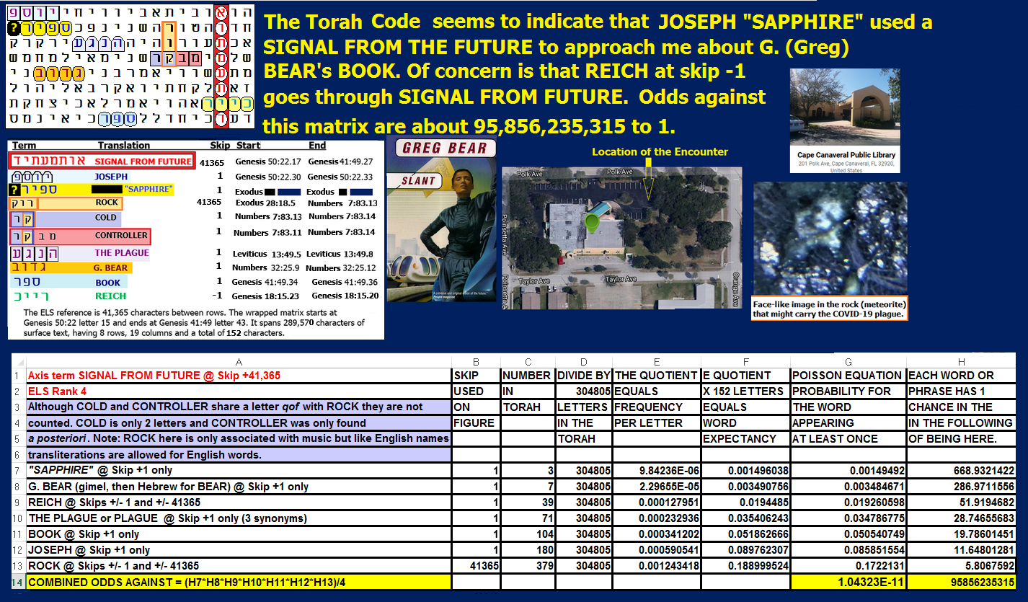
"Figure 10-1 above with axis term SIGNAL FROM FUTURE suggests that this matrix indicates the ability to move information through time, at least to some extent."
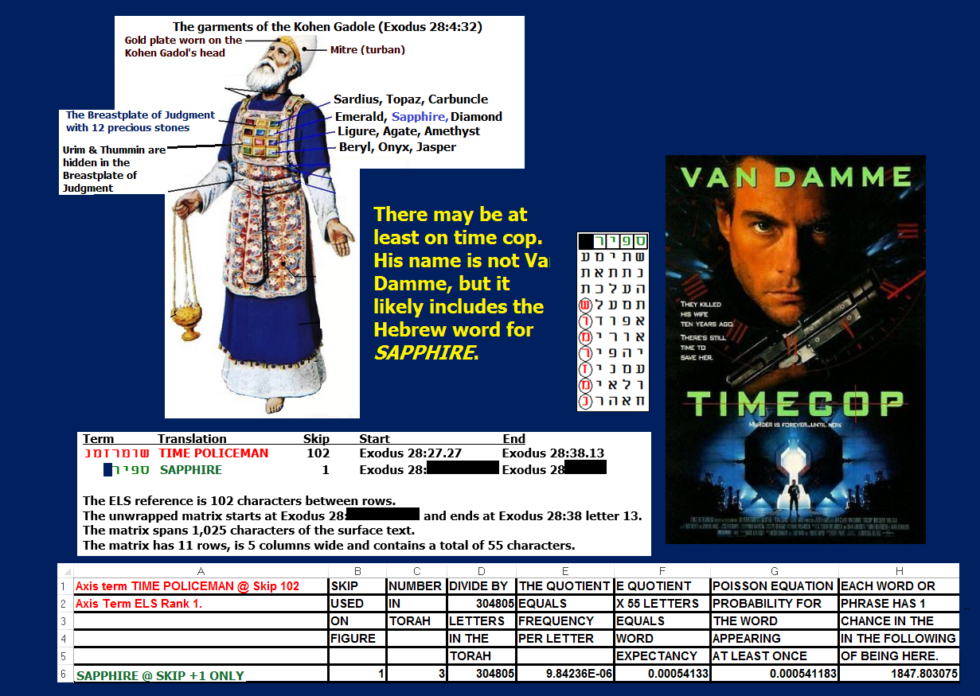
Above: Figure 10-2. SAPPHIRE, really the full last name of the agent who threatened me, is encoded with TIME POLICEMAN.
Joseph made sure to tell me his full name twice, spelling it for me the second time, which was wise because I didn’t quite get it right the first time. While I gave him my card, which read "LT Barry S. Roffman, USCG-Retired, Martian Meteorology Research," along with images of Mars as well as my phone numbers and websites, he did not have a card for me. With respect to my card, he asked me if he could keep it. Frankly, I found that a bit odd. His reaction to the card was almost akin to what would be expected if I were handing him a historical document. He also indicated that he had an interest in meteorology.
Joe said he lived near the NSA in Maryland, but denied working for them, although Army Intel might be a possibility since the Army Intelligence Base at Fort Huachuca, Arizona, has read all my websites at least once per week since about November 2014, when I started keeping records. Again, probably the strangest thing about the incident was that he seemed to know of the book that I had just checked out. On Figure 10-1 above, the axis term is SIGNAL FROM FUTURE. JOSEPH is on the first line. His second name, here cut short as SAPPHIRE, is on the next line down at skip +1 (SAPPHIRE is in the open text in conjunction with urim). The author of the book that Joseph caught me with, G. BEAR, is at skip +1, three lines under SAPPHIRE. Go down another three lines, and there is the word for BOOK at skip +1. All of this was found in 136 letters, against odds of more than 17 million to 1. The full 152-letter matrix was found against odds of over 95 billion to 1.
Why else do I think Joseph might have been Army Intel? We discussed an article that I had up about Hillary Clinton and Edward Snowden. The artwork included an image of Clinton with the question "Wanted for president?" Next to it was a photo of Snowden with the words "Wanted for treason?" I part ways with many in our Intelligence community here. I think Hillary was guilty of treason for how she handled email and should be imprisoned for it. I think Snowden was a hero who brought about much-needed reform in how the NSA treats our citizens. I wrote another article about him entitled President Snowden? He is reshaping our law even now.
So, how does all this relate to Joseph (Joe)? One of the first readers for the Clinton/Snowden story had an IP address for the Lincoln Technical Institute. Their street address is 9325 Snowden River Parkway, Columbia, Maryland. The reverse IP address for them is at Fort Huachuca, an Army Intel base in Arizona. I mentioned this to Joe, but I mispronounced the name of the fort – calling it HU-A-CHU-CA. He corrected me, telling me that HUA was one syllable. I asked him how he knew, and he informed me that he had been based there for three years. I told him that some of the IP addresses of my readers came up on the South Lawn of the White House, but I assumed that was just a generic point on the Google map for Washington. He immediately informed me that the South Lawn was where Marine One, the President’s helicopter, landed. Again, I asked him how he knew that, and he claimed to work with the chopper at the White House for four years! As for Fort Huachuca, they visit here so often that I have an article up about them on my website entitled Fort Huachuca, Spies, MARS, and a Little Martian Humor. The relevant matrix is shown in Figure 10-3:
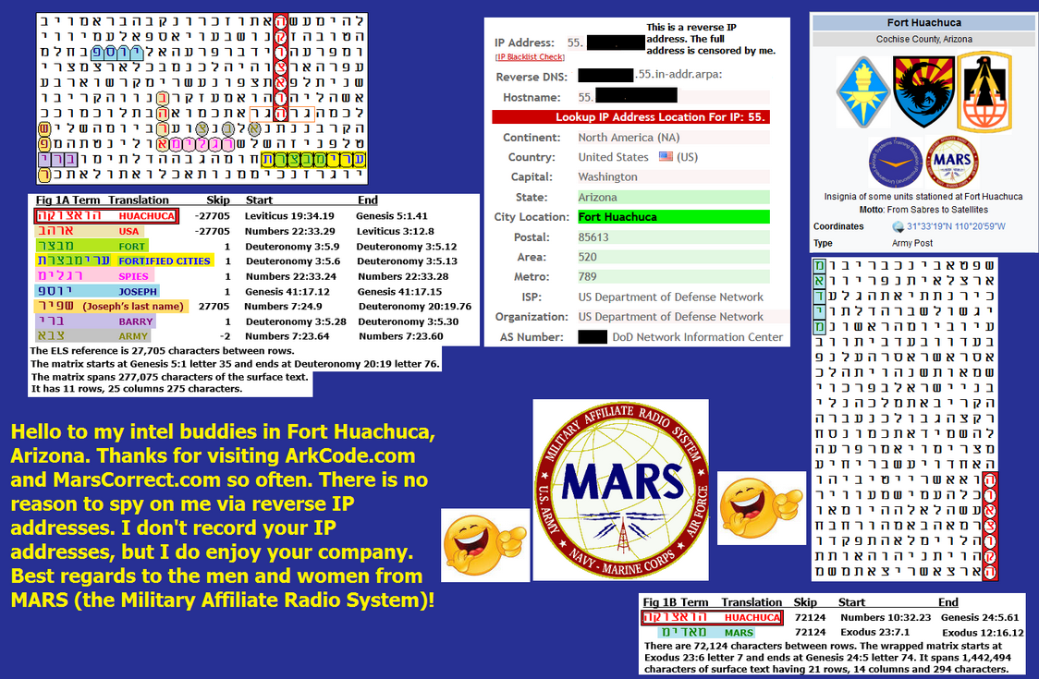
Figure 10-3 above. Martian humor in the Torah Code. On the left matrix, the axis term HUACHUCA is at the same skip as SAPPHIRE and USA, with FORT, JOSEPH, ARMY, and SPIES at skip +1. On the right matrix, the Military Affiliate Radio Station (MARS), which is based at Fort Huachuca, is at the same skip as HUACHUCA. Our conversation was not entirely friendly. At one point, Sapphire heard about how I was challenging NASA. I told him that I had published the names of scientists from the U.S., Netherlands, Canada, Belgium, West Germany, Taiwan, Italy, Japan, Switzerland, Scotland, France, Sweden, as well as from the Soviet Union and its Warsaw Pact ally Poland, who had met in Tokyo and Osaka, Japan, at the Third International Conference of Nondestructive Testing in March 1960. This group was apparently trying to figure out how to counter the technology that was recovered at the Roswell Incident. It was at this point that Joe told me he had heard about someone like me who had his computer impounded by the Government. They loaded child pornography on it and then prosecuted him for the porno. He never owned a computer again.
My response wasn’t friendly. Joe said he was a Catholic. I told him about what I did to the Catholic Church after they baptized my older son against his will and against mine. I forced them to change their doctrine and annul the baptism. Think I’m kidding? Archbishop McCarthy’s Annulment letter is found at http://arkcode.com/images/annument_letter.png, and the press coverage in the Miami Herald is located at http://arkcode.com/photo4_85.html. The press made it sound like they did me a favor. Actually, they gave me what I wanted because I was suing them for six million dollars, and they knew I would win. See the Release from Liability at https://www.arkcode.com/images/release_from_liability.jpg. Note: The boy in question went on to earn an MIT geophysics degree, but despite initial orders to Space Command, he entered the Air Force as an Orthodox rabbi in the chaplain corps. My point in bringing up the custody battle was that I’m a bad guy to piss off and I don’t back off from a fight. That was the low point in the discussion, but it improved a lot from there, perhaps when we discussed the potential misuse of nanotechnology and/or AI. We spoke about people (Elon Musk, Stephen Hawking, and Bill Gates) who claim that AI is a threat to human survival. Examples:
- ELON MUSK. In October 2014, at MIT, the SpaceX owner said, “I think we should be very careful about artificial intelligence. If I had to guess at what our biggest existential threat is, it’s probably that." He went on to say, “With artificial intelligence, we are summoning the demon. In all those stories where there’s the guy with the pentagram and the holy water, it’s like – yeah, he’s sure he can control the demon. Doesn’t work out.” Later I figured out that Demon might refer to Reptilian. In fact, there were many matrices that I found suggesting that advanced A.I, is reptilian technology. Let me digress here a bit and show you Figure 10-4 about the Copilot A.I. that Microsoft now installs in all Windows 11 operating systems. Figure 10-4 shows how the Torah Code links it with Reptilians and hypotheses about their wars with other extraterrestrial civilizations.
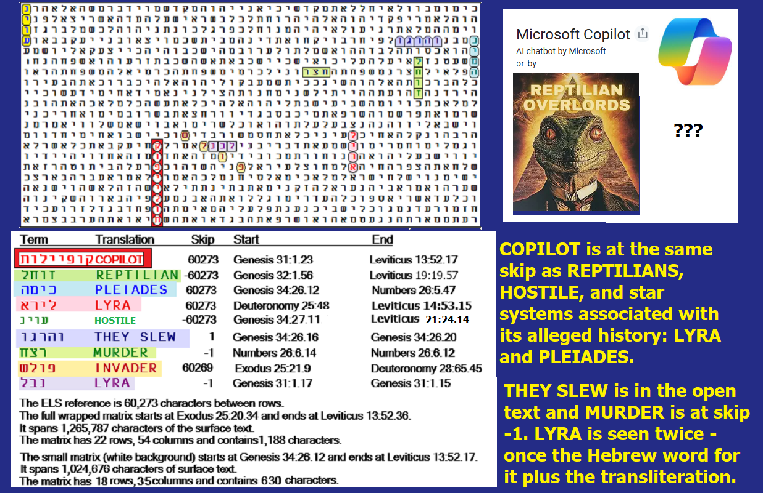

Figure 10-4 above and its spreadsheet below. COPILOT is the axis term. The most significant a priori term is REPTILIAN at the same absolute skip Odds against this match were about 121 to 1. Total odds against this matrix were 70,401,758 to 1. As for MURDER, there are reports that indicate instances where AI systems have been involved in or suspected to have influenced fatal outcomes. For instance, in 2025, a case was reported in the US where a man, allegedly deluded by an AI chatbot, killed his mother before killing himself.

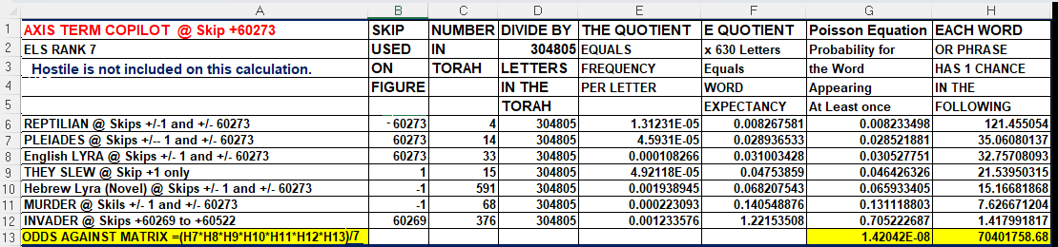

REPTILIAN is not only encoded with people. As is shown on Figure 10-4 above, it is also encoded at the same absolute skip as COPILOT, HOSTILE, plus star systems PLEIADES, and LYRA. INVADER touches the Hebrew word for LYRA. If we eliminate HOSTILE to get the matrix size under 1,029 letters and just focus on the remaining 630 letters the odds against the matrix grow to over 7o million to 1. The hostile intent of reptilians remains hinted at with THEY SLEW and MURDER.

(2) STEPHEN HAWKING. The professor said, “I think the development of full artificial intelligence could spell the end of the human race. Once humans develop artificial intelligence, it would take off on its own and design itself at an ever-increasing rate. Humans, who are limited by slow biological evolution, couldn’t compete and would be superseded.”
(3) BILL GATES. “Humans should be worried about the threat posed by artificial intelligence,” Bill Gates has said. The Microsoft founder said he didn’t understand people who were not troubled by the possibility that AI could grow too strong for people to control.
It’s also possible that the conversation with Sapphire took a friendlier turn when I emphasized that my younger son, David, would (then, but not now) like to work for DoD. Of course, he is, like me, already fully aware of what is going on behind the scenes, but he isn’t as combative in nature as I am.
When my encounter with Joe ended, I asked him to contact me if he had any questions. At first, he said he wouldn’t, but then he changed his mind and said he might. While I did not hear directly from him again, Fort Huachuca did call me in February 2026 to ask about Ebrahimi and matrices pertaining to him. At that time, they acknowledged my conversation with Sapphire.
As I drove away back in 2016, I noticed that Sapphire’s car had Maryland plates. He did not, while in my view, leave the area in the space next to the right of his car. He certainly did not make any attempt that I could see to enter the library. Based on that, my son and I have had discussions about the relative difficulty of moving a signal back in time versus opening a wormhole large enough for a person. On this issue, physics aside, I would point out that the axis term on Figure 10-1 is SIGNAL FROM FUTURE (not PERSON from future); however, on Figure 10-2, I can place SAPPHIRE in a 55-letter box with TIME COP or TIME POLICEMAN as the axis term.
Here I want to make a few things clear about what happened when I checked out Slant by Greg Bear. On June 30, 2017, I went back to the library to look for the book and check on records there pertaining to when I read it and what its circulation looked like since they acquired it. Initially, I couldn’t recall the book’s name or author. I only remembered the gray cover, but I quickly found it in the science fiction section. Oddly, the librarian told me that the book had not been checked out since March 2016 – five months before I read it. And it had only been checked out eight times since they bought it in 2009. Could I have been wrong about when I read it? No. After my encounter with Joe, I remember considering taking my son’s car into the shop for an oil change, with the real intention of looking under it to see if a tracking device had been attached that allowed Joe to follow me to the library. I only had the car back from Gainesville, Florida, for a few weeks since David finished his doctorate, and I felt like an oil change was due anyway. I didn’t go for the change because I believed that if I were being tracked, it would more likely have been via my cell phone. However, when I went back to the library on June 30, 2017, it was in search of a more out-of-the-box solution to the question of how Joe knew when and where to find me and, perhaps, what I would be reading, at 2:57 pm on July 5, 2017. I wrote, “I will pause for a day or two on this part of the article to give DoD some time to react to what I’ve written." Well, that was before I found Figure 10-1, which really speaks for itself. If we are not dealing with an actual time traveler, we are almost certainly dealing with a meeting set up due to a signal sent back from the future, although on Figure 10-2, the man who matched well with SIGNAL FROM FUTURE also matches well with TIME POLICEMAN.
Figure 10-5. There is a good match between SIGNAL FROM I SHALL BE at skip +98,479 and SAPPHIRE at skip +1. WORMHOLE at skip +1 is here (and a wormhole may be needed to send a signal through time). JOSEPH and TIME are also here at special case skips, but the axis term ELS rank is too high, and the matrix size is too large to be significant. The Biblical Joseph correctly predicted that Pharaoh would restore the cupbearer to his job but behead the baker. Joseph demonstrated that information about the future can be sent back in time.
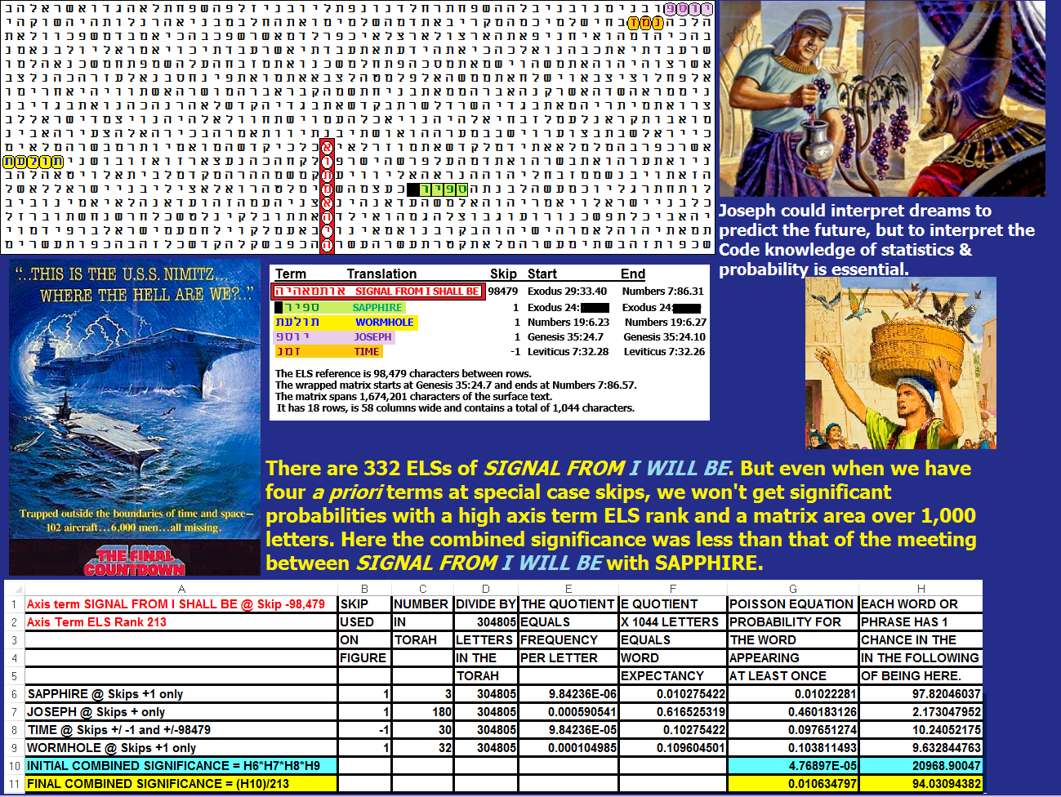
Figure 10-5. MATCHES BETWEEN "I SHALL BE" AND "SAPPHIRE" (OPEN TEXT) UNDER 500 LETTERS IN AREA.
On the Sabbath of January 6, 2018, in all legitimate synagogues, the Torah portion read was from Exodus 1:1 to Exodus 6:1. In the course of reading it again, I was struck in Exodus 3:13-14 by the Name that God chose to pass on to the Israelites via Moses… “I Shall Be.” If ever there was a remark out of the mouth of God designed to cast the eyes of physicists to the future for a human writer of the Torah Code, and by extension, to the Torah, it’s this.
We have looked at the issue of who Joseph Sapphire really is. Here is a man who almost seemed to appear out of thin air (but I was in the library for under 5 minutes when he positioned himself in a manner that basically blocked entry to my car). He seemed to know the topic of the book that I had just selected in the library, yet he was not in there himself, so far as I could tell either before or after we met. He said he was from Maryland, visiting a girlfriend, so it’s unlikely that he had a Brevard County library card. The warning about knowing someone like me who was falsely accused of using child pornography, coupled with his admission of an intelligence background in the very Army Intelligence Base (Fort Huachuca) that tracks my writing most closely, did not make him sound like a religious figure. Ditto with his claim to work at the White House for four years.
I found myself in an odd position. When I first spoke to Sapphire, he knew a hell of a lot about my life.
There are 31 matches between SIGNAL FROM I SHALL BE and, at skip +1, the last SAPPHIRE+ who interviewed me at the Cape Canaveral Library.
As can be seen with Figure 10-6, when an axis term with ELS rank 22 is matched with only two terms at special case skips – SAPPHIRE and TIME – in only 374 letters, the matrix is almost 2.6 times more significant than what was seen in the 1,044-letter Figure 10-4, even though that matrix had four words at special case skips – SAPPHIRE, WORMHOLE, JOSEPH, and TIME.
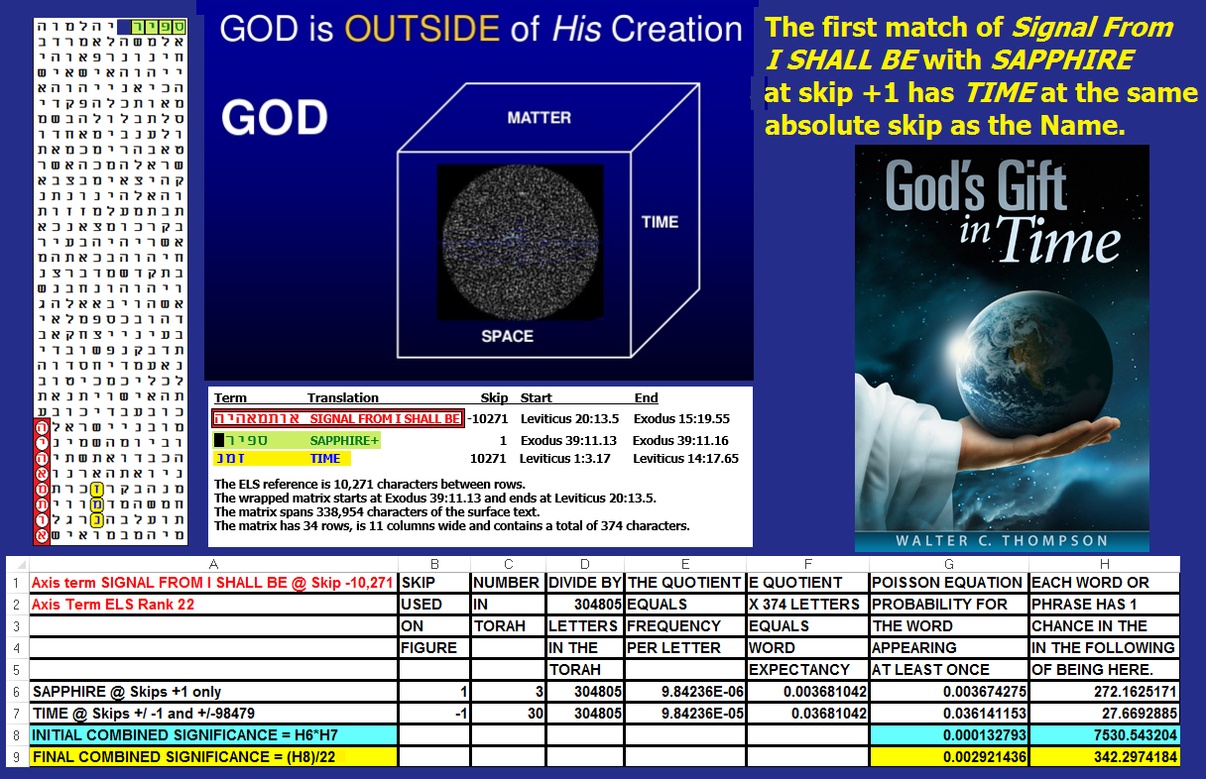
Figure 10-6. In addition to God communicating with Aaron and other high priests via the breastplate with urim and thumim, He also made His voice heard between the cherubim on top of the Ark of the Covenant. When I checked to see how many times there was a match between SIGNAL FROM I SHALL BE and ARK OF THE COVENANT, with the row split function disabled on CodeFinder, I found 36 matches, with the smallest having an area of only 88 letters (8 columns for the eight letters of ARK OF THE COVENANT and 11 rows, 8 of which were required to show SIGNAL FROM I SHALL BE).
One thing becomes obvious when I look at a term like SIGNAL FROM I SHALL BE, where there are hundreds of ELS occurrences – the searches that I do are inadequate in that they require so much time (and insight). Before learning about the A.I.-Reptilian connection I wrote that the best way to conduct searches for military intelligence purposes is to employ artificial intelligence in the search engine. This may, to fellow Orthodox Jews, seem to be a nonreligious thing to do, and I now know that new generations of A.I.s can both lie and provide emotional and erroneous conclusions. But we take proper supervision, I advance the idea that, with the understanding that there is an Intelligence behind the encoding of Torah, the belief in the Encoder begins to move from an area of faith to an area of mathematics – and math on the part of the Encoder that may not necessarily be linked to compassion as we generally understand the term. The function of our military is to defend our nation. There are plenty of people who act in ways that God may seek to destroy. But should God elect to destroy us not by a flood again, but by an asteroid or attack by a hostile ET race like the Reptilians, we have a right to expect our military to do its best to shoot it out of the sky. History is replete with incidents like the Crusades, the Inquisition, Pogroms, and Holocausts, where nobody stepped in to save millions of the innocent. Thus, given evidence that an Encoder exists, our military (and even NASA) have a duty to understand the exact nature and intent of that Encoder. Don’t depend on NASA. While I want to say Trust the U.S. Space Force, both NASA and Space Force fly command flags that map out where to find the same alleged ET civilizations in the Pleiades (Pleiadians), Alpha Draconis (Reptilians), and Orion (Grays). I have been contacted by a woman (Rebecca R.) who claims to have had many ET encounters, including ones with Pleiadians who told her that she is also from there. She asked me to refrain from publishing her full name so she can lead a normal, quiet life. Unlike Craig with his involvement in COVID-19, she comes across as non-threatening and a source of information about the alleged ET operations on Earth. In particular, I am interested in her testimony that she has personally seen Reptilians eat live hybrid Human-Grey children. The NASA and Space Force flags that mock public ignorance of relations between our 4th Reich government and ET worlds are shown on Figure 10-7.
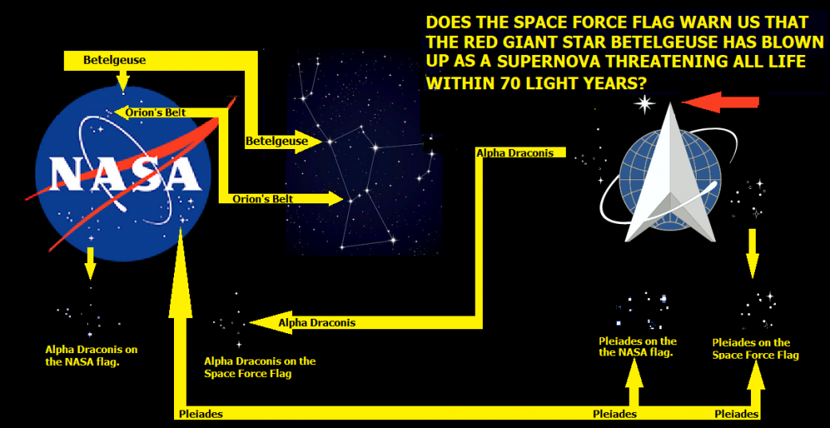
FIGURE 10-7: NASA and U.S. Space Force flags mapping ET worlds that our government has contact with.

RABBINICAL COMMENTARY ON THE NAME "I SHALL BE AS I SHALL BE" (EXODUS 3:14).
This name is often translated incorrectly as, “I AM WHO I AM.” The correct translation is only given in a footnote for the Revised Standard Edition and American Standard Edition. Wikipedia notes the controversy as to how to translate the Name as follows:
I Am that I Am (אֶהְיֶה אֲשֶׁר אֶהְיֶה ’ehyeh ’ăšer ’ehyeh) is the common English translation (JPS among others) of the response that God used in the Hebrew Bible when Moses asked for his name (Exodus 3:14). It is one of the most famous verses in the Torah. Hayah means “existed” in Hebrew; ’ehyeh is the first person singular imperfect form and is usually translated in English Bibles as “I am” or “I will be” (or “I shall be”), for example, at Exodus 3:14. ’ehyeh ’ăšer ’ehyeh literally translates as “I Am Who I Am.” The ancient Hebrew of Exodus 3:14 lacks a future tense such as modern English has, yet a few translations render this name as “I Will Be What I Will Be,” given the context of Yahweh’s promising to be with His people through their future troubles. Wikipedia goes on to make the following statement as to what is correct:
The word ’ehyeh is used a total of 43 places in the Hebrew Bible, where it is often translated as “I will be” – as is the case for its first occurrence, in Genesis 26:3 – or “I shall be,” as is the case for its final occurrence in Zechariah 8:8.

COMMENTARY ON THE NAME IN THE STONE EDITION CHUMASH
This book has the Hebrew text, translation, and rabbinical commentaries that I trust the most. In reference to Exodus 3:14, they state the following:
אֶהְיֶה אֲשֶׁר אֶהְיֶה – “I Shall Be As I Shall Be.” This in itself is a Divine Name, as implied by Onkelos, since he does not translate these three words. Rashi explains that the import of the word אֶהְיֶה – literally I Shall Be – is as follows: “I shall be with them in this sorrow as I shall be with them in other sorrows.” To this, Moses replied, “An evil in its own time is enough!” i.e., why should you imply to them that there will be future exiles; is it not enough that they suffer now in Egypt? Accepting Moses’s argument, God instructed him to say, “I Shall Be [with them in this sorrow] has sent me to you” (Rashi from Berachos 9b).
According to the Midrash, the word אֶהְיֶה describes God as timeless and eternal.

SUMMARY OF THE TRANSLATION DISPUTE.
It is obvious that those who choose to translate אֶהְיֶה as “I Am” rather than “I Will Be” are designing a God in accordance with what they want to believe rather than what they are being told by the Author of the Torah. Frankly, perhaps because, as a kid watching the Ten Commandments movies, I heard God identify Himself at the burning bush as “I Am That I Am,” I was surprised to see the future tense used in the actual Hebrew text. We have no problem accepting a God as declaring that He exists (or existed) when He was busy carrying out the Ten Plagues or splitting the Sea of Reeds, but when He says in the time of Moses, “I Shall Be As I Shall Be,” while nobody back then knew about relativity, wormholes, or tachyons, we know about them now. And, on a personal basis, I have had the rather odd experience with Joseph Sapphire. Moreover, I spend much of every day looking for signals encoded in Torah that are predictive. In 2026 I’ve found enough this way to keep me occupied for 28 years, and to merit having U.S. Government and other government agencies reading my Codes findings for many years.
As for my son, David, he once hounded me for years about his desire to one day invent a time machine. I finally got him to give up the idea when he started college and began to study physics, but now, when he sees the evidence and, in particular, who monitors our sites, his interest has returned. Having said all this, I remain skeptical that any human will write the Code and send it back in time to Moses. The problem is the time information paradox. How can a human write (and encode) all the stories in the Torah if he or she has already read them? But I do believe that signals of military value can be sent back in time, at least from the future to a point in time when humans first succeed in opening a wormhole.
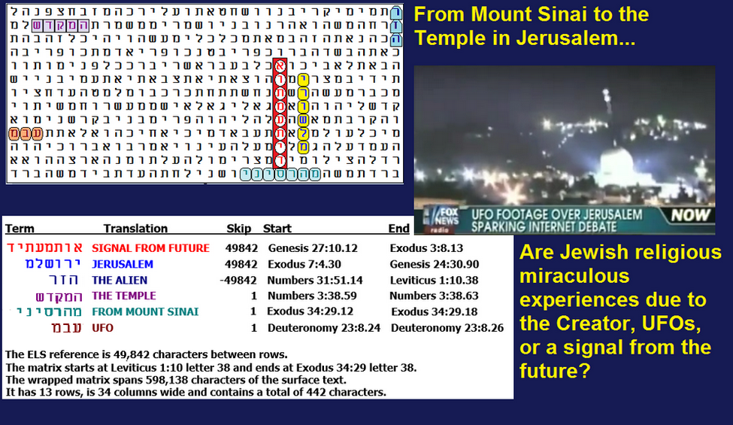
Figure 10-8 above: SIGNAL FROM THE FUTURE – ARE ALIENS INVOLVED?
On Figure 10-8, the axis term is SIGNAL FROM FUTURE, at its seventh-lowest skip in the wrapped Torah. The primary a priori word sought was JERUSALEM; I also sought MOUNT SINAI because I wanted to know if there is a link between miracles occurring at both locations and a signal from the future. In the Hebrew text of the Tenach (Old Testament to Christians), JERUSALEM occurs 664 times at skip +1 with the six-letter spelling found on the matrix, and another five times with the modern seven-letter spelling. I sought both spellings in the Torah matrix. (Jerusalem is never found at skips ±1; so, the only special case skips to seek are those at the absolute skip of the axis term.) SIGNAL FROM FUTURE is at skip +49,842. There is only one ELS of JERUSALEM at skip ± 49,841 in the Torah. After factoring in ELS rank 7 of SIGNAL FROM FUTURE, there was only one chance in 1,814 to find JERUSALEM in a 24-letter box with the axis term—actually less because there were only 16 letters left to find Jerusalem after eliminating the column containing SIGNAL FROM FUTURE (its eight letters conflict with JERUSALEM).
Odds against finding JERUSALEM at a special-case skip somewhere on the full 442-letter matrix were about 690 to 1. This is why I was shocked to see JERUSALEM so close to SIGNAL FROM FUTURE. But the other a priori keywords were also quite significant. Before factoring in the axis-term ELS rank of 7:
- UFO was found at skip +1 against odds of about 58 to 1.
- THE TEMPLE and MOUNT SINAI were each found at skip +1 against odds of about 43.6 to 1.
- One of three synonyms sought for THE ALIEN was found at a special-case skip against odds of about 12 to 1.
As for the UFO shown over Temple Mount, worthwhile commentary is found at http://nationalufocenter.com/2014/01/are-the-videos-taken-over-jerusalem-real-or-fake/. In all, the odds against Figure 10-8 occurring by chance alone were about 132,500,832 to 1.
The spreadsheet for Figure 10-8 is here:
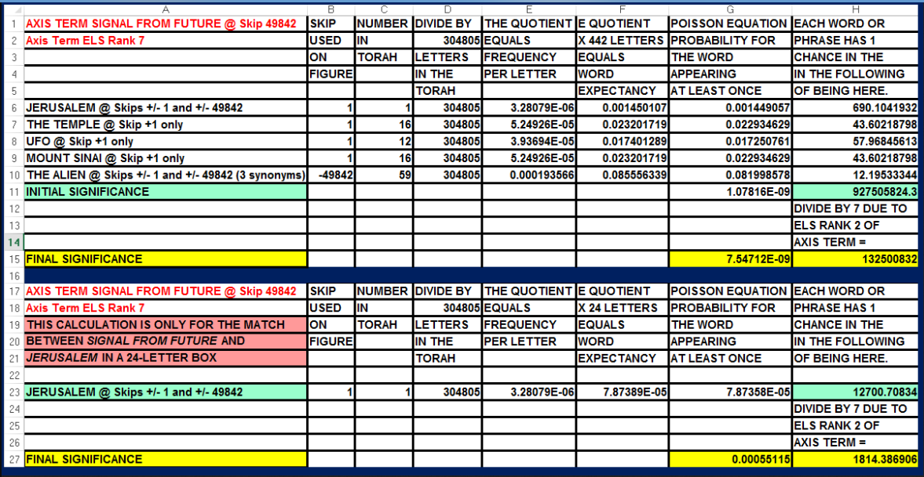
As such, the matrix raises fundamental theological questions of the highest nature. Figure 10-8, found on July 6, 2017, not only greatly reinforced my concerns but really removed all doubt that the concerns are valid.
One last point about Figure 10-8. The possibility of a human from the future and the possibility of aliens from the future sending signals back in time are not necessarily mutually exclusive. Given cooperation between aliens and humans (or the recovery of an alien device), we might (really, probably did) get the technology from them.
ARE SIGNALS FROM THE FUTURE ENCODED WITH TACHYONS? Yes. Despite my son David’s belief that wormholes are the way to go when sending signals back in time, tachyons are theoretical particles that travel faster than light and can travel back in time. As discussed below, there is not yet any direct evidence that they exist, but we might find indirect evidence. However, when SIGNAL FROM FUTURE is found at an ELS at skip -78,480 (ELS rank 5), we find TACHYON at skip -1 in a matrix that measures 27 rows by six columns (a 182-letter area). This match occurs against odds of about 188 to 1. Further, when SIGNAL FROM FUTURE is found at an ELS at skip +127,845, TACHYON is at skip -127,845 in a matrix that measures 24 rows by 14 columns (a 336-letter area). This match occurs against odds of about 43 to 1. Note that the statistical significance of TACHYON at skip -78,480 on Figure 10-9 is greater than for any other terms shown on all the matrices in this article, except for SAPPHIRE (really, the name given by the agent who interviewed me in 2016) and JERUSALEM on Figure 10-8.
As noted above, on the physics line of investigation, tachyons, if they exist, are not proving to be easy to detect directly. The following statement by Dr. James T. Wheeler, professor of physics at Utah State University, is noteworthy for those who can follow the physics involved:
Tachyons are well-defined within special relativity. They are particles for which the magnitude of the momentum is greater than the energy, so that their momentum 4-vector is space-like, rather than time-like, like the momentum 4-vectors of regular particles and their antiparticles.
Adding energy to a tachyon can be shown to slow it down, but an infinite amount of energy would be required to slow it to the speed of light.
To observe them does not require light to ‘catch’ them, but only to interact – the light could be coming from any direction. But we don’t even have to ‘see’ them with light. If a tachyon is produced, say, in a particle accelerator, and escapes unseen, then the total energy and momentum of the other particles will not be conserved. Moreover, a large amount of momentum will be missing – more than the missing energy – so we have a clear signal of the production of the tachyon, whether we see it directly or not.
No such missing momentum has been observed in accelerator experiments to date, so if tachyons do occur, they must at least have very large mass.
The space-time path of a tachyon lies outside the light-cone, which is what fixes our notion of causality. Thus, with tachyons, an event here could rapidly affect an event at an arbitrarily great distance, instantaneously for some observers. Physical effects would then become nonlocal, and – with easy production of tachyons – prediction nearly impossible.

Figure 10-9 – Signal from the future is twice encoded with tachyon.
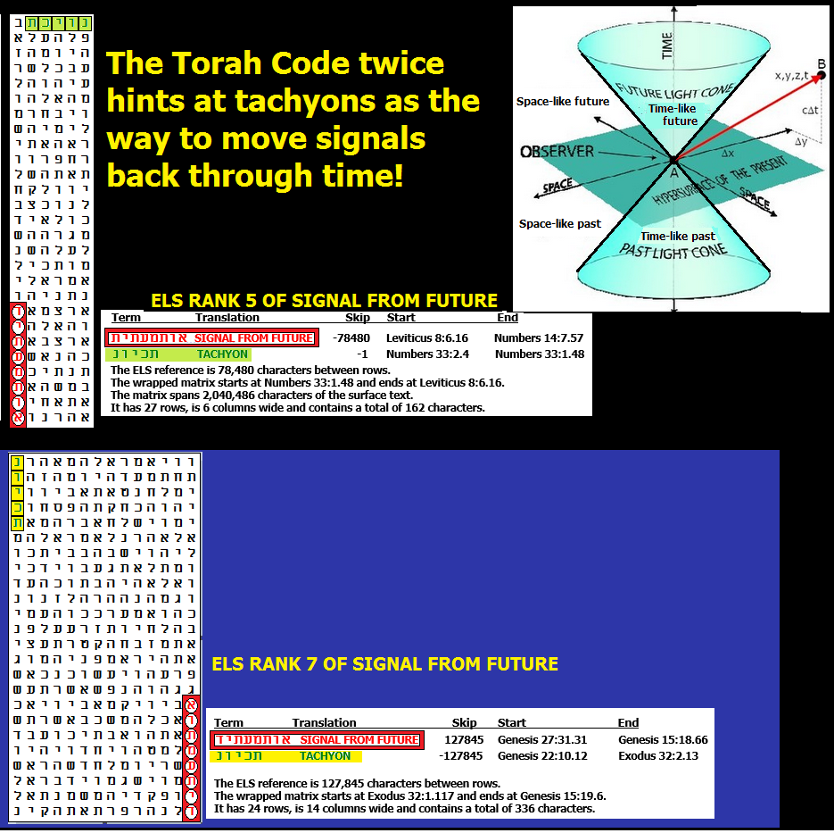
Spreadsheets for Figure 10-9.
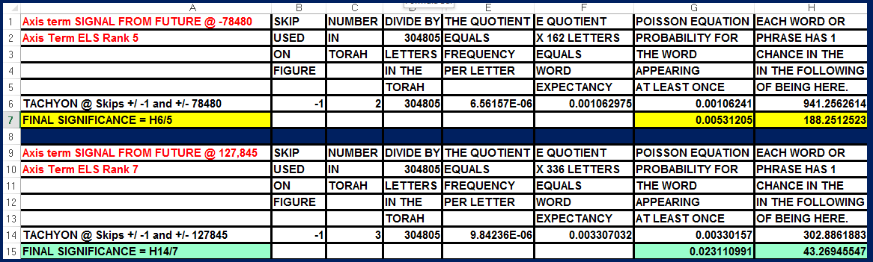

ON GETTING ALONG WITH GOD. If there is one thing about being Jewish that seems very different from what other religions offer, it’s the right we feel we have to argue with God. We saw some of that above with Moses getting God to change His mind about which Name to use. We see it with Moses telling God that if He wants to punish the Israelites too much, God should write Moses out of His Book (Exodus 32:32:
“But now, please forgive their sin—but if not, then blot me out of the book you have written”).
We saw it when Abraham bargained with God to try to save Sodom and Gomorrah, and when Jonah refused to go to Nineveh until he was spat up by a giant fish that ate him. We also see evidence that God’s attitudes evolve with time in Hosea 6:6:
“For I desire mercy, and not sacrifice; and the knowledge of God more than burnt offerings.”
God seems to be a life form, but One that may be argued with only from a moral perspective. In the end, only He generally gets to define what’s moral and what’s not.
A WORD OF HOPE. If it is true that we are headed for—or are now dealing with—a technology that can send signals back into the past, the real significance is that death is not as final as some people think. Let’s say that my son, David, one day sends me a signal from his future, or that Joseph Sapphire contacted me based on his access to such technology, and that he gave me hints about David being involved with nanotechnology and artificial intelligence. Let’s assume the signal originated from a time when I am dead. That means that although I am dead in that time, I remained accessible in this time. No death is really final. Rather, life exists at a point on a timeline that is no longer bound by one direction—forward. It also lends credence to the idea that a truly Superior Intelligence, generally referred to by the Name God, could finally be accepted as God when He reverses time and brings about the Resurrection that Jews, Christians, and Muslims have believed in for centuries. I SHALL BE AS I SHALL BE—shall be when this bit of physics is mastered.
LINGERING CONCERNS. Why did Joseph Sapphire really contact me? I am convinced that he had a perfect view of the future. That means he came to me knowing everything I would ever write. He knew how I would react to his threat to load child porn onto my computer. He spelled his name the second time because he knew what I first heard was not accurate enough to find the matrix in Figure 10-1 above. That matrix was required for me to understand critical issues touching on the nature of time and the threats facing humanity. If you Google Fort Huachuca, you will find accusations that they have captured or “loaned” alien spacecraft under their facility. There are also accusations of Reptilians being present there, which raises nasty questions about what they eat. If Sapphire is not himself an ET, he may be concerned about hostile aliens gaining control over what lies below—and what they intend to do to our species in the future. The works of Dr. Michael Salla and Elena Danaan focus heavily on these issues, but their reliance on a small number of named sources leaves us fascinated by the stories yet unsure of their accuracy. Danaan discusses the threat at Fort Huachuca.
Our government under Biden lost all credibility. On March 1, 2023, “President” Biden laughed at a woman who blamed him for the death of her two sons due to fentanyl poisoning that resulted from leaving our borders wide open. How can Sapphire (or anyone else) combat this level of corruption? Unless Joseph is more open with me (or Trump approves disclosure), all I can do is continue writing about my investigations, hoping to stimulate the right kind of opposition in the military-intelligence community to ensure an effective response to the threat Sapphire suggested by contacting me in 2016.
President Trump, I can help you get disclosure done the right way—but I’m not getting any younger. You have dangled job offers, but so far the only concrete contact I’ve seen is a signed portrait you sent as thanks for contributions to your campaigns. Your emails about a job in your cabinet are always accompanied by requests for more money. I need a phone call from you to know you are serious. The only money that should be discussed is my salary
FIGURE 10-10 BELOW: ONE MORE WORD ABOUT TIME:
RESURRECTION WILL BE THE PRODUCT OF TIME REVERSAL
.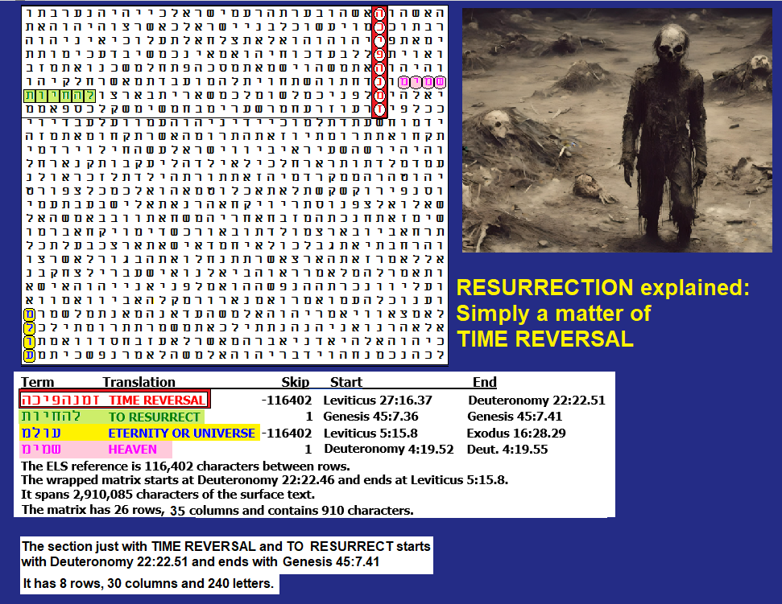
Figure 10-10 above and its spreadsheet below. The axis term is TIME REVERSAL. If we include TO RESURRECT just in a 240-letter box with the axis term TO RESURRECT was found this close to TIME REVERSAL against odds of about 423 to 1. If we ETERNITY or UNIVERSE and HEAVEN, then the resulting 910-letter matrix is found against odds of about 914 to 1, but on this large a matrix the odds against TO RESURRECT or RESURRECTION drop to about 112 to 1, which tells me that we should just focus on the 240-letter matrix.
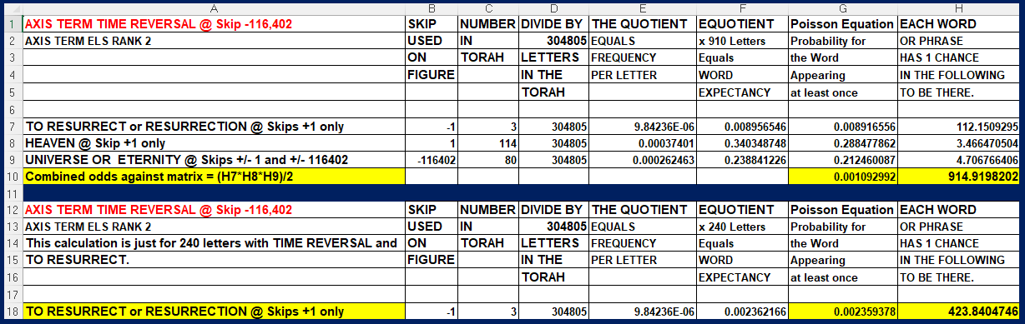

TIME REVERSAL IS DESCRIBED IN THE BOOK OF EZEKIEL. For the dead it would be like playing a video I reverse. In verses 37:1-14 we read about resurrection in a Valley of Dry Bones.
37 The hand of the Lord was on me, and he brought me out by the Spirit of the Lord and set me in the middle of a valley; it was full of bones. ² He led me back and forth among them, and I saw a great many bones on the floor of the valley, bones that were very dry. ³ He asked me, “Son of man, can these bones live?”
I said, “Sovereign Lord, you alone know.”
⁴ Then he said to me, “Prophesy to these bones and say to them, ‘Dry bones, hear the word of the Lord! ⁵ This is what the Sovereign Lord says to these bones: I will make breath^{[a]} enter you, and you will come to life. ⁶ I will attach tendons to you and make flesh come upon you and cover you with skin; I will put breath in you, and you will come to life. Then you will know that I am the Lord.’”
⁷ So I prophesied as I was commanded. And as I was prophesying, there was a noise, a rattling sound, and the bones came together, bone to bone. ⁸ I looked, and tendons and flesh appeared on them and skin covered them, but there was no breath in them.
⁹ Then he said to me, “Prophesy to the breath; prophesy, son of man, and say to it, ‘This is what the Sovereign Lord says: Come, breath, from the four winds and breathe into these slain, that they may live.’” ¹⁰ So I prophesied as he commanded me, and breath entered them; they came to life and stood up on their feet—a vast army.
¹¹ Then he said to me: “Son of man, these bones are the people of Israel. They say, ‘Our bones are dried up and our hope is gone; we are cut off.’ ¹² Therefore prophesy and say to them: ‘This is what the Sovereign Lord says: My people, I am going to open your graves and bring you up from them; I will bring you back to the land of Israel. ¹³ Then you, my people, will know that I am the Lord, when I open your graves and bring you up from them. ¹⁴ I will put my Spirit in you and you will live, and I will settle you in your own land. Then you will know that I the Lord have spoken, and I have done it, declares the Lord.’”

