Annex A

Torah Code Basics
The Torah Code hypothesis suggests that historically related words can be found encoded together at Equidistant Letter Sequences (ELS) within Torah matrices, these being significantly more compact than similar patterns found in non-religious texts. I have refined this hypothesis to account for the fact that most names requiring more than eight Hebrew letters are unlikely to appear in the Torah Code. However, shorter combinations—such as a brief first and last name, just a last name, or a last name paired with a first initial—often do appear within the Code.
While there is rabbinical tradition supporting the notion of such encoding in the Torah (the first five books of the Bible), no similar tradition exists for the remainder of the Bible. Although many hope to use the Torah Codes as a kind of prophetic tool or crystal ball, making predictions is difficult. The main challenge is not knowing in advance which words or names should be used as key search terms. As a result, many researchers limit their searches to events that have already occurred.
For 28 years the names that I chose to search for were largely those that were in recent headlines. This began to change when Obama was first elected as president. I watched with growing alarm. Although, as an Independent, I had voted for Democrats almost half the time before Obama, his promises of racial harmony went unfulfilled and were replaced by racial divisions at leves unseen before. Normal values were replaced by perversion, patriotism was replaced by Democrat accusations that loyal but conservative republican were really Nazis, our military was weakened by spending cuts, and much of their newly missing funds were packed into airliners and sent to Iran which was screaming “death to America” and “death to Israel.” Seats for those airliners were removed to fit in more cash to fund Iran’s nuclear bomb program in an effort to ensure the annihilation of America, Israel, and all western civilization. Over many years I was only amused by claims by some people about Obama being a reptilian alien. When I eventually looked for a find a matrix (Figure 3-5 in Chapter 3 of this book) that backed that idea, I first thought it was just a coincidence that could be used to attack the credibility of the Code. Then a pattern emerged. I began to check for matches between leading politicians here and overseas with Hebrew word for reptilian. The more radical and antisemitic they were, the more likely that I would find a match with supporting a priori key words that would increase the statistical value of the matrix.
Positive results may be misleading if we only see what was found, and not what was searched for but yielded nothing. When only successes are presented, the results may seem impressive. But when failures are also considered, we can more accurately evaluate the true value of those successes. So, I also looked for matches of Republicans with reptilians. I did not find one that was significant enough to make it into Chapter 3. So eventually I pushed harder. I am now a rock-solid republican. I had no choice. I had to see if ROFFMAN exists in sequence with REPUBLICAN. Before you reach for your pitchforks you should notice that I said above that I check for “supporting a priori key words that would increase the statistical value of the matrix.” One must check for close in terms that render a match negated. For instance, if there is a match of ROFFMAN REPTILIAN, what happens if the letters immediately before it spell IT IS NOT TRUE THAT? We cannot come to a hostile conclusion if the ELS train says IT IS NOT TRUE THAT ROFFMAN (is) REPTILIAN.” Having said that, ELS trains almost never exceed 10 letters and are normally limited to 8 or 9 letters. As FIGURE A-1 shows, the longer phrase requires 21 letters for the ELS. An ELS this long has never been found by Roffman.
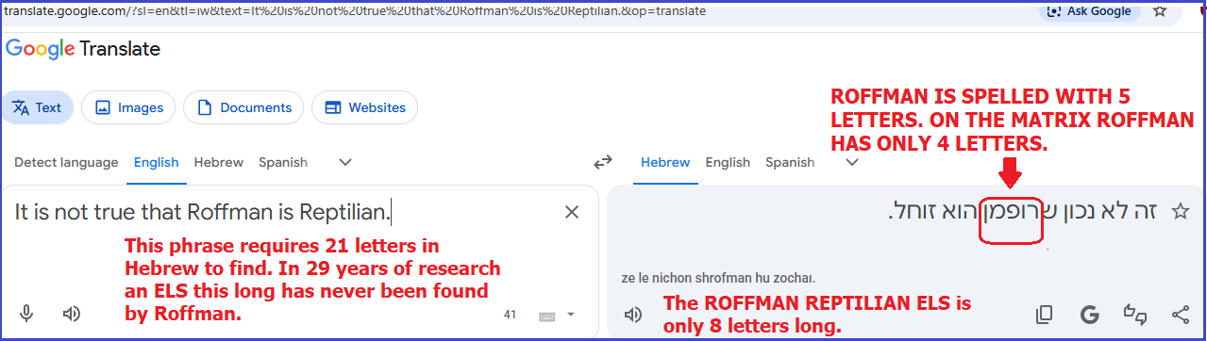Figure A-1 above: Partial response to claim that there is an ELS of ROFFMAN REPTILIAN.

However, sadly there is a Roffman cousin who is likely the subject of the matrix, I am not saying that he was born reptilian. I am saying that if he was not abducted and brain washed, he seems to have been a high paid collaborator. He has always voted 100% Democrat. Although he was my favorite relative for 50 years that came to a screeching end in 1997. When I was a kid this guy taught me how to play chess, how to ride a bike, and how to take the subway to the Franklin Institute science museum in Philly. Later he helped me write portions of my report, Mars Correct: Critique of all NASA Mars Weather Data. He was verbally opposed to the idea of aliens visiting Earth, and I caught him in a few lies related to contact between our government and ETs. He saw and heard something that I did but was intimidated by another relative to keep quiet about it. On the matrix I found his Hebrew 4-letter first name letter for letter touched the four Hebrew letters for COUSIN. His denial of what we had both experienced was the end of our relationship. Yes, the Torah Code goes down to this incredible level of detail.
REPTILIANS AND REPUBLICANS. Are there republican politicians who pair with reptilian in sequence? I have found two, but neither pair with additional descriptive terms. The first (8-letter) ELS has an R factor of 0.590 which means that there was an 87.29% that would be found. It was located at a very large skip -141,252 and is not statistically significant. The second find (R factor of 2.522) is more troubling. It was 9 letters at a skip of -1,237 against odds of about 332 to 1, The only reason I sought the ELS was just for control purposes, however if I get hired by the Trump Administration I will check see if the subject’s actions suggest the need for an additional, expanded Code search.
As will be shown later in relation to Ark Code research, this study addresses statistical significance. But ultimately, the test of success lies in predictive clarity: Originally, 29 years ago I asked, Do the encoded maps eventually lead to the recovery of the Ark of the Covenant in the area around 31°9′ North, 33°4′ East—specifically on the Bardawil or Zuqba Peninsula in Northern Egypt? That kind of proof still works. But since 2025 I have understood that the primary purpose of the Code is to name reptilian invaders of Earth whose purpose is to pose as political leaders where they work to destroy humanity. To those who see the evil that exists in Iran that we are destroying in war and wonder how President Obama could send plane loads of cash with billions of dollars funding the Iranian nuclear program, you ask why he did it. My answer is simple. The Code reveals that Obama is, like Biden, devoted to our destruction. But despite matrices like those shown in Chapter 3, we need their X-rays, bloodwork and DNA to nail their true identity unless they were merely abducted and brain washed by the enemy. We need full disclosure to defeat alien infiltration of our government and those of Russia, China, Canada, Australia, Ireland and Iran.
ELS Map 1 (shown below) provides insight into the another type of proof. While the general course of 252.35° True runs from JERUSALEM (starting with the letter yud) to the Zuqba Peninsula (beginning with the letter tsadeh) in Egypt, the more refined course angle of 251.565° runs from the last letter of TEMPLE (shin) to the first letter of ARK OF THE COVENANT (alef).
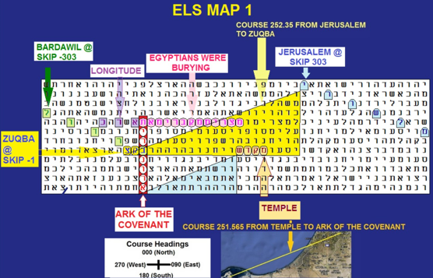
Figure A-2 above: ELS Map 1. ELS maps involving the Ark of the Covenant that housed the 10 Commandments generally have a course of 251.565°, true from the first encoded letter to the last. This results from a ratio of one row down and three columns left, portrayed with the interval, or ELS, being equal to the number of letters shown on each line, unless a “row skip” (explained below) is used. Note that the spaces between words are removed. So, the example of an ELS above would appear in a “matrix” as follows in Figure A-3:
M | A | N | W | A | L | K
E | D | O | U | T | H | E
E | D | O | O | R | I | N
T | O | T | H | E | S | T
A | N | D | S | T | H | A
T | S | E | A | T | E | D
8 | 0 | 0 | 0 | F | A | N
S

Figure A-3 above - example of how to read an ELS text. Further, it should also be pointed out that the really proper way to display the above would be to wrap it into a cylinder with a circumference of 7 letters.
Axis Term: The first term sought is the “axis term.” The axis term appears vertically. Hebrew is normally read right to left. The code is really based on a spiraling cylinder. The ELS or “skip” of the axis term = the number of letters on each line. In general, the minimum length of an axis term should be at least six letters. Most often, it is difficult to find axis terms longer than eight letters unless one uses a wrapped search, making more than one computer pass through the 304,805 letters of Torah.
Row Split: If a term like Ark of the Covenant has a skip or Equidistant Letter Sequence (ELS) of 306 letters, the computer will place 306 letters on each line. When the second letter of the term arises (without a row split), it will appear directly below or above the first letter. However, if a row split of 2 is used, the computer will only place half of the 306 (153) letters on each line, and there will be an extra row between each of the letters of the axis term. If a row split of 3 is used, there will be two extra rows between each letter of the axis term. The larger the row split, the more terms you can match with an axis term, but it is also true that as the row split increases, matrix significance generally decreases.
Word Frequency: Just as in English, some words have very high frequency (like THE or AND). In Hebrew, two or three letter words are extremely high in frequency unless they are composed of somewhat rare letters. The higher the frequency of a word in the open text or at an ELS, the lower the significance of its match with an axis term.
Matrix Size: The bigger the matrix, the more likely it is that short or moderate length ELSs (up to 6 letters) will be found somewhere on the matrix. This is like looking in a phone book. If you rip a page out at random and look for a single last name, it probably will not be there. But if you use the entire phone book, the chances of finding it are greatly improved.
Spelling: Even within Torah, there are multiple spellings of the same word. Code adversary Dr. Brendan McKay points out that on the Rabbi Abulafia synagogue in Tiberias, Israel, the rabbi’s name is spelled four different ways on the same building. The more spellings one can use to find a match, the less significant the match will be. Such multiple spellings must be factored into any probability calculation describing the significance of a matrix.
Wrapped vs. Unwrapped Matrices: The best Torah Codes programs allow the computer to make multiple passes through the 304,805 letters of the Torah to locate a term at an Equidistant Letter Sequence (ELS). This multi-pass approach is especially important when searching for axis terms that are eight or more letters long, as many such terms can only be found with more than one Torah pass. A wrapped matrix simulates how Jews read the Torah—finishing the last word of Deuteronomy each year on Simchat Torah in October, and then immediately beginning again with the first word of Genesis.
Some Codes researchers, particularly in Israel, do not use software like CodeFinder, which can locate wrapped matrices. These researchers are limited to unwrapped matrices where the software only makes a single pass through the Torah. Although I believe CodeFinder is the best Torah Codes tool available, I have not been able to persuade many of my Orthodox Jewish colleagues to use it. Their hesitation stems from the fact that CodeFinder includes files for the New Testament. Many Orthodox Jews strictly avoid any mention of the Nazarene’s name and will not allow any version of the New Testament into their homes.
While the New Testament files can be deleted, my colleagues are unwilling to take even that step. I have repeatedly asked Kevin Acres—the gentile creator of CodeFinder software—to offer a version without the New Testament files. Unfortunately, more than two decades of such requests have gone unanswered. Recently I learned that he passed away. This has significantly limited access for Israeli researchers, who arguably have the best understanding of the Hebrew used in Torah Codes matrices, and thus the best chance of recognizing the true nature of the Torah Code, assuming it is not merely a technological masterpiece engineered by aliens or a future human military civilization.

Torah Code Restrictions and Modification to Probability Calculations.
My basic protocol for calculating the significance of matrices is found in my web article on Skip Tables. With time, the value of short ELSs that were not at skips +1, -1, N, or -N, where N is the skip of the axis term, has come into question by me many other Torah Codes experts. Therefore, the following modifications have been built into my work for most of the last 29 years:
(1) Emphasize keywords found at skip +1 by just using their frequency at skip +1 alone. This usually (but not always) equates to their frequency in the open text, the exception being when two sequential words make up one larger word with a different meaning.
(2) Emphasize key words found at skip -1, N, and -N where N is the axis term skip by just using their frequencies at -1, N, -N, and also +1.
(3) Reject any matrix with an axis term less than six letters in length.
(4) Reject any matrix with no axis term that is just a mix of short 3 to 5-letter ELSs.
(5) Reject any 3-letter ELS that does not have its letters within three letters of each other.
(6) While I may show them and while I often discuss them, I reject all a posteriori findings for calculation purposes.
(7) I would never do a matrix based on a year as an axis term because it is too short, and because I have seen many thousands of times that years are not statistically important. Or to phrase it another way, there is no evidence seen that dating events was a purpose of the Code. This fits in with the concept that God, in His mercy, hides the date of death for most people.
(8) Axis terms that can be found at a single ELS like Ark of the Covenant (in Hebrew alef resh vav nun bet resh yud tav) are never split into two spatially separated words like Ark and Covenant. The term must appear as eight letters in sequence as it appears in Torah, or theoretically as nine letters in sequence as it appears in the 3rd to 6th chapters of Joshua as Ark of THE Covenant (alef resh vav nun HEY bet resh yud tav). There are no such ELS maps found with text outside of Torah.
(9) Because many names require a wrapped search (more than one computer pass through the Torah’s 304,805 letters) to find, the wrapped search is the method used to find the name rather than splitting it.
(10) Where a full first and last name cannot be found at an ELS even in a wrapped search, the first name initial and last name are sought. This generally occurs where a name has any of the following letters: multiple samechs, tets, gimels, and zayins. In such cases, if the name is just a transliteration, a shin/sin may be substituted for a samech, and a tav may be substituted for a tet.
I do not usually assign any significance to the axis term unless very long (although it is extremely rare that I ever find one over 10 letters in length).
A WORD ABOUT WHAT TO EXPECT – MATCHING A 7-LETTER KEY WORD WITH A 10-LETTER AXIS TERM: I was asked to match COVID-19 with the name of a man who found a meteorite that might have been the source of the virus – EBRAHIMI. Here is what I wrote:
The trick is to find what is actually there. For COVID-19, it takes 7 Hebrew letters, which would more likely be an axis term than an a priori key word. There are four transliterations that would work. They are (with frequency in Torah in unwrapped and wrapped finds) as follows:
kuf vav vet yud dalet yud tet (0/8)
caf vav vet yud dalet yud tet (7/35)
kuf vav vav yud dalet yud tet (1/15)
caf vav vav yud dalet yud tet (14/58)
So, without more than one computer pass through Torah (an unwrapped search), there are, in 304,805 letters of Torah, 22 possible matches for an axis term. With a wrapped search, there are 116 possible matches. Usually, I look for an axis term to be eight letters long. Eight is OK, especially when there is a relatively low frequency letter like tet, but to find a 7-letter key term that has a letter like tet, samekh, or zayin is extremely rare. Likewise, to put COVID-19 first and expect to find a 10-letter Hebrew word like one spelling of EBRAHIMI is basically unheard of. Results for keywords that are not axis terms are generally as follows:
3 letters – too short and easy to find. Rarely of great value unless at skip +1 and with rare letters.
4 letters – still short. Rarely of great value unless they are in a special case skip (+/- 1 or the absolute skip of the axis term).
5 letters – good but only excellent if they are in a special case skip or have rare letters.
6 letters – good to great.
7 letters – very good.
8 letters – rare (except with ARK OF THE COVENANT)
9 or more letters – exceedingly rare. Basically, not seen.
R VALUES: I generally don’t rely on Rotenberg R-values unless I’m working with a 10-letter axis term—or in rare cases, a 9-letter term containing infrequent Hebrew letters like tet, samech, gimel, or zayin. Although R-values are included in CodeFinder reports, I routinely remove them because I disagree with how the program applies them. As a rule, I assign no statistical weight to axis terms that are eight letters or fewer. Additionally, the higher the ELS rank of an axis term, the more I penalize the combined odds of a matrix.
In technical terms, p is the probability that the characters of an ELS will randomly match the characters of the text at a given position. N is the number of possible placements for an ELS at the specified skip. The R-value is defined as 1/E, where E = pN. E represents the expected number of times an ELS with an absolute skip smaller than the found skip would randomly appear in a permuted version of the Torah. For further explanation, see CodeFinder: Scores or Probabilities by Dr. Robert Haralick.
Here’s an example of an R-value calculation: suppose an axis term was found twice in wrapped Torah, but the matrix displays the instance at the higher skip. This term has an R-value of 0.484, which indicates there is roughly a 32.8% chance of finding it based on letter frequency. (To convert an R-value from the CodeFinder report—such as 0.484—into a percentage chance, enter .484 into a scientific calculator like the TI-30XA, press "2nd function," then "LOG," followed by "1/x," and multiply the result by 100.)

NOT EVERYTHING THAT LOOKS IMPRESSIVE IS IMPRESSIVE
The recurring question that arises whenever a new matrix is discovered is (or should be): “Is this finding statistically significant, or simply the result of high probability?” Professional researchers often turn to the Monte Carlo technique to answer this. Dr. Robert Haralick, who wrote the foreword to my Ark Code book, discusses the concept of probability on his website at http://www.torah-code.org/probability/probability.shtml. He also explains the idea of scrambling Torah texts to create what are known as “Monkey Texts” at http://www.torah-code.org/monkey_texts.shtml. Both discussions are vital to understand the Monte Carlo method.
Applied to Torah Codes, this technique involves scrambling the Torah text 10,000 or even 100,000 times, then comparing the occurrence of key term meetings in the real Torah with those in the scrambled texts. The level at which the Torah is scrambled—letter, word, or verse—matters greatly. Since much attention is given to keywords appearing in specific phrases, scrambling at the verse level is likely the most appropriate.
For instance, if you scramble the Torah 10,000 times and find 1,000 instances where the Monkey Texts produce tighter or smaller term meetings than the original, that suggests a one-in-ten chance the original matrix occurred by chance, statistically insignificant. But if only 100 such occurrences are found, then the original matrix might have just a one-in-a-hundred probability of happening by chance, which becomes more compelling.
When I began my research, the Monte Carlo method posed two major challenges: (a) it was often very slow due to the sheer volume of data—304,805 letters per scrambled Torah—and (b) it required specialized software that was not available to the general public. Because of these limitations, I developed an alternative method.
My approach focuses on matrix size (number of rows and columns), the number of ways a key term can appear within that matrix (vertically, horizontally, diagonally, forwards, and backwards), and how frequently that term appears at an ELS given the constraints of the matrix. It also accounts for the percentage of the Torah represented within the matrix, the chi-square value, and the combined total probability for everything found. Importantly, these results must be adjusted to reflect the impact of terms that were searched for but not found.
For more details, see Ark Code, Appendices A and B (pages 183–221). Note: In the case of ELS maps, the probabilities must also be adjusted to account for the requirement that the discovered terms appear at precise course angles corresponding to real-world map coordinates.

ROFFMAN SKIP FORMULA
Ways (either forwards, backwards, or diagonal) a term can fit in a matrix is determined as follows:
(1) Let the number of skips possible in a forward direction on a row of length (r), where r = the number of columns in the matrix, be equal to “Sr.”
(2) Likewise, let the number of skips possible in a vertical direction on a column of length (c), where c = the number of rows in the matrix, be equal to “Sc.”
(3) The Roffman Skip Formula for total skips is as follows:
Skips = 2(Sr + Sc + 2[Sr][Sc]) = 2Sr + 2Sc + 4SrSc.
Where do we find values for Sc or Sr? Use the following ROFFMAN SKIP TABLES found on my website:
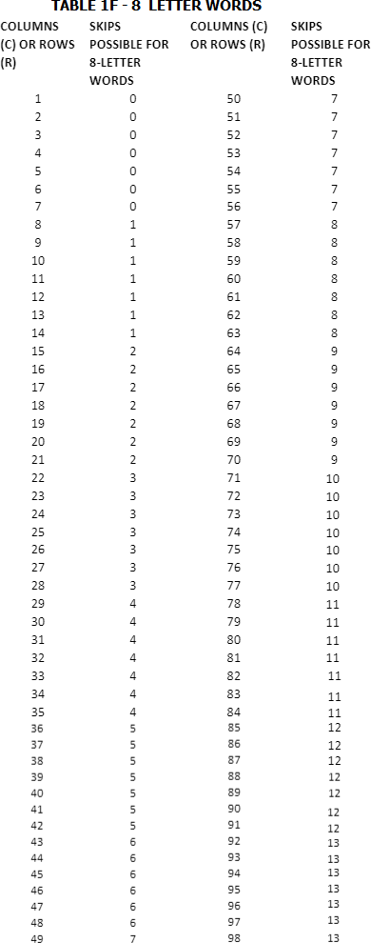
As an example, for 8-letter axis terms use the table below
We apply the Poisson Equation to see the probability that they are present at least once. This is necessary to determine the true probability for each word. Just because a word is likely to appear once per plot does not imply it will always be there. Words may average out to many times per plot area without actually being in a given plot of that area. Of course, if the expected frequency is sufficiently high, we eventually reach a probability like 0.9999999, which we simply round off as 1.0.

HOW TO FIND THE CHANCE OF A TERM APPEARING AT LEAST ONCE
- FIND THE PROBABILITY IT DOES NOT OCCUR BY THE POISSON EQUATION. x (-lambda)
f(x) = Lambda e x = 0; lambda = expected frequency per matrix x!
- 1 - f(0) = THE PROBABILITY OF OCCURRING AT LEAST ONCE. (where f(0) = the probability it will not occur)
On an Excel or Works spreadsheet, place head columns as follows:
A: Whatever identifies the calculation;
B: Skips Used on the Matrix;
C: Number of hits (on CodeFinder or similar software) in Skip Range;
D: Divide by 304,805 Letters in Torah or Control;
E: The Quotient Equals Frequency Per letter;
F: E Quotient Multiplied by Letters on Matrix = Word Expectancy;
G: Poisson Equation = 1-EXP(-F#) where # equals the row number of the item in Column F in question on the spreadsheet. If you want to know the chance for the item to be on the matrix, head to Column H accordingly. The value of Column H will be the reciprocal of the value found in Column G by the Poisson Equation.
Note: While this author (Barry S. Roffman) discovered the Roffman Skip Formula, my son (an MIT geophysics graduate), Rabbi/Air Force Major Robert Roffman, is the author of the spreadsheets and the man who first introduced the use of the Poisson Equation into my research.

ROW SPLIT AND WRAPPED MATRICES
There is some indication that when using a row skip—or row split—function for the axis term, the true value of an open-text match should be calculated by dividing the standard probability by the row split value. For example, the lowest ELS for the Ark of the Covenant was found at skip -306 (with a cylinder circumference of 306 letters). This term had approximately a one-in-2,931 chance of appearing in a 104-letter matrix alongside the phrase "Egyptians were burying." At skip -306, the row split function was not enabled in CodeFinder.
Had the row split been enabled and set to 2 (thus halving the cylinder circumference to 153 letters), and assuming the matrix area remained the same, I would have divided the 2,931 probability by 2, yielding a revised chance of about one in 1,465. However, in this specific case, the matrix with a 153-letter circumference would have been larger, since the match found using the 306-letter circumference was already nearly as tight as possible with the row split function turned off.
There is also discussion about adjusting a matrix’s statistical value based on the number of Torah passes made by CodeFinder during a wrapped (rounded torus) search before locating an axis term. For more on this, see the permutation experiment available at: https://www.arkcode.com/custom3_53.html.

SPECIAL CASE SKIPS
Finally, when computing the value of a priori open text terms on a matrix, it is my practice to only employ the frequency of this term at Skip +1 (in unwrapped Torah) on my spreadsheet in column C. However, if the a priori term appears at skip -1, N (parallel to, in the same direction, and at the skip of the axis term), or -N (parallel to, in the opposite direction, and at the skip of the term) in column C, I list the frequency (number of hits) as the total hits at skips +1, -1, N, and -N (with wrapped Torah allowed if that was required to find the axis term). These skips are considered special because they seem to leap out at the eye of the researcher and make the case for deliberate encoding seem more plausible.

THE TALMUD MAY INDICATE SOMETHING ABOUT WHY WE FIND NAMES ENCODED.
In a discussion of names and prophecy, the Talmud (Gemara for Berachos 7b) indicates that God inspires parents to select a name that has significance unbeknownst to the parent. Many years later, the aptness of the name becomes apparent to all.
THE LONGER THE NAME, THE LESS LIKELY THAT IT WILL BE AT AN ELS.

Many Codes advocates have been proceeding under the rabbinical (Vilna Gaon) claim that everyone’s life is predicted in the Torah – birth, death, all details, etc. But the full 10-letter Hebrew name for the United States (Alef Resh Tsadeh Vav Tav Hey Bet Resh Yud Tav, pronounced Artzot HaBrit) is not present at an ELS in unwrapped or wrapped Torah (or even if we search the entire Tenach/Old Testament). We can, however, find transliterations of the United States as are shown on Figure A-4 below.
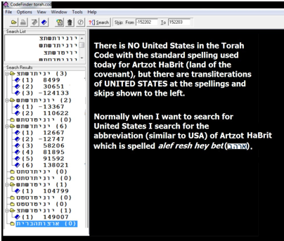
FIGURE A-4 above: Transliterations of UNITED STATES.
There are several possible spellings for UNITED STATES or its abbreviation. Because USA is only four letters in Hebrew, I generally don’t use it unless it is at a special case skip (+/- 1 or +/- the skip of the first term (axis term) used to start the matrix). Alternately, we could look for America, but due to time constraints, I seldom do unless the national location of an event is critical.
The most common ceiling of letters found at ELS without snooping for additional words before or after an axis term (first term sought) is eight letters. Nine-letter ELSs arise, perhaps 5% of the time, while 10-letter ELSs are probably found much less than 1% of the time. For example, suppose we just look for an ELS that has eight letters – Alef Bet Alef Bet Alef Bet Alef Bet. In wrapped Torah (where the computer makes several passes through Torah), it’s there 48 times, but in unwrapped Torah (one computer search of the Torah), it’s there only 5 times. What happens if we add a letter Alef at the end to make a 9-letter ELS to hunt for? We do not find this 9-letter ELS even once in the wrapped Torah. We hit the ceiling at eight letters. However, if instead of adding an Alef at the end of the first 8-letter ELS sought, we add a Bet at the beginning to get the nine letters of Bet Alef Bet Alef Bet Alef Bet Alef Bet, we do find it at ELS once. But the nine letters here are the limit, and it is only found in the wrapped Torah. It does not exist in one pass through the Torah. There, the limit remains at eight letters.
My son, Dr. David Roffman, and I have performed many experiments looking for names of people, whether his school colleagues or U.S. presidents, and the 8-letter limit was almost always there. So, what about people with names that require more than eight letters? We generally kick back to initials, or forms that eliminate vowel letters, but even then, we don’t always find everybody. Further, even if we did find everybody, it would generate serious questions about free will if their fates were prerecorded. This is a problem for Judaism, as our faith strongly backs the concept of free will.
So, what is really going on? To understand, we need to consider another Code written by God (though possibly modified by aliens) – the Genetic Code. I have written in my book and to Dr. Rips before about DNA-structured Code matrices, but this is not the point I wish to make here.
Consider, if you will, the cases of murderers who have murderers up their family trees. There are many of them. But having fathers, grandfathers, and great-grandfathers who were criminals does not mean that their descendants must be criminals too. There is free will, and people can overcome bad genes (as with many modern Australians who often trace their ancestry to prisoners brought there from England). People can learn from mistakes made by their ancestors; however, we are not shocked when they do not. So, it may be with the Codes. Not everyone’s name is at an ELS. But when a name is at an ELS, there may be a tendency for events to unfold in that life that match what is seen in the text that is close to the ELS name. A bad ELS location may imply a tendency to have something negative happen, while a positive environment in the Torah text may be a blessing. Therefore, parents should check the ELS location before settling on a name. However, it is more than possible that some names they might choose have no ELS – especially when the names are (a) very long, or (b) contain hard-to-find letters like zayin (Z), tet instead of tav for T, or samech instead of shin for S.
This also makes sense when we consider the issue of how a text as beautiful and coherent as Torah could possibly be written while the Author must consciously alter the proposed text to accommodate the fates of billions of people. No adjustment in text design was required. Rather, people adjust to their ELS location. Earlier, I had written that, “There might be cases, however, where the proximity of names and events is meant to serve as a warning. While there have not yet been enough cases to prove such links, if they exist, they probably are similar in nature to what is seen on a matrix like that under Vatican Rule seen on Figure A-5.” However, I now believe that an exception is with respect to a warning that top Democrats under and including Obama and Biden are, in fact, reptilian invaders or brainwashed people hostile to our species.
During the 2008 Presidential campaign, a record $745,000,000 was raised for the election of Barack Obama (Kamala Harris spent 1.5 billion dollars in 2024). Where did it come from? Before Trump, all major candidates (including Obama and McCain) except Ron Paul were members of the Council on Foreign Relations (CFR). Who on Biden’s team was a member of the CFR? Harris is. Of the CFR Group on the Biden Team. Jewish members of the CFR include Antony Blinken, Secretary of State, Janet Yellen, Secretary of the Treasury, Ron Klain, Chief of Staff, and Jeffery Zients, Counselor to the President. Non-Jewish CFR members of Biden’s cabinet include Vice President Kamala Harris, Lloyd Austin, Secretary of Defense, Linda Thomas-Greenfield, UN Ambassador, Cecilia Rouse, Council of Economic Advisors, Alejandro Mayorkas, Secretary of Homeland Security, Jake Sullivan, National Security Advisor, John Kerry, Special Envoy for Climate, Susan Rice, Chief of Domestic Council, William J. Burns, Director of the CIA, Kurt M. Campbell, Indo-Pacific Tsar, Thomas Vilsack, Secretary of Agriculture, Gina Raimondo, Secretary of Commerce, and Eric S. Lander, Director of Office of Science and Technology.
Sojourners Magazine wrote in January 2021 that among Biden’s nominations for his Cabinet, there were 15 heads of executive departments, as well as 10 other Cabinet-level positions. In this group, there are at least eight Catholics and seven Jews, who control the CFR. In fact, who is the real power behind many politicians? Many think it’s (self-hating) Jews on Biden’s staff that would be the Secretary of State, the Secretary of the Treasury, the Chief of Staff, and a Counselor to the President. Yet, Biden was a true enemy of Israel. But the CFR is also suspected by many to be none other than the Vatican itself. As such, I searched for two words in sequence: VATICAN RULE. See Figure A-5. I found it at its minimum ELS of -24,686, and in a two-column by 15 rows matrix with OBAMA. If I expanded the matrix to four columns, BARACK was there at skip -1 (from Numbers 7:13, letters four back to 2) touching OBAMA.
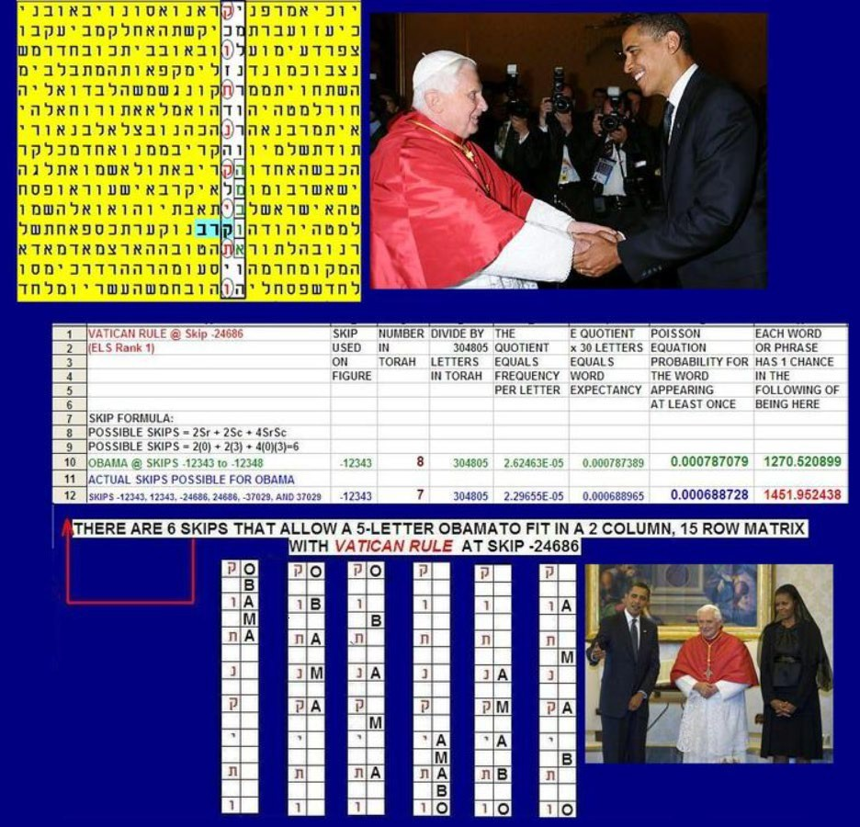

Figure A-5 above. Note how the letters of VATICAN fit in with those of OBAMA. This kind of match may suggest that such a link exists in the real world.
Sometimes we find descriptions of places encoded. In Figures A-6, A-7, and A-8, PHILADELPHIA shares a letter hey with THE CITY in the open text below. Figures A-6, A-7, and A-8 are below. I grew up in Philadelphia, and though it is known as the City of Brotherly Love, I hated it because it was also a city of mass murders. When I saw that with no row split employed, PHILADELPHIA touched and was, in the open text, just one letter below CITY (see Figures A-6 to A-7. I was surprised, but I wanted to know if the murderous link was also included on the matrix. Perhaps:

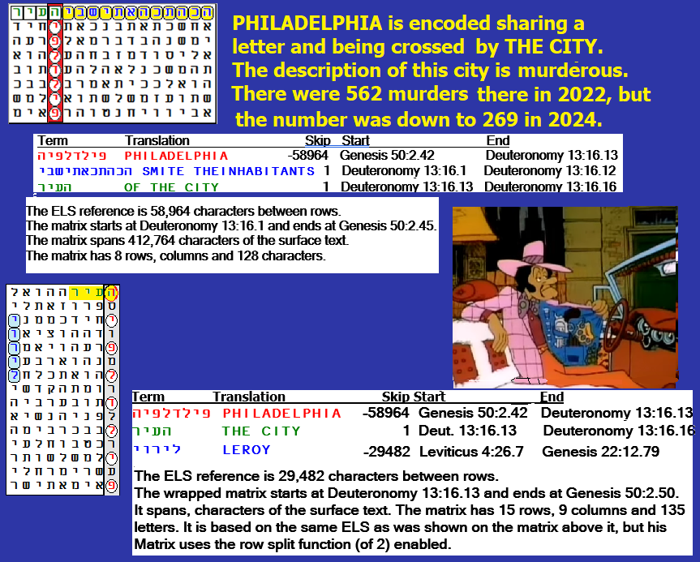
FIGURE A-6 above: PHILADELPHIA matrices.
The word CITY above is at the end of the words SMITE THE INHABITANTS OF THAT. This set me off singing an old, popular song about Bad, bad, LEROY Brown. So, I looked for LEROY and found him with the above material. Although his letters are vertical with no line separations, as is normally seen in an axis term that has no row split, here there is a row split of 2 used for the Philadelphia axis term. While it still stands out, this is not a special case skip.
The Leroy I Knew. Back in 1968, I worked during weekends at the Temple University emergency room on weekends. For many nights, we had a repeat, black, drunk patient. I don’t remember his last name. For at least the first two weeks, we sewed up knife wounds. Then we took a bullet out of him. The next weekend, he walked in holding his abdomen in his hands. In this way, he kept his intestines from spilling out of a bad cut. When two doctors rushed in to treat him minutes after his arrival, I will never forget that one of them proclaimed, “You sure have a lot of guts, Leroy.” The second doctor immediately followed up with, “Yea, Leroy, all over the table.” A good story like this often has a matrix behind it.
Suppose we do find a statistical tendency to support the Codes with respect to the fates of people. In that case, my hypothesis is that it will usually not be because they have been encoded to definitely do something. Rather, we are seeing the result of the analogy of good or bad genes with good or bad location of the names at ELS. The location of the ELS does NOT require the person to experience that fate, but it makes it more likely that they will experience the fate suggested than someone who has no such ELS location in Torah. I went looking for Philadelphia. In unwrapped text, it was only there once. But in wrapped text, Philadelphia is there 4 times. The first thing to look for? CITY. It matches perfectly with PHILADELPHIA at skip-58,964 (ELS rank 3) in wrapped Torah (see image above). All of this implies that experiments designed should perhaps aim at matching names to a pre-specified set of related terms, very much as we did before. But we should not expect to find all names or all fates encoded. For example, the Israeli Newspaper HaAretz spells the name Goldwasser (a prisoner of Hezbollah who was murdered in Lebanon) as gimel vav lamed dalet vav vav samech resh, and this name does not appear at an ELS in Torah Codes. This is only eight letters, but samech and gimel are low-frequency letters. The famous Rabbi Schneerson does not have his 10-letter last name encoded, though we can find the name on his grave, Menachem Mendel. Also missing: former Israeli Prime Minister Ehud Olmert. His 10-letter name (spelled Alef Hey Vav Dalet Alef Vav Lamed Mem Resh Tet) is not at an ELS. We can find Olmert followed (but not preceded by) by Resh Hey Mem, the abbreviation for Prime Minister, at skip-293 and in a 55-letter box along with the word for President or Prince (Nun Sin Yud Alef). Skip -293 is the fourth lowest skip of Olmert. But it should be noted that the three letters to form the abbreviation for Prime Minister are the third (Hey), fifth (Mem), and seventh (Resh) most common letters in Torah, comprising over 23% of it. We also find Olmert at an ELS in sequence with the same three letters scrambled in a meaningless fashion after his name as Hey Resh Mem, and Resh Mem Hey, if we search the wrapped Torah.
There are many fates that don’t match the names. However, if such a blessing or curse effect is present, we should expect to see a slightly greater rate of matching fates in Codes texts than in control texts – again, not because they are deliberately encoded, but because they have received a blessing or curse of some sort at name selection. While it also seems to exist, I am not yet as confident of any deliberate encoding for terms that do not require redundant a priori course angles like the ELS Maps posted on Figure A-1 and on the list below as Figure A-7.

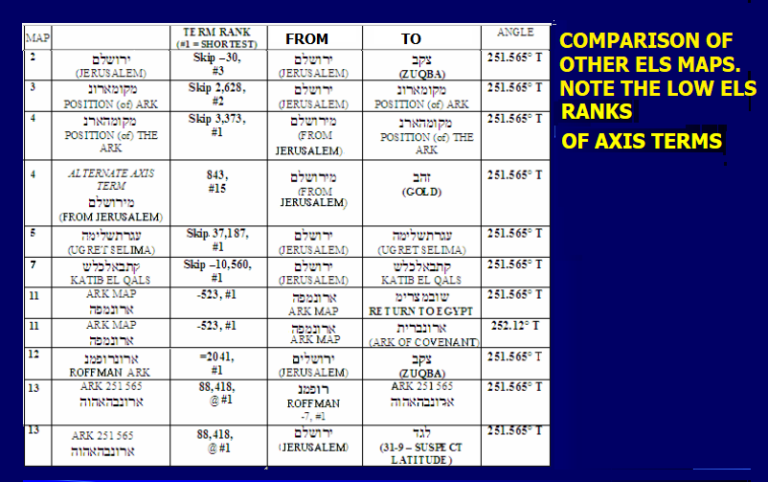

FIGURE A-7 above. ELS maps exist in many places in Torah. The course angle is redundantly encoded as 251.565 degrees from the site where the Ark was kept in Jerusalem to a spot on the El Zuqba peninsula in the northern Sinai. There is a salt marsh near it called Ugret Selima. The coordinates of the site are 31 degrees 9 minutes North, 33 degrees 4 minutes East. To arrive at this course, the ratio from the first position encoded to the possible current location is one row down and three columns left on the matrix.
Some examples follow:

Figure A-8: ELS Map 2:
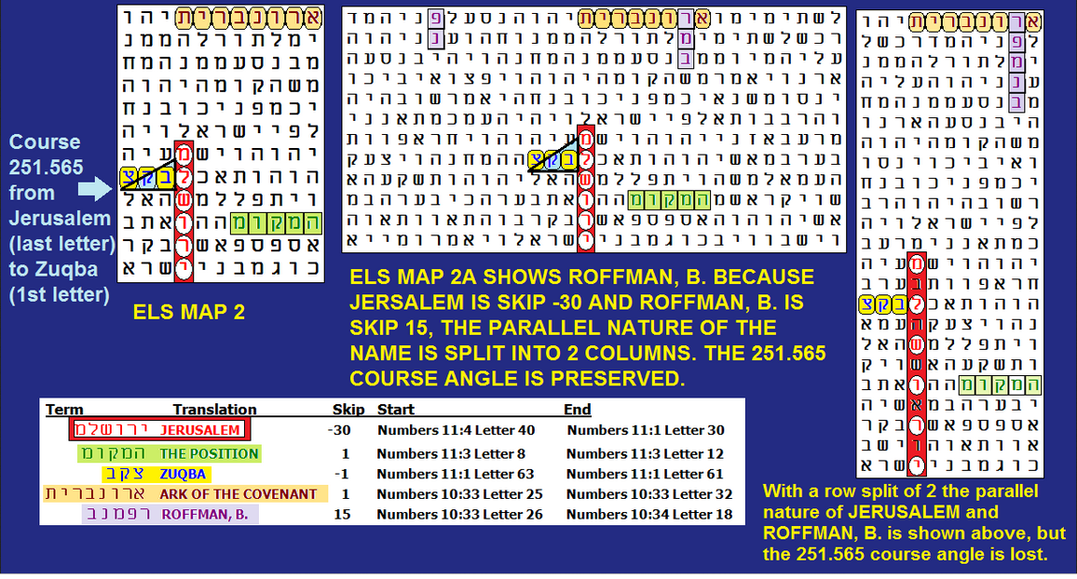
Figure A-9: ELS Map 3. On this matrix, the axis term is POSITION (of) ARK. The angle from JERUSALEM to POSITION (of) ARK again equals a course heading of 251.565 degrees True. Running into POSITION (of) ARK is the LAND OF EGYPT. POSITION (of) ARK is at its second lowest skip in Torah.
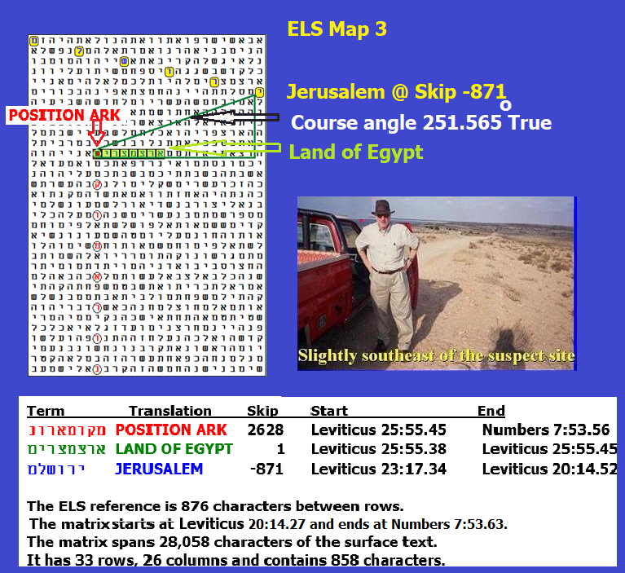
FIGURE A-10 above: POSITION OF ARK
How is the course angle calculated? The ordinate is six rows down from the first letter (yud) of JERUSALEM. The abscissa is 18 columns to the left with the first letter (mem) of POSITION (of) ARK (it’s also the last letter of LAND OF EGYPT). The ratio of rows (6) to columns (18) is 0.33333. Now, on a TI-30XA calculator, hit the second function and tangent. This angle is the arctangent (18.43494882 degrees). Next, since the direction is in the third quadrant, hit the +/- button and get -18.43494882 degrees. To this add 270 degrees and get 251.5650512 degrees True from JERUSALEM (Temple Mount) to POSITION (of) ARK on the El Zuqba peninsula in the Northern Sinai desert. I tried to reach the site in 1999 and again in 2004. It sits in a military restricted zone forbidden to foreigners. On my last expedition, with some help via a friend of Egyptian General Benil Shaddah, I got within a mile of the site, but the men that I paid to drive me there (over sand dunes in a truck with low-inflated tires) did not want me to get out of the truck, and I was not permitted to use my metal detector. Nor did I have any GPS equipment with me. The driver said I might be shot if I were spotted in my Indiana Jones hat. At that time, Dr. Zawi Hawass was in charge of Egyptian antiquities. He was adamantly opposed to helping any expedition aimed at supporting Judaism or Christianity. Now, in 2026, I am 79 years old. Even if I could raise the money and obtain the permits required to dig at the site, I would need a younger, healthy partner. Perhaps there is someone reading this book now who will accomplish the tasks needed. If so, please contact me through my email address: barrysroffman@gmail.com.

